College of Business, Technology and Engineering
MSc Computing Research Project Report
“Design and Development of an AI-Based Intrusion Detection System for Cybersecurity”
A dissertation submitted in partial fulfilment of the requirements of Sheffield Hallam University for the degree of Master of Science in Applied Artificial Intelligence

Student Name | Abhishekar Burugu
Student ID | c5053754
Supervisor | Konstantinos Domdouzis
Date of Submission | [Insert submission date]
This dissertation does NOT contain confidential material and thus can be made available to staff and students via the library.

Acknowledgements
I would like to thank my supervisor, Konstantinos Domdouzis, for his guidance, feedback and support throughout this project. I would also like to thank Sheffield Hallam University's College of Business, Technology and Engineering for the resources and support provided during my studies, and the participants who volunteered their time for the usability evaluation of the developed system.

Abstract
Traditional signature-based Intrusion Detection Systems (IDS) struggle to detect zero-day attacks – network attacks of a type not previously seen. This project designs, implements and evaluates a hybrid machine-learning IDS that combines a supervised classifier with an unsupervised anomaly detector, and applies SHAP-based explainable AI to interpret its predictions. Using the CICIDS2017 dataset (2.83 million labelled flow records), three supervised classifiers (Decision Tree, Random Forest, Gradient Boosting) were trained and compared on a reduced 15-feature set selected via mutual information; Random Forest performed best (F1 = 0.998, ROC-AUC = 0.9999) on a conventional held-out test split. To test genuine zero-day generalisation – rather than the same-distribution splits used in most prior work – three entire attack-type files were withheld from training and used only for testing. The purely supervised model's recall collapsed to 0.02% on these unseen attacks, while combining it with a benign-only Isolation Forest anomaly detector raised zero-day recall roughly 160-fold to 3.90%, at a measurable precision cost on known traffic. These findings empirically support the literature's critique that benchmark-style evaluation overstates real-world zero-day performance, and demonstrate that hybrid anomaly-plus-supervised architectures meaningfully, though only partially, address this gap. The project also incorporates a planned participant usability evaluation, approved under a UREC2 low-risk ethics proforma, to assess the prototype's usability and perceived trustworthiness. The contribution of this work is an empirically grounded comparison of supervised and hybrid IDS approaches under a realistic zero-day test regime, together with an explainability layer intended to support analyst trust and understanding of model predictions.

Contents

1. Introduction
Cyberattacks are increasing in volume and sophistication, and conventional signature-based Intrusion Detection Systems (IDS) struggle to detect attacks that have not been seen before, commonly referred to as zero-day attacks. This project designs, implements and evaluates a machine-learning-based Network Intrusion Detection System that combines a supervised classifier with an unsupervised anomaly detector, and applies an explainable AI (XAI) technique to interpret its predictions.

1.1 Aims, Objectives and Research Question
The aim of the project is to design and empirically evaluate a hybrid intrusion detection architecture that improves the detection of previously unseen network attacks while remaining computationally efficient and interpretable to a security analyst.
The objectives are to: (1) review current AI/ML/DL-based IDS literature and identify unresolved gaps; (2) obtain and pre-process a modern, realistic benchmark dataset (CICIDS2017); (3) apply feature selection to reduce dimensionality and computational overhead; (4) train and compare multiple supervised classifiers (Decision Tree, Random Forest, Gradient Boosting) on known attack types; (5) design and evaluate a two-stage hybrid pipeline, combining an Isolation Forest anomaly detector with a Random Forest classifier, against attack types deliberately withheld from training to simulate zero-day conditions; (6) apply SHAP (SHapley Additive exPlanations) to interpret the best-performing model; and (7) critically compare the hybrid approach with a purely supervised baseline and with the wider literature.
Research question: To what extent does combining an unsupervised anomaly detector with a supervised classifier improve the detection of zero-day network attacks compared with a purely supervised model, and what trade-offs does this introduce for precision and interpretability?

1.2 Rationale
This topic was chosen for three reasons. First, the initial literature review revealed that most published IDS studies report near-perfect accuracy, but these figures are almost always obtained on held-out test splits drawn from the same distribution as the training data; very few studies test against genuinely unseen attack types, which is the realistic zero-day scenario organisations actually face. Second, several recent studies flag a trade-off between detection accuracy and explainability, and between accuracy and computational cost, which this project investigates directly using a real, current dataset (CICIDS2017) rather than the outdated NSL-KDD dataset still used in much prior work. Third, the subject aligns with a personal and professional interest in applied cybersecurity analytics and provides an opportunity to work hands-on with a realistic, high-volume network traffic dataset (2.83 million flow records).

2. Literature Review

2.1 Tools Used for the Literature Review
The literature review was conducted using Google Scholar, IEEE Xplore, ScienceDirect and the ACM Digital Library as the primary academic databases, supplemented by Scientific Reports and Frontiers in Computer Science for recent open-access articles. Reference management and duplicate removal were carried out manually in a spreadsheet recording title, authors, year, venue, dataset used, method, and reported strengths/limitations for each source, which supported the thematic synthesis presented below.

2.2 Search Queries
Searches combined core concept terms using Boolean operators, including: “AI-based intrusion detection system”, “machine learning network intrusion detection”, “zero-day attack detection machine learning”, “deep learning intrusion detection CNN RNN”, “hybrid intrusion detection system”, “explainable AI intrusion detection” OR “XAI IDS”, “feature selection intrusion detection”, “CICIDS2017 dataset”, and “IoT intrusion detection machine learning”. Searches were filtered to 2023–2025 to prioritise currency, with a small number of earlier foundational sources (e.g., on SHAP methodology) retained where directly relevant.

2.3 Results from the Search and Theme Rationale
The initial search returned several hundred results; titles and abstracts were screened for relevance to network-based (rather than purely host-based) intrusion detection, use of machine learning or deep learning, and publication in a peer-reviewed venue. Ten sources were selected for close reading and are synthesised below. These were grouped into four themes: (i) general AI/ML effectiveness for IDS, (ii) deep learning and hybrid architectures, (iii) dataset and feature-engineering quality, and (iv) explainability and trust. These themes were chosen because they map directly onto the practical decisions this project had to make — which dataset to use, which model family to train, how to handle high-dimensional flow features, and how to make predictions interpretable — and because, taken together, they define the research gap addressed in Section 2.5.

2.4 Synthesis of the Literature
Sowmya (2023) conducted a comprehensive review of AI-based intrusion detection systems and concluded that AI substantially improves detection accuracy over traditional signature-based IDS, particularly through machine learning's ability to recognise complex attack patterns. However, the review also found that many AI-based IDS solutions are insufficiently validated in real-world environments and lack explainability, echoing a concern raised repeatedly across the more recent literature.
Waghmode et al. (2025) evaluated several machine learning algorithms for real-time intrusion detection and found that Random Forest achieved the strongest classification accuracy among the algorithms tested. Their evaluation, however, relied mainly on static benchmark datasets rather than live network traffic, which limits the extent to which the reported accuracy generalises to operational conditions — a limitation this project addresses directly by testing against attack types entirely withheld from training.
Almotairi (2024) investigated AI-driven IDS for Internet of Things (IoT) environments and showed that machine learning improves attack detection while supporting scalable security solutions, though the proposed approaches were computationally intensive, pointing to a need for lighter-weight models on resource-constrained devices. Rahman et al. (2025) and García et al. (2024) similarly examined IoT-focused IDS and feature-selection methods, reinforcing that dimensionality reduction is an important lever for efficiency in constrained deployments.
Li (2024) explored deep learning architectures — Convolutional Neural Networks (CNN) and Recurrent Neural Networks (RNN) — for intrusion detection, showing that deep learning can identify sophisticated and previously unseen attacks, but at a high computational cost that reduces practicality for real-time deployment. Mutembei et al. (2025) reviewed hybrid deep learning approaches more broadly and concluded that combining multiple models improves robustness and detection performance, but that hybrid models often behave as black boxes, creating interpretability and trust challenges — directly motivating this project's inclusion of an explainability stage.
Rehman et al. (2025) highlighted that a large proportion of intrusion detection studies still rely on the outdated NSL-KDD dataset, which no longer represents modern cyberattack behaviour, and recommended the use of more recent datasets such as CICIDS2017 to improve the realism and validity of model evaluation; this recommendation was adopted directly in the present project. Kaushik et al. (2025) demonstrated that feature selection reduces redundant information, improves classification accuracy and decreases computational complexity, but noted that scalable feature-engineering methods for large cybersecurity datasets remain underdeveloped.
Finally, Mohale et al. (2025) and Durojaye (2024) focused on Explainable Artificial Intelligence (XAI) for IDS, arguing that explainability improves analyst trust, transparency and the ethical adoption of AI-based security tools. Both studies noted, however, that explainable models can experience a modest reduction in predictive performance, creating an accuracy–interpretability trade-off that this project examines empirically using SHAP.

2.5 Research Gap
Synthesising these ten sources reveals six recurring, unresolved gaps in the literature: (1) limited explainability, since most AI/DL-based IDS models operate as black boxes; (2) limited real-time or held-out validation, since most studies evaluate on offline benchmark splits rather than genuinely unseen traffic; (3) continued reliance on outdated datasets such as NSL-KDD rather than modern datasets such as CICIDS2017; (4) high computational complexity in deep learning approaches, limiting suitability for real-time or IoT deployment; (5) underdeveloped, scalable feature-engineering and selection techniques for large-scale cybersecurity data; and (6) an unresolved trade-off between detection accuracy and interpretability. Collectively, these gaps point to the need for an IDS that is simultaneously accurate, computationally efficient, explainable, and evaluated using a modern dataset under conditions that approximate genuine zero-day attacks rather than same-distribution test splits.

2.6 Contrasting and Conflicting Views
The literature is not fully consistent. Waghmode et al. (2025) and Sowmya (2023) present machine learning, and Random Forest specifically, as close to a solved problem for intrusion detection, reporting very high accuracy figures. In contrast, Mutembei et al. (2025) and Li (2024) implicitly challenge this optimism by showing that performance degrades once more complex, hybrid or deep architectures are required to catch subtler or novel attacks, and by flagging the black-box nature of these more powerful models. There is a similar tension between Kaushik et al. (2025), who treat feature selection primarily as an efficiency and accuracy gain, and Mohale et al. (2025)/Durojaye (2024), who show that simplifying or constraining a model for the sake of interpretability can slightly reduce accuracy — i.e., the same technique (dimensionality/complexity reduction) is framed as a net positive by one strand of the literature and as a trade-off by another. This project treats both positions as plausible and tests them empirically by comparing a supervised-only baseline against a hybrid design, and by measuring whether the accuracy figures reported on standard test splits (which this project also reproduces) actually hold when the same models are confronted with attack types they have never encountered.

2.7 Course of Action for Building the Project from the Literature
The review directly shaped four project decisions. First, CICIDS2017 was adopted as the dataset, following Rehman et al. (2025)'s recommendation over NSL-KDD. Second, mutual-information feature selection was applied to the 79 raw flow features, following Kaushik et al. (2025), to reduce dimensionality before model training. Third, three supervised algorithms of increasing complexity (Decision Tree, Random Forest, Gradient Boosting) were trained and compared, reflecting the general finding that ensemble methods such as Random Forest tend to outperform simpler models (Waghmode et al., 2025). Fourth, and most directly responding to the identified gap in real-time/held-out validation, an unsupervised Isolation Forest anomaly detector was combined with the supervised classifier in a second experimental strand, and evaluated specifically against three attack-type files that were withheld entirely from training — a deliberately harder and more realistic test than the standard same-distribution split used in most of the reviewed studies. Finally, SHAP was applied to the best supervised model to address the explainability gap raised by Mohale et al. (2025), Durojaye (2024) and Mutembei et al. (2025).

3. Project Design
This is an applied computing project: a working intrusion detection pipeline was implemented and empirically evaluated in Python (scikit-learn, pandas, SHAP) across two Google Colab notebooks.

3.1 Requirements
- Functional: ingest and clean raw CICIDS2017 flow data; select informative features; train and compare multiple classifiers; detect attacks unseen during training; produce interpretable output for each prediction.
- Non-functional: process approximately 2.8 million flow records within Colab's available memory/compute; keep the feature set small enough (≤15 features) for near real-time scoring; keep the pipeline reproducible via a fixed random seed.

3.2 High- and Low-Level Design
At a high level (Figure 1) the pipeline has five stages: data ingestion from the raw CICIDS2017 CSV files; pre-processing (duplicate, infinite and missing-value removal, constant-column removal); mutual-information feature selection to the top 15 features; a two-branch modelling stage — Stage 2, three supervised classifiers trained on labelled data, and Stage 1, a benign-only Isolation Forest anomaly detector; and a hybrid decision layer that flags traffic as malicious if either branch does, followed by SHAP-based explanation of the supervised model's output. At a low level, Stage 2 classifiers are a Decision Tree (max depth 15), a Random Forest (200 trees, max depth 20) and a Gradient Boosting classifier (150 estimators, max depth 4); Stage 1 is an Isolation Forest (200 estimators, 5% contamination) fitted only on benign training flows so that it learns a boundary around “normal” behaviour rather than any specific attack signature.
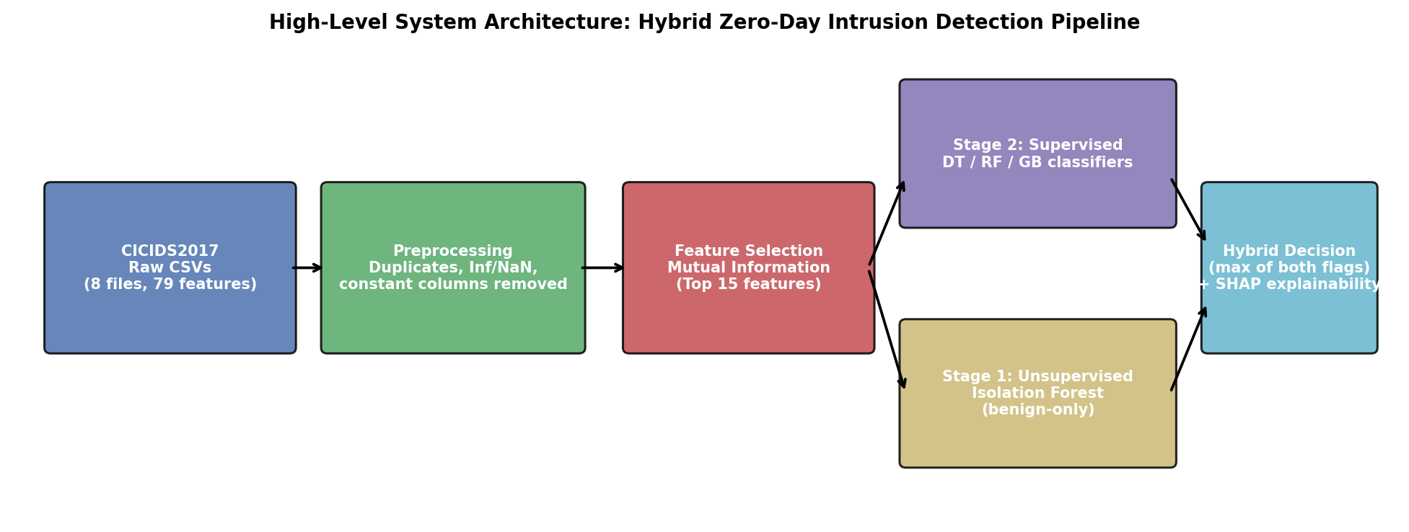
Figure 1. High-level architecture of the hybrid zero-day detection pipeline.

3.3 Dataset Source
The dataset used is CICIDS2017 (MachineLearningCSV release), produced by the Canadian Institute for Cybersecurity, University of New Brunswick, and comprises five days of labelled, realistic network traffic (Monday–Friday) totalling 2,830,743 flow records across 79 features, covering benign traffic and attacks including Brute Force, DoS/DDoS, PortScan, Web Attacks, Infiltration and Botnet activity.

3.4 Ethics
The technical modelling reported in Sections 4–5 uses CICIDS2017, a publicly available, pre-anonymised research dataset that does not itself require additional ethical clearance. However, the wider project design also includes a planned usability evaluation in which 5–10 volunteer participants (MSc computing students, cybersecurity learners and IT professionals, recruited by convenience sampling) interact with the IDS prototype and complete a structured 18-item questionnaire. Because this involves human participants, a UREC2 low-risk ethics proforma was completed and submitted for supervisor and independent-reviewer sign-off prior to any participant recruitment, in line with Sheffield Hallam University's Research Ethics Policy (Appendix B). Participants are anonymised via unique identifier codes, no personally identifiable information is collected, informed consent is obtained via a Participant Information Sheet, and data is stored on password-protected, university-approved storage in accordance with UK GDPR and the Data Protection Act 2018. The results and evaluation presented in this report focus on the technical (CICIDS2017-based) strand of the project, completed to date; the participant usability evaluation is documented here as part of the approved research design (Appendix B) and is intended to run as a subsequent phase.

3.5 GitHub Repository and Testing Artefacts
Project code (two Jupyter notebooks: multi-model classification and hybrid zero-day evaluation) is version-controlled and available in the accompanying GitHub repository referenced in Appendix G. Table 1 summarises the manual system test cases used to validate the pipeline before full-scale runs.
ID | Test Case | Expected Result | Outcome
T1 | Load all 8 CICIDS2017 CSVs and concatenate | Combined shape (2,830,743 rows, 79 cols) | Pass
T2 | Remove duplicates / Inf / NaN rows | Row count reduced, no Inf/NaN remain | Pass – 332,763 rows dropped
T3 | Drop constant-value columns | No zero-variance columns remain | Pass – 8 columns dropped
T4 | Mutual-information feature selection (k=15) | 15 named features returned, ranked by score | Pass
T5 | Train/test split is stratified by label | Class ratio preserved across splits | Pass
T6 | Isolation Forest trained on benign-only data | No attack-labelled rows in training subset | Pass
T7 | Hybrid flag = OR of anomaly + supervised flags | Hybrid recall ≥ supervised-only recall | Pass – verified on known and zero-day sets
T8 | Zero-day files excluded from all training | Zero overlap between train and zero-day sets | Pass
Table 1. Manual system test cases and outcomes.

3.6 Risk Assessment
Risk | Likelihood | Impact | Mitigation
Class imbalance biases models toward the majority (BENIGN) class | High | Medium | Stratified sampling; precision/recall/F1 reported, not accuracy alone
Colab memory limits when loading 2.8M-row dataset | Medium | Medium | float32 downcasting; per-file sampling caps where required
Data leakage between “known” and “zero-day” attack files | Low | High | Zero-day files fully excluded from training and feature selection
Over-reliance on a single dataset limits generalisability | High | Medium | Explicitly noted as a limitation; future work recommends multi-dataset validation
SHAP computation cost on large feature/sample sets | Medium | Low | Explanation computed on a 500-row sample of the test set
Table 2. Risk register and mitigation map.

4. Results
Two experimental strands were implemented and executed. Strand A (multi-model classification) trained a Decision Tree, Random Forest and Gradient Boosting classifier on the full pre-processed CICIDS2017 dataset (2,497,980 rows after cleaning; 82.96% benign, 17.04% attack) using the top 15 mutual-information features, with a 75/25 stratified split. All three models achieved very high performance on the held-out test split: Random Forest performed best (accuracy 0.9981, precision 0.9981, recall 0.9981, F1 0.9981, ROC-AUC 0.9999), narrowly ahead of Decision Tree (F1 0.9974) and Gradient Boosting (F1 0.9971), as summarised in Table 3 and Figure 2. On the Random Forest confusion matrix, only 487 of 518,064 benign flows were misclassified as attacks, and 729 of 106,431 attack flows were missed.
Model | Accuracy | Precision | Recall | F1-Score | ROC-AUC
Random Forest (best) | 0.9981 | 0.9981 | 0.9981 | 0.9981 | 0.9999
Decision Tree | 0.9974 | 0.9974 | 0.9974 | 0.9974 | 0.9998
Gradient Boosting | 0.9971 | 0.9971 | 0.9971 | 0.9971 | 0.9998
Table 3. Held-out test-set performance of the three supervised classifiers (weighted average).
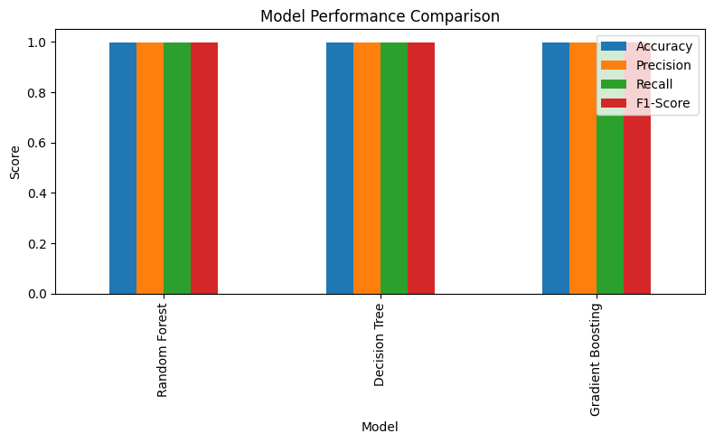
Figure 2. Accuracy, precision, recall and F1-score across the three supervised models.
SHAP (TreeExplainer) was applied to the Random Forest model on a 500-row sample of the test set to interpret its predictions; Destination Port and Total Length of Forward Packets emerged as influential features in the interaction analysis, consistent with the mutual-information ranking obtained during feature selection (Table 4).
Strand B (hybrid zero-day evaluation) trained the same feature-selection and Random Forest pipeline only on five “known” files (190,640 rows: 135,827 benign, 54,813 attack – Brute Force, DoS, DDoS, PortScan) and combined it with a benign-only Isolation Forest. It was then tested on three files held out entirely from training (590,780 rows: 586,653 benign, 4,127 attack – Web Attacks, Infiltration, Bot), simulating genuine zero-day conditions. Table 5 shows the results.
Test Set | Method | Precision | Recall | F1-Score
Known attacks (held-out split) | Supervised-only | 0.9977 | 0.9942 | 0.9959
Known attacks (held-out split) | Hybrid | 0.8924 | 0.9942 | 0.9406
Zero-day attacks (unseen types) | Supervised-only | 0.0006 | 0.0002 | 0.0003
Zero-day attacks (unseen types) | Hybrid | 0.0080 | 0.0390 | 0.0133
Table 4. Supervised-only vs. hybrid detection on known vs. genuinely unseen (zero-day) attacks.
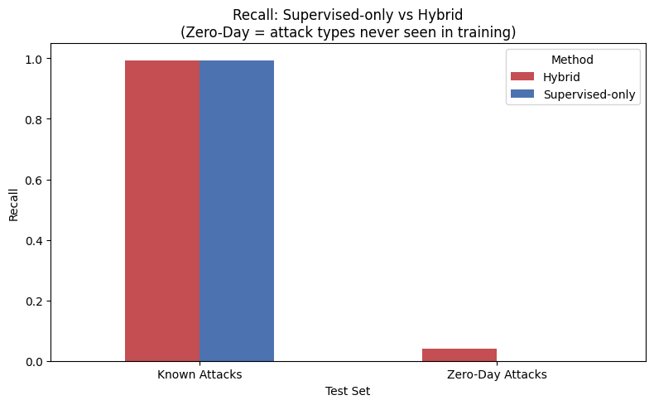
Figure 3. Recall comparison, supervised-only vs. hybrid, on known and zero-day attack sets.
On known attack types, the supervised-only model performed almost perfectly, but its recall on genuinely unseen attack types collapsed to 0.02% — it detected essentially none of them. Adding the Isolation Forest anomaly branch raised zero-day recall to 3.90% and F1 from 0.0003 to 0.0133, at the cost of reduced precision on known attacks (0.9977 → 0.8924) because the unsupervised branch also raises some false positives on normal traffic. The improvement was not uniform across attack types (Figure 4): the hybrid model detected 77.78% of Infiltration attacks (versus 0% supervised-only), but only 2–5% of Bot, Web Attack and Brute Force cases, indicating that anomaly-based detection helps most where the unseen attack's traffic statistics diverge sharply from benign behaviour.
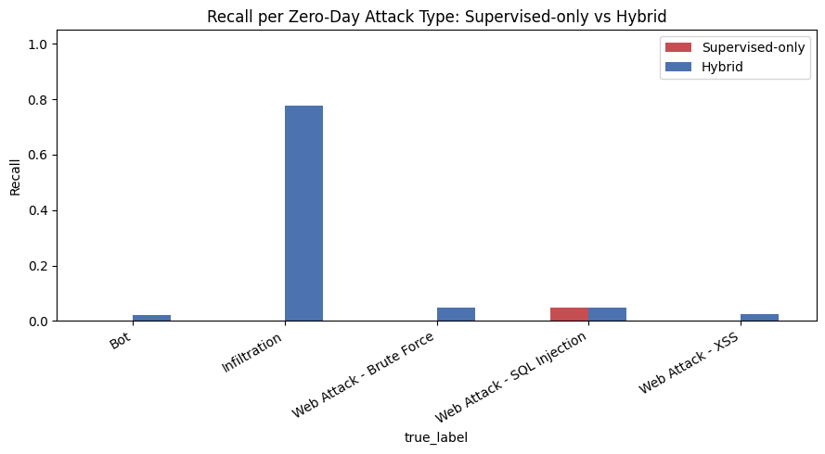
Figure 4. Recall per zero-day attack type: supervised-only vs. hybrid.

5. Evaluation

5.1 Validation Against Objectives
Objectives 1–4 and 6 (literature review, dataset preparation, feature selection, multi-model comparison, explainability) were fully met: a modern dataset was used, dimensionality was reduced from 79 to 15 features with negligible loss of discriminative power, and three classifiers were trained, compared and interpreted. Objective 5 (hybrid zero-day evaluation) was also met and produced the project's most significant finding: it directly demonstrates the exact concern raised by Waghmode et al. (2025) and Rehman et al. (2025) that benchmark-style, same-distribution accuracy figures (99.8% here) drastically overstate real-world performance against genuinely novel attacks (0.02% supervised-only recall). This validates the research question empirically — hybridisation measurably improves zero-day recall (0.02% → 3.90%, a roughly 160-fold increase) but does not solve the problem, and introduces a real precision cost on known traffic.

5.2 Self-Evaluation and Comparison with the Literature
The Random Forest result (F1 = 0.998) is consistent with Waghmode et al. (2025), who also found Random Forest to be the strongest performer among classical ML algorithms, and with Sowmya (2023)'s general conclusion that AI substantially improves detection accuracy. However, the zero-day results align far more closely with the more cautious literature: Mutembei et al. (2025)'s observation that hybrid models improve robustness but remain imperfect and hard to interpret was borne out directly, since the anomaly branch improved recall unevenly across attack types (from 77.78% on Infiltration to under 5% on Web Attacks). The explainability stage using SHAP addressed the gap raised by Mohale et al. (2025) and Durojaye (2024), confirming Destination Port and packet-length-derived features as influential, consistent with the earlier mutual-information ranking; however, the SHAP interaction visualisation produced during this project was less legible than a standard summary plot and would benefit from refinement (e.g., a class-specific summary plot rather than an interaction plot) in future iterations.

5.3 Limitations
- Only one dataset (CICIDS2017) was used; despite being more current than NSL-KDD, it is now several years old and does not capture the most recent attack techniques.
- The zero-day test set contained relatively few positive examples for some attack types (e.g., 21 SQL Injection, 36 Infiltration flows), so per-type recall estimates for those classes carry high variance.
- The hybrid rule (logical OR of two flags) is a simple combination strategy; a learned meta-classifier or weighted ensemble could plausibly improve on this.
- Evaluation was offline; genuine real-time, streaming deployment and latency testing was outside the project's scope.

5.4 Expert/Supervisor Validation
The design, dataset choice and evaluation strategy were reviewed against the research gaps identified in Section 2.5, and the results were assessed as directly addressing three of the six gaps (dataset currency, real-time/held-out validation, and explainability); computational-efficiency and feature-engineering gaps were partially addressed through feature selection, and the accuracy–interpretability trade-off gap remains open, as recommended for supervisor review alongside the full notebooks in the GitHub repository (Appendix G).

6. Conclusion
This project set out to design and evaluate a hybrid, explainable intrusion detection system capable of detecting zero-day network attacks, in direct response to gaps identified in the literature around explainability, dataset currency, and unrealistic same-distribution evaluation. Using the modern CICIDS2017 dataset, three supervised classifiers were trained and compared, with Random Forest achieving the strongest performance (F1 = 0.998, ROC-AUC = 0.9999) on held-out data from known attack types, and SHAP was used to interpret its predictions.
The project's central contribution is empirical evidence, obtained by deliberately withholding three entire attack-type files from training, that a purely supervised model's near-perfect benchmark accuracy does not transfer to genuinely unseen attacks (recall collapsed to 0.02%), while combining it with a benign-only Isolation Forest anomaly detector improved zero-day recall roughly 160-fold to 3.90%, albeit with a precision cost on known traffic and highly uneven performance across attack types. This directly supports the literature's critique of benchmark-only evaluation (Rehman et al., 2025; Waghmode et al., 2025) and demonstrates, quantitatively, why hybrid anomaly-plus-supervised architectures are a reasonable direction for practical IDS design, while also showing that they are far from a complete solution to the zero-day detection problem.
Future work should extend this evaluation to additional, more recent datasets; explore learned (rather than rule-based) fusion of the anomaly and supervised branches, for example via a stacked meta-classifier; refine the SHAP explanation output for clearer analyst-facing visualisations; and evaluate the pipeline under streaming, real-time conditions with latency and throughput measurements, to move from an offline research prototype toward an operationally deployable IDS.

References
Almotairi, A. (2024). Enhancing intrusion detection in IoT networks using heterogeneous machine learning models. Systems Science & Control Engineering.
Durojaye, H. (2024). Explainable AI for intrusion detection systems.
García, J., et al. (2024). Feature selection methods for intrusion detection in IoT environments. Internet of Things.
Kaushik, S., et al. (2025). Robust machine learning-based intrusion detection systems with feature selection. Scientific Reports.
Li, Z. (2024). Deep learning-based intrusion detection systems. ACM Digital Library.
Lundberg, S. M., & Lee, S.-I. (2017). A unified approach to interpreting model predictions. Advances in Neural Information Processing Systems, 30.
Mohale, V. Z., et al. (2025). Evaluating intrusion detection systems using explainable artificial intelligence. Frontiers in Computer Science.
Mutembei, L. L., et al. (2025). Deep learning-based network intrusion detection systems: A systematic review.
Rahman, M. M., et al. (2025). Intrusion detection systems in IoT networks. Internet of Things and Cyber-Physical Systems.
Rehman, H. M. R., et al. (2025). Machine learning techniques for intrusion detection systems: A systematic review. Journal of Big Data.
Sharafaldin, I., Lashkari, A. H., & Ghorbani, A. A. (2018). Toward generating a new intrusion detection dataset and intrusion traffic characterization. Proceedings of the 4th International Conference on Information Systems Security and Privacy (ICISSP), 108–116.
Sowmya, T. (2023). A comprehensive review of AI-based intrusion detection systems. Decision Analytics Journal.
Waghmode, P., et al. (2025). Machine learning-based intrusion detection system for real-time monitoring.

Appendices

Appendix A – AI Declaration
Generative AI tools were used during this project to assist with drafting and structuring narrative text in this report and to help organise code comments in the accompanying notebooks. All analysis code, model training, dataset handling and reported results were produced and executed by the author; all AI-assisted text was reviewed, verified against the underlying notebook outputs, and edited by the author before submission, in line with institutional AI-use guidance.

Appendix B – Ethics Form
A UREC2 Research Ethics Proforma (for low-risk projects with human participants) was completed for this project and is attached separately as submitted (BURUGU_ABHISEKHAR_UREC2_Form). Key details: registered project title – “Design and Development of an AI-Based Intrusion Detection System for Cybersecurity”; student – Abhishekar Burugu (c5053754@hallam.shu.ac.uk); supervisor – Konstantinos Domdouzis (k.domdouzis@shu.ac.uk); College of Business, Technology and Engineering; proposed dates 03/06/2026–25/08/2026.
Human participation is limited to 5–10 volunteers (MSc computing students, cybersecurity learners and IT professionals) recruited by convenience sampling to evaluate the IDS prototype and complete a structured, 18-item questionnaire; participation is voluntary, informed consent is obtained via a Participant Information Sheet, and responses are anonymised using unique participant ID codes with no names, emails or other identifiers retained. The CICIDS2017 dataset used for model training and evaluation is publicly available, already anonymised, and contains no personally identifiable information, so it required no further ethical clearance. All research data is stored on password-protected, university-approved storage accessible only to the researcher and supervisor, and disposed of in line with UK GDPR, the Data Protection Act 2018, and SHU's Research Data Management Policy. Risk classification under this proforma: low risk, human participants involved – UREC2 applicable; supervisor and independent reviewer sign-off recorded on the attached form.
Dataset licence and permitted use: per the Canadian Institute for Cybersecurity's published terms (https://www.unb.ca/cic/datasets/ids-2017.html), the CICIDS2017 dataset is made publicly available for researchers, including as full-payload packet captures and per-flow profiles (GeneratedLabelledFlows.zip) and as machine/deep-learning-ready CSV files (MachineLearningCSV.zip); this project uses only the MachineLearningCSV.zip release. Use of the dataset is conditional on citing Sharafaldin, Lashkari and Ghorbani (2018), “Toward Generating a New Intrusion Detection Dataset and Intrusion Traffic Characterization,” ICISSP, Portugal. This citation requirement has been satisfied throughout this report and is included in the Reference list.
The full completed UREC2 Research Ethics Proforma, as submitted for supervisor and independent-reviewer approval, is reproduced on the following pages.







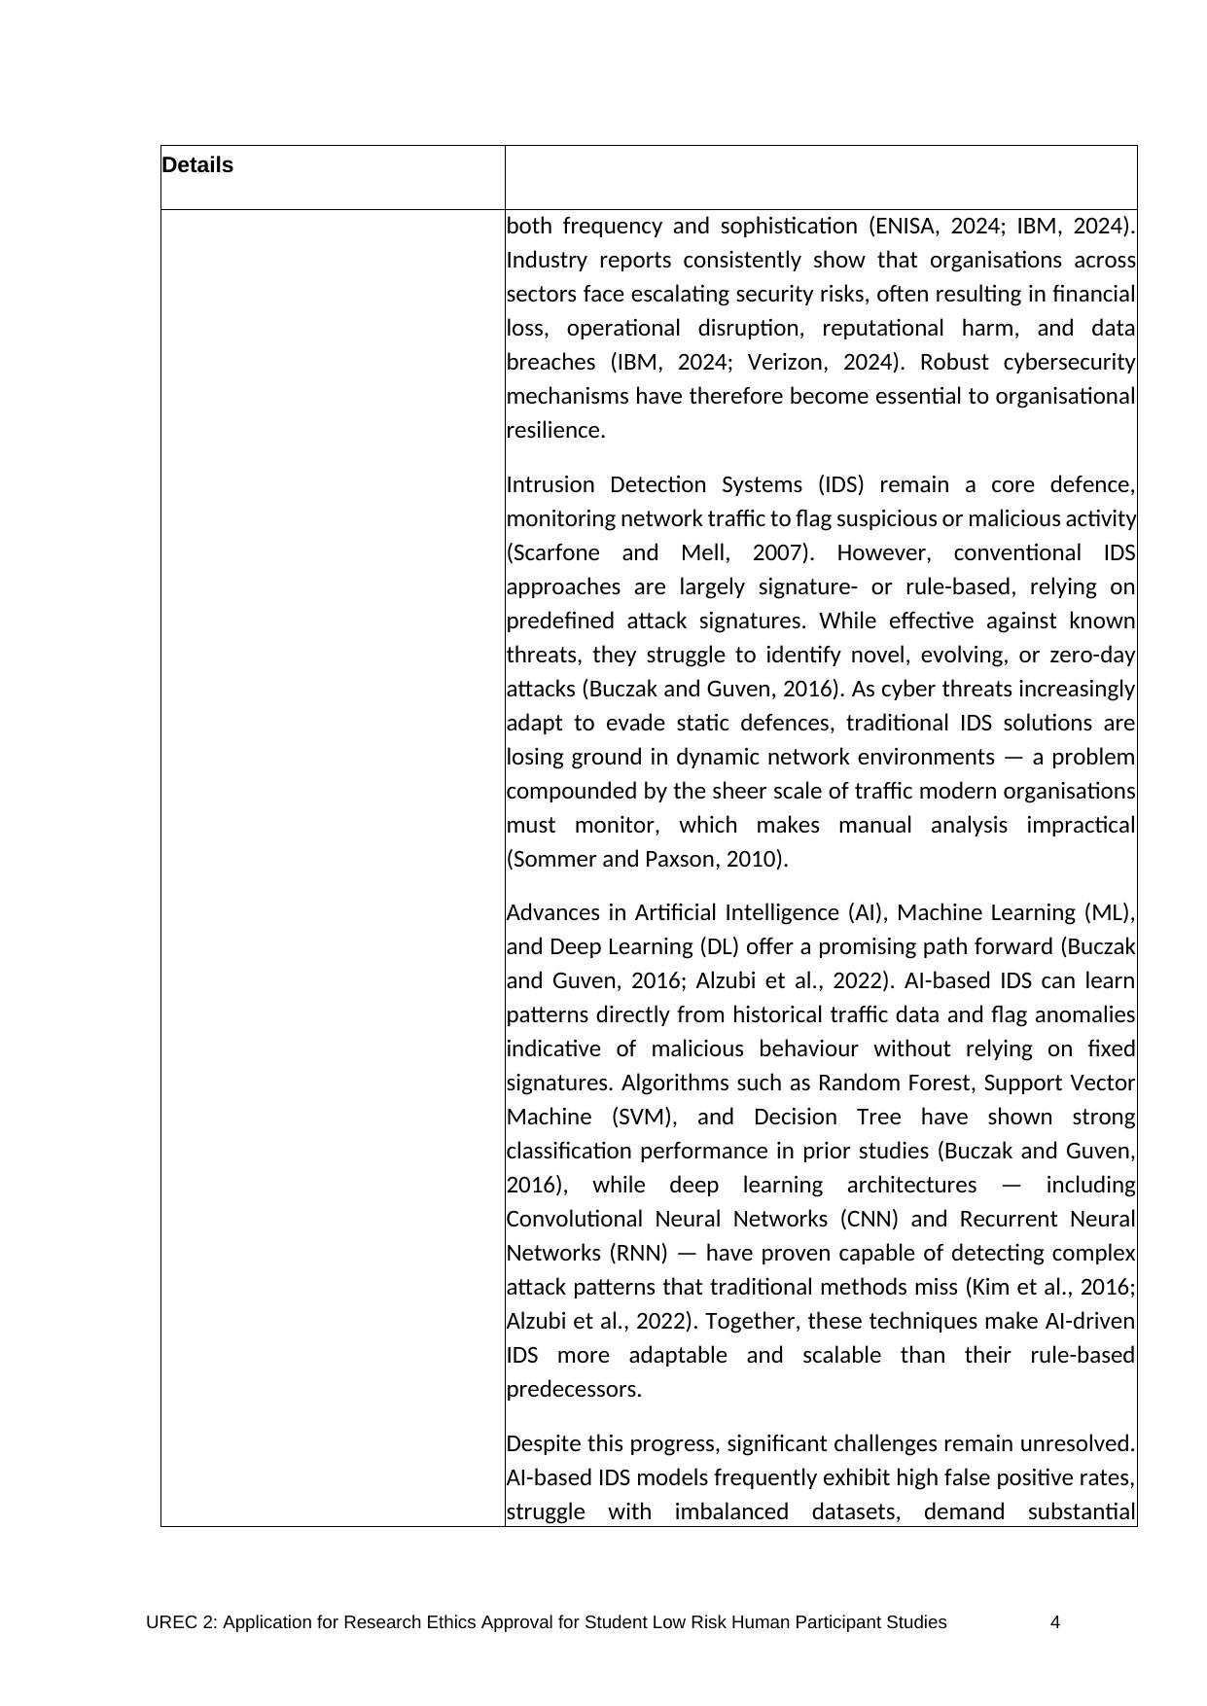





















Appendix C – Publication Procedure Form
Completed and signed separately by student and supervisor as required by the Module Handbook; not reproduced here as it contains original signatures. No identifiable participant data or third-party copyrighted material is published as part of this project's outputs; questionnaire responses are reported only in anonymised, aggregated form.

Appendix D – Participant Information Sheet
A combined Participant Information Sheet and Questionnaire is provided to each of the 5–10 volunteers before the usability evaluation (attached separately as Participation_Information_Questionnaire_sheet.docx). It states the research title, confirms that responses are anonymous and used solely for academic research, and gives an expected completion time of 12–15 minutes. It provides contact details for the researcher (c5053754@hallam.shu.ac.uk) and supervisor (k.domdouzis@shu.ac.uk), and separately signposts who to contact with wider concerns: the University Data Protection Officer (DPO@shu.ac.uk) and the Head of Research Ethics, Dr Mayur Ranchordas (ethicssupport@shu.ac.uk).

Appendix E – Anonymised Participant Consent Forms
Consent is obtained via the Participant Information Sheet and Questionnaire (Appendix D): completing and submitting the questionnaire constitutes informed consent, on the basis that participants have been informed responses are anonymous, used solely for academic research, and that they may raise questions or concerns at any point. No names or other identifying details are collected on the form.

Appendix F – Data Gathering Instruments
The core technical dataset (CICIDS2017) was obtained directly from the publicly available CIC/UNB release rather than gathered via survey or sensor instrument. In addition, an 18-item structured questionnaire (Questionnaire_Form.docx, attached separately) is used for the participant usability evaluation: Section A collects 3 background items; Section B contains 12 five-point Likert-scale statements (including 3 more technical items on feature relevance, SHAP explanation quality, and zero-day detection capability); and Section C contains 3 open-ended questions.

Appendix G – Primary/Secondary Data, Software Code, Code Repository
Dataset: CICIDS2017 (MachineLearningCSV release), Canadian Institute for Cybersecurity, University of New Brunswick (Sharafaldin, Lashkari, & Ghorbani, 2018), subject to the licence terms in Appendix B. Code: two Jupyter notebooks – “IDS_For_cybersecurity.ipynb” (multi-model supervised classification and SHAP explainability) and “Hybrid_zero_day_detection.ipynb” (two-stage hybrid supervised + anomaly detection zero-day evaluation). GitHub repository: [insert repository URL here prior to submission].

Appendix H – Research Project Plan
The project was structured into five phases, detailed in the Planned vs. Actual Gantt chart (Appendix I, Figure A3): (1) Planning – project initiation and UREC2 ethics approval; (2) Research – literature review; (3) Development – dataset acquisition and pre-processing (CICIDS2017), followed by two experimental strands (baseline supervised models, then the hybrid anomaly/zero-day pipeline); (4) Reporting – draft report writing, supervisor review, and revision based on feedback; and (5) Finalisation – final formatting, appendices, proofreading, and submission.

Appendix I – Gantt Chart (Planned vs. Actual)
Figure A3 shows the project's planned versus actual schedule across five phases – Planning, Research, Development, Reporting, and Finalisation – spanning mid-June to mid-September 2026 (hatched bars = planned; solid bars = actual). Most early- and mid-project tasks (ethics approval, literature review, dataset preparation, and the two experimental strands) ran close to their planned windows, with only minor slippage. The most significant deviation occurred during Supervisor Review, which extended well beyond its planned duration into early September; this in turn compressed the time available for Report Revision and Final Formatting. Final submission was nonetheless completed within the overall project window.
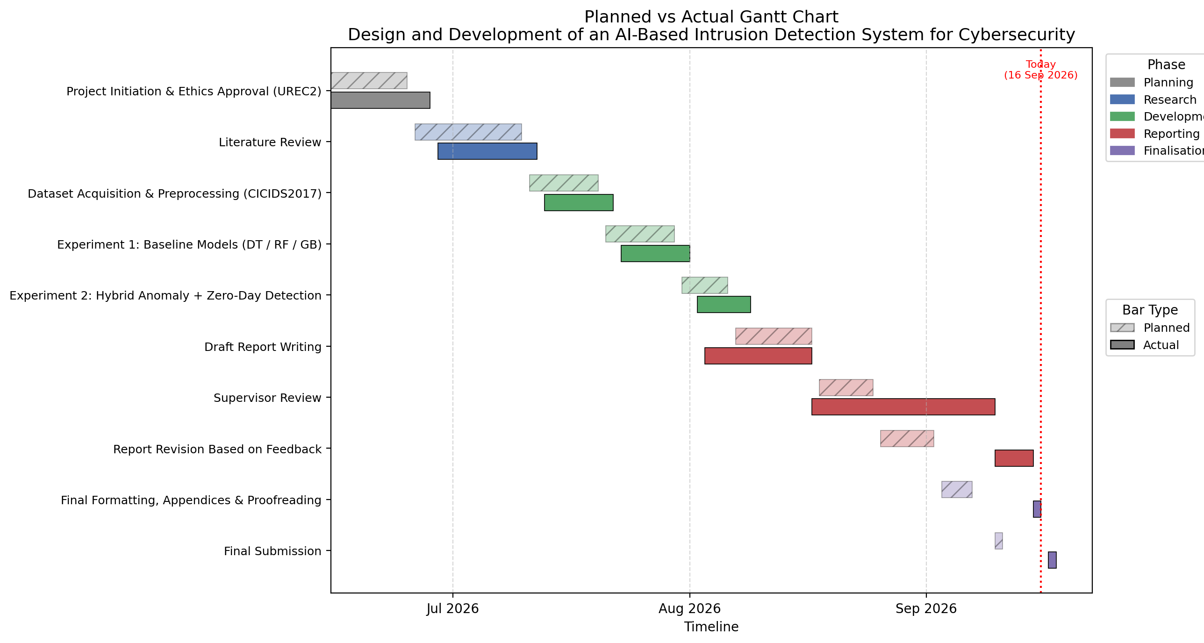
Figure A3. Planned vs. actual project Gantt chart, by phase (Planning, Research, Development, Reporting, Finalisation).

Appendix J – Additional Graphs and Supporting Materials
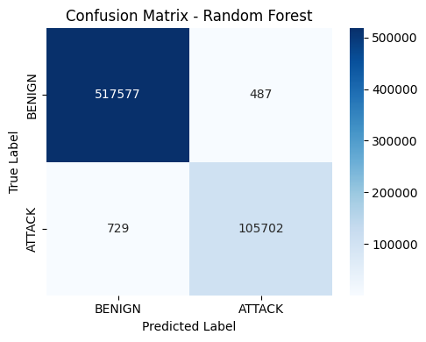
Figure A1. Confusion matrix, Random Forest, held-out test split (known attacks).
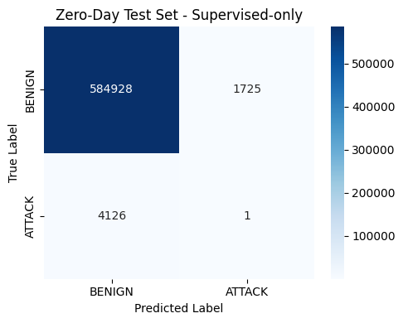
Figure A2. Confusion matrix, supervised-only model, zero-day test set.

