**C-DAC Mumbai Date 26/09/2024**

**Subject: Algorithm and Data Structure**

**Assignment 2**

1. Printing Patterns

Problem: Write a Java program to print patterns such as a right triangle of stars.

Test Cases:

Input: n = 3

Output:

*

**

***

Input: n = 5

Output:

*

**

***

****

*****

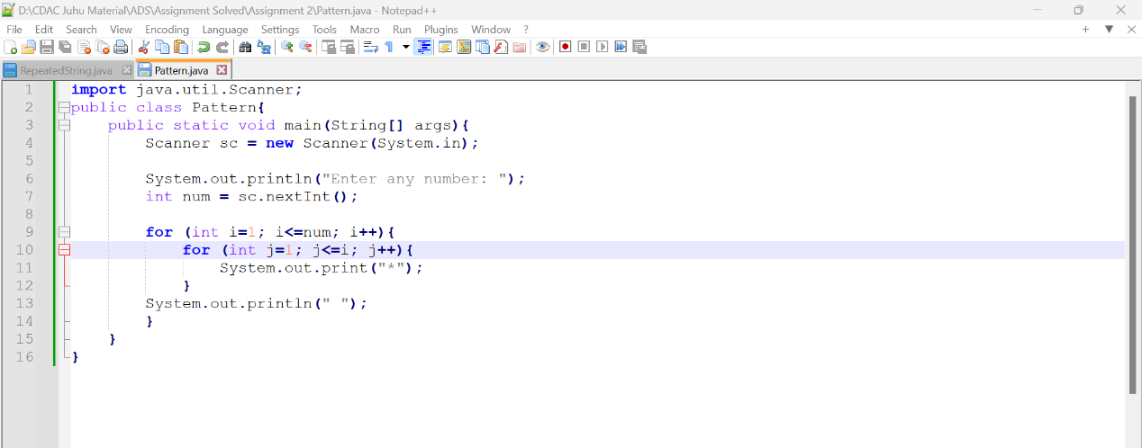

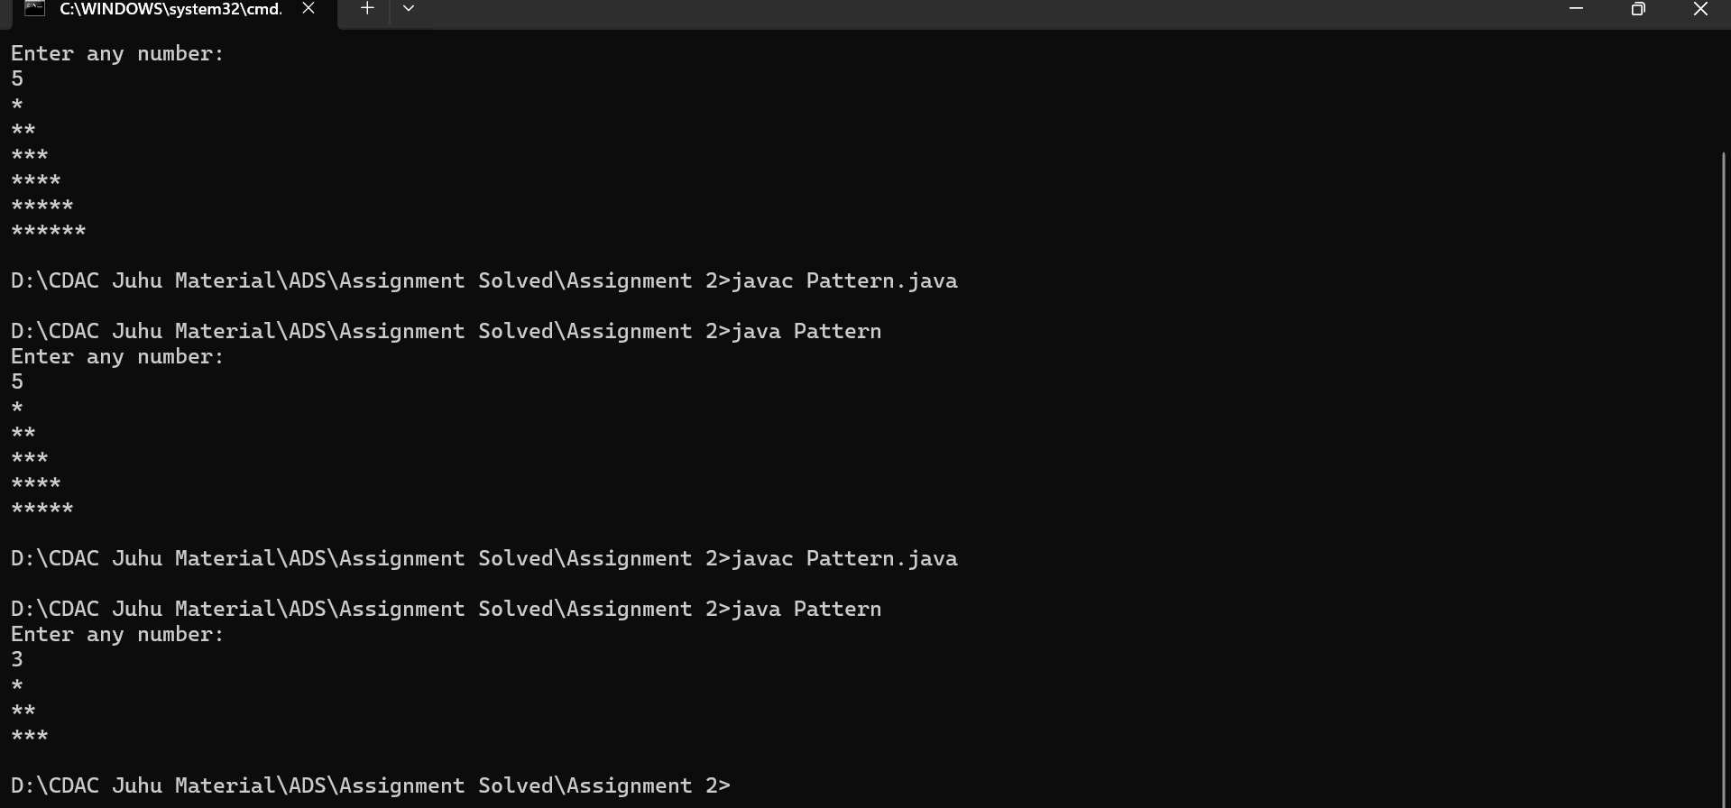

2. Remove Array Duplicates

Problem: Write a Java program to remove duplicates from a sorted array and return the new length of the array.

Test Cases:

Input: arr = [1, 1, 2]

Output: 2

Input: arr = [0, 0, 1, 1, 2, 2, 3, 3]

Output: 4

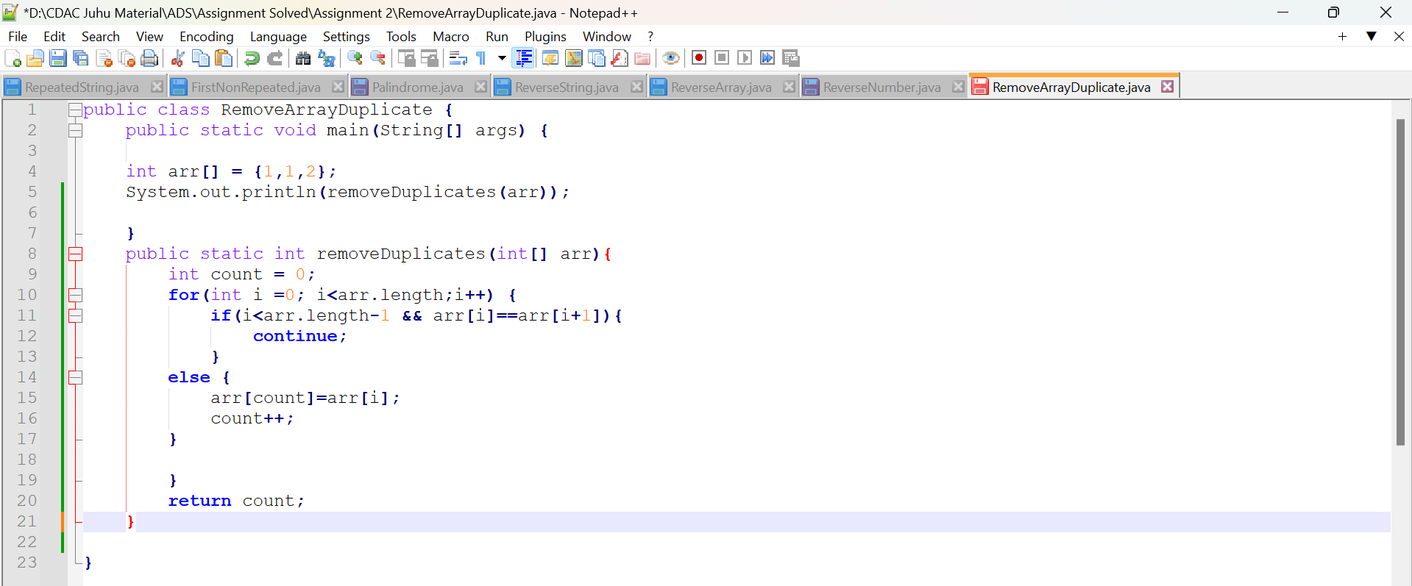

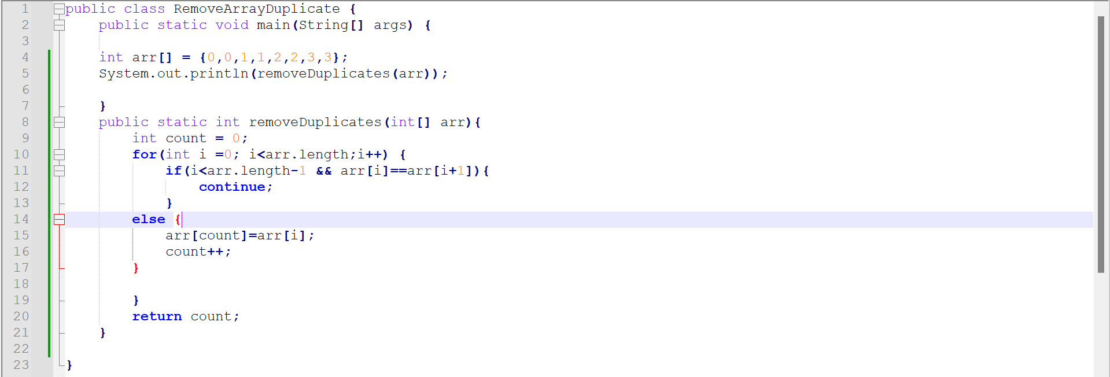

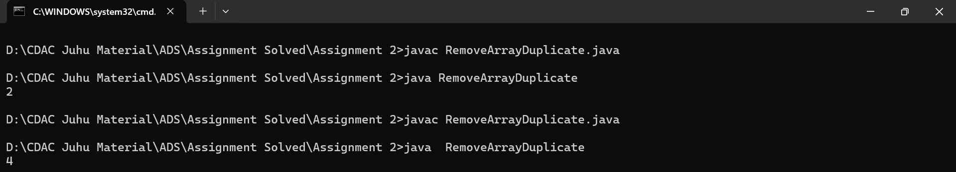

3. Remove White Spaces from String

Problem: Write a Java program to remove all white spaces from a given string.

Test Cases:

Input: "Hello World"

Output: "HelloWorld"

Input: " Java Programming "

Output: "JavaProgramming"

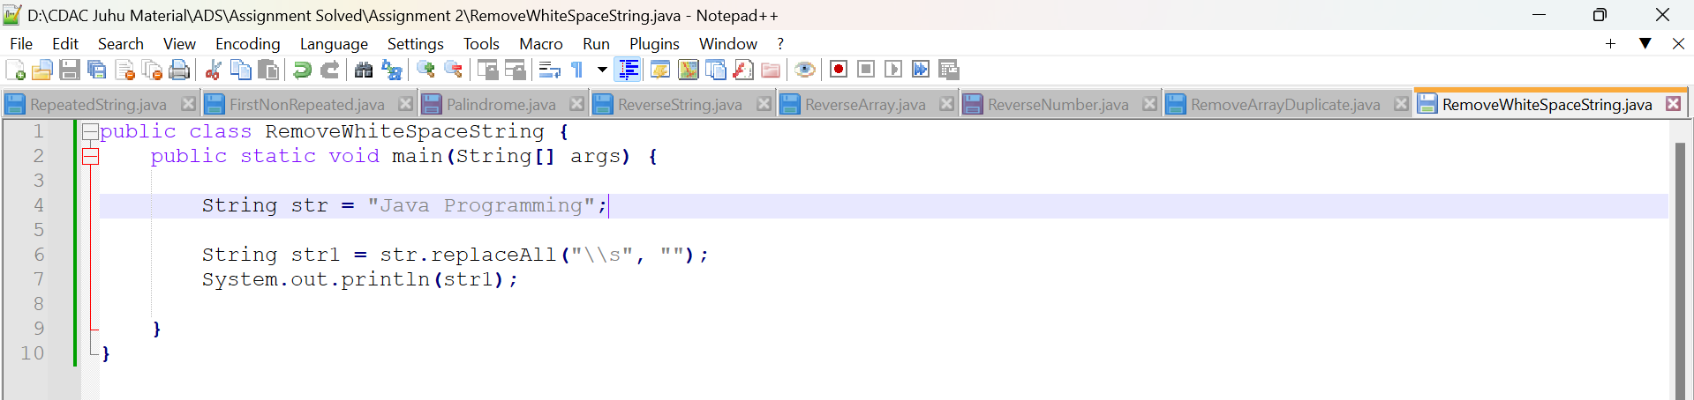

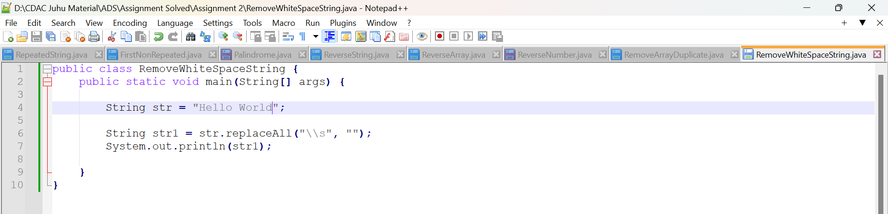

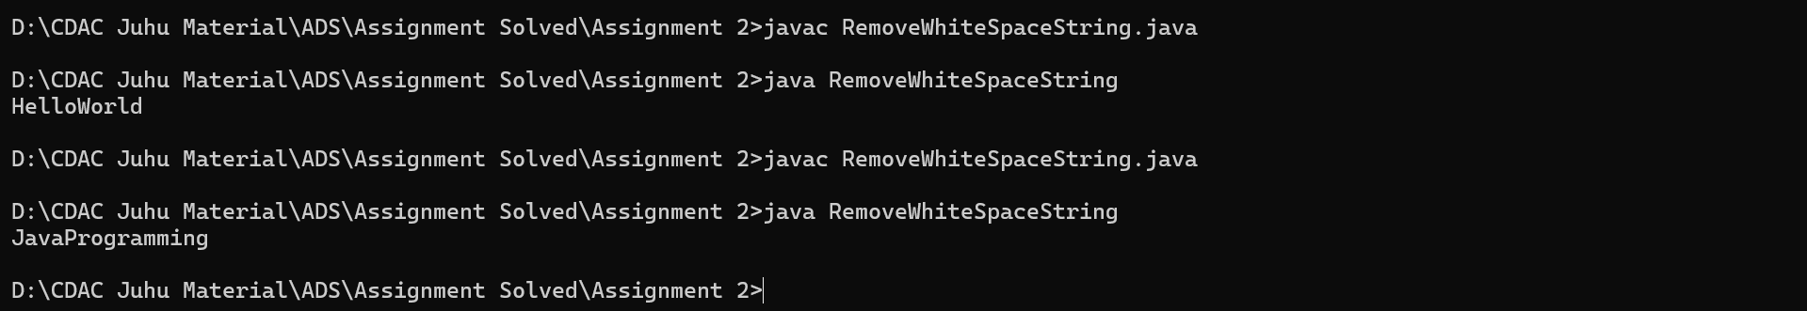

4. Reverse a String

Problem: Write a Java program to reverse a given string.

Test Cases:

Input: "hello"

Output: "olleh"

Input: "Java"

Output: "avaJ"

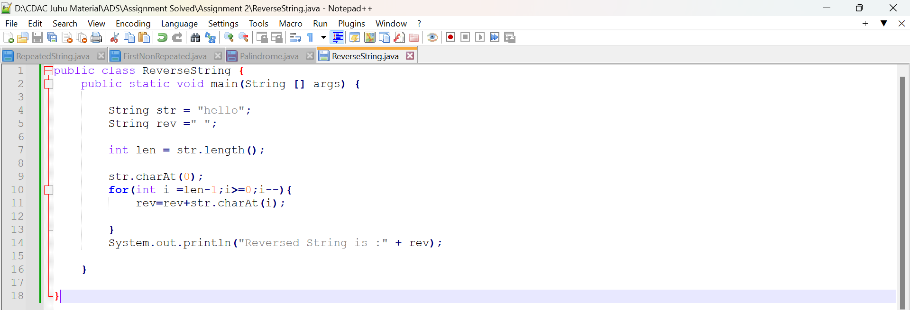

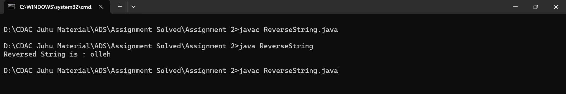

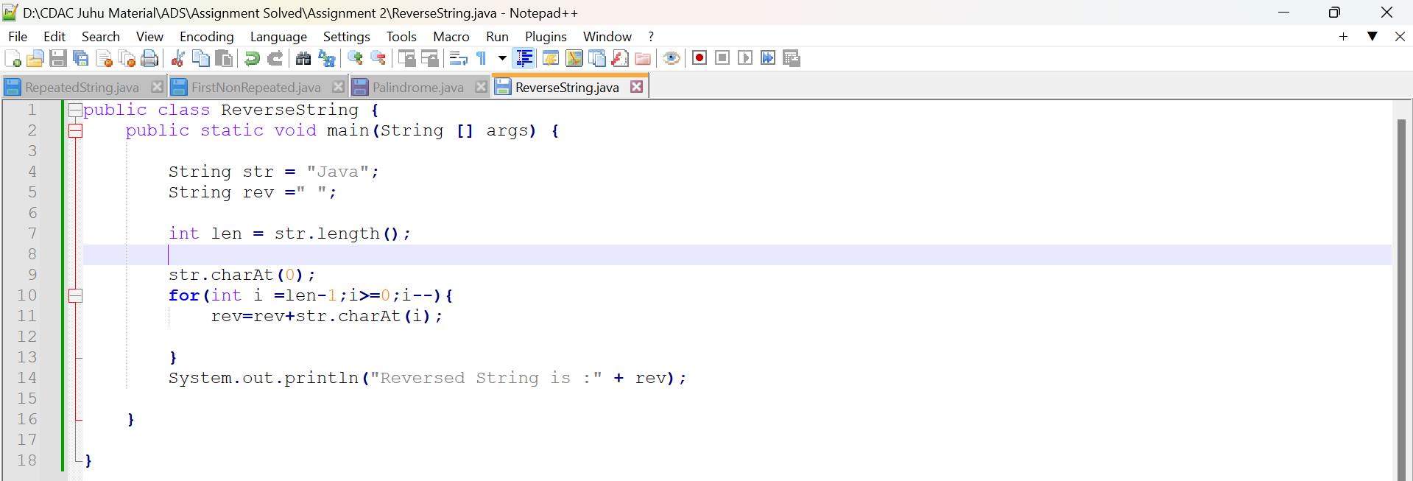

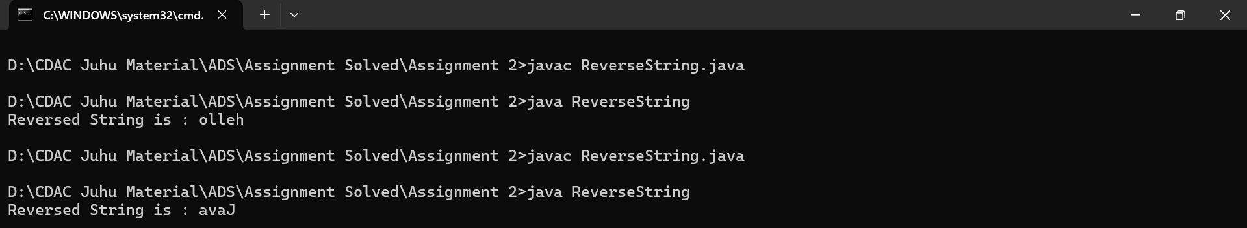

5. Reverse Array in Place

Problem: Write a Java program to reverse an array in place.

Test Cases:

Input: arr = [1, 2, 3, 4]

Output: [4, 3, 2, 1]

Input: arr = [7, 8, 9]

Output: [9, 8, 7]

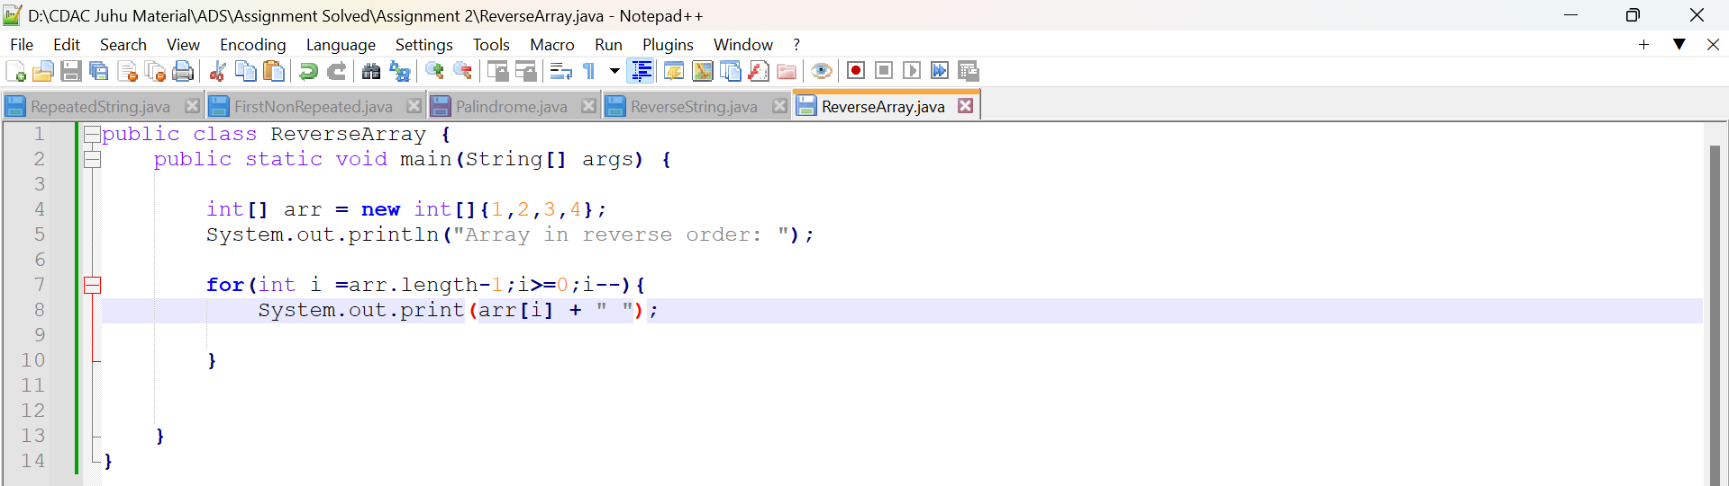

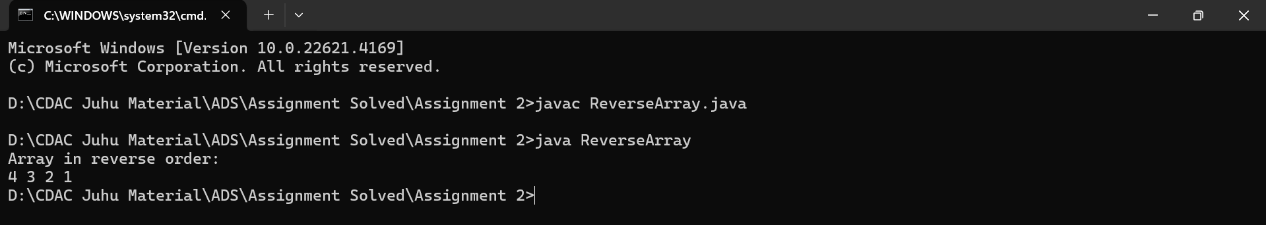

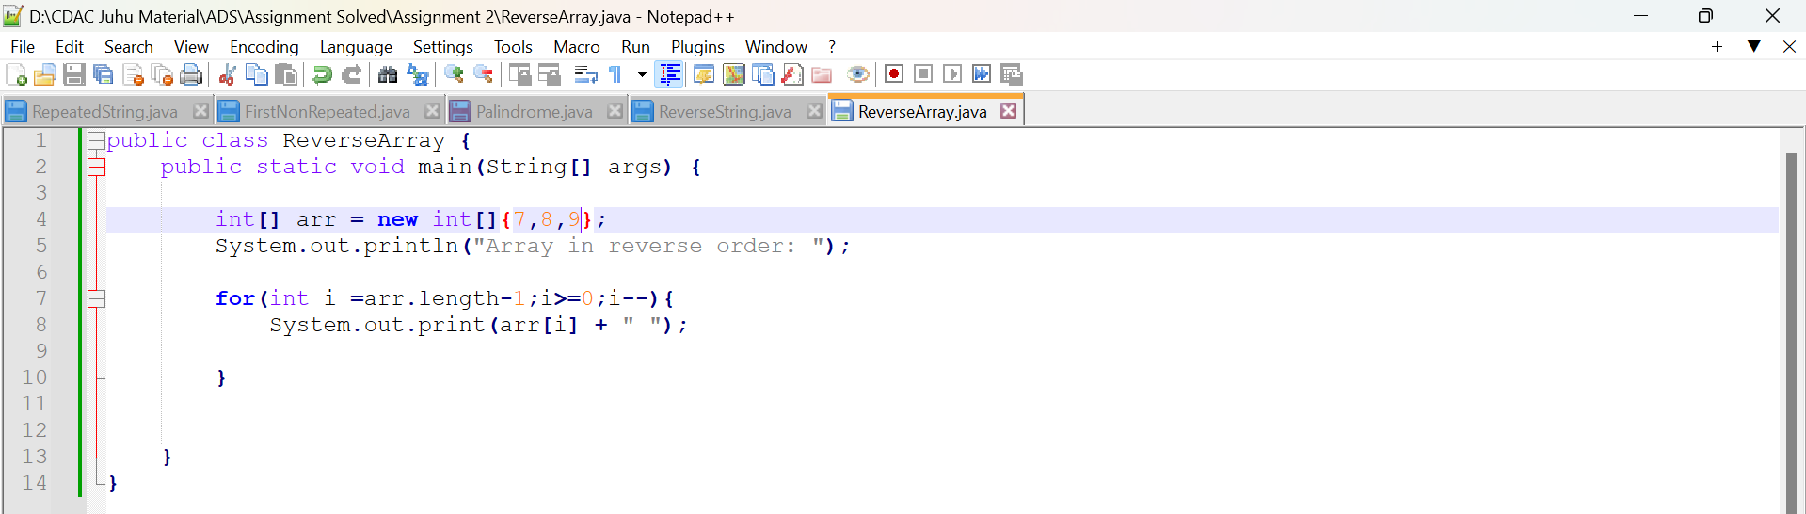

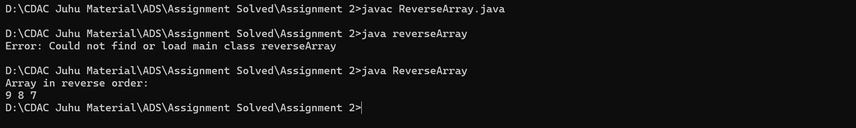

6. Reverse Words in a String

Problem: Write a Java program to reverse the words in a given sentence.

Test Cases:

Input: "Hello World"

Output: "World Hello"

Input: "Java Programming"

Output: "Programming Java"

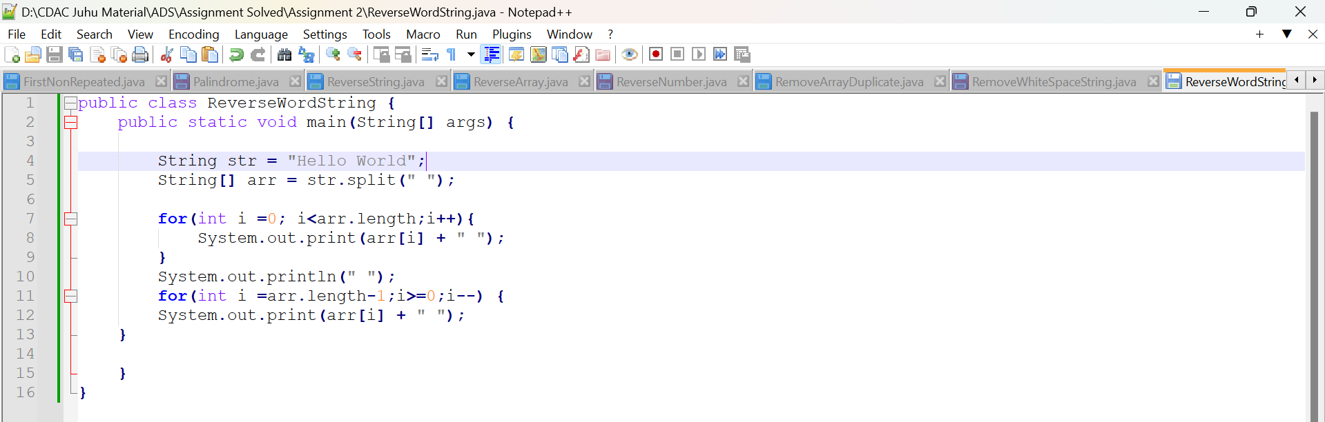

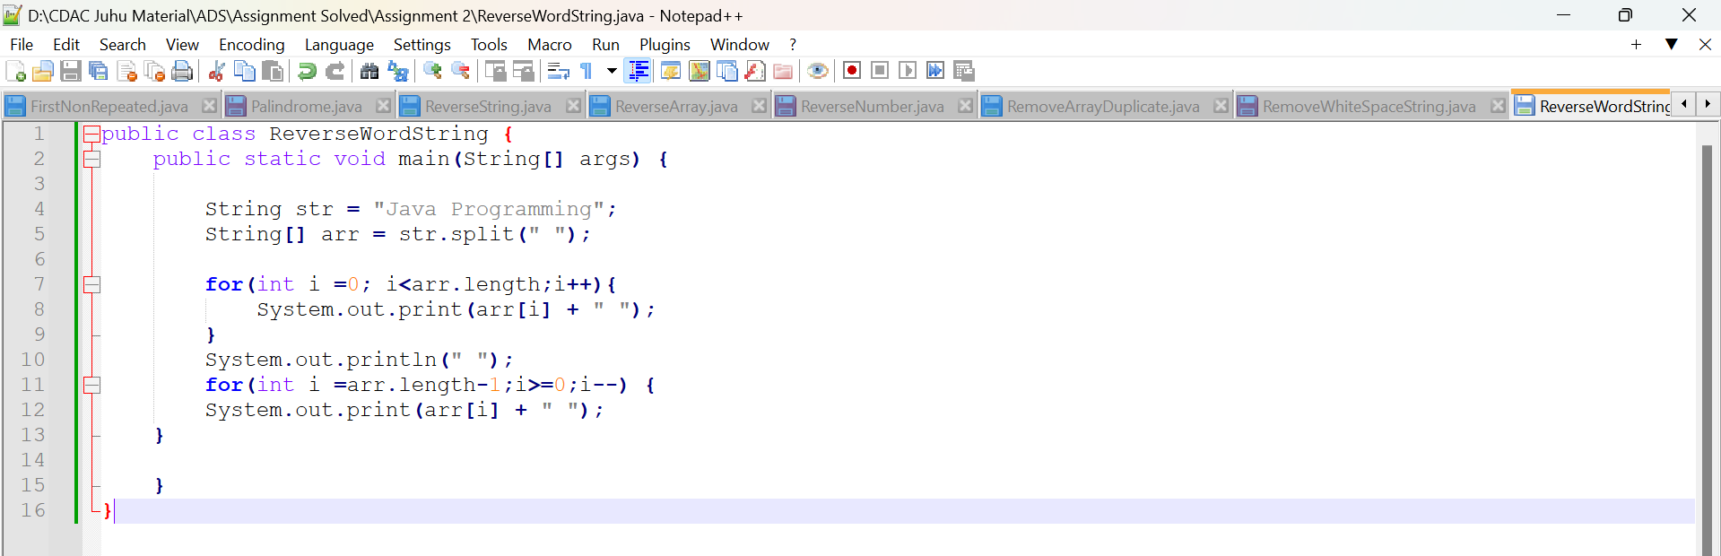

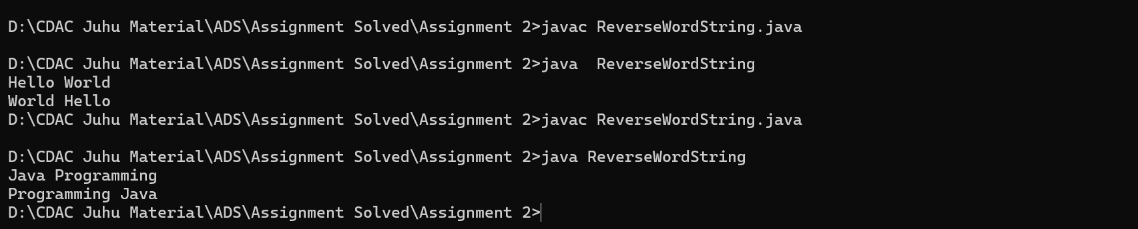

7. Reverse a Number

Problem: Write a Java program to reverse a given number.

Test Cases:

Input: 12345

Output: 54321

Input: -9876

Output: -6789

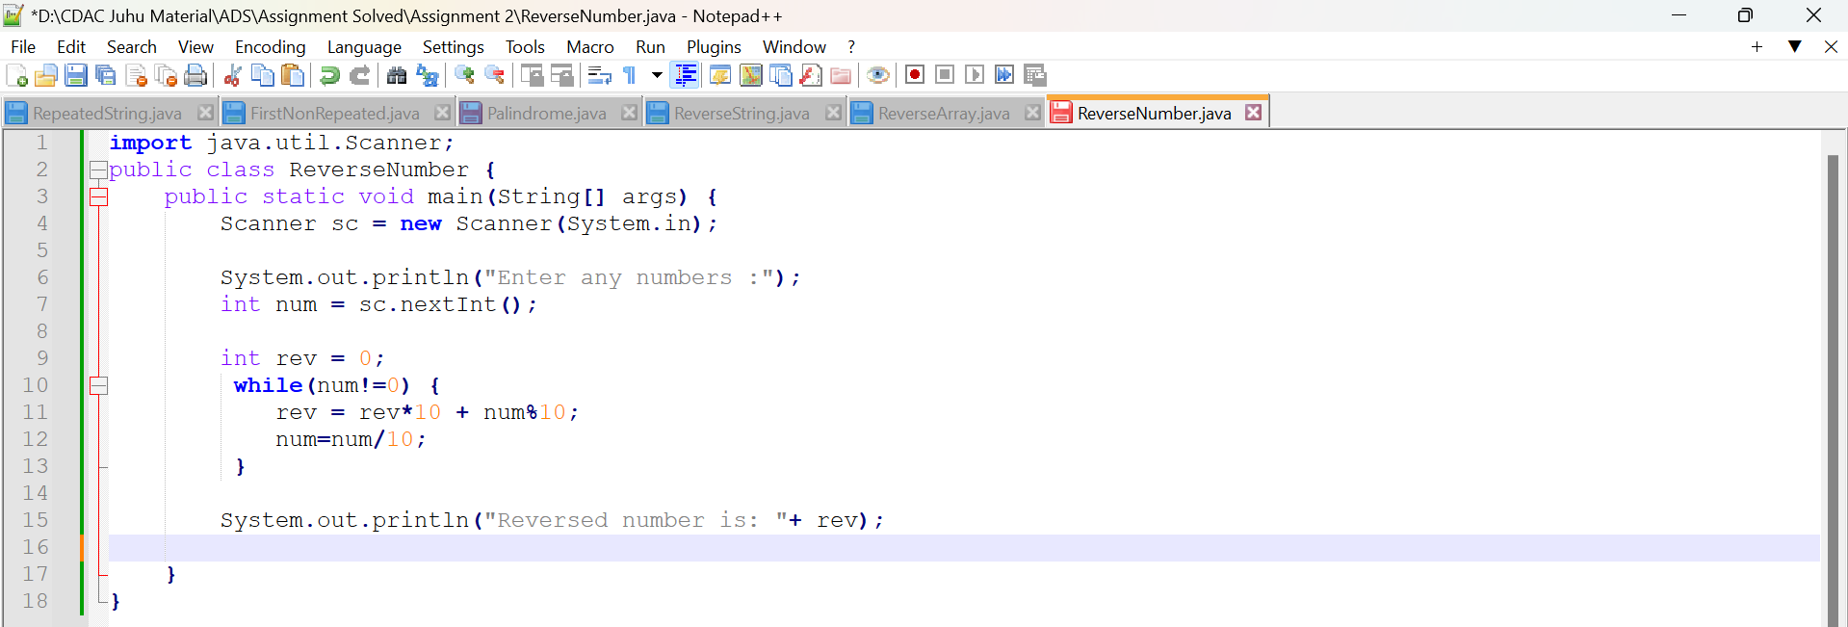

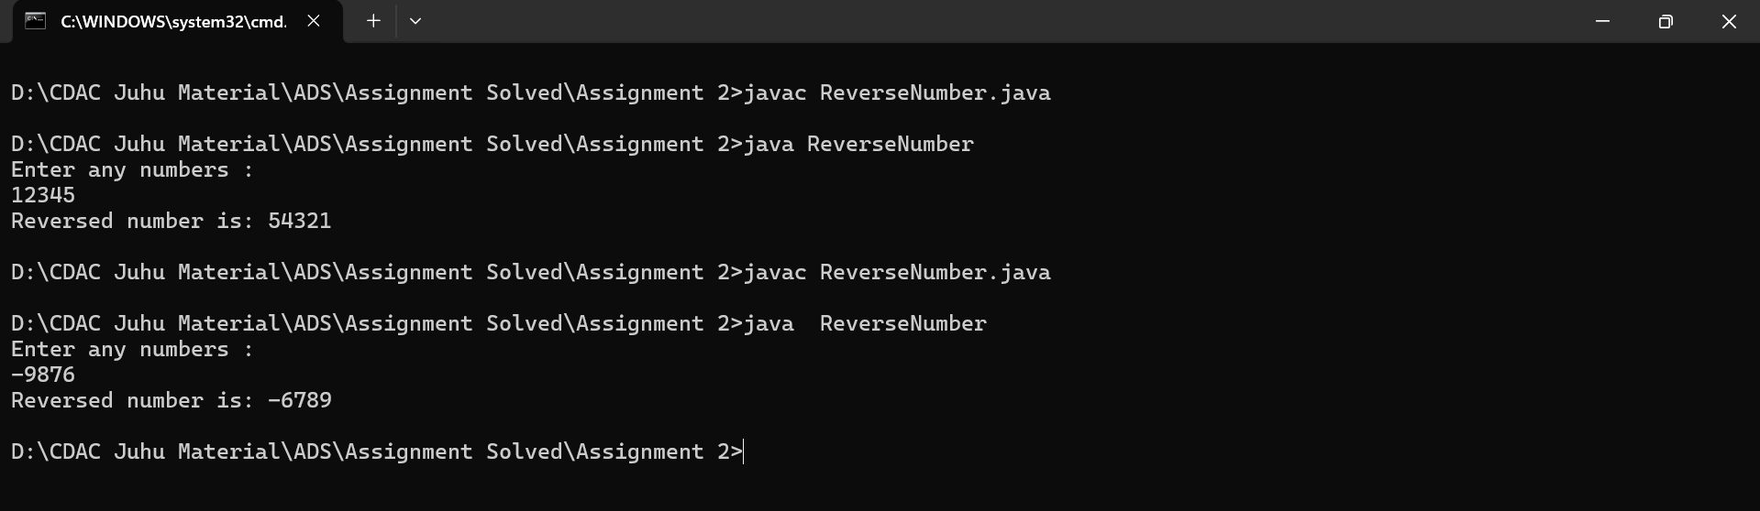

8. Array Manipulation

Problem: Perform a series of operations to manipulate an array based on range update queries. Each query adds a value to a range of indices.

Test Cases:

Input: n = 5, queries = [[1, 2, 100], [2, 5, 100], [3, 4, 100]]

Output: 200

Input: n = 4, queries = [[1, 3, 50], [2, 4, 70]]

Output: 120

9. String Palindrome

Problem: Write a Java program to check if a given string is a palindrome.

Test Cases:

Input: "madam"

Output: true

Input: "hello"

Output: false

Here’s a continuation of the list of assignment questions starting from question 21, with two test cases for each:

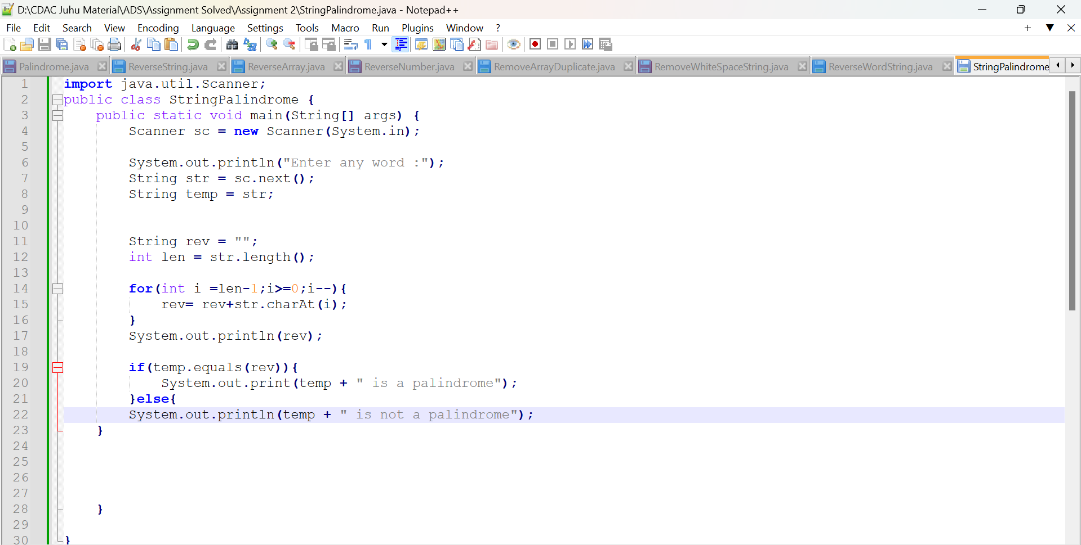

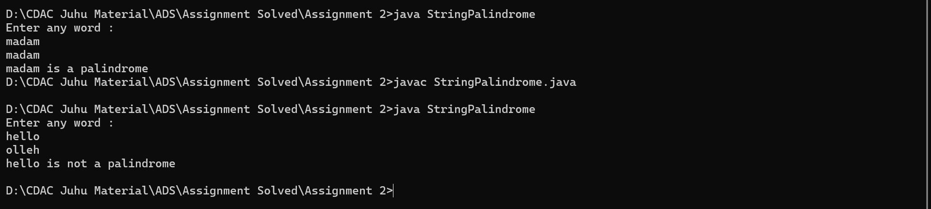

10. Array Left Rotation

Problem: Write a Java program to rotate an array to the left by d positions.

Test Cases:

Input: arr = [1, 2, 3, 4, 5], d = 2

Output: [3, 4, 5, 1, 2]

Input: arr = [10, 20, 30, 40], d = 1

Output: [20, 30, 40, 10]  
