**Assignment No.4**

1. Write a program that demonstrates widening conversion from int to double and prints the result.

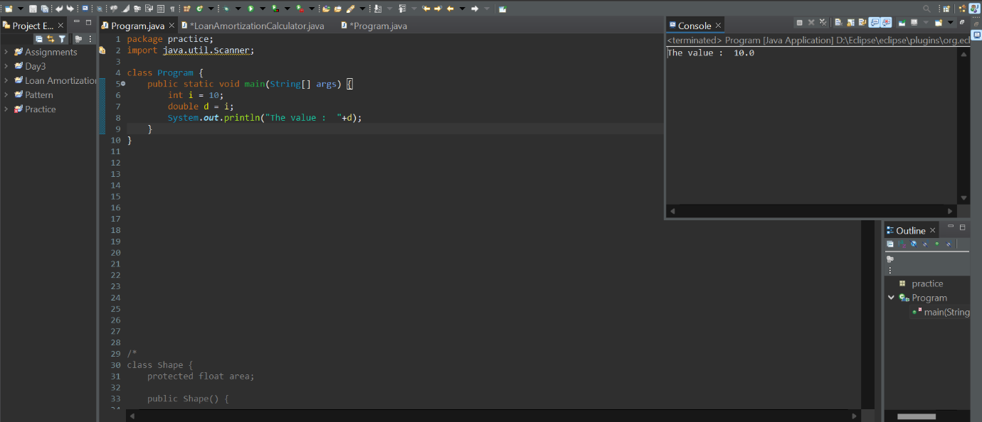

1. Create a program that demonstrates narrowing conversion from double to int and prints the result.

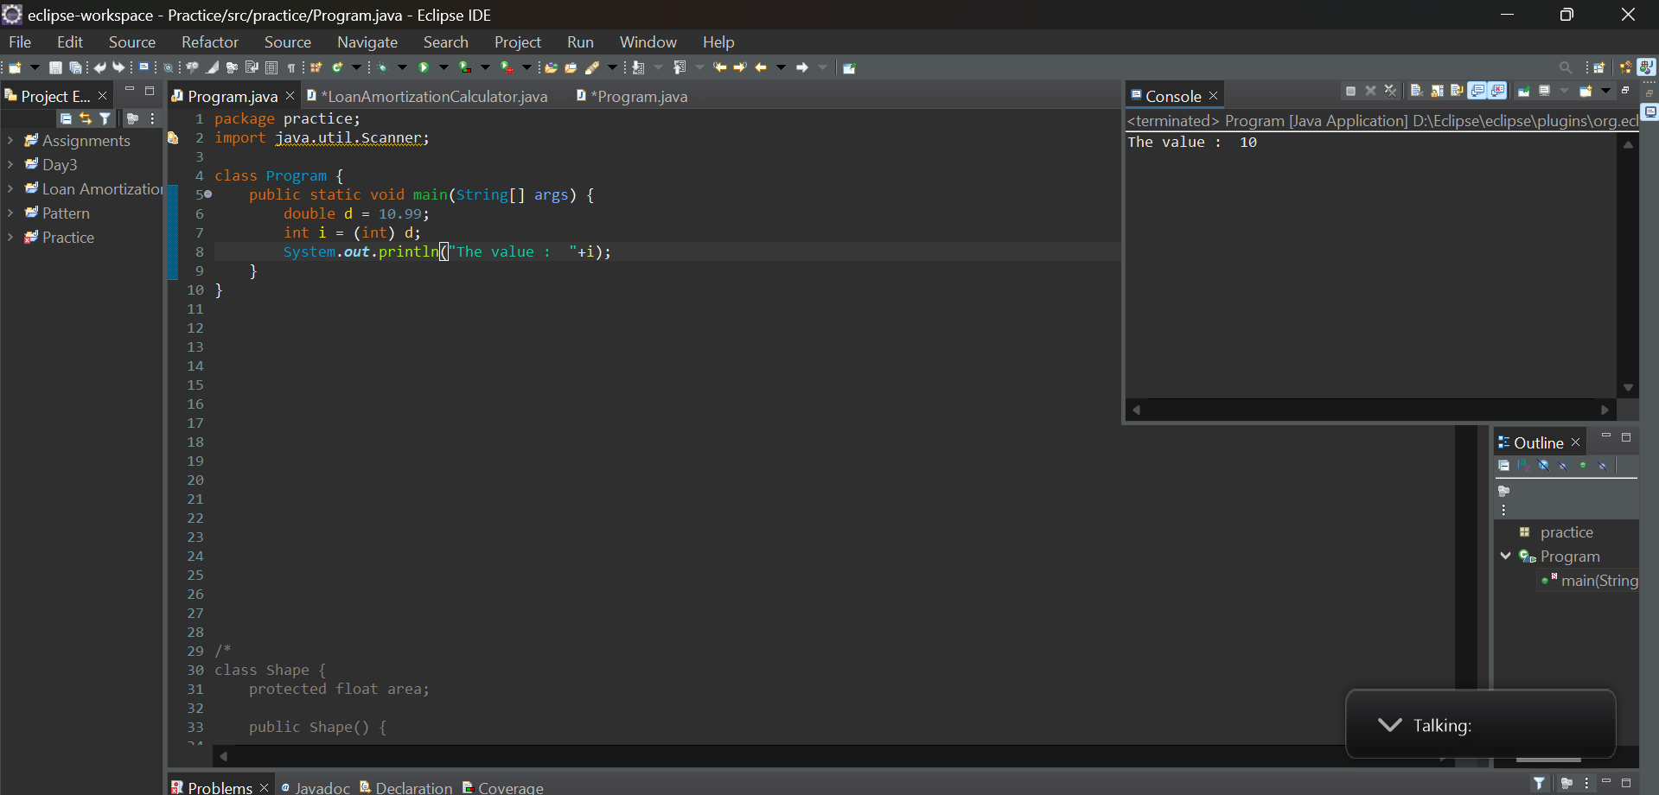

1. Write a program that performs arithmetic operations involving different data types (int, double, float) and observes how Java handles widening conversions automatically.

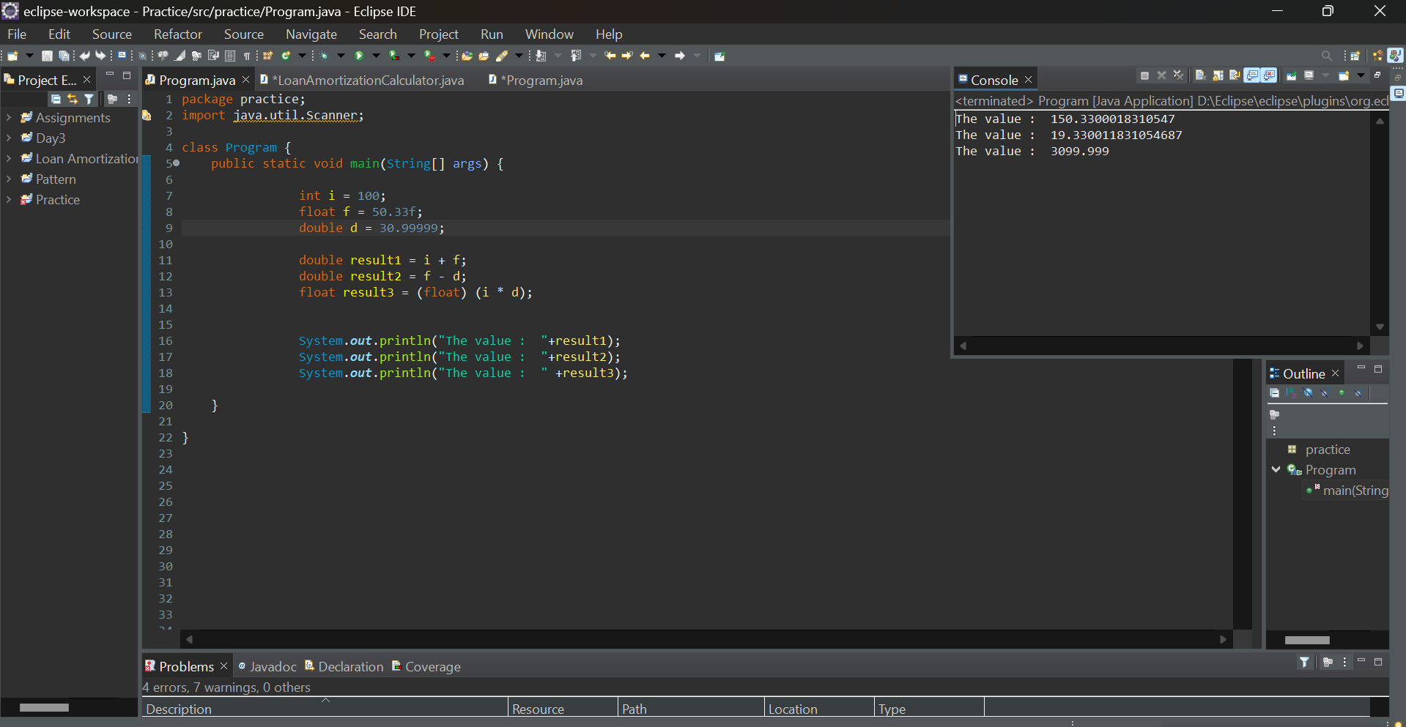

1. Write a Program that demonstrates widening conversion from int to (double,float, boolean, string) and prints the result.

