Name : Abhishek Yadav
Roll No: CS12B032
Networks Lab : 2

1.1 : Followed all the steps successfully. (this part of Assignment, I did with Korra Jayanth)
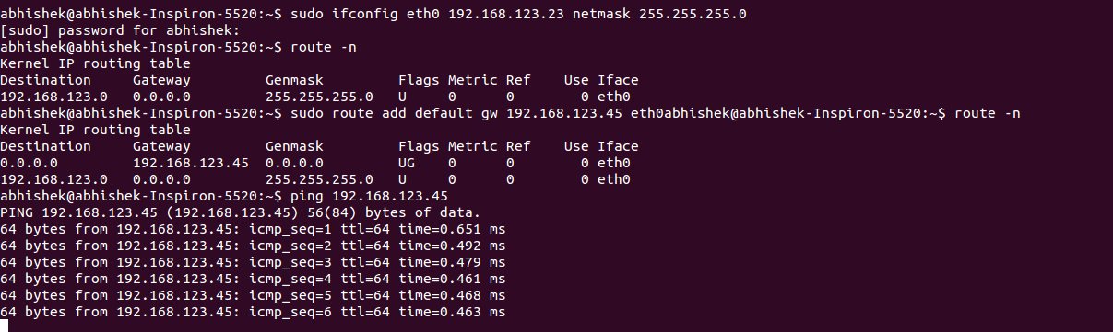

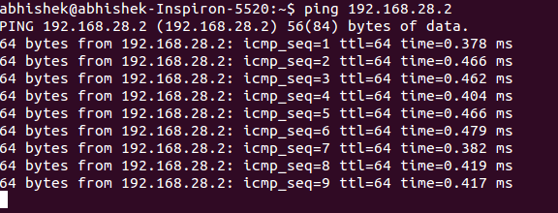
1.2 : Used the 192.168.123.45 as the gateway to connect to the destination ip 192.168.123.8 . Set the DNS server to the department DNS server 10.6.0.11 .

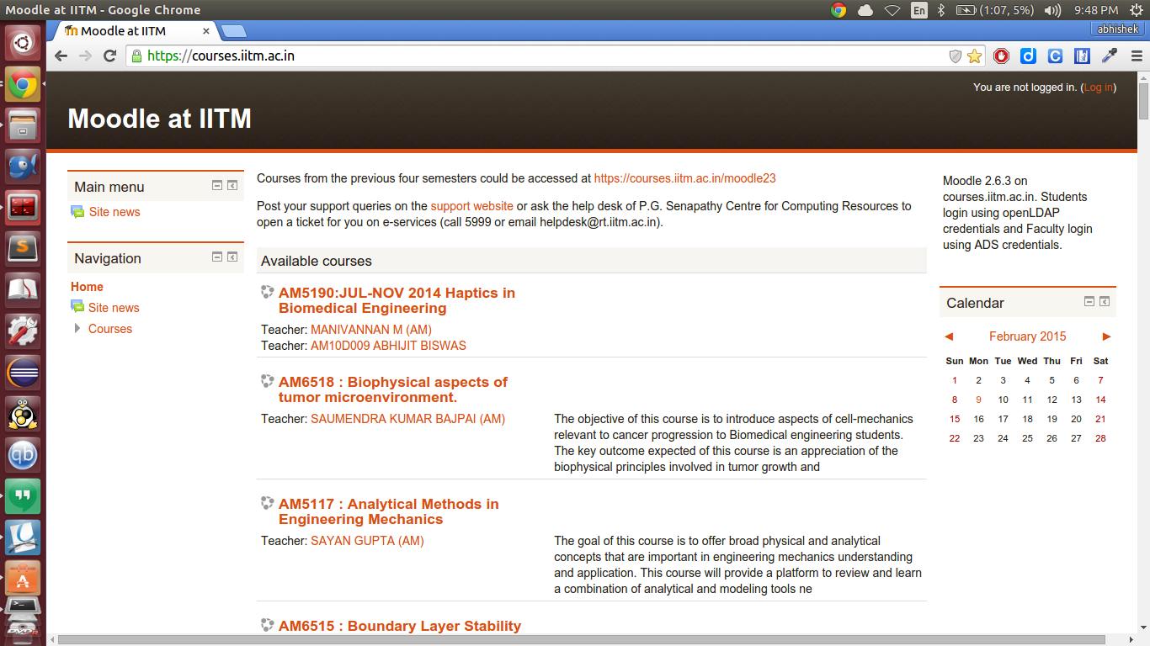
Accessed the department server

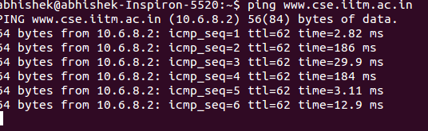

2.
1: DNS request uses UDP protocol.
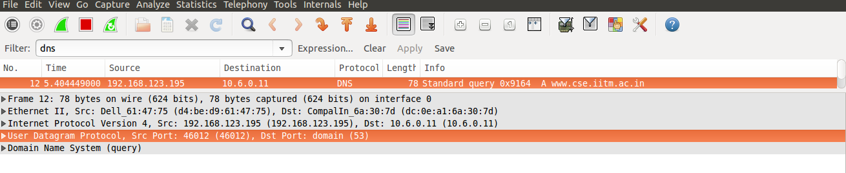

2: Destination and source MAC addresses for ARP requests.
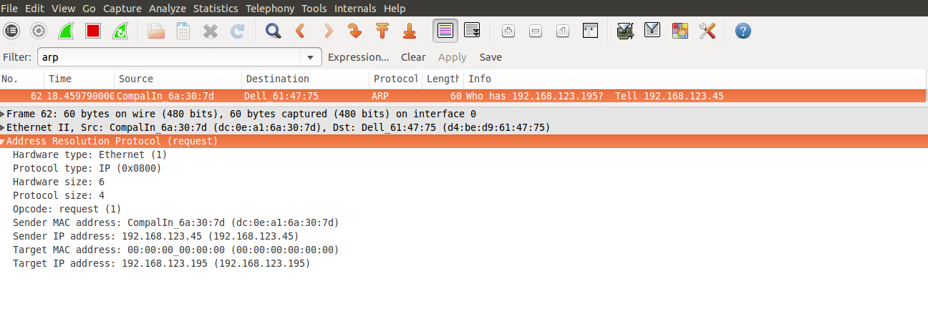

2.3: Value present in the type field : 0 (Echo (ping) reply )

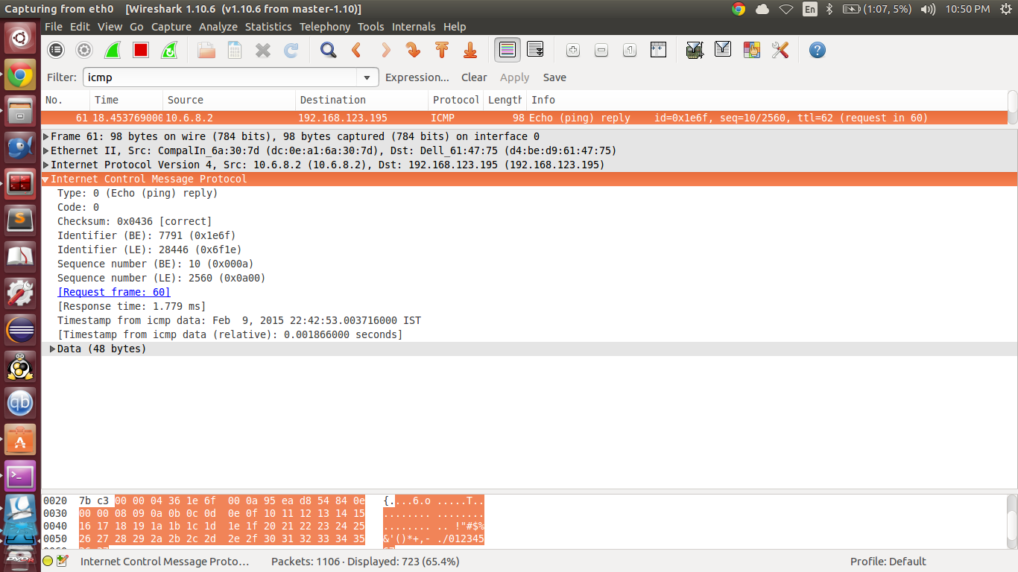

** Size of the ICMP datafield : 48 bytes

** Data being sent is highlited in the image
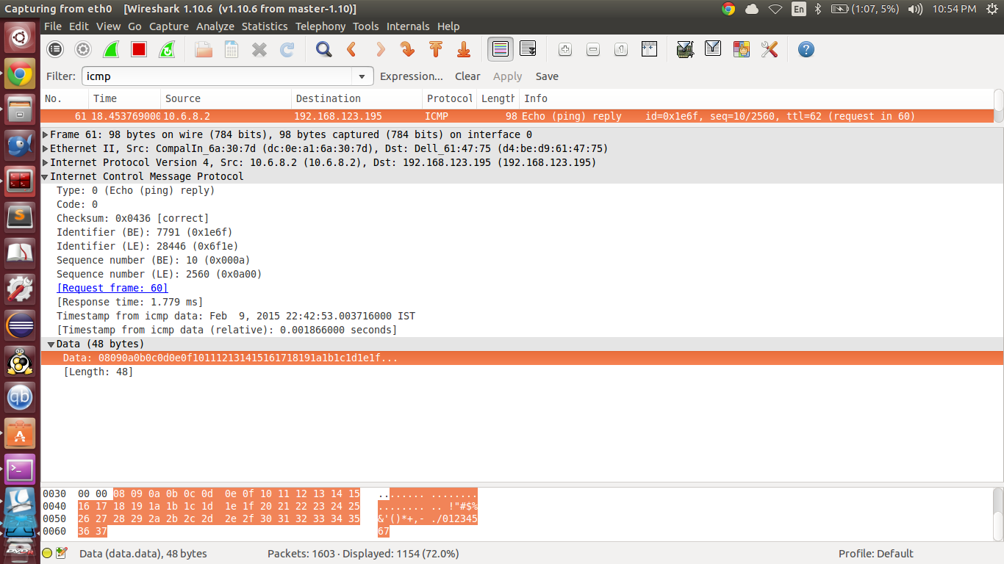

4. User-agent field is highlighted:

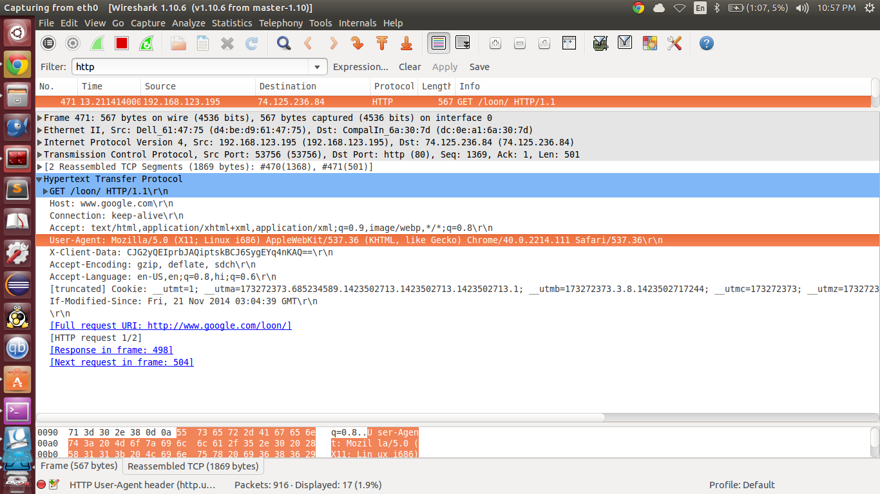

2.5:

one used to filter the requests using tcp protocol and another icmp protocol while pinged to www.google.com

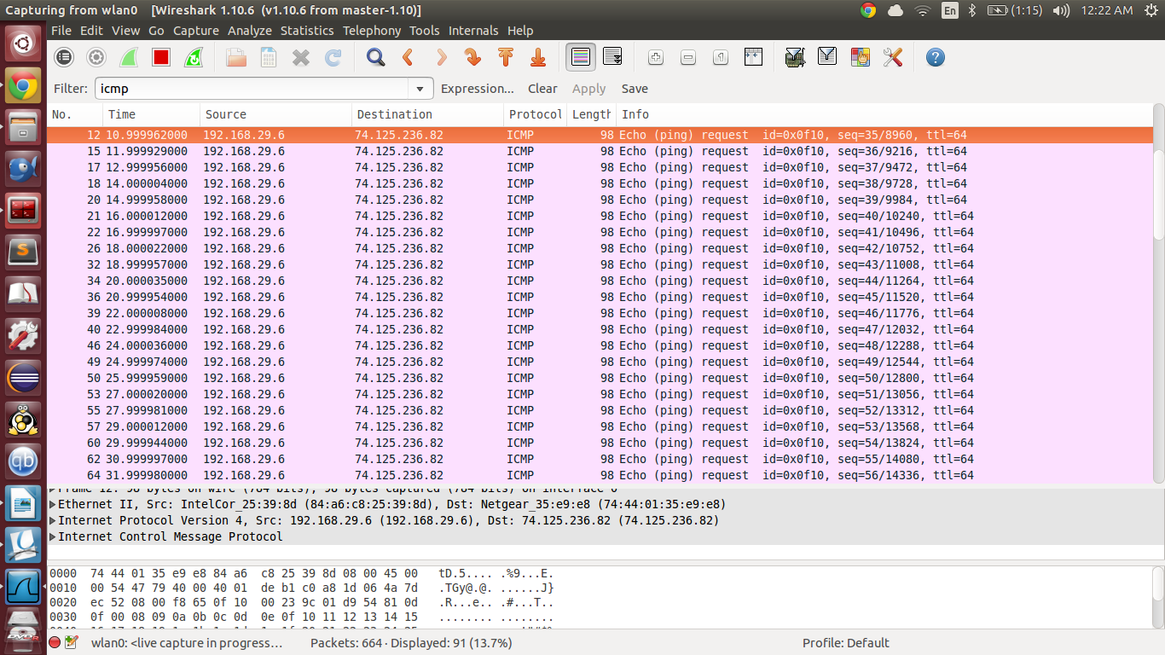

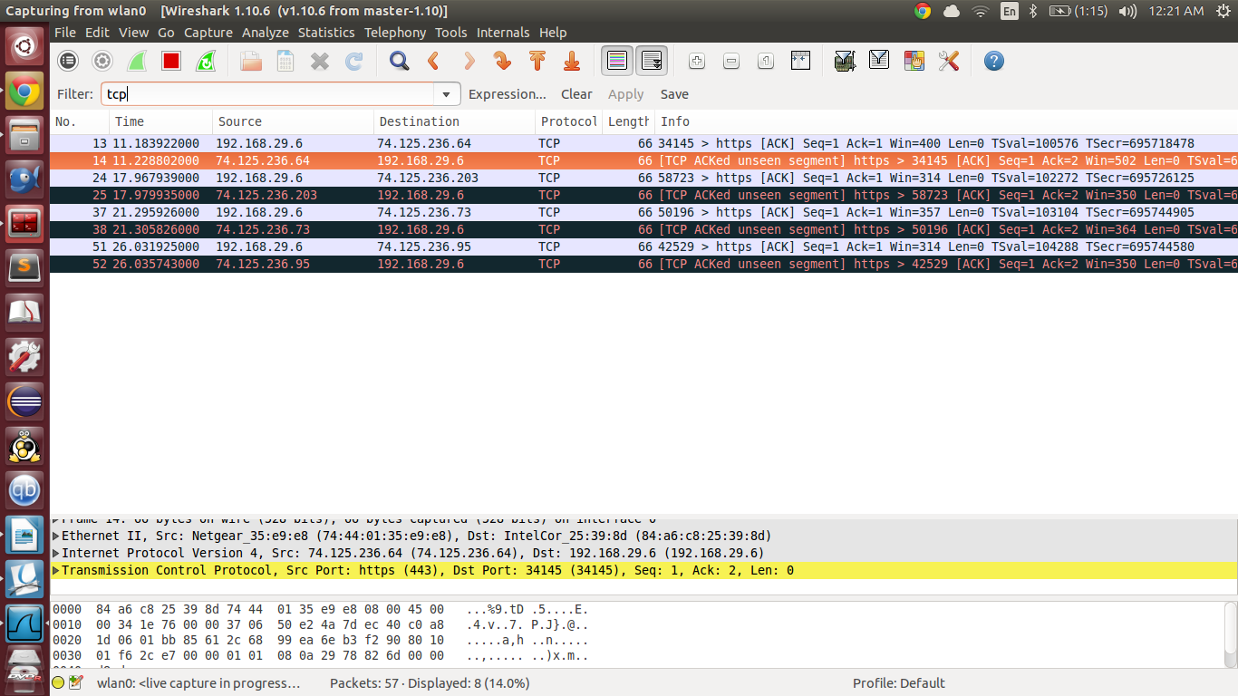

2.2 . The Treause Hunt:

1. IP address of X is : 10.6.15.92 and name is : Bob (person, first to say Hi )
2. IP address if Y is : 10.22.21.249 and name is : Abhik

First message of the conversation : Hi Abhik!
Last message of the conversation : Hahahaha :D Third world problems :P

2. The file was split into 12 (10+2) packets.

