INDIAN INSTITUTE OF TECHNOLOGY MADRAS
DEPARTMENT OF COMPUTER SCIENCE AND ENGINEERING

Course Name: Programming and Data Structure Lab Course No: CS2710
Full Marks: 15 (LabTest-1) Date: 19 / 09 / 2016 Time: 3 hours

Instructions:
You are supplied with two files: ROLLNO_labtest1_prob1.c and ROLLNO_labtest1_prob2.c. First, replace these file-names with your Roll-Numbers where the ROLLNO keyword appears in the file-name. You can only modify the mentioned areas (where it is denoted as “// Write C-code Here”) in these two .c files. You are not allowed to modify/change any other portion of the given code. Please make sure that your programs compile and run successfully. Finally, submit only two .c files (i.e., ROLLNO_labtest1_prob1.c and ROLLNO_labtest1_prob2.c) in the mentioned submission links given in MOODLE.

Problem-1: [ 7 Marks ]

Suppose that we have a linked list of points in the X-Y plane. We want to sort the list simultaneously with respect the X-coordinates and with respect to the Y-coordinates. To achieve this goal, we maintain two pointers in each node. One set of these pointers is used to sort the list with respect to the X-values, the other with respect to the Y-values. The following figure demonstrates this concept.

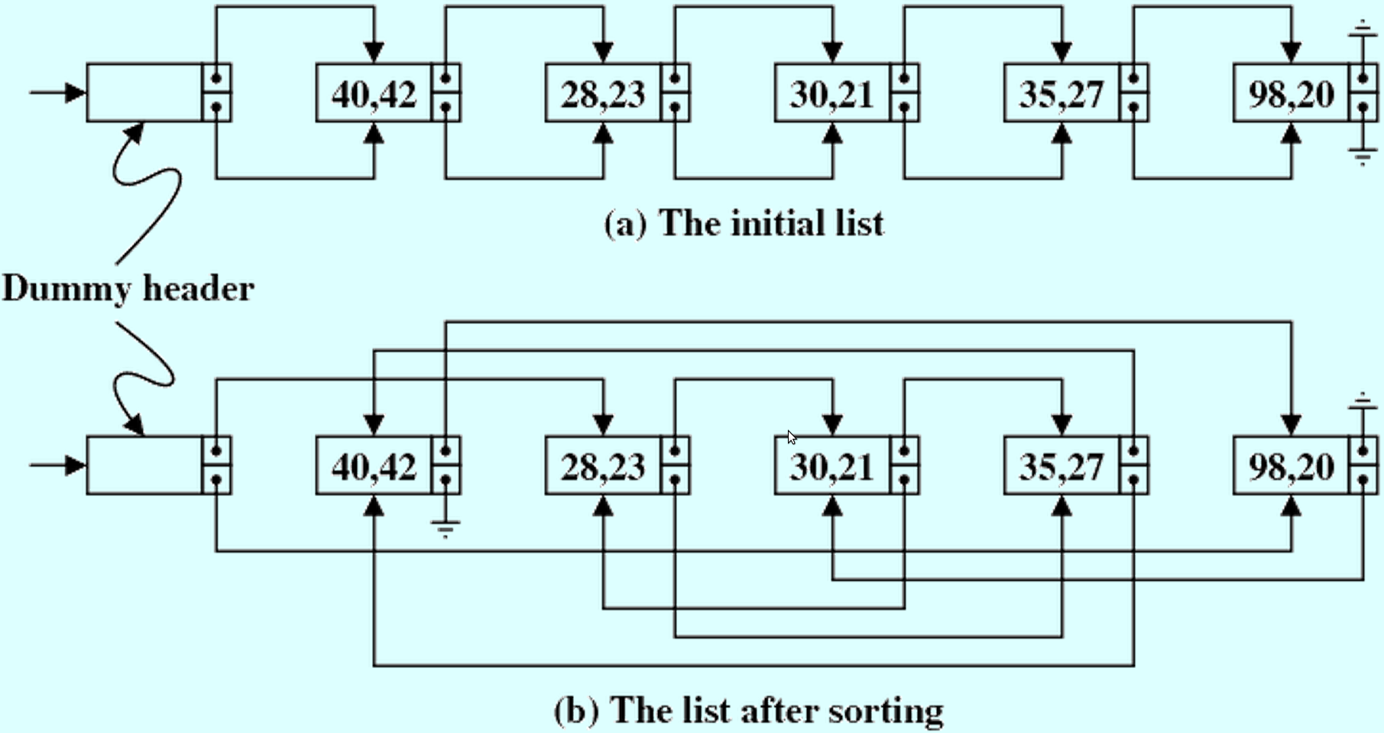
In view of this representation, we declare some relevant data types as follows.
typedef struct _node {
int x;
int y;
struct _node *nextx;
struct _node *nexty;
} node;
typedef node *list;
First, generate a random list of points with integer coordinates. At this point, you do not worry about sorting of the elements, but insert every new element at the end of the new list with respect to both the nextx and nexty pointers. A function to do that is given below.
#include <stdio.h>
#include <stdlib.h>
#include <time.h>

list genRandList ( int n )
{
list L;
node *p, *q;
int i;
/* Create dummy header */
L = (list)malloc(sizeof(node));
L -> x = L -> y = 0;
L -> nextx = L -> nexty = NULL;
/* Insert random elements at the end of the list */
srand((unsigned int)time(NULL));
p = L;
for (i=0; i<n; ++i) {
q = (node *)malloc(sizeof(node));
q -> x = 1000 + rand() % 9000;
q -> y = 1000 + rand() % 9000;
q -> nextx = q -> nexty = NULL;
p -> nextx = p -> nexty = q;
p = q;
}
return L;
}
Complete the C-function with the following prototype:
void printList ( list L, int flag );
This function prints the list headed by the pointer L. Now, each node has two pointers. The flag indicates whether the list is to be traversed along the nextx pointers, or along the nexty pointers.
Complete the two C-functions with the following prototypes:
void bubbleSortX ( list L );
void bubbleSortY ( list L );
The first function is meant for bubble-sorting the list headed by L with respect to the x-values, and the second with respect to the y-values. You are not supposed to separate the x and y coordinates of a point. This means that a swap in only the x-values or only the y-values in two nodes is not permitted. If you swap both the x and y values together, you disturb the order in the values with respect to which you are not sorting. So you must adjust the relevant pointers in the nodes in order to effect two independent sorting of the same list.
Your functions should be compatible with the following main() function.
#define N 100
#define WRT_X 0
#define WRT_Y 1
int main ()
{
list L;
L = genRandList(N);
printf("\nInitial list with respect to x pointers:\n"); printList(L,WRT_X);
printf("\nInitial list with respect to y pointers:\n"); printList(L,WRT_Y);
bubbleSortX(L);
bubbleSortY(L);
printf("\nFinal list with respect to x pointers:\n"); printList(L,WRT_X);
printf("\nFinal list with respect to y pointers:\n"); printList(L,WRT_Y);
return(0);
}
Report the output of your program for a random list of 100 points.

Sample Output:
Initial list with respect to x pointers:
(8819,9618) (8589,1044) (9705,8523) (6264,9407) (8792,4613) (8090,1571)
(7630,5719) (4810,4851) (8927,3233) (7097,2454) (9693,8946) (7902,7518)
(4484,1503) (7529,8466) (4996,6951) (6408,3815) (6569,4997) (3859,3627)
(3520,6475) (3034,8665) (7441,1125) (6588,2423) (3196,1398) (6275,8476)
(9983,9724) (9930,9677) (6022,5185) (4547,9506) (5688,8428) (5324,7036)
(5380,1732) (9851,8301) (3081,1062) (1928,5601) (6537,1315) (4266,1330)
(1440,9854) (2754,9988) (7604,5381) (8464,7588) (5105,5747) (4617,1127)
(9932,5516) (6985,2972) (3944,8661) (9008,5676) (9393,6211) (3978,2474)
(3625,2258) (4427,9162) (2573,5046) (6845,9365) (2252,8599) (6706,8857)
(3980,2522) (3797,5437) (7269,7414) (2916,4553) (2930,6253) (6525,3226)
(4914,2885) (7903,4307) (5448,8233) (3133,8073) (6843,6560) (4588,5769)
(7958,1433) (2486,9211) (6384,8192) (5420,9364) (9715,8217) (2153,4336)
(2983,4069) (7890,2265) (6674,1767) (1843,1588) (3653,8746) (2247,5453)
(4331,4380) (3527,7527) (7292,7115) (3296,5251) (4900,2134) (1814,1284)
(6679,6234) (7000,6394) (1803,8153) (7082,3786) (8574,4972) (2403,5248)
(5740,3246) (3188,5745) (8345,4435) (1198,2676) (5167,1077) (6555,2459)
(4544,8851) (4062,8444) (7338,4876) (8728,4017)

Initial list with respect to y pointers:
(8819,9618) (8589,1044) (9705,8523) (6264,9407) (8792,4613) (8090,1571)
(7630,5719) (4810,4851) (8927,3233) (7097,2454) (9693,8946) (7902,7518)
(4484,1503) (7529,8466) (4996,6951) (6408,3815) (6569,4997) (3859,3627)
(3520,6475) (3034,8665) (7441,1125) (6588,2423) (3196,1398) (6275,8476)
(9983,9724) (9930,9677) (6022,5185) (4547,9506) (5688,8428) (5324,7036)
(5380,1732) (9851,8301) (3081,1062) (1928,5601) (6537,1315) (4266,1330)
(1440,9854) (2754,9988) (7604,5381) (8464,7588) (5105,5747) (4617,1127)
(9932,5516) (6985,2972) (3944,8661) (9008,5676) (9393,6211) (3978,2474)
(3625,2258) (4427,9162) (2573,5046) (6845,9365) (2252,8599) (6706,8857)
(3980,2522) (3797,5437) (7269,7414) (2916,4553) (2930,6253) (6525,3226)
(4914,2885) (7903,4307) (5448,8233) (3133,8073) (6843,6560) (4588,5769)
(7958,1433) (2486,9211) (6384,8192) (5420,9364) (9715,8217) (2153,4336)
(2983,4069) (7890,2265) (6674,1767) (1843,1588) (3653,8746) (2247,5453)
(4331,4380) (3527,7527) (7292,7115) (3296,5251) (4900,2134) (1814,1284)
(6679,6234) (7000,6394) (1803,8153) (7082,3786) (8574,4972) (2403,5248)
(5740,3246) (3188,5745) (8345,4435) (1198,2676) (5167,1077) (6555,2459)
(4544,8851) (4062,8444) (7338,4876) (8728,4017)

Final list with respect to x pointers:
(1198,2676) (1440,9854) (1803,8153) (1814,1284) (1843,1588) (1928,5601)
(2153,4336) (2247,5453) (2252,8599) (2403,5248) (2486,9211) (2573,5046)
(2754,9988) (2916,4553) (2930,6253) (2983,4069) (3034,8665) (3081,1062)
(3133,8073) (3188,5745) (3196,1398) (3296,5251) (3520,6475) (3527,7527)
(3625,2258) (3653,8746) (3797,5437) (3859,3627) (3944,8661) (3978,2474)
(3980,2522) (4062,8444) (4266,1330) (4331,4380) (4427,9162) (4484,1503)
(4544,8851) (4547,9506) (4588,5769) (4617,1127) (4810,4851) (4900,2134)
(4914,2885) (4996,6951) (5105,5747) (5167,1077) (5324,7036) (5380,1732)
(5420,9364) (5448,8233) (5688,8428) (5740,3246) (6022,5185) (6264,9407)
(6275,8476) (6384,8192) (6408,3815) (6525,3226) (6537,1315) (6555,2459)
(6569,4997) (6588,2423) (6674,1767) (6679,6234) (6706,8857) (6843,6560)
(6845,9365) (6985,2972) (7000,6394) (7082,3786) (7097,2454) (7269,7414)
(7292,7115) (7338,4876) (7441,1125) (7529,8466) (7604,5381) (7630,5719)
(7890,2265) (7902,7518) (7903,4307) (7958,1433) (8090,1571) (8345,4435)
(8464,7588) (8574,4972) (8589,1044) (8728,4017) (8792,4613) (8819,9618)
(8927,3233) (9008,5676) (9393,6211) (9693,8946) (9705,8523) (9715,8217)
(9851,8301) (9930,9677) (9932,5516) (9983,9724)

Final list with respect to y pointers:
(8589,1044) (3081,1062) (5167,1077) (7441,1125) (4617,1127) (1814,1284)
(6537,1315) (4266,1330) (3196,1398) (7958,1433) (4484,1503) (8090,1571)
(1843,1588) (5380,1732) (6674,1767) (4900,2134) (3625,2258) (7890,2265)
(6588,2423) (7097,2454) (6555,2459) (3978,2474) (3980,2522) (1198,2676)
(4914,2885) (6985,2972) (6525,3226) (8927,3233) (5740,3246) (3859,3627)
(7082,3786) (6408,3815) (8728,4017) (2983,4069) (7903,4307) (2153,4336)
(4331,4380) (8345,4435) (2916,4553) (8792,4613) (4810,4851) (7338,4876)
(8574,4972) (6569,4997) (2573,5046) (6022,5185) (2403,5248) (3296,5251)
(7604,5381) (3797,5437) (2247,5453) (9932,5516) (1928,5601) (9008,5676)
(7630,5719) (3188,5745) (5105,5747) (4588,5769) (9393,6211) (6679,6234)
(2930,6253) (7000,6394) (3520,6475) (6843,6560) (4996,6951) (5324,7036)
(7292,7115) (7269,7414) (7902,7518) (3527,7527) (8464,7588) (3133,8073)
(1803,8153) (6384,8192) (9715,8217) (5448,8233) (9851,8301) (5688,8428)
(4062,8444) (7529,8466) (6275,8476) (9705,8523) (2252,8599) (3944,8661)
(3034,8665) (3653,8746) (4544,8851) (6706,8857) (9693,8946) (4427,9162)
(2486,9211) (5420,9364) (6845,9365) (6264,9407) (4547,9506) (8819,9618)
(9930,9677) (9983,9724) (1440,9854) (2754,9988)

Problem-2: [ 8 Marks ]

Suppose you want to implement two stacks using a single array. Two possibilities are outlined here:

- Odd-even strategy: In this case, Stack 1 uses locations 0, 2, 4, ... of the array, whereas Stack 2 uses the array locations 1, 3, 5, ...
- Colliding strategy: In this case, the two stacks start from the two ends of the array and grow in opposite directions (towards one another).
The following figure demonstrates these two strategies.
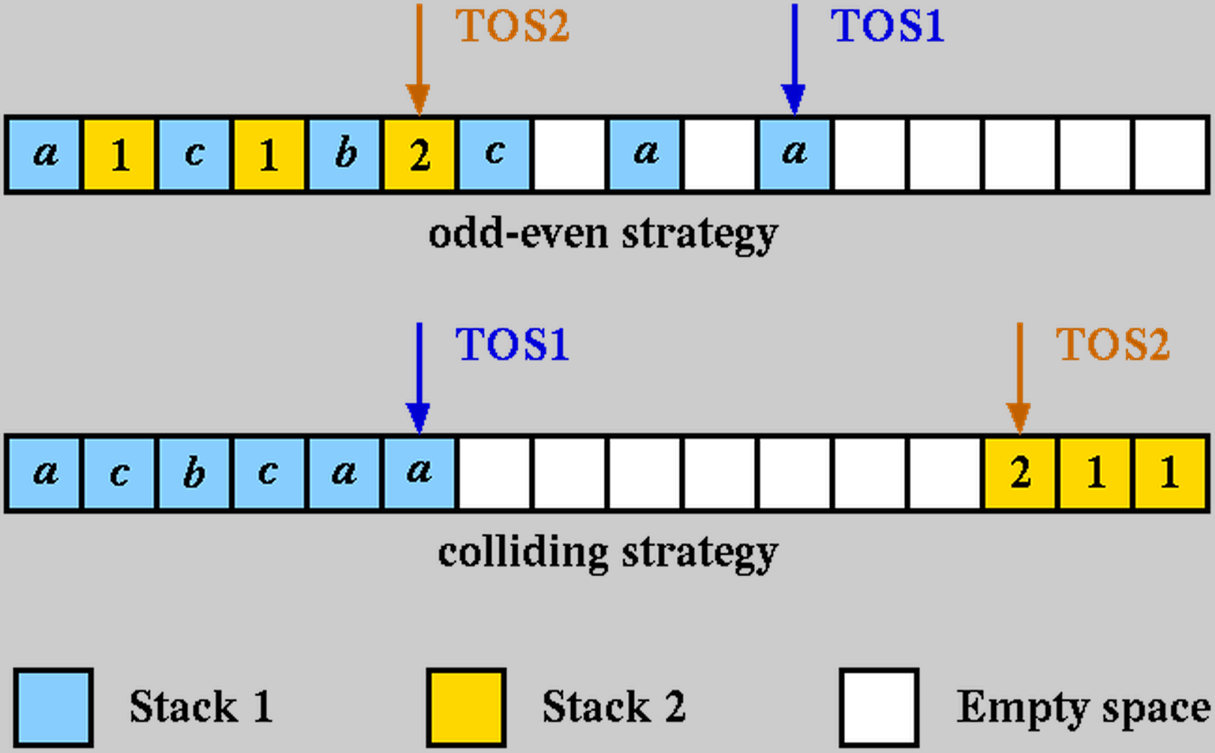

Implement both the strategies. Write two sets of initialize, push and pop routines corresponding to the two strategies. Complete the following three C-functions with the prototypes given below.
- Initialize Stack: void initStack ( int option );
- Push into Stack: void pushStack ( int which , char what , int option );
- Pop from Stack: void popStack ( int which , int option );
Please note that, your code should also print Overflow-Error (from pushStack function) and Underflow-Error (from popStack function) for both the stacks.
Show the output of your code on randomly generated sequences of requests. In order to have good-looking outputs, you may enforce the following:
- Keep the array size small, say 32 (max).
- For the first few iterations do push only.
- Subsequently make push twice as likely as pop.
- Make the first stack twice more active (on an average) than the second.
You may rely on the randomness of C's built-in pseudorandom generator to ensure these statistical properties. Your functions should be compatible with the following main() function.
#include <stdio.h>
#include<stdlib.h>
#define MAX_SIZE 32

char store[MAX_SIZE];
int tos1, tos2;

int main ()
{
int i, option, which, action;
char what;

srand((unsigned int)time(NULL));

printf("Enter strategy -- 0 (odd-even) or 1 (colliding) : ");
scanf("%d",&option);
initStack(option);

i = 0;
while (1) {
++i;
printf("Iteration %3d : ", i); fflush(stdout);

/* Initially make push */
/* Then make push twice as likely as pop */
if (i <= 8) action = 1;
else action = rand() % 3;

/* Make Stack 1 twice more active than Stack 2 */
which = (rand() % 3) ? 1 : 2;

if (action) { /* Push */
what = ((which == 1) ? 'a' : 'A') + (rand() % 26);
printf("Push %c in stack %d. New stack : ",what,which); fflush(stdout);
pushStack(which,what,option);
}
else { /* Pop */
printf("Pop in stack %d. New stack : ",which); fflush(stdout);
popStack(which,option);
}
printStack();
}
return(0);
}

Don't print very big output files. Generate 4 runs of your program with a total size of less than 300 lines. Two runs should correspond to the odd-even strategy, the remaining two the colliding strategy.

Sample Output:
Enter strategy -- 0 (odd-even) or 1 (colliding) : 0
Iteration 1 : Push p in stack 1. New stack : p_______________________________
Iteration 2 : Push i in stack 1. New stack : p_i_____________________________
Iteration 3 : Push o in stack 1. New stack : p_i_o___________________________
Iteration 4 : Push x in stack 1. New stack : p_i_o_x_________________________
Iteration 5 : Push z in stack 1. New stack : p_i_o_x_z_______________________
Iteration 6 : Push r in stack 1. New stack : p_i_o_x_z_r_____________________
Iteration 7 : Push n in stack 1. New stack : p_i_o_x_z_r_n___________________
Iteration 8 : Push f in stack 1. New stack : p_i_o_x_z_r_n_f_________________
Iteration 9 : Pop in stack 1. New stack : p_i_o_x_z_r_n___________________
Iteration 10 : Push s in stack 1. New stack : p_i_o_x_z_r_n_s_________________
Iteration 11 : Push j in stack 1. New stack : p_i_o_x_z_r_n_s_j_______________
Iteration 12 : Push W in stack 2. New stack : pWi_o_x_z_r_n_s_j_______________
Iteration 13 : Pop in stack 1. New stack : pWi_o_x_z_r_n_s_________________
Iteration 14 : Push X in stack 2. New stack : pWiXo_x_z_r_n_s_________________
Iteration 15 : Push g in stack 1. New stack : pWiXo_x_z_r_n_s_g_______________
Iteration 16 : Push x in stack 1. New stack : pWiXo_x_z_r_n_s_g_x_____________
Iteration 17 : Pop in stack 2. New stack : pWi_o_x_z_r_n_s_g_x_____________
Iteration 18 : Pop in stack 1. New stack : pWi_o_x_z_r_n_s_g_______________
Iteration 19 : Push t in stack 1. New stack : pWi_o_x_z_r_n_s_g_t_____________
Iteration 20 : Pop in stack 1. New stack : pWi_o_x_z_r_n_s_g_______________
Iteration 21 : Push e in stack 1. New stack : pWi_o_x_z_r_n_s_g_e_____________
Iteration 22 : Pop in stack 1. New stack : pWi_o_x_z_r_n_s_g_______________
Iteration 23 : Push R in stack 2. New stack : pWiRo_x_z_r_n_s_g_______________
Iteration 24 : Push p in stack 1. New stack : pWiRo_x_z_r_n_s_g_p_____________
Iteration 25 : Push I in stack 2. New stack : pWiRoIx_z_r_n_s_g_p_____________
Iteration 26 : Push r in stack 1. New stack : pWiRoIx_z_r_n_s_g_p_r___________
Iteration 27 : Push h in stack 1. New stack : pWiRoIx_z_r_n_s_g_p_r_h_________
Iteration 28 : Push u in stack 1. New stack : pWiRoIx_z_r_n_s_g_p_r_h_u_______
Iteration 29 : Push C in stack 2. New stack : pWiRoIxCz_r_n_s_g_p_r_h_u_______
Iteration 30 : Push v in stack 1. New stack : pWiRoIxCz_r_n_s_g_p_r_h_u_v_____
Iteration 31 : Pop in stack 1. New stack : pWiRoIxCz_r_n_s_g_p_r_h_u_______
Iteration 32 : Pop in stack 1. New stack : pWiRoIxCz_r_n_s_g_p_r_h_________
Iteration 33 : Push f in stack 1. New stack : pWiRoIxCz_r_n_s_g_p_r_h_f_______
Iteration 34 : Push Y in stack 2. New stack : pWiRoIxCzYr_n_s_g_p_r_h_f_______
Iteration 35 : Push n in stack 1. New stack : pWiRoIxCzYr_n_s_g_p_r_h_f_n_____
Iteration 36 : Pop in stack 1. New stack : pWiRoIxCzYr_n_s_g_p_r_h_f_______
Iteration 37 : Push D in stack 2. New stack : pWiRoIxCzYrDn_s_g_p_r_h_f_______
Iteration 38 : Push t in stack 1. New stack : pWiRoIxCzYrDn_s_g_p_r_h_f_t_____
Iteration 39 : Push E in stack 2. New stack : pWiRoIxCzYrDnEs_g_p_r_h_f_t_____
Iteration 40 : Push O in stack 2. New stack : pWiRoIxCzYrDnEsOg_p_r_h_f_t_____
Iteration 41 : Push x in stack 1. New stack : pWiRoIxCzYrDnEsOg_p_r_h_f_t_x___
Iteration 42 : Push k in stack 1. New stack : pWiRoIxCzYrDnEsOg_p_r_h_f_t_x_k_
Iteration 43 : Push f in stack 1. New stack : Error: Overflow in Stack 1.

Enter strategy -- 0 (odd-even) or 1 (colliding) : 0
Iteration 1 : Push p in stack 1. New stack : p_______________________________
Iteration 2 : Push w in stack 1. New stack : p_w_____________________________
Iteration 3 : Push i in stack 1. New stack : p_w_i___________________________
Iteration 4 : Push m in stack 1. New stack : p_w_i_m_________________________
Iteration 5 : Push q in stack 1. New stack : p_w_i_m_q_______________________
Iteration 6 : Push i in stack 1. New stack : p_w_i_m_q_i_____________________
Iteration 7 : Push d in stack 1. New stack : p_w_i_m_q_i_d___________________
Iteration 8 : Push l in stack 1. New stack : p_w_i_m_q_i_d_l_________________
Iteration 9 : Pop in stack 2. New stack : Error: Underflow in Stack 2.

Enter strategy -- 0 (odd-even) or 1 (colliding) : 1
Iteration 1 : Push j in stack 1. New stack : j_______________________________
Iteration 2 : Push x in stack 1. New stack : jx______________________________
Iteration 3 : Push U in stack 2. New stack : jx_____________________________U
Iteration 4 : Push r in stack 1. New stack : jxr____________________________U
Iteration 5 : Push K in stack 2. New stack : jxr___________________________KU
Iteration 6 : Push z in stack 1. New stack : jxrz__________________________KU
Iteration 7 : Push m in stack 1. New stack : jxrzm_________________________KU
Iteration 8 : Push b in stack 1. New stack : jxrzmb________________________KU
Iteration 9 : Pop in stack 2. New stack : jxrzmb_________________________U
Iteration 10 : Pop in stack 1. New stack : jxrzm__________________________U
Iteration 11 : Pop in stack 2. New stack : jxrzm___________________________
Iteration 12 : Pop in stack 1. New stack : jxrz____________________________
Iteration 13 : Pop in stack 1. New stack : jxr_____________________________
Iteration 14 : Push n in stack 1. New stack : jxrn____________________________
Iteration 15 : Push D in stack 2. New stack : jxrn___________________________D
Iteration 16 : Push c in stack 1. New stack : jxrnc__________________________D
Iteration 17 : Push H in stack 2. New stack : jxrnc_________________________HD
Iteration 18 : Pop in stack 1. New stack : jxrn__________________________HD
Iteration 19 : Push G in stack 2. New stack : jxrn_________________________GHD
Iteration 20 : Push f in stack 1. New stack : jxrnf________________________GHD
Iteration 21 : Pop in stack 1. New stack : jxrn_________________________GHD
Iteration 22 : Push V in stack 2. New stack : jxrn________________________VGHD
Iteration 23 : Push f in stack 1. New stack : jxrnf_______________________VGHD
Iteration 24 : Pop in stack 2. New stack : jxrnf________________________GHD
Iteration 25 : Push n in stack 1. New stack : jxrnfn_______________________GHD
Iteration 26 : Pop in stack 2. New stack : jxrnfn________________________HD
Iteration 27 : Pop in stack 1. New stack : jxrnf_________________________HD
Iteration 28 : Push z in stack 1. New stack : jxrnfz________________________HD
Iteration 29 : Push G in stack 2. New stack : jxrnfz_______________________GHD
Iteration 30 : Push a in stack 1. New stack : jxrnfza______________________GHD
Iteration 31 : Push X in stack 2. New stack : jxrnfza_____________________XGHD
Iteration 32 : Push w in stack 1. New stack : jxrnfzaw____________________XGHD
Iteration 33 : Push L in stack 2. New stack : jxrnfzaw___________________LXGHD
Iteration 34 : Push S in stack 2. New stack : jxrnfzaw__________________SLXGHD
Iteration 35 : Push q in stack 1. New stack : jxrnfzawq_________________SLXGHD
Iteration 36 : Pop in stack 1. New stack : jxrnfzaw__________________SLXGHD
Iteration 37 : Push m in stack 1. New stack : jxrnfzawm_________________SLXGHD
Iteration 38 : Push Y in stack 2. New stack : jxrnfzawm________________YSLXGHD
Iteration 39 : Push z in stack 1. New stack : jxrnfzawmz_______________YSLXGHD
Iteration 40 : Push h in stack 1. New stack : jxrnfzawmzh______________YSLXGHD
Iteration 41 : Push y in stack 1. New stack : jxrnfzawmzhy_____________YSLXGHD
Iteration 42 : Push N in stack 2. New stack : jxrnfzawmzhy____________NYSLXGHD
Iteration 43 : Pop in stack 1. New stack : jxrnfzawmzh_____________NYSLXGHD
Iteration 44 : Push i in stack 1. New stack : jxrnfzawmzhi____________NYSLXGHD
Iteration 45 : Push c in stack 1. New stack : jxrnfzawmzhic___________NYSLXGHD
Iteration 46 : Push s in stack 1. New stack : jxrnfzawmzhics__________NYSLXGHD
Iteration 47 : Push X in stack 2. New stack : jxrnfzawmzhics_________XNYSLXGHD
Iteration 48 : Push q in stack 1. New stack : jxrnfzawmzhicsq________XNYSLXGHD
Iteration 49 : Push v in stack 1. New stack : jxrnfzawmzhicsqv_______XNYSLXGHD
Iteration 50 : Push a in stack 1. New stack : jxrnfzawmzhicsqva______XNYSLXGHD
Iteration 51 : Push l in stack 1. New stack : jxrnfzawmzhicsqval_____XNYSLXGHD
Iteration 52 : Push l in stack 1. New stack : jxrnfzawmzhicsqvall____XNYSLXGHD
Iteration 53 : Push h in stack 1. New stack : jxrnfzawmzhicsqvallh___XNYSLXGHD
Iteration 54 : Pop in stack 1. New stack : jxrnfzawmzhicsqvall____XNYSLXGHD
Iteration 55 : Push k in stack 1. New stack : jxrnfzawmzhicsqvallk___XNYSLXGHD
Iteration 56 : Push x in stack 1. New stack : jxrnfzawmzhicsqvallkx__XNYSLXGHD
Iteration 57 : Push q in stack 1. New stack : jxrnfzawmzhicsqvallkxq_XNYSLXGHD
Iteration 58 : Push F in stack 2. New stack : jxrnfzawmzhicsqvallkxqFXNYSLXGHD
Iteration 59 : Pop in stack 2. New stack : jxrnfzawmzhicsqvallkxq_XNYSLXGHD
Iteration 60 : Push A in stack 2. New stack : jxrnfzawmzhicsqvallkxqAXNYSLXGHD
Iteration 61 : Pop in stack 1. New stack : jxrnfzawmzhicsqvallkx_AXNYSLXGHD
Iteration 62 : Push z in stack 1. New stack : jxrnfzawmzhicsqvallkxzAXNYSLXGHD
Iteration 63 : Push v in stack 1. New stack : Error: Overflow in stack.

Enter strategy -- 0 (odd-even) or 1 (colliding) : 1
Iteration 1 : Push C in stack 2. New stack : _______________________________C
Iteration 2 : Push z in stack 1. New stack : z______________________________C
Iteration 3 : Push n in stack 1. New stack : zn_____________________________C
Iteration 4 : Push h in stack 1. New stack : znh____________________________C
Iteration 5 : Push k in stack 1. New stack : znhk___________________________C
Iteration 6 : Push q in stack 1. New stack : znhkq__________________________C
Iteration 7 : Push e in stack 1. New stack : znhkqe_________________________C
Iteration 8 : Push a in stack 1. New stack : znhkqea________________________C
Iteration 9 : Push t in stack 1. New stack : znhkqeat_______________________C
Iteration 10 : Push z in stack 1. New stack : znhkqeatz______________________C
Iteration 11 : Push f in stack 1. New stack : znhkqeatzf_____________________C
Iteration 12 : Pop in stack 1. New stack : znhkqeatz______________________C
Iteration 13 : Push x in stack 1. New stack : znhkqeatzx_____________________C
Iteration 14 : Push Z in stack 2. New stack : znhkqeatzx____________________ZC
Iteration 15 : Pop in stack 2. New stack : znhkqeatzx_____________________C
Iteration 16 : Push e in stack 1. New stack : znhkqeatzxe____________________C
Iteration 17 : Push q in stack 1. New stack : znhkqeatzxeq___________________C
Iteration 18 : Push t in stack 1. New stack : znhkqeatzxeqt__________________C
Iteration 19 : Push v in stack 1. New stack : znhkqeatzxeqtv_________________C
Iteration 20 : Push r in stack 1. New stack : znhkqeatzxeqtvr________________C
Iteration 21 : Push Q in stack 2. New stack : znhkqeatzxeqtvr_______________QC
Iteration 22 : Push v in stack 1. New stack : znhkqeatzxeqtvrv______________QC
Iteration 23 : Pop in stack 1. New stack : znhkqeatzxeqtvr_______________QC
Iteration 24 : Pop in stack 2. New stack : znhkqeatzxeqtvr________________C
Iteration 25 : Pop in stack 1. New stack : znhkqeatzxeqtv_________________C
Iteration 26 : Pop in stack 2. New stack : znhkqeatzxeqtv__________________
Iteration 27 : Push v in stack 1. New stack : znhkqeatzxeqtvv_________________
Iteration 28 : Push k in stack 1. New stack : znhkqeatzxeqtvvk________________
Iteration 29 : Push i in stack 1. New stack : znhkqeatzxeqtvvki_______________
Iteration 30 : Pop in stack 1. New stack : znhkqeatzxeqtvvk________________
Iteration 31 : Pop in stack 2. New stack : Error: Underflow in Stack 2.

