**Advanced Database**

**System Design**

**CS632**

**Final Project**

By

**Abhinaya Dhandapani**

UCID: ad546

Student ID: 31390890

Email: ad546@njit.edu

**Contents**

MovieZ Ticket Booking System 3

Tools 3

System Flow 3

Main Page Link 3

Screen Shots 4

Table Scripts 8

PSP Code 9

# **MovieZ Ticket Booking System:**

People need balance in their life. The more they work, the more entertainment is required. One such entertainment is cinemas. Watching movies from home is fun, but watching from theatre is extraordinary. Now-a-days movie tickets’ demand is increasing. Unlike olden days where people had to go to the theatre to secure a ticket, now they can easily book tickets online from the comfort of their home. I am going to build one such ‘Movie Ticket Booking System’.

# **Tools:**

|  |  |
| --- | --- |
| Language: | HTML, PSP, JavaScript, CSS |
| Database: | SQL, PL/SQL |
| Software: | Notepad++, Aqua Data Studio, MobaXterm, Google Chrome |
| Hardware: | Intel(R) Core(TM) i5 Processor, 6.0 GB RAM |
| Operating System: | Windows 10 |

# **System Flow:**

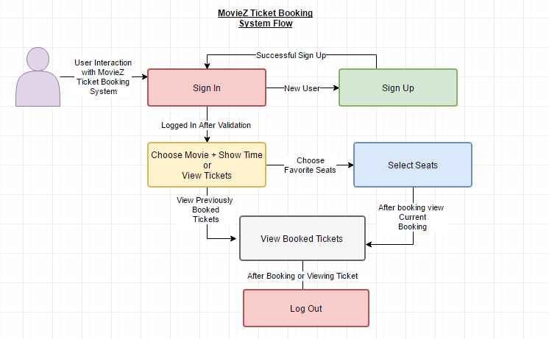

# **Main Page Link:**

http://prophet.njit.edu:7780/CS632S102_013/signin

# **SCREEN SHOTS:**

**Sign In Page:**

If already the user has signed up he/she can Sign In straight away else the Sign Up link is clicked.

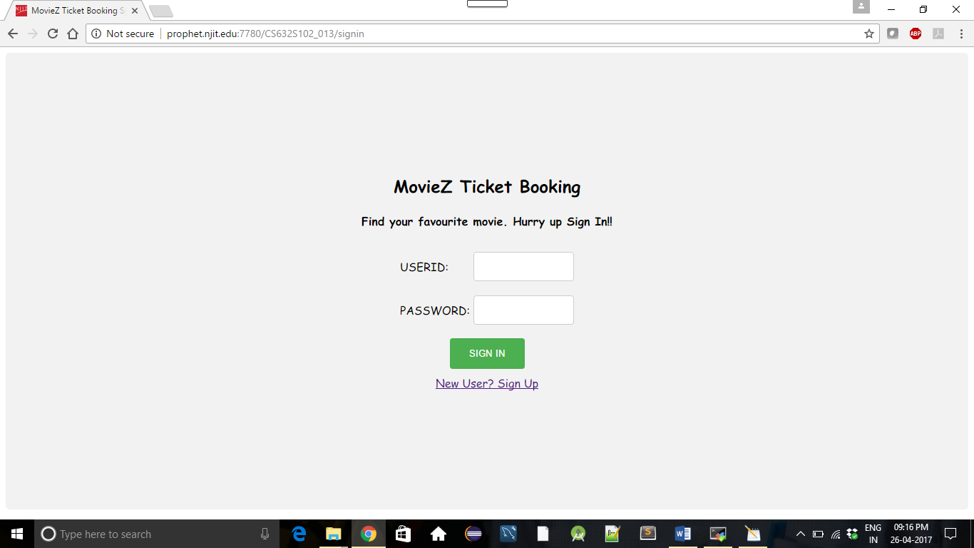

**Sign Up Page: (After Sign up)**

Page will get redirected to the sign in page for logging in, to book the tickets.

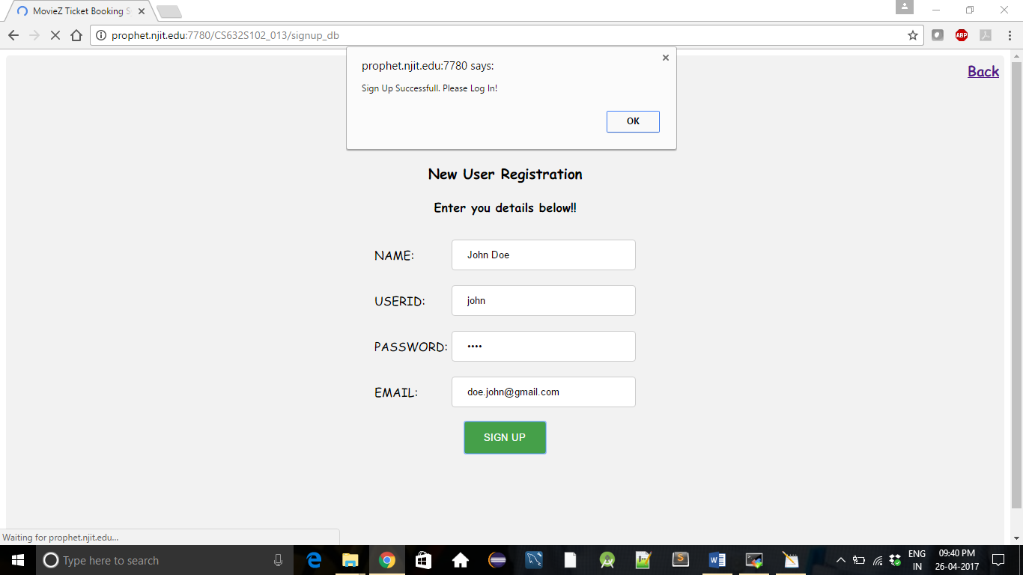

**Sign In Page – password doesn’t match:**

Validation check. This checks the database whether the entered userid and password matches with the one in the DB.

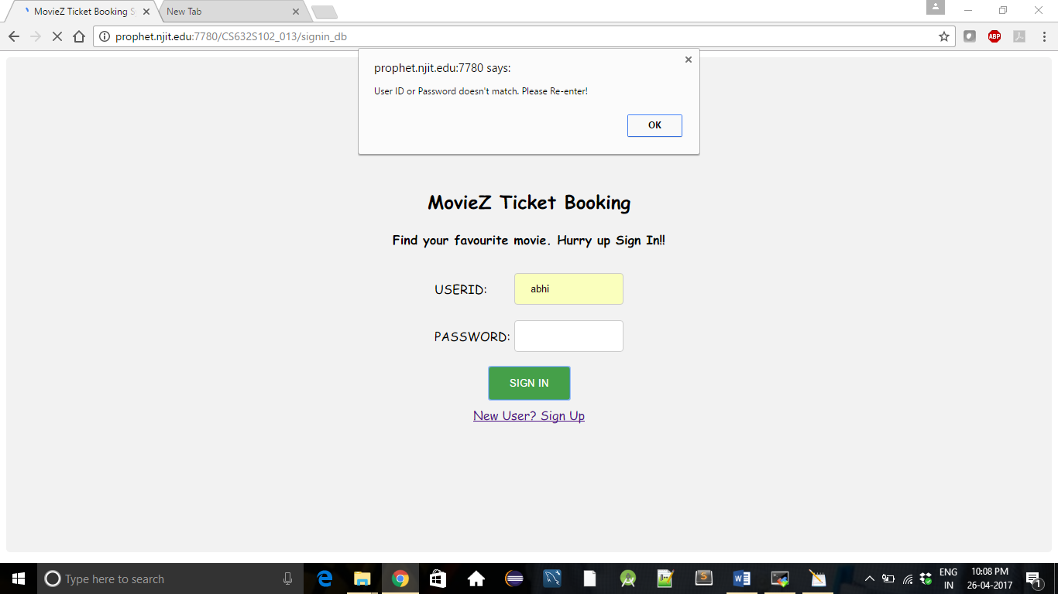

**Movie and show time choosing Page:**

Two drop down lists to select the user desired movie and show time. We can either book new tickets or view the previously booked tickets.

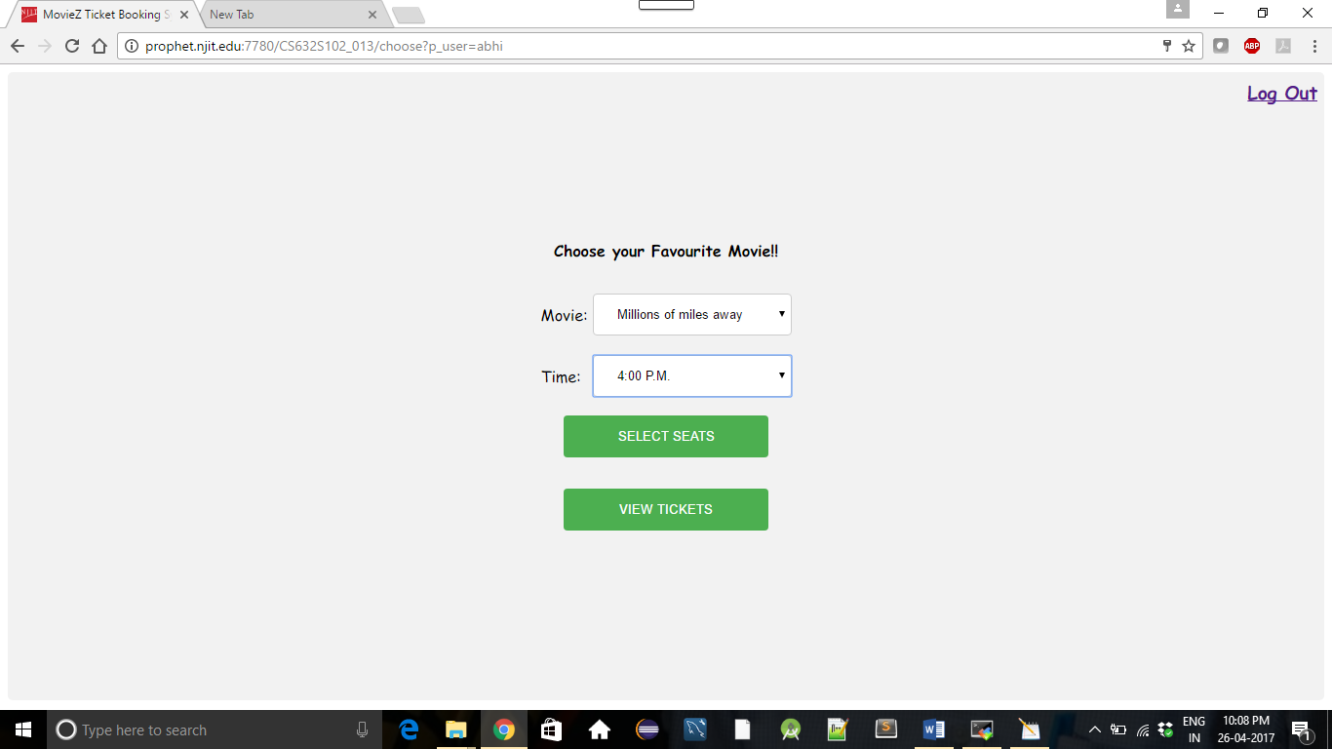

**Selecting seats Page:**

The red boxes indicated the already booked seats and grey ones are available for the current user to book. Once the user selects the seats and clicks ‘Book’ – the tickets are blocked for the current user.

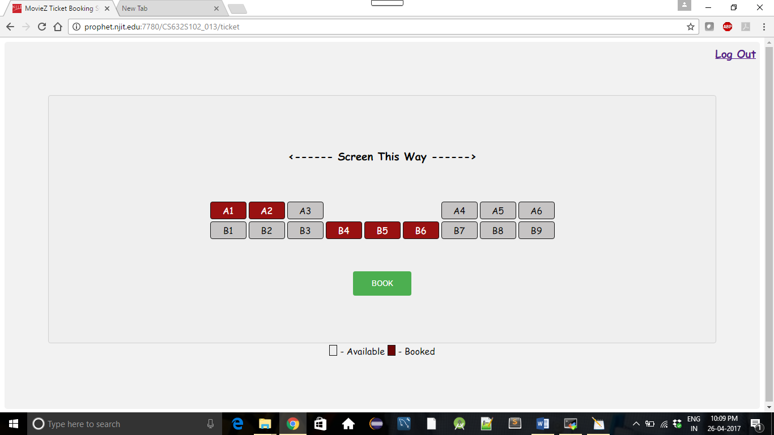

**Page after successful ticket booking:**

Confirmation page which will direct us to view the booking.

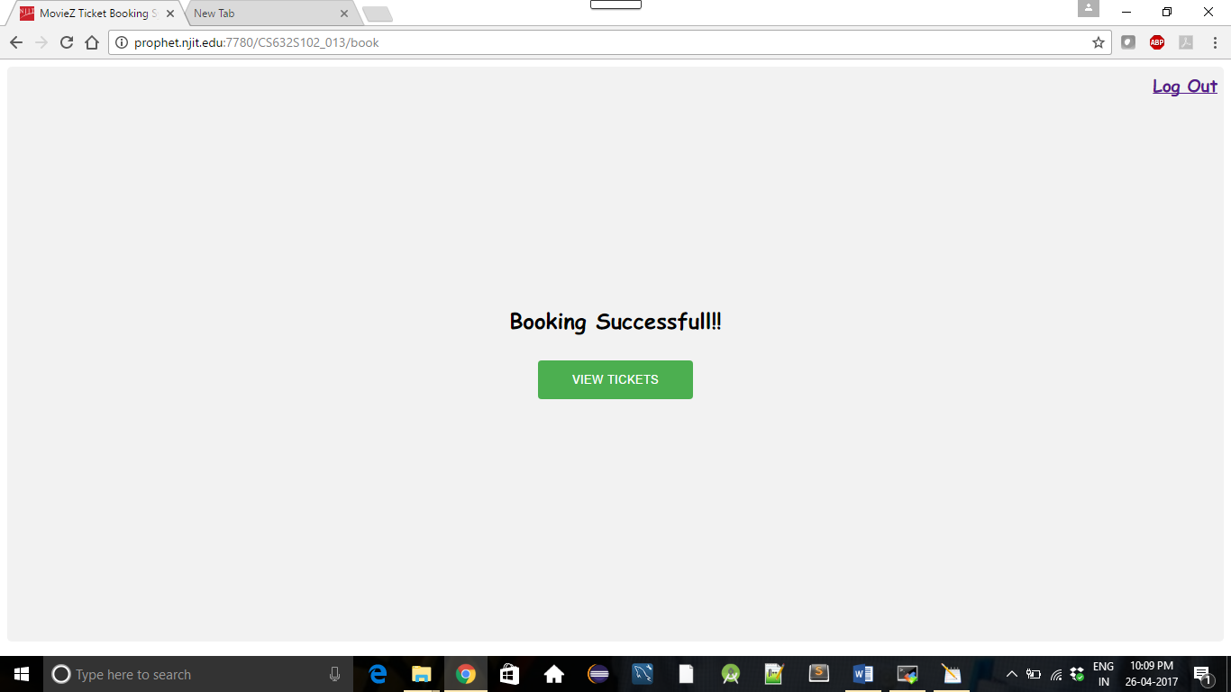

**Tickets display Page:**

This displays the logged in user’s booked tickets.

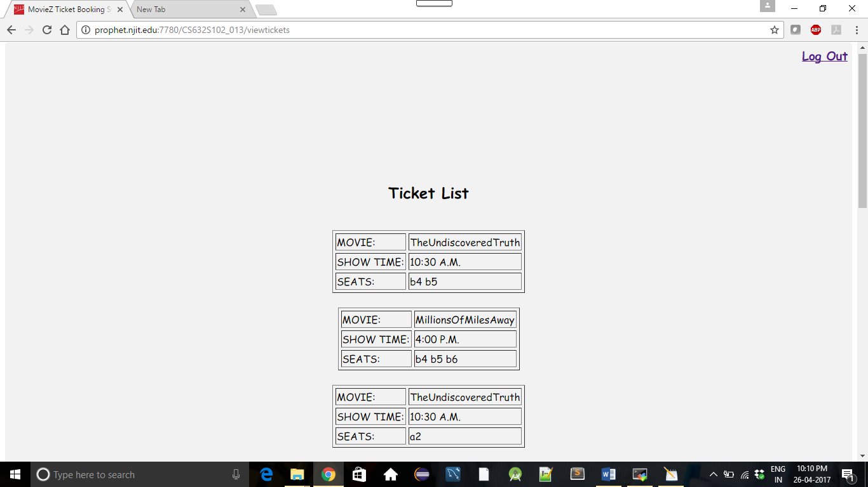

# **TABLE SCRIPTS:**

|  |
| --- |
| create table register(  name varchar2(25),  userid varchar2(25),  pwd varchar2(25),  email varchar2(25)  )  /  create table booking(  userid varchar2(25),  mname varchar2(20),  mtime varchar2(20),  seats varchar2(50)  )  /  create table tickets(  mname varchar2(20),  mtime varchar2(20),  a1 varchar2(5),  a2 varchar2(5),  a3 varchar2(5),  a4 varchar2(5),  a5 varchar2(5),  a6 varchar2(5),  b1 varchar2(5),b2 varchar2(5),b3 varchar2(5),b4 varchar2(5),b5 varchar2(5),b6 varchar2(5),b7 varchar2(5),  b8 varchar2(5),b9 varchar2(5)  )  / |

# **PSP CODE:**

**signin.psp**

|  |
| --- |
| <%@ page language="PL/SQL" %>  <%@ plsql procedure="signin" %>  <HTML>  <HEAD>  <TITLE>MovieZ Ticket Booking System</TITLE>  <style>  input[type=text], select {  width: 100%;  padding: 12px 20px;  margin: 8px 0;  display: inline-block;  border: 1px solid #ccc;  border-radius: 4px;  box-sizing: border-box;  }  input[type=password], select {  width: 100%;  padding: 12px 20px;  margin: 8px 0;  display: inline-block;  border: 1px solid #ccc;  border-radius: 4px;  box-sizing: border-box;  }  input[type=submit] {  width: 10%;  background-color: #4CAF50;  color: white;  padding: 14px 20px;  margin: 8px 0;  border: none;  border-radius: 4px;  cursor: pointer;  }  input[type=submit]:hover {  background-color: #45a049;  }  body {  font-family: Comic Sans MS;  }  div {  border-radius: 5px;  background-color: #f2f2f2;  padding: 150px;  }  </style>  </HEAD>  <BODY>  <div>  <CENTER><H2> MovieZ Ticket Booking </H2>  <H4> Find your favourite movie. Hurry up Sign In!! </H4></CENTER>  <FORM ACTION="signin_db" METHOD="post">  <CENTER><TABLE CELLSPACING="2" BORDER="0">  <TR><TD>USERID:</TD><TD ALIGN="left"><INPUT TYPE="text" SIZE="10" NAME="p_user"/></TD></TR>  <TR><TD>PASSWORD:</TD><TD ALIGN="left"><INPUT TYPE="password" SIZE="10" NAME="p_pwd"/></TD></TR>  </TABLE>  <INPUT TYPE="submit" NAME="p_submit" VALUE="SIGN IN"/><BR>  <A HREF="signup">New User? Sign Up</A></CENTER>  </FORM>  </div>  </BODY>  </HTML> |

**signin_db.psp**

|  |
| --- |
| <%@ page language="PL/SQL" %>  <%@ plsql procedure="signin_db" %>  <%@ plsql parameter="p_user" default="NULL" %>  <%@ plsql parameter="p_pwd" default="NULL" %>  <%@ plsql parameter="p_submit" default="NULL" %>  <HTML>  <HEAD>  <TITLE>MovieZ Ticket Booking System</TITLE>  </HEAD>  <%!  p_uname varchar2(25);  p_pass varchar2(25);  %>  <BODY>    <%  BEGIN  SELECT userid,pwd INTO p_uname,p_pass FROM register where userid=p_user;    IF p_uname=p_user AND p_pass=p_pwd THEN  %>  <script type="text/javascript">window.open("choose?p_user=<%=p_user%>","_self");</script>  <%  ELSE  %>  <script type="text/javascript">window.alert("User ID or Password doesn't match. Please Re-enter!");  window.open('signin',"_self");</script>  <%  END IF;  EXCEPTION  WHEN OTHERS THEN  %>  <script type="text/javascript">window.alert("Something went wrong. Please Re-enter!");  window.open('signin',"_self");</script>  <%  END;  %>  </BODY>  </HTML> |

**signup.psp**

|  |
| --- |
| <%@ page language="PL/SQL" %>  <%@ plsql procedure="signup" %>  <HTML>  <HEAD>  <TITLE>MovieZ Ticket Booking System</TITLE>  <style>  input[type=text], select {  width: 100%;  padding: 12px 20px;  margin: 8px 0;  display: inline-block;  border: 1px solid #ccc;  border-radius: 4px;  box-sizing: border-box;  }  input[type=password], select {  width: 100%;  padding: 12px 20px;  margin: 8px 0;  display: inline-block;  border: 1px solid #ccc;  border-radius: 4px;  box-sizing: border-box;  }  input[type=submit] {  width: 10%;  background-color: #4CAF50;  color: white;  padding: 14px 20px;  margin: 8px 0;  border: none;  border-radius: 4px;  cursor: pointer;  }  input[type=submit]:hover {  background-color: #45a049;  }  body {  font-family: Comic Sans MS;  }  div {  border-radius: 5px;  background-color: #f2f2f2;  padding: 125px;  }  </style>  </HEAD>  <BODY>  <div>  <h3><A HREF="signin" style="position: absolute; top: 15px; right: 15px; text-align: right;">Back</A></h3>  <CENTER>  <H3> New User Registration</H3>  <H4> Enter you details below!! </H4></CENTER>  <FORM ACTION="signup_db" METHOD="post">  <CENTER><TABLE CELLSPACING="2" BORDER="0">  <TR><TD>NAME:</TD><TD ALIGN="left"><INPUT TYPE="text" SIZE="25" NAME="p_name"/></TD></TR>  <TR><TD>USERID:</TD><TD ALIGN="left"><INPUT TYPE="text" SIZE="25" NAME="p_user"/></TD></TR>  <TR><TD>PASSWORD:</TD><TD ALIGN="left"><INPUT TYPE="password" SIZE="25" NAME="p_pwd"/></TD></TR>  <TR><TD>EMAIL:</TD><TD ALIGN="left"><INPUT TYPE="text" SIZE="25" NAME="p_email"/></TD></TR>    </TABLE>  <INPUT TYPE="submit" NAME="p_submit" VALUE="SIGN UP"/></CENTER>  </FORM>  </div>  </BODY>  </HTML> |

**signup_db.psp**

|  |
| --- |
| <%@ page language="PL/SQL" %>  <%@ plsql procedure="signup_db" %>  <%@ plsql parameter="p_name" default="NULL" %>  <%@ plsql parameter="p_user" default="NULL" %>  <%@ plsql parameter="p_pwd" default="NULL" %>  <%@ plsql parameter="p_email" default="NULL" %>  <%@ plsql parameter="p_submit" default="NULL" %>  <%!  i integer;  %>  <HTML>  <HEAD>  <TITLE>MovieZ Ticket Booking System</TITLE>  </HEAD>  <BODY>  Hi <%=p_user%>  <%  BEGIN  INSERT INTO REGISTER VALUES(p_name,p_user,p_pwd,p_email);  i:=sql%rowcount;  if i>0 then  %>  <script type="text/javascript">window.alert("Sign Up Successfull. Please Log In!");  window.open('signin',"_self");</script>  <%  else  %>  <script type="text/javascript">window.alert("Something went wrong. Try Again!");  window.open('signup',"_self");</script>  <%  end if;  EXCEPTION  WHEN OTHERS THEN  %>  <script type="text/javascript">window.alert("Something went wrong. Please Re-enter!");  window.open('signup',"_self");</script>  <%  END;  %>  </BODY>  </HTML> |

**choose.psp**

|  |
| --- |
| <%@ page language="PL/SQL" %>  <%@ plsql procedure="choose" %>  <%@ plsql parameter="p_user" default="NULL" %>  <HTML>  <HEAD>  <TITLE>MovieZ Ticket Booking System</TITLE>  <style>  input[type=text], select {  width: 100%;  padding: 12px 20px;  margin: 8px 0;  display: inline-block;  border: 1px solid #ccc;  border-radius: 4px;  box-sizing: border-box;  }  input[type=password], select {  width: 100%;  padding: 12px 20px;  margin: 8px 0;  display: inline-block;  border: 1px solid #ccc;  border-radius: 4px;  box-sizing: border-box;  }  input[type=submit] {  width: 20%;  background-color: #4CAF50;  color: white;  padding: 14px 20px;  margin: 8px 0;  border: none;  border-radius: 4px;  cursor: pointer;  }  input[type=submit]:hover {  background-color: #45a049;  }  body {  font-family: Comic Sans MS;  }  div {  border-radius: 5px;  background-color: #f2f2f2;  padding: 150px;  }  </style>  </HEAD>  <BODY>  <div>  <h3><A HREF="signin" style="position: absolute; top: 15px; right: 15px; text-align: right;">Log Out</A></h3>  <CENTER><H4> Choose your Favourite Movie!! </H4></CENTER>  <FORM ACTION="ticket" METHOD="post">  <CENTER><TABLE CELLSPACING="2" BORDER="0">  <TR><TD>Movie:</TD>  <TD ALIGN="left">  <SELECT NAME="p_movie">  <OPTION VALUE="TheUndiscoveredTruth">The Undiscovered Truth</OPTION>  <OPTION VALUE="MillionsOfMilesAway">Millions of miles away</OPTION>  <OPTION VALUE="CaptainFantastic">Captain Fantastic</OPTION>  <OPTION VALUE="Guarded">Guarded</OPTION>  </SELECT></TD></TR>  <TR><TD>Time:</TD>  <TD ALIGN="left">  <SELECT NAME="p_time">  <OPTION VALUE="Morning">10:30 A.M.</OPTION>  <OPTION VALUE="Evening">4:00 P.M.</OPTION>  </SELECT></TD></TR>  </TABLE>  <INPUT TYPE="submit" NAME="p_submit" VALUE="SELECT SEATS"/>  </CENTER>  <input type="hidden" name="p_user" value="<%=p_user%>">  </FORM>  <CENTER>  <FORM ACTION="viewtickets" METHOD="post">  <INPUT TYPE="submit" value="VIEW TICKETS">  <INPUT TYPE="hidden" NAME="p_user" value=<%=p_user%>>  </FORM></CENTER>  </div>  </BODY>  </HTML> |

**ticket.psp**

|  |
| --- |
| <%@ page language="PL/SQL" %>  <%@ plsql procedure="ticket" %>  <%@ plsql parameter="p_user" default="NULL" %>  <%@ plsql parameter="p_movie" default="NULL" %>  <%@ plsql parameter="p_time" default="NULL" %>  <%@ plsql parameter="p_submit" default="NULL" %>  <HTML>  <HEAD>  <style>  input[type=text], select {  width: 100%;  padding: 12px 20px;  margin: 8px 0;  display: inline-block;  border: 1px solid #ccc;  border-radius: 4px;  box-sizing: border-box;  }  input[type=password], select {  width: 100%;  padding: 12px 20px;  margin: 8px 0;  display: inline-block;  border: 1px solid #ccc;  border-radius: 4px;  box-sizing: border-box;  }  input[type=submit] {  width: 10%;  background-color: #4CAF50;  color: white;  padding: 14px 20px;  margin: 8px 0;  border: none;  border-radius: 4px;  cursor: pointer;  }  input[type=checkbox] {  background-color:#c6c4c4;  border:1px solid #111111;  }  input[type=submit]:hover {  background-color: #45a049;  }  body {  font-family: Comic Sans MS;  }  div {  border-radius: 5px;  background-color: #f2f2f2;  padding: 75px;  }  div label input {  margin-right:100px;  padding: 5px;  }  #ck-button {  margin:2px;  background-color:#EFEFEF;  border-radius:4px;  border:1px solid #D0D0D0;  overflow:auto;  float:center;  }  #ck-button label {  float:left;  width:4.0em;  }  #ck-button label span {  background-color:#c6c4c4;  border:1px solid #111111;  text-align:center;  padding:3px 0px;  display:block;  border-radius:4px;  }  #ck-button label input {  position:absolute;  top:-20px;  }  #ck-button input:hover + span {  background-color:#efE0E0;  }  #ck-button input:checked + span {  background-color:#911;  color:#fff;  }  #ck-button input:checked:hover + span {  background-color:#c11;  color:#fff;  }    .button {  background-color: #006400; /* Green */  border: none;  color: white;  padding: 15px 32px;  text-align: center;  text-decoration: none;  display: inline-block;  font-size: 16px;  margin: 4px 2px;  cursor: pointer;  }    </style>  <script>      </script>  <TITLE>MovieZ Ticket Booking System</TITLE>  <%!  i integer:=0;  p_a1 varchar2(5);p_a2 varchar2(5);p_a3 varchar2(5);p_a4 varchar2(5);p_a5 varchar2(5);p_a6 varchar2(5);  p_b1 varchar2(5);p_b2 varchar2(5);p_b3 varchar2(5);p_b4 varchar2(5);p_b5 varchar2(5);p_b6 varchar2(5);  p_b7 varchar2(5);p_b8 varchar2(5);p_b9 varchar2(5);  %>  </HEAD>  <BODY>  <div>  <h3><A HREF="signin" style="position: absolute; top: 15px; right: 15px; text-align: right;">Log Out</A></h3>  <%select a1,a2,a3,a4,a5,a6,b1,b2,b3,b4,b5,b6,b7,b8,b9 into p_a1,p_a2,p_a3,p_a4,p_a5,p_a6,p_b1,p_b2,p_b3,p_b4,p_b5,p_b6,p_b7,p_b8,p_b9 from tickets where mname=p_movie and mtime=p_time;%>  <FORM ACTION="book" METHOD="post">  <CENTER>  <div id="ck-button">  <h3><------ Screen This Way ------></h3><BR><BR>  <TABLE CELLSPACING="2" BORDER="0" >    <TR><TD><label>  <input type="checkbox" name = "p_a1" class="check" id = "p_check" value="a1" <%if p_a1 IS NOT NULL then%>disabled="disabled" checked="checked"<%end if;%>><span>A1</span>  </label></TD>  <TD><label>  <input type="checkbox" name = "p_a2" class="check" id = "p_check" value="a2" <%if p_a2 IS NOT NULL then%>disabled="disabled" checked="checked"<%end if;%>><span>A2</span>  </label></TD>  <TD><label>  <input type="checkbox" name = "p_a3" class="check" id = "p_check" value="a3" <%if p_a3 IS NOT NULL then%>disabled="disabled" checked="checked"<%end if;%>><span>A3</span>  </label></TD>  <TD></TD><TD></TD><TD></TD>  <TD><label>  <input type="checkbox" name = "p_a4" class="check" id = "p_check" value="a4" <%if p_a4 IS NOT NULL then%>disabled="disabled" checked="checked"<%end if;%>><span>A4</span>  </label></TD>  <TD><label>  <input type="checkbox" name = "p_a5" class="check" id = "p_check" value="a5" <%if p_a5 IS NOT NULL then%>disabled="disabled" checked="checked"<%end if;%>><span>A5</span>  </label></TD>  <TD><label>  <input type="checkbox" name = "p_a6" class="check" id = "p_check" value="a6" <%if p_a6 IS NOT NULL then%>disabled="disabled" checked="checked"<%end if;%>><span>A6</span>  </label></TD></TR>    <TR><TD><label>  <input type="checkbox" name = "p_b1" class="check" id = "p_check" value="b1" <%if p_b1 IS NOT NULL then%>disabled="disabled" checked="checked"<%end if;%>><span>B1</span>  </label></TD>  <TD><label>  <input type="checkbox" name = "p_b2" class="check" id = "p_check" value="b2" <%if p_b2 IS NOT NULL then%>disabled="disabled" checked="checked"<%end if;%>><span>B2</span>  </label></TD>  <TD><label>  <input type="checkbox" name = "p_b3" class="check" id = "p_check" value="b3" <%if p_b3 IS NOT NULL then%>disabled="disabled" checked="checked"<%end if;%>><span>B3</span>  </label></TD>  <TD><label>  <input type="checkbox" name = "p_b4" class="check" id = "p_check" value="b4" <%if p_b4 IS NOT NULL then%>disabled="disabled" checked="checked"<%end if;%>><span>B4</span>  </label></TD>  <TD><label>  <input type="checkbox" name = "p_b5" class="check" id = "p_check" value="b5" <%if p_b5 IS NOT NULL then%>disabled="disabled" checked="checked"<%end if;%>><span>B5</span>  </label></TD>  <TD><label>  <input type="checkbox" name = "p_b6" class="check" id = "p_check" value="b6" <%if p_b6 IS NOT NULL then%>disabled="disabled" checked="checked"<%end if;%>><span>B6</span>  </label></TD>  <TD><label>  <input type="checkbox" name = "p_b7" class="check" id = "p_check" value="b7" <%if p_b7 IS NOT NULL then%>disabled="disabled" checked="checked"<%end if;%>><span>B7</span>  </label></TD>  <TD><label>  <input type="checkbox" name = "p_b8" class="check" id = "p_check" value="b8" <%if p_b8 IS NOT NULL then%>disabled="disabled" checked="checked"<%end if;%>><span>B8</span>  </label></TD>  <TD><label>  <input type="checkbox" name = "p_b9" class="check" id = "p_check" value="b9" <%if p_b9 IS NOT NULL then%>disabled="disabled" checked="checked"<%end if;%>><span>B9</span>  </label></TD></TR>  </TABLE>  <input type="hidden" name="p_movie" value="<%=p_movie%>">  <input type="hidden" name="p_time" value="<%=p_time%>">  <input type="hidden" name="p_user" value="<%=p_user%>"><BR><BR>  <INPUT TYPE="submit" NAME="p_submit" VALUE="BOOK"/>    </div>        <input type="button" style="background-color:#c6c4c4; border:1px solid #111111;"> - Available  <input type="button" style="background-color:#6d0505; border:1px solid #111111;"> - Booked  </CENTER>  </FORM>  </div  </BODY>  </HTML> |

**book.psp**

|  |
| --- |
| <%@ page language="PL/SQL" %>  <%@ plsql procedure="book" %>  <%@ plsql parameter="p_movie" default="NULL" %>  <%@ plsql parameter="p_time" default="NULL" %>  <%@ plsql parameter="p_user" default="NULL" %>  <%@ plsql parameter="p_a1" default="NULL" %>  <%@ plsql parameter="p_a2" default="NULL" %>  <%@ plsql parameter="p_a3" default="NULL" %>  <%@ plsql parameter="p_a4" default="NULL" %>  <%@ plsql parameter="p_a5" default="NULL" %>  <%@ plsql parameter="p_a6" default="NULL" %>  <%@ plsql parameter="p_b1" default="NULL" %>  <%@ plsql parameter="p_b2" default="NULL" %>  <%@ plsql parameter="p_b3" default="NULL" %>  <%@ plsql parameter="p_b4" default="NULL" %>  <%@ plsql parameter="p_b5" default="NULL" %>  <%@ plsql parameter="p_b6" default="NULL" %>  <%@ plsql parameter="p_b7" default="NULL" %>  <%@ plsql parameter="p_b8" default="NULL" %>  <%@ plsql parameter="p_b9" default="NULL" %>  <%@ plsql parameter="p_submit" default="NULL" %>  <HTML>  <HEAD>  <TITLE>MovieZ Ticket Booking System</TITLE>  <style>  input[type=text], select {  width: 100%;  padding: 12px 20px;  margin: 8px 0;  display: inline-block;  border: 1px solid #ccc;  border-radius: 4px;  box-sizing: border-box;  }  input[type=password], select {  width: 100%;  padding: 12px 20px;  margin: 8px 0;  display: inline-block;  border: 1px solid #ccc;  border-radius: 4px;  box-sizing: border-box;  }  input[type=submit] {  width: 20%;  background-color: #4CAF50;  color: white;  padding: 14px 20px;  margin: 8px 0;  border: none;  border-radius: 4px;  cursor: pointer;  }  input[type=submit]:hover {  background-color: #45a049;  }  body {  font-family: Comic Sans MS;  }  div {  border-radius: 5px;  background-color: #f2f2f2;  padding: 245px;  }  </style>  <%!  p_seats varchar2(50):='';  p_count integer:=0;  %>  </HEAD>    <BODY>  <div>  <h3><A HREF="signin" style="position: absolute; top: 15px; right: 15px; text-align: right;">Log Out</A></h3>    <%  BEGIN  if p_a1 is not null then  UPDATE TICKETS SET a1=p_a1 WHERE mname=p_movie and mtime=p_time;  p_seats := p_seats||' '||p_a1;  end if;  if p_a2 is not null then  UPDATE TICKETS SET a2=p_a2 WHERE mname=p_movie and mtime=p_time;  p_seats := p_seats||' '||p_a2;  end if;  if p_a3 is not null then  UPDATE TICKETS SET a3=p_a3 WHERE mname=p_movie and mtime=p_time;  p_seats := p_seats||' '||p_a3;  end if;  if p_a4 is not null then  UPDATE TICKETS SET a4=p_a4 WHERE mname=p_movie and mtime=p_time;  p_seats := p_seats||' '||p_a4;  end if;  if p_a5 is not null then  UPDATE TICKETS SET a5=p_a5 WHERE mname=p_movie and mtime=p_time;  p_seats := p_seats||' '||p_a5;  end if;  if p_a6 is not null then  UPDATE TICKETS SET a6=p_a6 WHERE mname=p_movie and mtime=p_time;  p_seats := p_seats||' '||p_a6;  end if;  END;  if p_b1 is not null then  UPDATE TICKETS SET b1=p_b1 WHERE mname=p_movie and mtime=p_time;  p_seats := p_seats||' '||p_b1;  end if;  if p_b2 is not null then  UPDATE TICKETS SET b2=p_b2 WHERE mname=p_movie and mtime=p_time;  p_seats := p_seats||' '||p_b2;  end if;  if p_b3 is not null then  UPDATE TICKETS SET b3=p_b3 WHERE mname=p_movie and mtime=p_time;  p_seats := p_seats||' '||p_b3;  end if;  if p_b4 is not null then  UPDATE TICKETS SET b4=p_b4 WHERE mname=p_movie and mtime=p_time;  p_seats := p_seats||' '||p_b4;  end if;  if p_b5 is not null then  UPDATE TICKETS SET b5=p_b5 WHERE mname=p_movie and mtime=p_time;  p_seats := p_seats||' '||p_b5;  end if;  if p_b6 is not null then  UPDATE TICKETS SET b6=p_b6 WHERE mname=p_movie and mtime=p_time;  p_seats := p_seats||' '||p_b6;  end if;  if p_b7 is not null then  UPDATE TICKETS SET b7=p_b7 WHERE mname=p_movie and mtime=p_time;  p_seats := p_seats||' '||p_b7;  end if;  if p_b8 is not null then  UPDATE TICKETS SET b8=p_b8 WHERE mname=p_movie and mtime=p_time;  p_seats := p_seats||' '||p_b8;  end if;  if p_b9 is not null then  UPDATE TICKETS SET b9=p_b9 WHERE mname=p_movie and mtime=p_time;  p_seats := p_seats||' '||p_b9;  end if;    select count(*) into p_count from booking where userid=p_user and mname=p_movie and mtime=p_time and seats=p_seats;    if p_count=0 then  INSERT INTO BOOKING VALUES (p_user,p_movie,p_time,p_seats);  end if;    %>  <CENTER><H2>Booking Successfull!!</H2>  <FORM ACTION="viewtickets" METHOD="post">  <INPUT TYPE="submit" value="VIEW TICKETS">  <INPUT TYPE="hidden" NAME="p_user" value=<%=p_user%>>  </FORM></CENTER>  </div>  </BODY>  </HTML> |

**viewtickets.psp**

|  |
| --- |
| <%@ page language="PL/SQL" %>  <%@ plsql procedure="viewtickets" %>  <%@ plsql parameter="p_user" default="NULL" %>  <HTML>  <HEAD>  <TITLE>MovieZ Ticket Booking System</TITLE>  <style>  input[type=text], select {  width: 100%;  padding: 12px 20px;  margin: 8px 0;  display: inline-block;  border: 1px solid #ccc;  border-radius: 4px;  box-sizing: border-box;  }  input[type=password], select {  width: 100%;  padding: 12px 20px;  margin: 8px 0;  display: inline-block;  border: 1px solid #ccc;  border-radius: 4px;  box-sizing: border-box;  }  input[type=submit] {  width: 10%;  background-color: #4CAF50;  color: white;  padding: 14px 20px;  margin: 8px 0;  border: none;  border-radius: 4px;  cursor: pointer;  }  input[type=submit]:hover {  background-color: #45a049;  }  body {  font-family: Comic Sans MS;  }  div {  border-radius: 5px;  background-color: #f2f2f2;  padding: 200px;  }  </style>  <%!  cursor cur_tic is select mname,mtime,seats from booking where userid=p_user;  i integer:=0;  %>  </HEAD>  <BODY>  <div>  <h3><A HREF="signin" style="position: absolute; top: 15px; right: 15px; text-align: right;">Log Out</A></h3>  <CENTER><H2>Ticket Details</H2></CENTER>  <%  for tic in cur_tic loop  %>  <CENTER><TABLE CELLSPACING="4" BORDER="1">  <TR><TD>MOVIE:</TD><TD><%=tic.mname%></TD></TR>  <TR><TD>SHOW TIME:</TD><TD><%if tic.mtime='Morning' then%>10:30 A.M.<%else%>4:00 P.M.<%end if;%></TD></TR>  <TR><TD>SEATS:</TD><TD><%=tic.seats%></TD></TR>  <BR>  </TABLE></CENTER>  <%  end loop;  %>  </div>  </BODY>  </HTML> |