Eureka Server
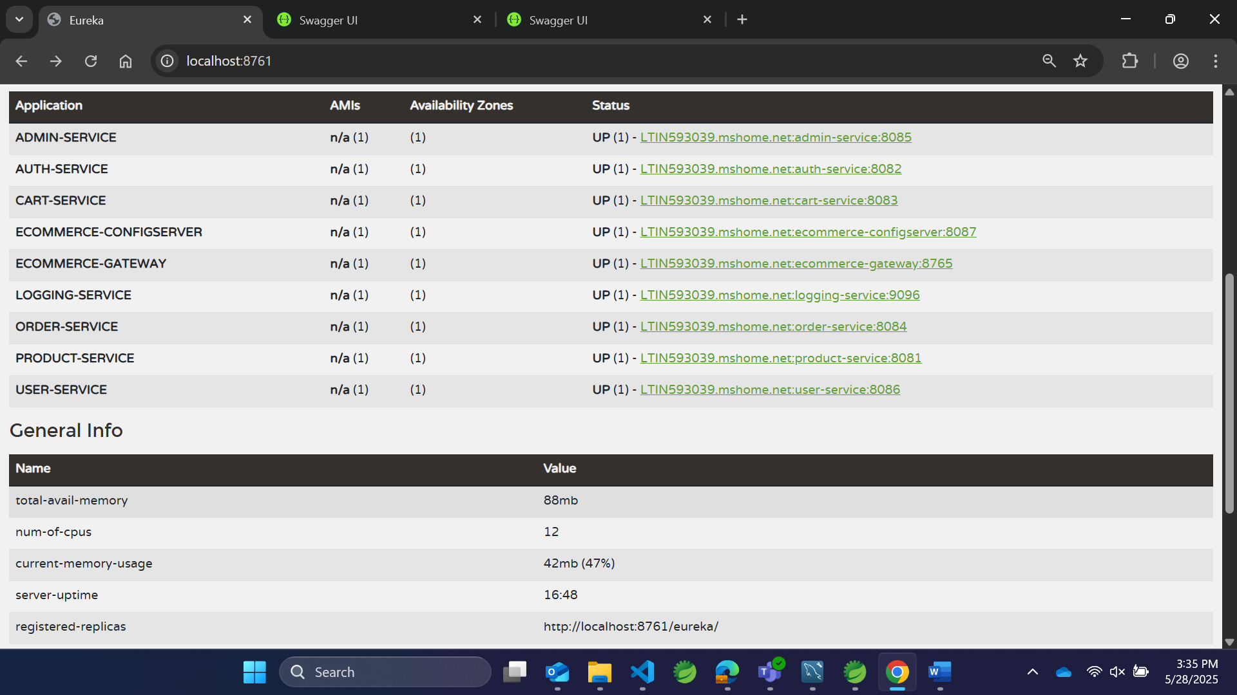

User Service with user functionality.
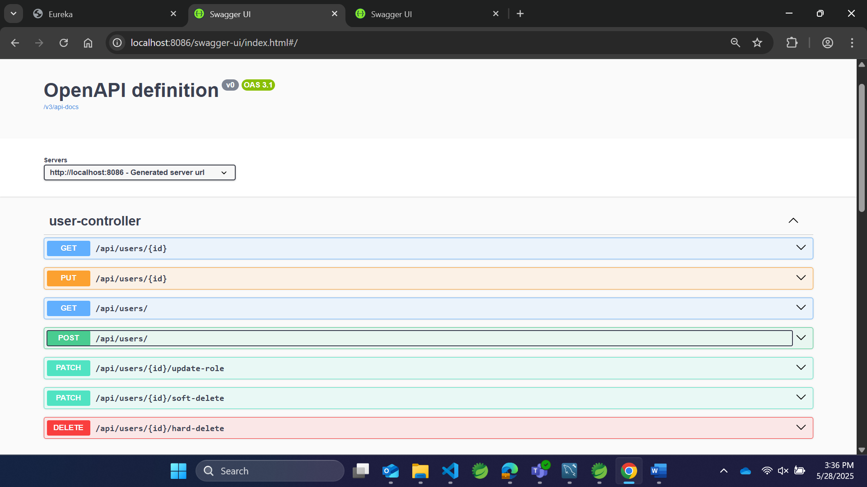
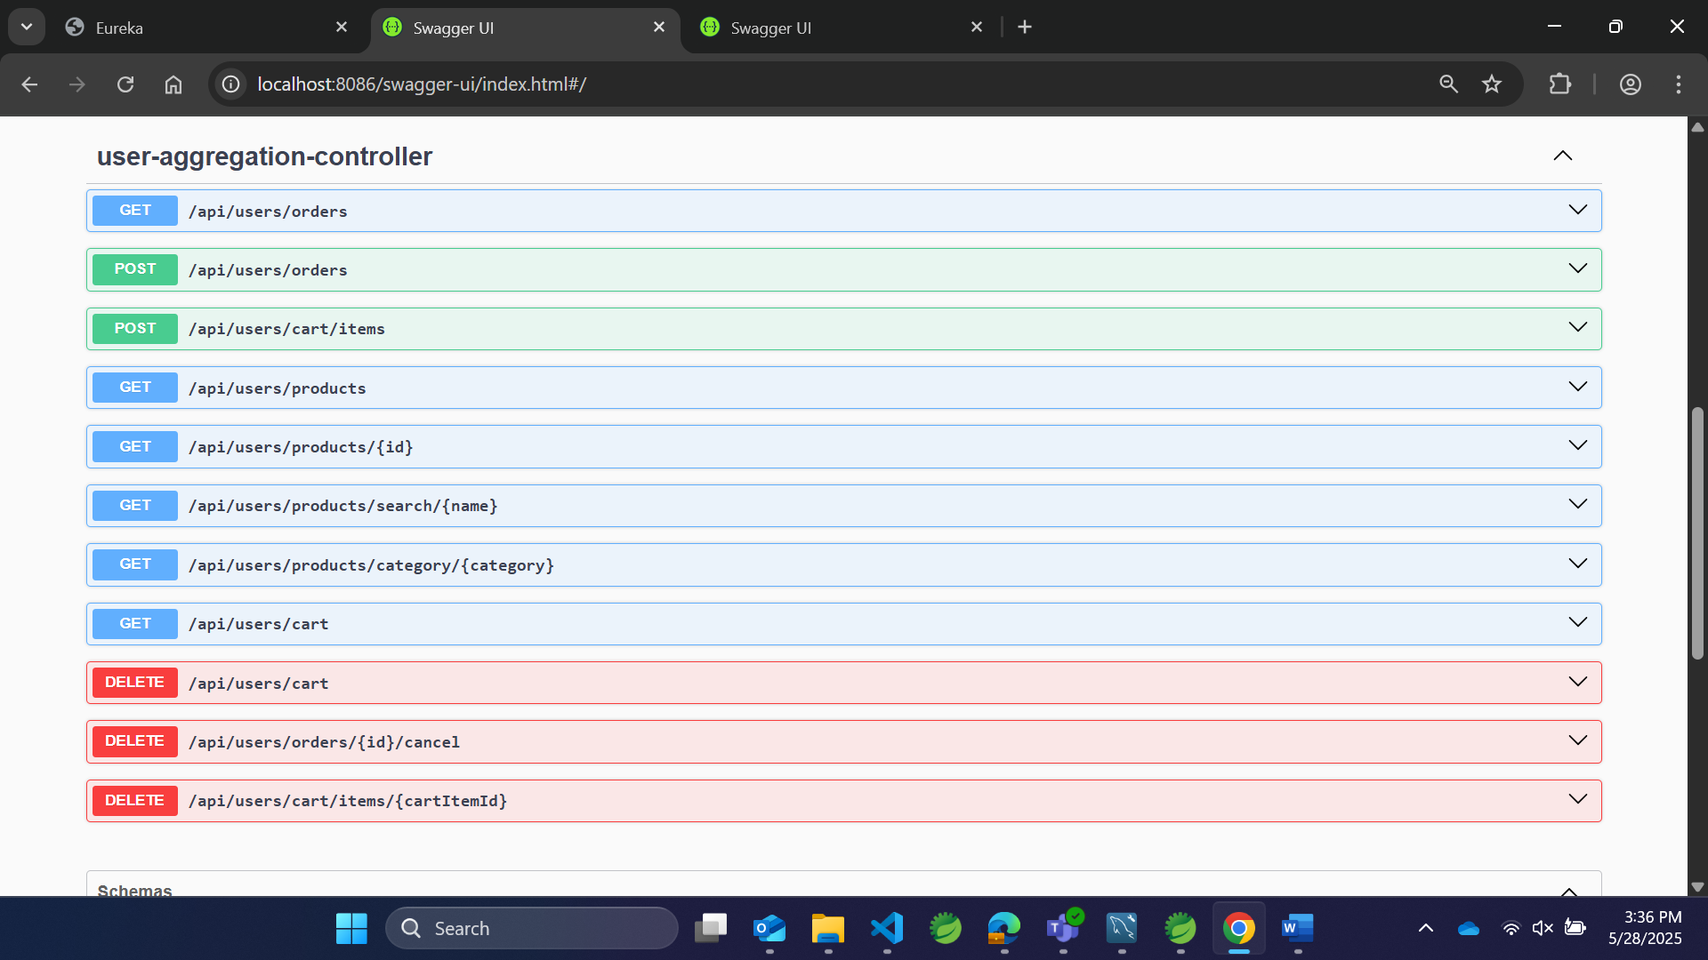

Admin With Admin Functionality.
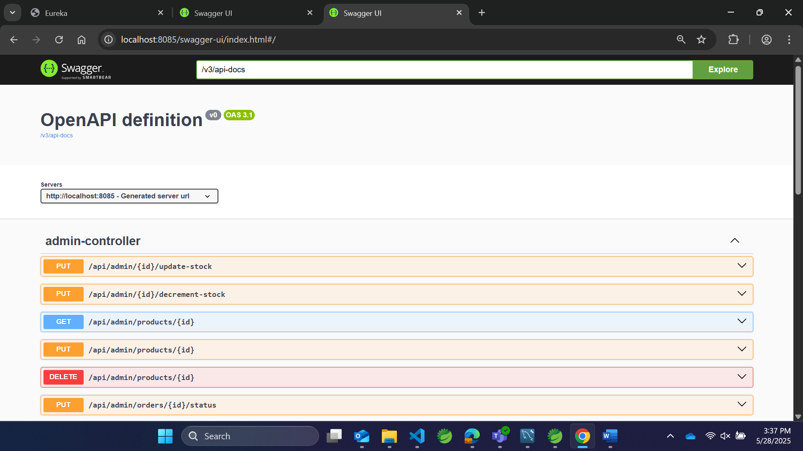
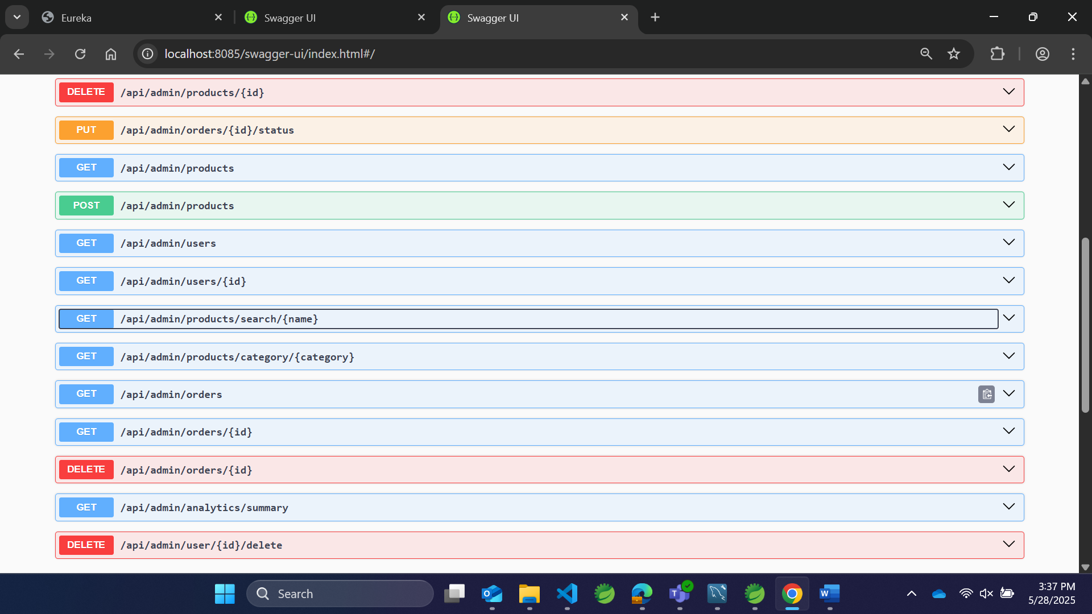

Security
Auth Service
Port no
8082
Admin
User
Admin-service
Port no: 8085
User-service
Port no: 8086
Project
Orders
Cart Item
Products
Users
Order-service
Port no: 8084
Cart-service
Port no: 8083
Product-service
Port no: 8081
Config
Service
Port no: 8071
Api gateway
Service
Port no :8761

