# To setup new directory

# git init

# git add .

# ren gitignore.txt .gitignore

# git commit -m "my commit"

# git remote add origin https://github.com/abhigad/TestGit1.git

# git push -u origin master

# GIT check

# git status

# git log

# git show

# 

To *stage* a file is simply to prepare it finely for a commit. Git, with its index allows you to commit only certain parts of the changes you've done since the last commit. Say you're working on two features - one is finished, and one still needs some work done. You'd like to make a commit and go home (5 o'clock, finally!) but wouldn't like to commit the parts of the second feature, which is not done yet. You stage the parts you know belong to the first feature, and commit. Now your commit is your project with the first feature done, while the second is still in work-in-progress in your working directory.

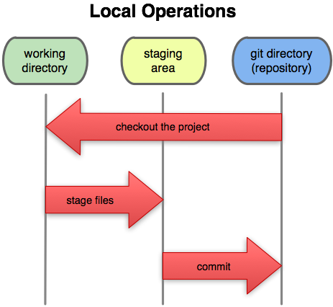

# [What does git push -u mean?](https://stackoverflow.com/questions/5561295/what-does-git-push-u-mean)

--to push changes to Master

git remote add origin https://github.com/abhigad/TestGit1.git

git push -u origin master

"Upstream" would refer to the main repo that other people will be pulling from, e.g. your GitHub repo. The -u option automatically sets that upstream for you, linking your repo to a central one. That way, in the future, Git "knows" where you want to push to and where you want to pull from, so you can use git pull or git push without arguments. A little bit down, [this article](http://mislav.uniqpath.com/2010/07/git-tips/) explains and demonstrates this concept.

# Setup new Branch in Git

git branch WIP --create branch WIP

git checkout WIP --Switch to branch WIP

git remote add WIP https://github.com/abhigad/TestGit1.git

git push -u WIP --push the branch

https://backlog.com/git-tutorial/branching/rebase-branch/

git push. The git push command is used to upload local repository content to a remote repository. Pushing is how you transfer commits from your local repository to a remote repo. It's the counterpart to git fetch , but whereas fetching imports commits to local branches, pushing exports commits to remote branches.

[git push origin master]

You are ready to push your first commit to the remote repository. The push here is for pushing your changes which requires a branch to push to call it origin and then specify the branch name master (the default branch that always exists on any repository.Jul 15, 2018

# To add a file to git

git status --to check the status of secondfilr

git add SecondFile.txt

git commit --only locally

git push

# Git Merge WIP to Dev

git checkout Dev

git merge WIP

# Pull n Push Changes Locally

git pull https://github.com/abhigad/TestGit1.git Dev

git push https://github.com/abhigad/TestGit1.git Dev

<https://blog.devmountain.com/git-vs-github-whats-the-difference/>

<https://www.w3docs.com/learn-git/git-add.html>

<https://mislav.net/2010/07/git-tips/>

<https://backlog.com/git-tutorial/branching/resolve-merge-conflict/>

<https://www.git-scm.com/docs/gittutorial/1.8.2>