Run, debug and deploy Nesi
Prepared By: AppCentrica

Solution overview
Check out/clone the appropriate branch of the Nesi application from source control.
- All documentation should be located in the Documents folder
- All binaries that are referenced by various projects are stored under Nesi.Bin. Some of these binaries may also be available through Nuget, so they should be removed and references should be re-added as package references instead.
- Each project is located in its own folder, with all solution files available in the root folder.
- There are four main executable/deployable projects:
  - Nesi.WebApi. Asp.Net Web Api, used by the angular component of the application
  - Nesi.SignalR. Asp.Net SignalR application.
  - Nesi.Web. Asp.Net web forms application. This is referred to as legacy code, implementation currently being replaced with the Angular component. Currently, they will run side-by-side.
  - The Angular side of the application, located in the “angular” folder.
- For non-angular deployment, open the Nesi.All solution. It contains the Web Api, Web forms and the SignalR applications, together with all dependent projects. The solution should build right out of source control, with no additional steps. If there are errors, please ensure all Nuget packages have downloaded correctly.

Debugging
In this document, we will not focus on how to debug the SignalR application; it is rarely debugged, and all subsequent techniques will also apply to it.
An important point to remember, is that the Angular application and the Web Forms application will not run unless they are in the same folder. This introduces certain limitations in how things can be set-up for debugging.

Debugging the Web Api
If you want to run and test the web api project in isolation, set it as start-up project, and press (Ctrl+) F5. The configuration settings that are loaded in this case, are those from the default web.config.
The api includes swagger support, which can be reached by navigating to /swagger. Please note that swagger can do much more than manual api invocation; it can be setup to do typescript proxy generation, automated testing, etc.
To execute an authorized operation, expand to it and click the red button on the top right. Enter your credentials and the page will reload. The button should change to blue. You can now make authorized calls directly from the page.
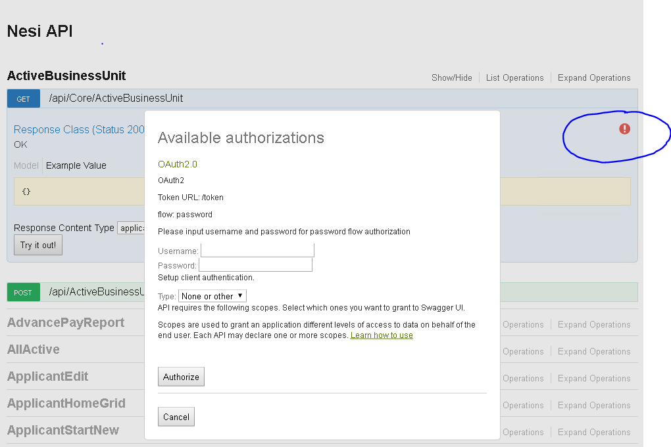
Additionally, you can grab a token by going to the bottom of the page to the Authorization Section, fill in the desired credentials and click Try it Out. You can copy the returned token and use it in applications like Postman to make direct, authorized, calls to the application.
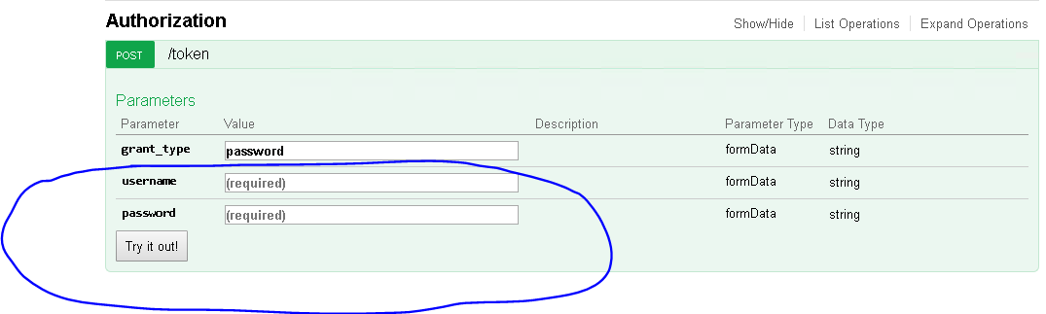

Deploying to IIS and attaching
Depending on what your needs are, you may deploy all or part of the solution to your local IIS instance and then debug as needed by attaching to the correct IIS process. By default, each project contains a publish profile called Local which you can use to deploy your projects to a standard location (If you get a publish error, make sure you start VS as Admin; it may be required that folders need to be created and that requires elevated privileges).
It is not recommended that you point your IIS website directly to your source code location. Instead, use the publish feature. This will properly build and transform your application before copying the files to the IIS folder. Currently, the settings used are those in the default web.config file.
To help with creation of websites, Application pools, bindings, etc. in local IIS, a script called CreateInitialWebsites.ps1 has been added to the PowershellScripts folder in the solution.
The created URLs are:
- http://nesi.hub.localhost/
- http://nesi.web.localhost/
- http://nesi.api.localhost/

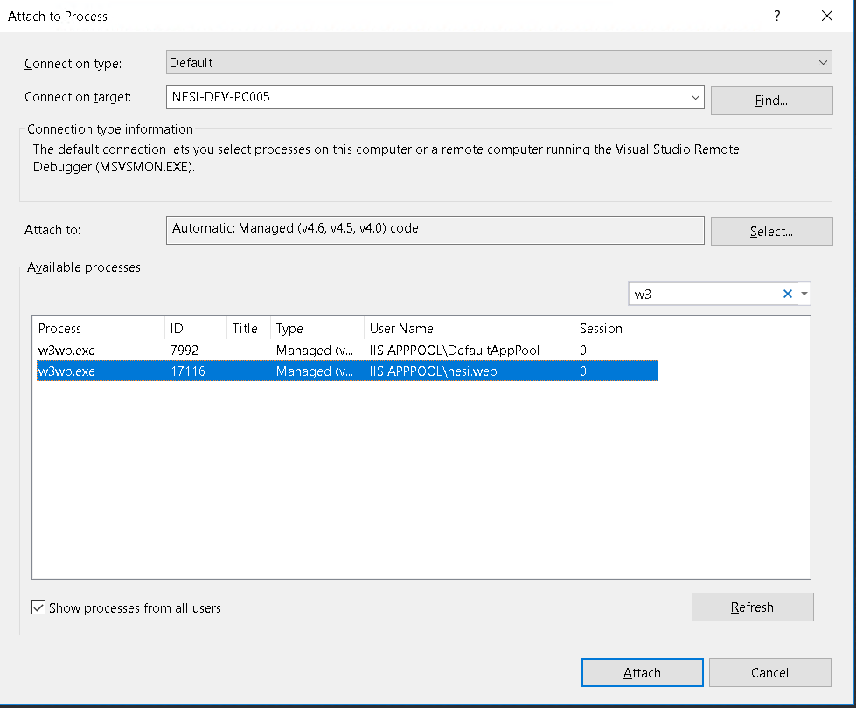
Figure 1: Attaching to website running locally
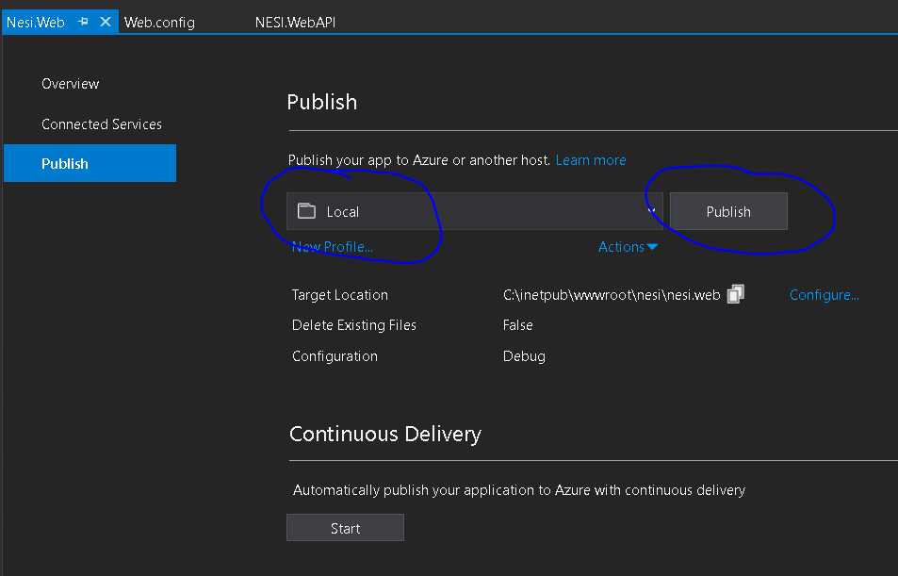
Figure 2: Deploying to IIS from Visual Studio

Debugging the angular component
Note that due to the current solution architecture, it is not possible to debug both the angular code and the legacy web forms at the same time.
In general, to debug the angular code, you will need to build it first (run the build.bat script) and run ng serve --port YOUR_PORT (or one of the available npm run YOUR_PROFILE commands from package.json). You have to make sure that this port matches the one specified in the application’s launch.json file.
To ensure that your running version of the angular component uses the desired version of the web api, you may need to modify the configuration.ts file.
We have added a default angular configuration, running on port 4600 that is out of the box bound to nesi.X.localhost services described above.
To start debugging the Angular component against these services:
- Run the npm run localiis (ng serve –port 4600 ) command,
- Change the launch.json port to 4600
- Press F5 to debug.

Deploying the Angular component
To deploy the angular component to the local IIS, build your project, then run the CopyToLocalIIS.bat script (you will need to open console window or IDE as Administrator). This will copy all the build output to the standard IIS location. This allows you to fully run the solution locally and attach to various components if required.
You can also run the copyFrontEnd.bat script. This will copy the angular build output side by side with the Web Forms component. This will allow local debugging of the Web Forms component (Not yet tested).

Summary

First time only
- Run the PowershellScripts/ CreateInitialWebsites.ps1 script

Debug Web Api
- In Nesi.All.sln, set the project as start-up and press F5
- Use the provided swagger page or a tool like Postman/Fiddler to make authorized calls

Deploy all to local IIS
- For each project in Nesi.All, right-click on project/Publish/ Local
- Build Angular (build.bat script in the Angular folder)
- Run CopyToLocalIIS.bat
- Attach as needed

Debug Angular
- Make sure all components in Nesi.All.sln deployed to IIS.
- Run npm run localiis
- Make sure port in .vscode/launch.json is set to 4600
- F5 to debug

