CSE5 ITP Application Development
Project Plan

Project Title: Waste Management – Bin Monitoring System

Table of Contents
1 Overview 3
1.1 Project Objectives 4
1.2 Project Constraints 4
1.3 Project Risks 4
2 Proposed Solution 5
2.1 Business Requirements 5
2.2 Architecture 6
2.3 Development 6
2.4 Testing 6
2.5 Deployment 8
3 Project Resources 8
3.1 Roles and Responsibilities 8
3.2 Issue Escalation 8
3.3 Project Staffing Plan 8
3.4 Project Materials 8
4 Project Approach 9
4.1 Development Model 9
4.2 Configuration Management 9
4.3 Communication Management 10
4.4 Change Management 10
4.5 Testing 10
4.6 Documentation 10
5 Estimate 11
6 Schedule 11

Overview
We have public services and waste management organisations that have been around for a long duration, they have not changed much in terms of the operation efficiency—until the last few years.
There are two innovative functions of smart waste management that have been developed recently: operational efficiency and waste reduction.

Need for project
Smart bins provide data for councils and businesses to maximise efficiencies and improve public health. They could also be one of the keys to building a smart city. The sanitation specialists must still physically go to the dumpster to check trash levels and thus reduces the efficiency and thereby increasing the cost.

Challenges

- The time duration to implement the system could prove to be challenging as learning phase for these technologies is steep.
- As mentioned earlier the learning phase for our team to adapt to this would be a healthy challenge. It requires us to learn technology and implement in short duration.
- Training for this project has been planned really well. We have subscribed to top-notch course on udemy and have guidance from technology experts.

Opportunities
Such an intelligent system provides various benefits to the society and the organizations.

- Both private and public waste management services can benefit from smart bins. For a small very small cost invested in a sensor technology, they can increase your operational efficiency.
- Clearly if implemented well this technology can reduce the cost for the organization in the long term. As it helps to make process efficient and thus reducing cost overheads.

Project Objectives
This section should specifically list project objectives. These are the criteria which will be used to measure project success. For example:

- Complete application implementation by the end of week 12 of the semester 2(year 2018).
- The application needs to display a map of the town council area (zoomable)
- Displays clusters of bins (and their percentage average capacity wherein zooming on clusters will show sub-clusters (and their percentage average capacity) and further zooming will show individual bins (and their percentage capacity)
- The system allows a group of users to set a threshold value for a bin capacity and the system notifies particular group of users when a bin has reached a certain level.

Project Constraints
The system has various constraints to be successful.
- Technologies used in developing the system have been identified to be Angular 6, NodeJS and MongoDB.
- The scope of the system is limited to a council level for initial release and have tendency to be expanded in later releases.
- Time frame to complete the project has been decided to be 12 weeks.

The hardware is beyond the scope of the project. It has been developed and the application needs to adapt to the data provided by it.

Project Risks
We have identified below possible risks that could affect the completion or the correct implementation of the project

- Time frame: The major challenge for this project is to complete it within the given duration of 12 weeks.

- Risk Probability -- We have estimated occurring of exceeding the time frame to be very unlikely.
- Risk Impact -- The impact would be significant as it will lead to an unfinished project.
- Risk Mitigation -- There has been continuous project progress check placed to keep track of the progress. Every week we organise a progress meeting and try to over some things which are slowing the progress.

Proposed Solution

Business Requirements
To gather requirements and understanding then clearly we have proposed various effective ways such as evaluating existing process, Interview with clients and studying already existing similar system.

- Interview with the client:
There was a meeting session organised with the client where we have chance to understand the expectations of the clients. The discussion led to understand requirements clearly and gave our team opportunity to ask questions.

2. Studying already developed similar application:
We have identified various system which are similar to the project being developed by us. The idea was to understand how systems have been implemented and try to learn positives and the negatives of such systems. This helped us to avoid certain pitfall and also motivated us to improve already existing systems.
The detailed study has been mentioned in the Research document for this project.

User Interface (UI) requirements
User Interface of the application requires to have a Map displayed on the application where in the user can see the status of bins. Also, zooming and out would change how the information is being displayed.
UI provides easy navigation for the user to switch between various councils and move to different setting of the system.

Define specific technology requirements
The system needs to be developed for web platform. The client has mentioned the technologies they require the project to be developed in.
The frontend of the application is being developed in Angular 6 with designing done in bootstrap. Bootstrap provides beautiful css styles which significantly reduces development time of the application.
The backend system will be developed in node Js while accessing and saving data to MongoDB database.

Architecture
The following diagram clearly explains how the whole stack comes into play to support the functionalities of the system.
The client being the frontend of our system.

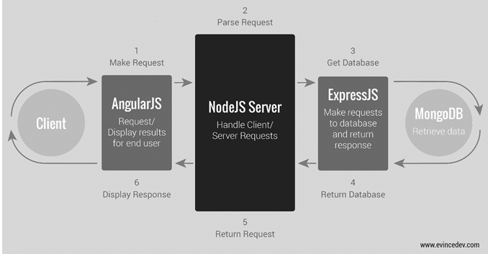

Mockup Designs
Dashboard of the application:

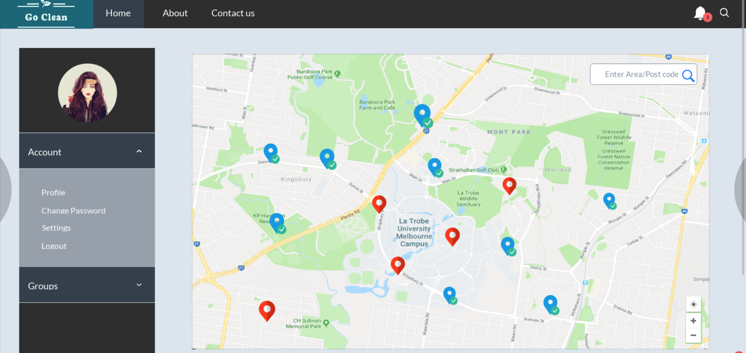

Login screen of the screen:

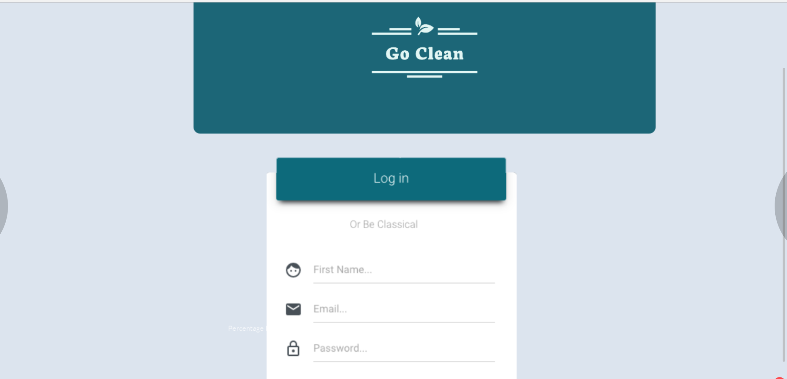

Functional Specifications
Functional specifications include details regarding how the application will interface with, for example, legacy applications, provide database models and describe the relationships between the different data entities, and detail how each component of the application interacts with every other component. (Need to be discussed)

Technical Specifications
Technical specifications might include the following:

- Platform specifications: Application is being developed for web platfrom with responsive design so that it could adapt to various hardwares in the market.
- Development languages: Javascript, HTML, TypeScript.

Development
The development of the application has been divided in various sprints/phases. The tasks for each phase has been clearly identified.

- Phase 1: Design mockup website and generate UML diagram.
- Phase 2: During phase 2 we would develop a front end using bootstrap which allows to incorporate beautiful css themes into the development and then integrate leaflet component to it.
- Phase 3: Develop node js api to support calls from the front end.
- phase 4: Connect frontend to the backend while implementing the functional requirements of the application.
- Phase 5: Testing and improvement.

Testing
For testing the flow/system of the website. We will have peer reviews sessions in which each team member will review the work of other team member. If the reviewer feels that something needs to be improved or some part is functioning properly. It will be addressed by the respective team member who has worked on that part. Post making the improvement, there would be another session that would take place with the reviewer in which he would test the system again. These sessions will keep happening until or unless the reviewer does not show a green flag to the developer.

For tracking this, we will create the respective (Peer review) tasks in the trello that would be assigned to the person who would review it and gives his remark on the testing.

Project Resources

Roles and Responsibilities

We are a team of three who worked on the various aspects of the website. Those areas include the front end and the back end of the whole system. Abhishek Gupta and Ravi Rathore have worked on the front end of the website which can also be called (the skeleton of the website) which include building up the whole layout of the website, different components, user interface, and navigations using the following technologies:
- Angular 6
- Java-script
- HTML
- CSS

The backend or the brain of the website was after looked after by Jatin Mittal which include providing the data to the front-end users through various APIs, makes the database connection, authentication of the user, makes sure the validation of the various fields, adding the admin users to the database, giving latest data of each bin, Sending response to the requestors. Below technologies were used for carrying out these responsibilities.
- Node.js
- Firebase
- Express.
- Restful API

In addition, responsibilities were not only limited to that. Each member has used the trello board extensively for making the user stories on which one has worked throughout the semester. This has helped us in gauging how much work which needs to be done and in tracking where are we standing on the progress side. Moreover, Team’s responsibility was to push the work that they worked on in the bit bucket so that if one needs to check or review the other’s work, it could have been done easily.

Each team member had taken the ownership of the piece on which he has worked on, in case anybody had needed help then a meeting was arranged for discussing the issues and finding out the resolution for it. Although if the team was not able to address that issue, project manager was approached via e-mail for the completing the needful.

Issue Escalation

The general idea of how we as a team went for the escalation of the issues was by making the hierarchical structure of Reaching the respective person. The issues were solved at the personal level first, if the issues do not get resolved at the personal level then the other team members were involved for removing the issues. If in case the issues cannot be resolved at the team level, then the team had communicated to the project manager about the issues and asked for her expertise in resolving the issue.
So, there was a hierarchical structure which we have followed in terms of escalating the issues.

PERSONAL LEVEL → TEAM LEVEL → MANAGER LEVEL→ CLIENT LEVEL.

Project Staffing Plan

Our staffing plan of the project details that there are three resources that worked on building up the whole project. Each of the software development phase was looked after by the respective team member on which he had worked. We have sliced down the work for each team member. Each member had worked on different technologies and on the areas, which were divided among us. The technologies and areas of work were divided based on the knowledge that one already had.

Abhishek and Ravi were working on handling the front end of the project which would require the skills needed for making the skeleton of the website. Both team members had some prior experience and knowledge working on the front side which have helped the team in making a good progress in the front side without investing too much time in learning. On the other hand, Jatin had some prior experience working on mainly in the back-end areas. This approach of splitting the work had helped the team working more efficiently and beautifully.

Project Materials

There would not be any hardware material, physical network infrastructure and peripherals that were required to the team in terms of the development of the project. We had used open source free software’s that do not demand any kind of licensing and subscription.

Though we did need the mocked-up data from the client so that we could use that in displaying the information of the bins on the maps.

Project Approach

Development Model

As far as development model was concerned, we had planned to work according to the Agile methodology which is more efficient and effective as compared to other development models.
Agile provides multiple opportunities for stakeholder and team engagement – before, during, and after each Sprint. By involving the client in every step of the project, there is a high degree of collaboration between the client and project team, providing more opportunities for the team to truly understand the client’s vision.

Moreover, While the team needs to stay focused on delivering an agreed-to subset of the product’s features during each iteration, there is an opportunity to constantly refine and reprioritize the overall product backlog. New or changed backlog items can be planned for the next iteration, providing the opportunity to introduce changes within a few weeks.

Agile is a powerful tool for software development, not only providing benefits to the development team, but also providing several important business benefits to the client. This process has helped in making a good progress in terms of prioritizing and completing the project on time.

Configuration Management
N/A

Communication Management

The medium of communication between the team members and the project manager was done by using Slack and trello which are very well known, professional tools for professional conversation. Trello gave
Us the visual overview of what was being worked on. Moreover, it’s an open source free tool. The real time update was amazingly fast. On one page, we had the opportunity see all our items.
Creating the issues and assigning it to the team members were easy and gave us the functionality of drag and drop to the different phases of the development.

On the other hand, Slack was a medium where all the team member can talk at one place. The beautiful feature of slack was that it can be integrated with our trello board which is project organization tool.so we can directly refer to our stories while talking on the slack. Slack made it really simple to share the files quickly within the entire team and also has Dropbox integration for more in depth file access.

In addition, slack gave us the functionality of sharing the code snippets which was a great feature that had help us increasing our productivity by leaps and bounds.

Change Management
N/A

Testing
For testing the flow/system of the website. We have had peer review sessions in which each team member had review the work of other team member. If the reviewer feels that something needs to be improved or some part is functioning properly. It was addressed by the respective team member who has worked on that part. Post making the improvement, there had been another session that took place with the reviewer in which he had test the system again. These sessions had been happening until or unless the reviewer does not show a green flag to the developer.

There have been various testing sessions that have happened with the team in which the team has tested end to end functionality of the website. There were lot of issues that we found out during the testing like notifications, UI changes and bin latest data. We have managed to ensure that our website runs free of bugs. There have been unit testing and system testing that was done to ensure the robustness of the website.
For tracking this, we had created the respective (Peer review) tasks in the trello that were assigned to the person who had reviewed it and gave his remark on the testing.

Documentation

As far as documentation in concerned, we as a team are going with the approach of documenting the whole website features/functionality in the form of modules. This approach gives a clear picture how the website and different functions are being operating on a system level.

Various modules throughout the website are:

- User Login
- User Sign up
- Dashboard
- User profile
- Notifications
- Groups
- statistics
- Map Search

User Login:

This is the very first page of the website which shows the information of login the user in the system. The login form has two fields followed by the login button and sign up button. The two fields are email id and password which would be entered in the fields. The user will be logged in the system if the id and password match in the database. If it does not match, then the system will ask the user again to enter the email id and password.

User signup:

The other module which is there on the login page is sign up. If the user is new and want to be a part of the system, then the user can enter the asked details in the various fields and can sign up for the system. The data that would be asked to enter in the fields are name, email id and password. As far as robustness is concerned, if the user in any case enters an email which is in incorrect format then the application would not crash rather it would ask the user to enter the correct email again.

Dashboard:

The main focus area of the website is the map where all the bin data will be shown to the user. Data will be shown in three colors according to the bin level. If the bin level is less than 24 then the bins will appear red on the map, if the bin level is greater than 24 then the bins will appear orange on the map. Likewise, they will be seen green if the level is greater than 50. Maps can be zoomed in and zoomed out. While zooming out, the overall analysis for one area will be shown with the details of the average of the bin area. There is a search bar on the map which is used to filter the bin data according to the location.

User Profile:

User profile consists of the various fields that include the further details of the user. These details would be personal details of the users. These details include Address, City, country, middle name, postal code, user name and so on. These details can be stored once the user is logged in the system. Moreover, these details will be updated in the database for that particular user who is logged in into the system at that point of time.

Notifications:

Notifications are in the header of the website which has a drop-down functionality of showing the notifications to the user. The notifications will give us the details of which bin id is filled and the percentage filled of the bin. Moreover, if the user selects one notification, the background area would turn grey so as to tell the user that it has been read. In addition to that, the status of the notification message would turn to read in the database. Additionally, if the notifications are not read, they will continue to pop up in the notification label with the number of the notifications which are unread.

Groups:

Groups is a part of navigation bar which give us the details of the list of users who can be notified about the bin. There is an edit button which can be clicked to select the list of users for saving the users to the notification group which is created in the database. Those saved users will get the notifications in the form of email and notification bar on the website. The detail will consist of the bin information about the level of space left in the bin and hardware id of the bin.

Statistics:

Statistics is also a part of the navbar/ side bar which gives us the information of average bin level left according to the days of the week which are further divided by the different colors. This analysis is being done is to give an overall idea to the user about the trend of the garbage which gets filled in a week in different locations. There is one more pie chart which is there that gives us the information of the bin data there for each location area for which we are storing the data in the database.

Map Search:

Map Search is a search bar which is located right above the map on the right-hand side of the website. Search bar is used to search the bin data to be displayed on the map according to the location which will be selected by the user. Suppose if a user selects only one location for instance (Preston), so the bin data for that location will be shown on the map. This is how user can search according to a location or have data shown on map for each location using the select all locations.

Estimate
N/A

Schedule
The project schedule can be completed only after all project tasks have been defined and prioritized. The schedule is one of the last components of a project plan to be completed.

