AI ASSISTANT CODING
ASSIGNMENT 8.1
P. ABHIGNA
2303A54069
BATCH:- 48
TASK 1 (Password Strength Validator – Apply AI in Security Context):
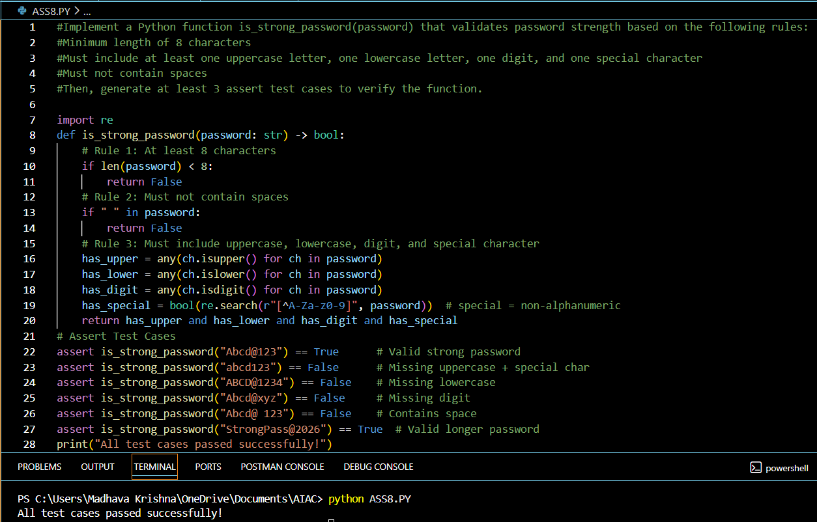

Explanation:
This function checks if a password is strong. It must be at least 8 characters long, contain uppercase and lowercase letters, a number, and a special character, and it should not have spaces.

USING DOCSTRING:
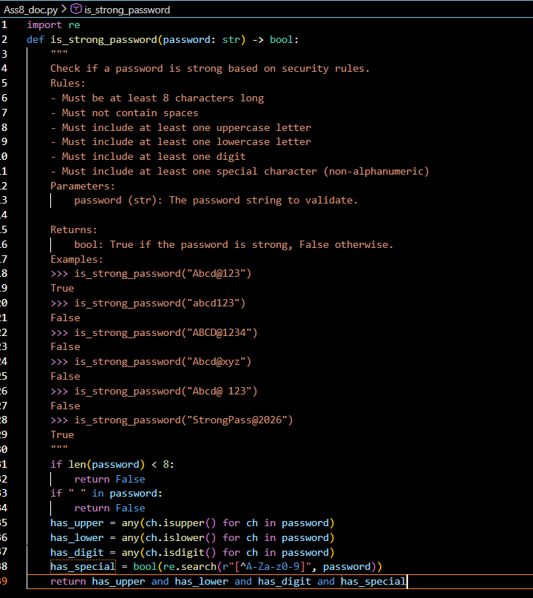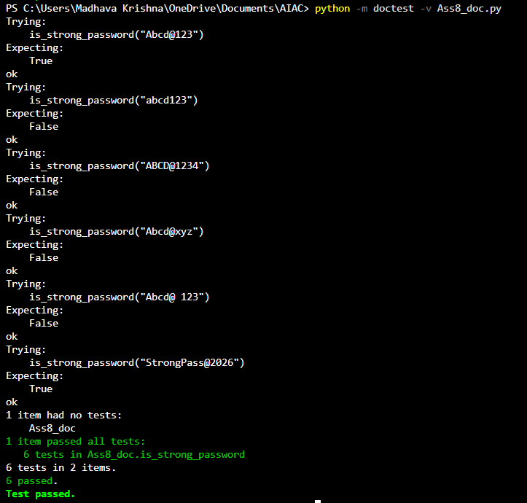

TASK 2 (Number Classification with Loops – Apply AI for Edge Case Handling):
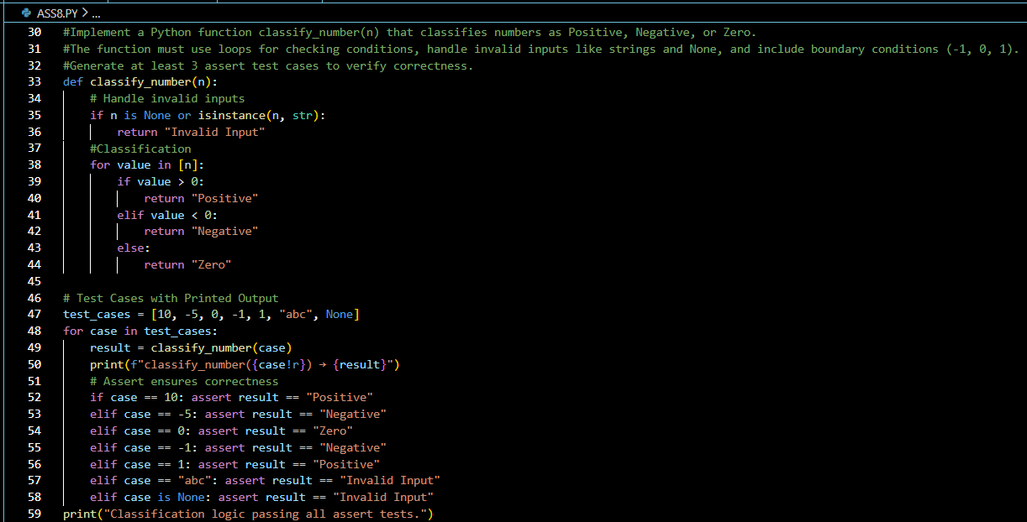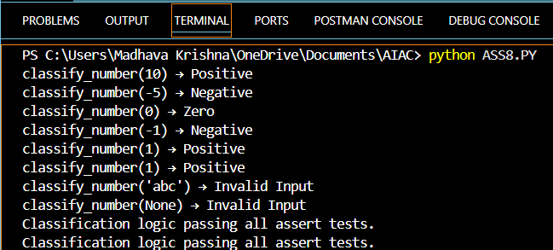

Explanation:
This function classifies a number as Positive, Negative, or Zero. It also handles invalid inputs like strings or None. Loops are used to check conditions step by step.

USING DOCSTRING:
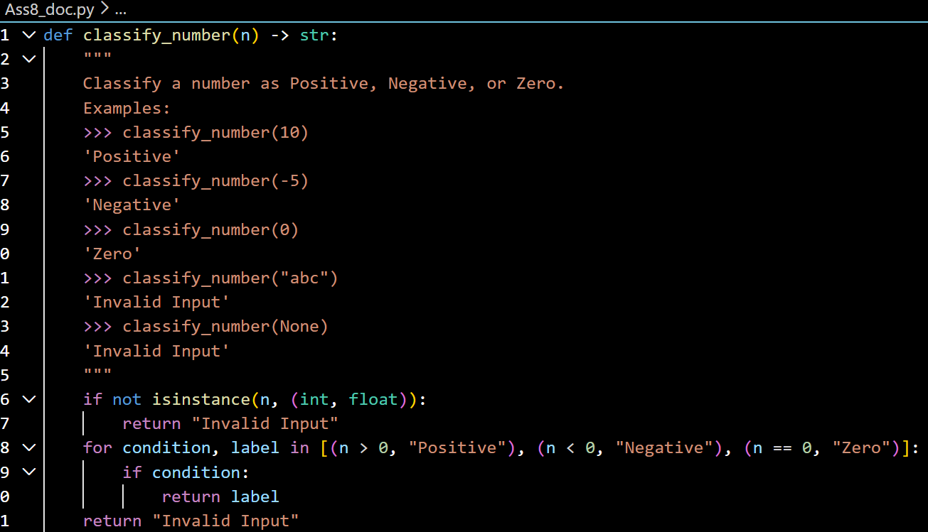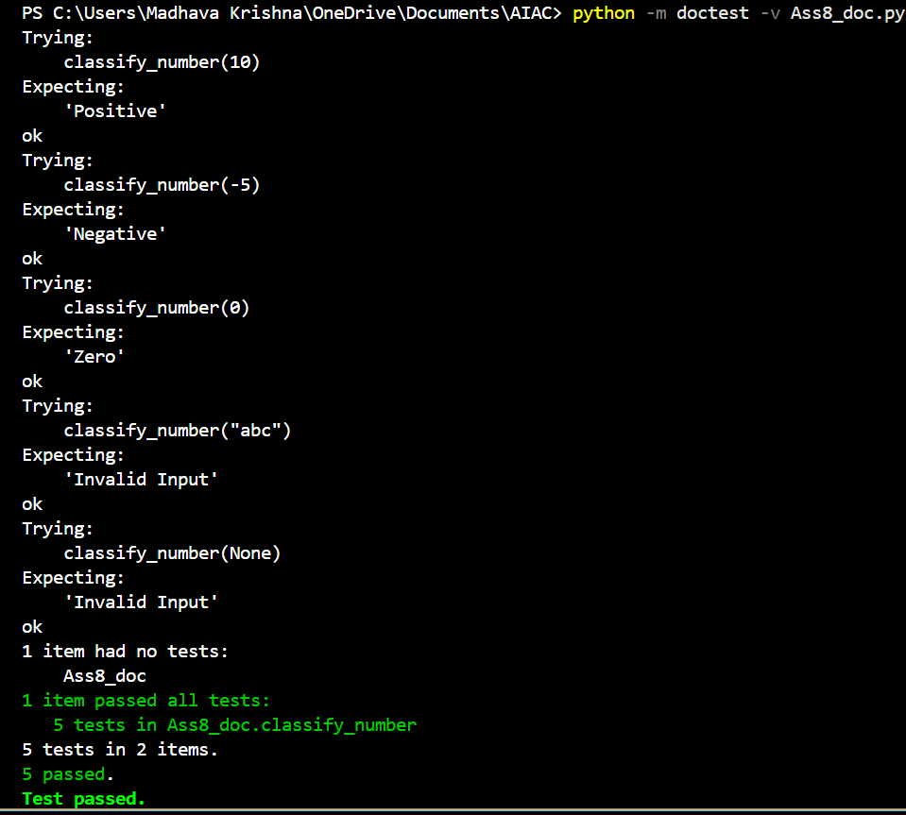

TASK 3 (Anagram Checker – Apply AI for String Analysis):

PROMPT:
# Implement a Python function is_anagram(str1, str2) that checks if two strings are anagrams.
# Requirements:
# - Ignore case, spaces, and punctuation
# - Handle edge cases (empty strings, identical words)
# Then, generate at least 3 assert test cases to verify the function.
assert is_anagram("listen", "silent") == True # anagram
assert is_anagram("hello", "world") == False # not an anagram
assert is_anagram("Dormitory", "Dirty Room") == True # phrase anagram
assert is_anagram("", "") == True # empty strings
assert is_anagram("School master", "The classroom") == True # multi-word anagram
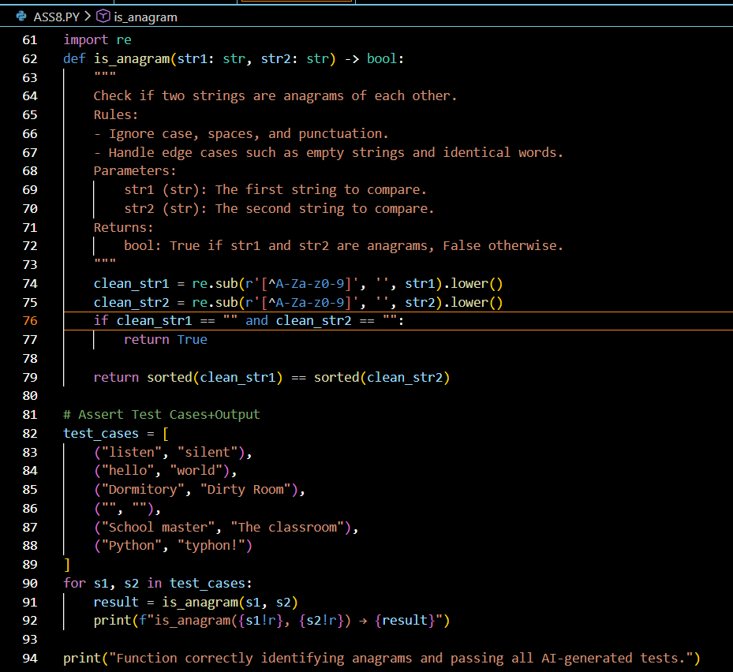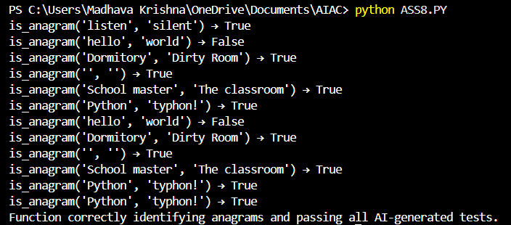
Explanation:
This function classifies a number as Positive, Negative, or Zero. It also handles invalid inputs like strings or None. Loops are used to check conditions step by step.

USING DOCSTRING:
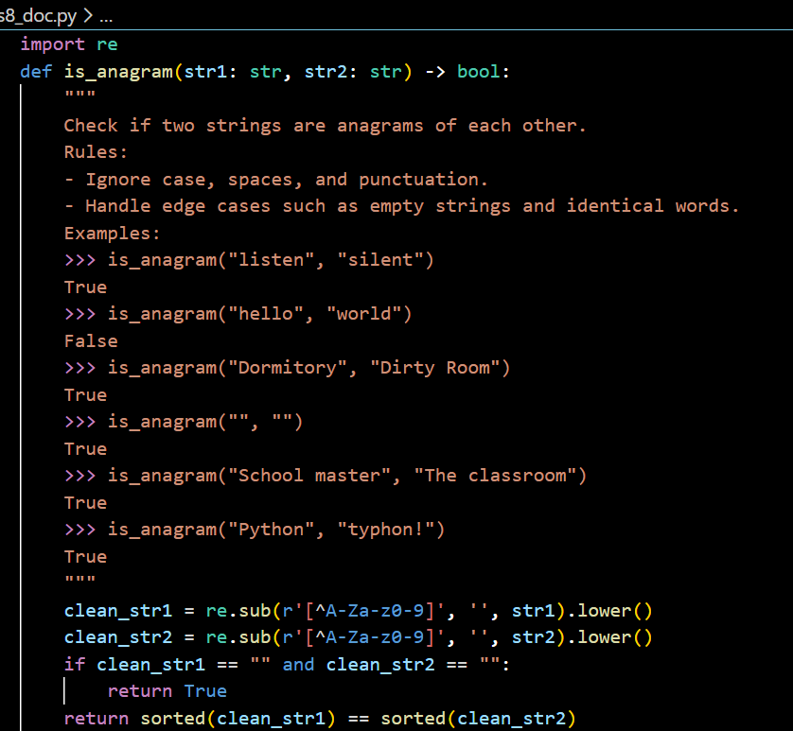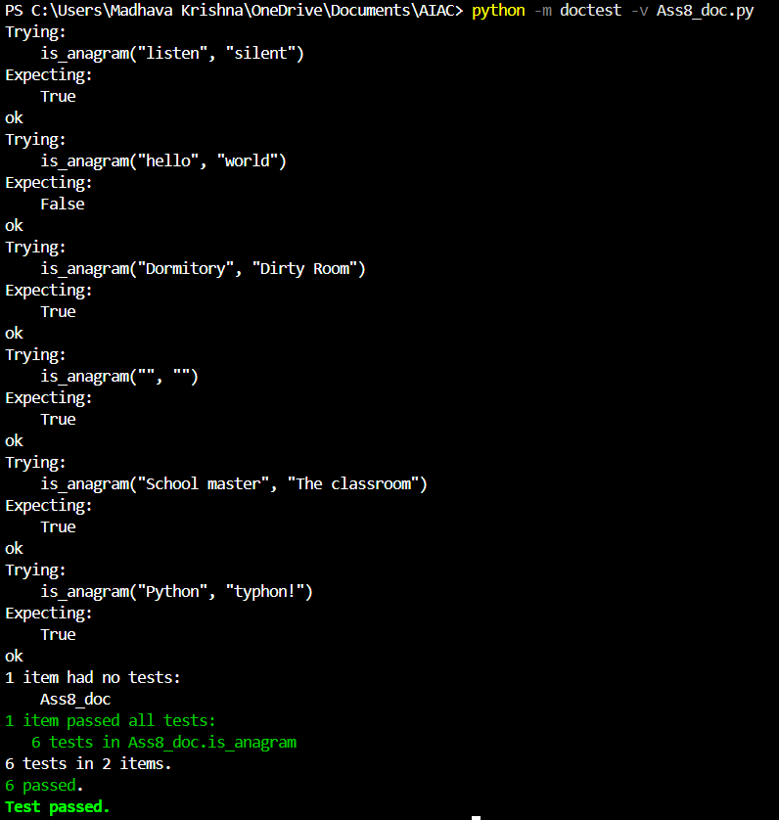

TASK 4 Inventory Class – Apply AI to Simulate Real-World Inventory System):

PROMPT:
# Implement a Python class Inventory with methods:
# - add_item(name, quantity)
# - remove_item(name, quantity)
# - get_stock(name)
# Requirements:
# - Manage stock levels
# - Prevent negative stock
# - Return 0 if item does not exist
# Then, generate at least 3 assert test cases to verify the class functionality.
inv = Inventory()
inv.add_item("Pen", 10)
assert inv.get_stock("Pen") == 10
inv.remove_item("Pen", 5)
assert inv.get_stock("Pen") == 5
inv.add_item("Book", 3)
assert inv.get_stock("Book") == 3
inv.remove_item("Book", 10)
assert inv.get_stock("Book") == 0
print("All test cases passed successfully!")
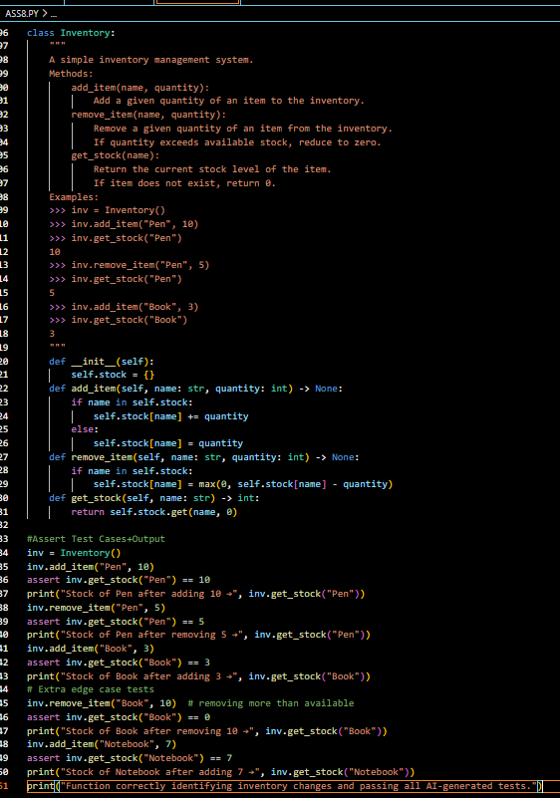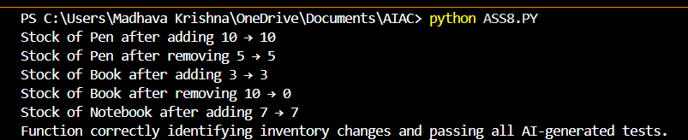
Explanation:
This class simulates a simple inventory system. You can add items, remove items, and check stock. It ensures stock doesn’t go below zero and returns 0 if an item doesn’t exist.

USING DOCSTRING:
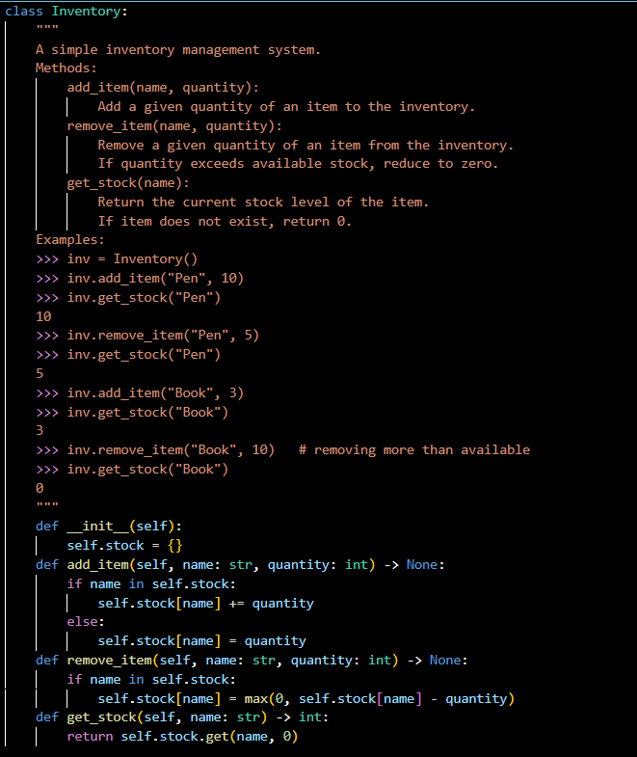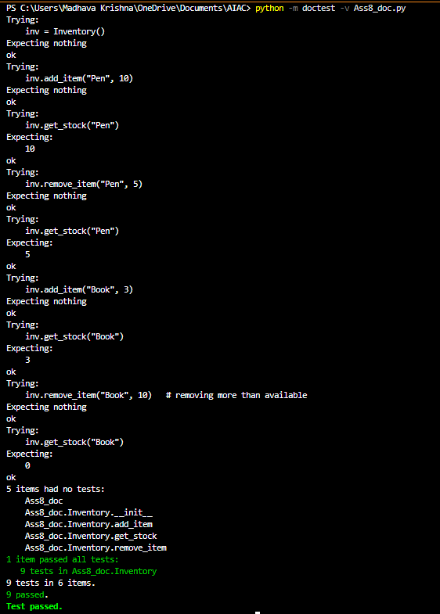

TASK 5 (Date Validation & Formatting – Apply AI for Data Validation):

PROMPT:
# Implement a Python function validate_and_format_date(date_str) that validates and formats dates.
# Requirements:
# - Input must be in "MM/DD/YYYY" format
# - Handle invalid dates
# - Convert valid dates to "YYYY-MM-DD"
# Then, generate at least 3 assert test cases to verify the function.
assert validate_and_format_date("10/15/2023") == "2023-10-15"
assert validate_and_format_date("02/30/2023") == "Invalid Date"
assert validate_and_format_date("01/01/2024") == "2024-01-01"
assert validate_and_format_date("13/01/2023") == "Invalid Date"
assert validate_and_format_date("12/31/2025") == "2025-12-31"
print("All test cases passed successfully!")
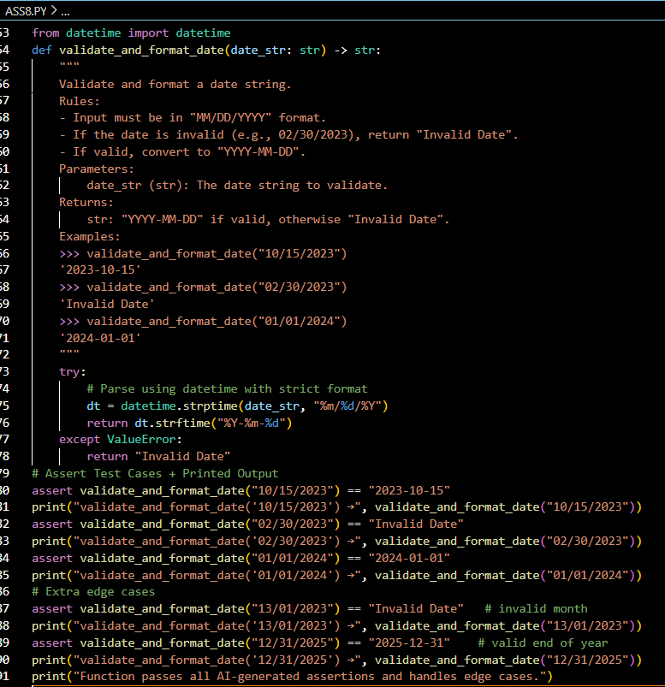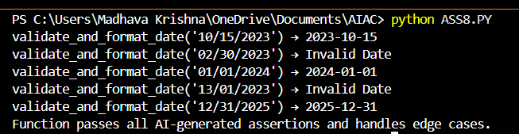
Explanation:
This function validates dates in the format MM/DD/YYYY. If the date is valid, it converts it to YYYY-MM-DD. If invalid (like 02/30/2023), it returns “Invalid Date.”

USING DOCSTRING:
