AI ASSISTANT CODING
ASSIGNMENT-6.3
TASK 1: Classes (Student Class)
PROMPT

Create a Python program that defines a Student class with the following requirements:

- Attributes: name, roll_number, and branch

- A constructor (init) to initialize these attributes

- A method display_details() that prints the student information in a readable format After defining the class:
- Create at least one Student object

- Call the display_details() method to show the output

CODE:
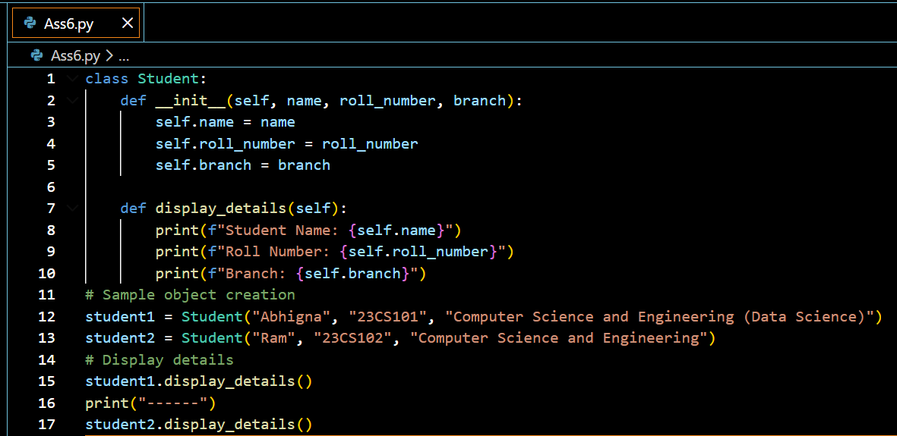

OUTPUT:

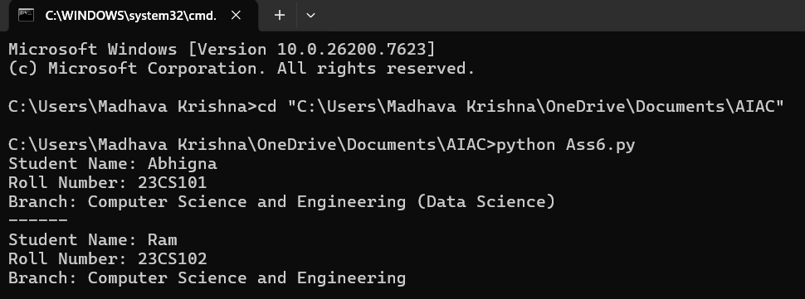

EXPLANATION:

A class Student is defined to represent student data.constructor initializes name, roll_number, and branch.display_details() prints student information in a readable format.An object student1 is created and the method is called to display
details.Demonstrates basic OOP concepts: class, object, constructor, and method.

TASK 2 : Loops (Multiples of a Number)
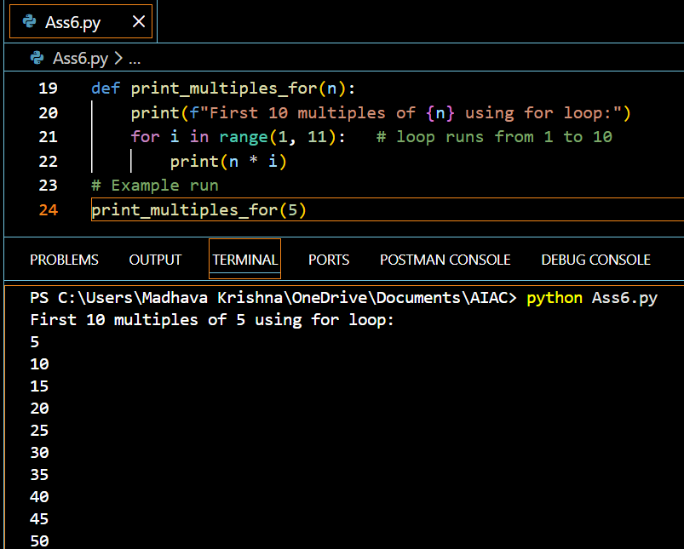
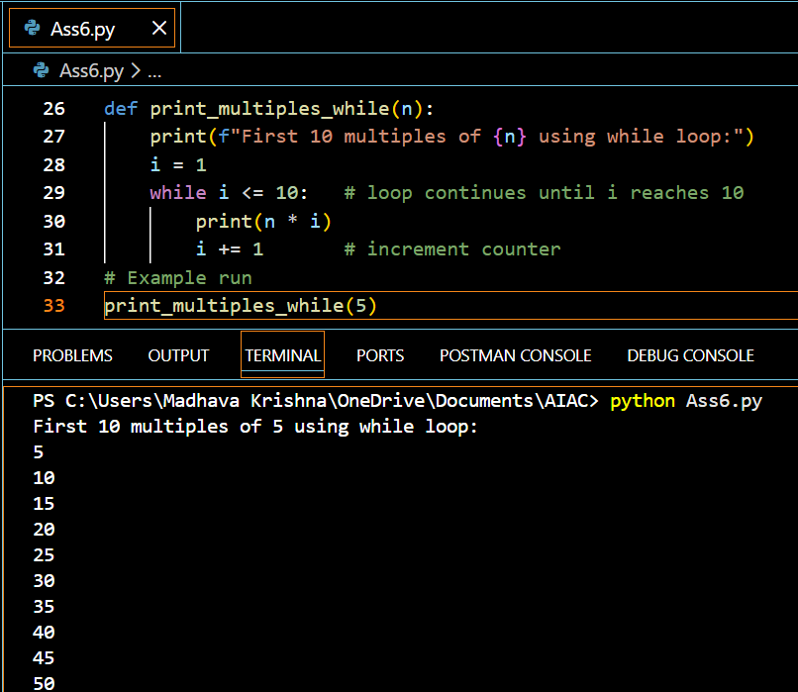
EXPLANATION
Two functions generate the first 10 multiples of a given number.for loop uses range(1, 11) to repeat exactly 10 times.while loop runs until the condition i <= 10 becomes false.Both loops multiply the number with the loop counter.Shows how the same logic can be implemented using different loops.
TASK 3: Conditional Statements (Age Classification)
CODE:
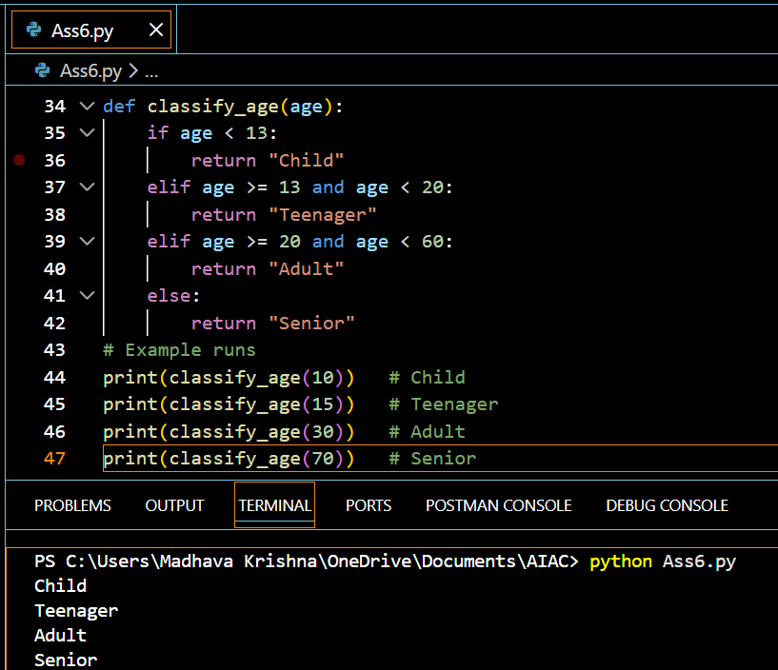
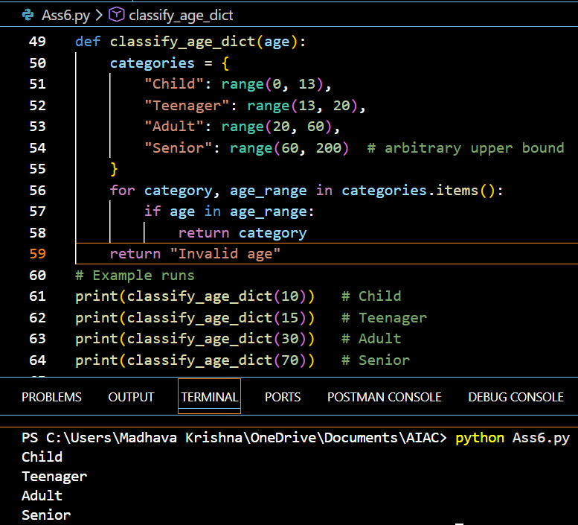

EXPLANATION:
classify_age_nested() uses if-elif-else to group age logically.Conditions are checked from smallest to largest age range.HANDLE invalid age (negative values).classify_age_alternative() uses ranges stored in a dictionary.Demonstrates conditional logic and an alternative clean approach.
TASK-4: For and While Loops (Sum of First n Numbers)

CODE:

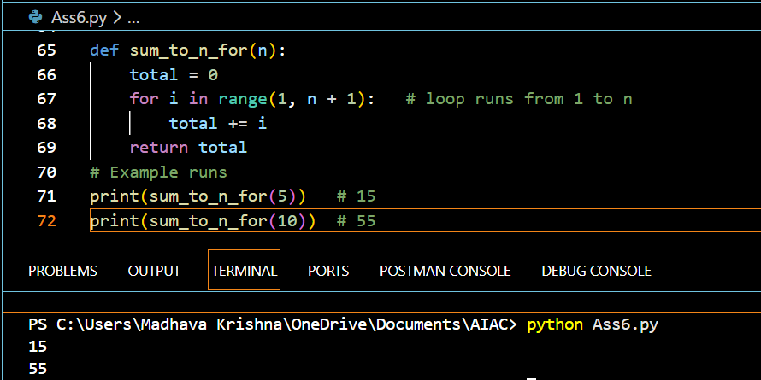

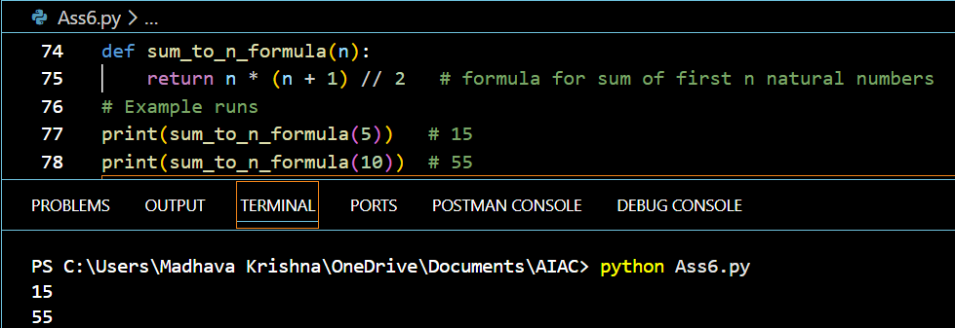

EXPLANATION

for loop adds numbers from 1 to n step by step.while loop does the same using a condition-controlled loop.Formula method uses n(n+1)/2 for direct calculation.Formula is the most efficient (O(1)), loops are O(n).Shows comparison between iterative and mathematical solutions.

TASK-5: Classes (Bank Account Class)

CODE:
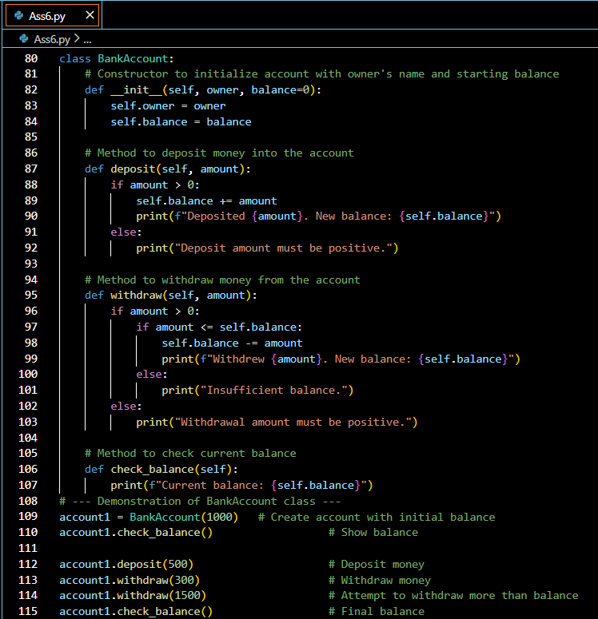

OUTPUT:

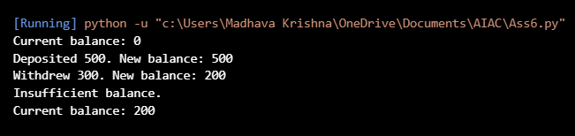

EXPLANATION:
Represents a real-world bank account using a class.Stores account_holder_name and balance as attributes.deposit() adds money after validating positive amount.withdraw() checks for sufficient balance before deduction.Demonstrates encapsulation, validation, and method usage.

