AI Assisted Coding
P. ABHIGNA
2303A54069
B-48
Lab 2:
Exploring Additional AI Coding Tools beyond Copilot – Gemini (Colab) and Cursor AI

Task 1: Statistical Summary for Survey Data
PROMPT:- Python code that reads a list of numbers and calculates the mean, minimum, and maximum values short with explanation.
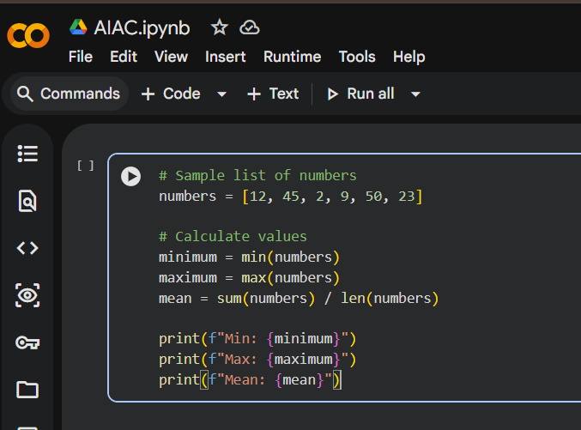
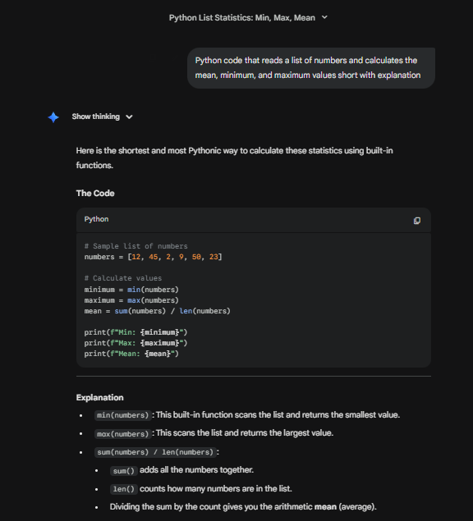

Task 2: Armstrong Number – AI Comparison
PROMPT:- Python code which checks whether the number is Armstrong number or not give short code with explanation.
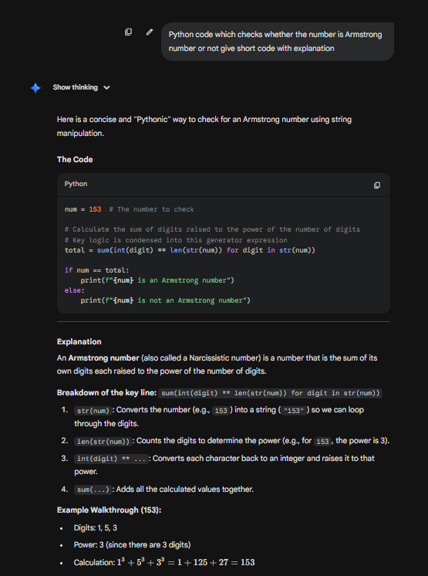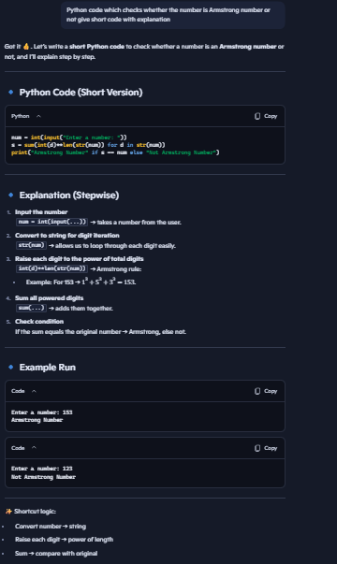
Feature | Gemini |  |  | Copilot
Digit Loop | Goes through digits one by one directly |  |  | Makes a list of digits first, then goes through them
Sum | Adds numbers directly while looping |  |  | Adds numbers after making the list
If Check | Uses normal if ... else with two lines |  |  | Uses short one-line if ... else
Style | Looks short and stylish |  |  | Looks clear and step-by-step
Clarity | Good for quick logic |  |  | Easier for students to learn

Task 3: Leap Year Validation Using Cursor AI
PROMPT1:- Write a Python program to check if a year is a leap year
PROMPT2:- Give me a short Python code with explanation to check leap year
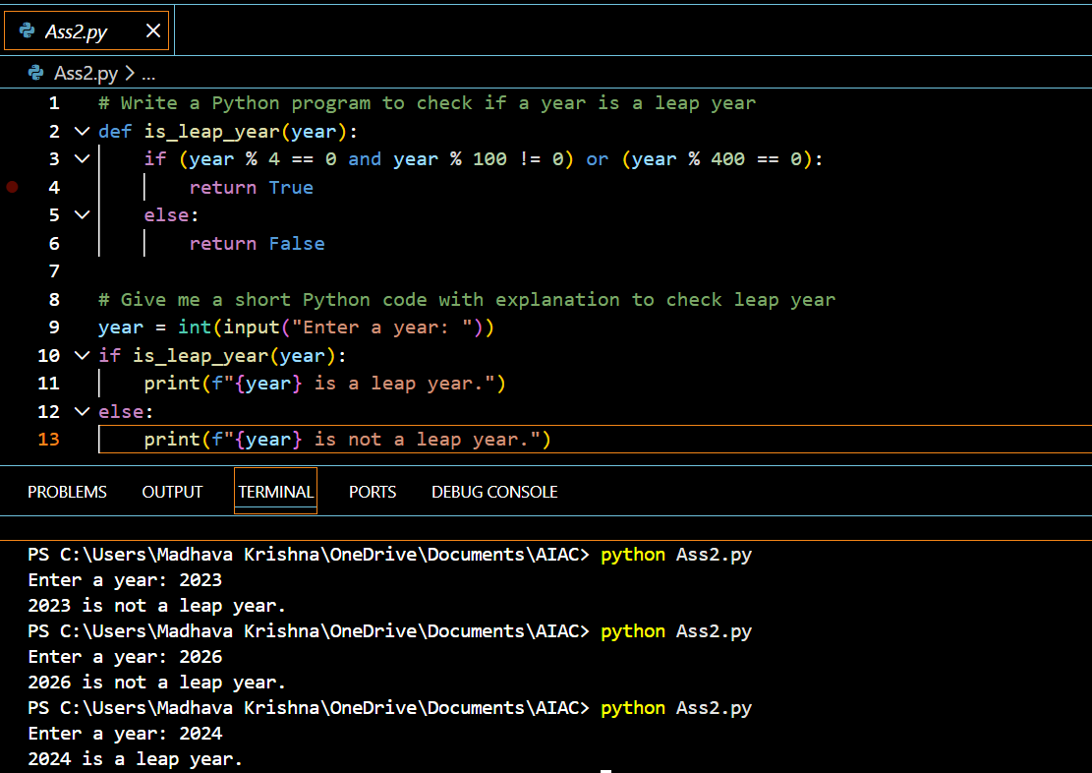
Explanation:-
- Divide by 4 rule
If a year divides evenly by 4 → it might be a leap year. Example: 2024 ÷ 4 = 506 → possible leap year.
- Divide by 100 rule
If a year divides evenly by 100 → it is not a leap year (skip). Example: 1900 ÷ 100 = 19 → not leap year.
- Divide by 400 rule (special case)
If a year divides evenly by 400 → it is a leap year. Example: 2000 ÷ 400 = 5 → leap year.
 | First Code | Second Code
Readability | Easier for beginners | Slightly harder for beginners
Length | More lines | Fewer lines
Style | Traditional if...else | Short form code
Best for | Learning, exams | Quick coding, professionals

Task 4: Student Logic + AI Refactoring (Odd/Even Sum)
PROMPT:- Short code to sum even and odd numbers from a tuple with explanation
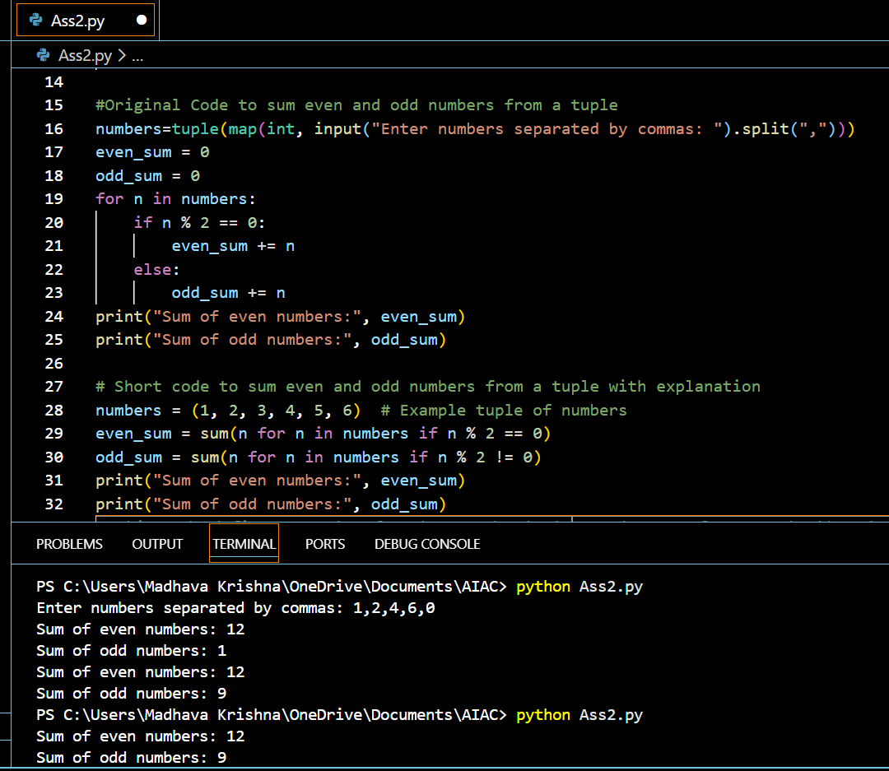
Original Code | Refactored Code | Improvement
8+ lines | 4 lines | Shorter, compact
Step-by-step | Clean one-liners | Easier to read
Manual loop | Built-in sum() | Faster
Basic Python | Clean Python style | Professional

