AI Assisted Coding
Assignment- 4.1
P. Abhigna
2303A54069
Batch- 48

Problem Statement 1- Customer Email Classification
Tasks
- Prepare five short sample emails, each belonging to one of the above categories.
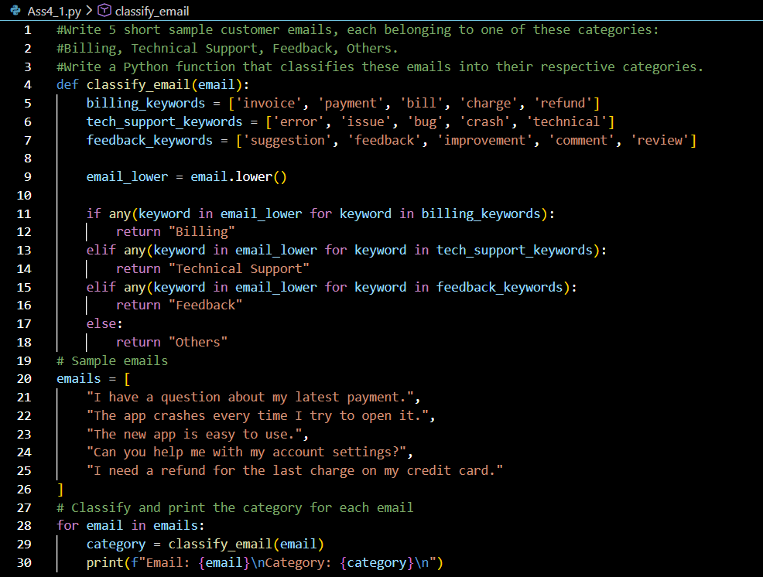
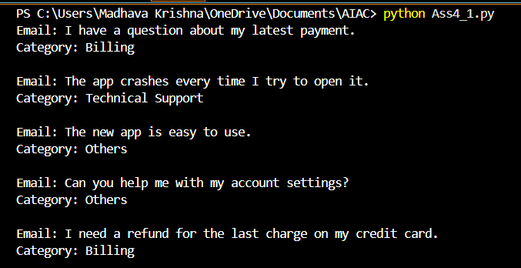
- Write a zero-shot prompt to classify a given email into one of the categories without providing any examples.
- Write a one-shot prompt by including one labeled email example and ask the model to classify a new email.
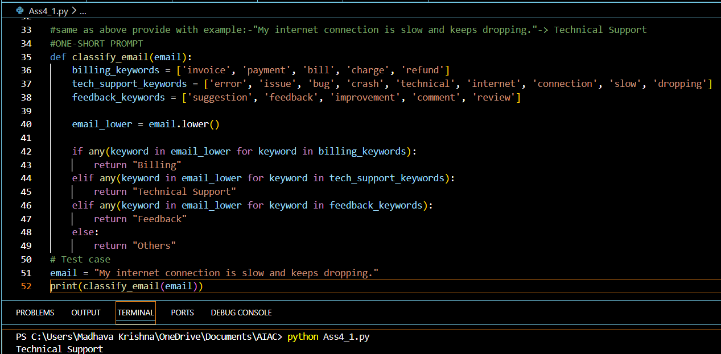
- Write a few-shot prompt by including two or three labelled email examples and ask the model to classify a new email.
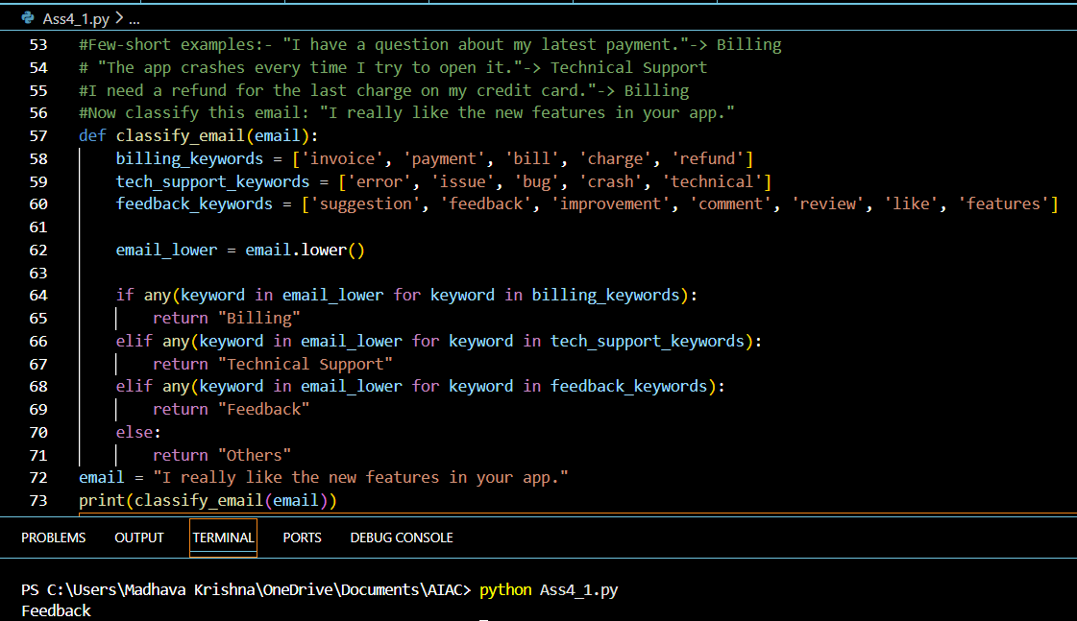
- Compare the outputs obtained using zero-shot, one-shot, and few-shot prompting techniques and briefly comment on their effectiveness
Technique | Test Email Example | Output | Why It Works / Fails
Zero-Shot | “I have a question about my latest payment.” | Billing | The model directly matches “payment” with billing keywords. Works, but may misclassify if wording is unusual.
One-Shot | “My internet connections is slow and keeps dropping.” | Technical Support | A single example reinforces the technical error theme, guiding the model to classify correctly. Limited if only one example is given.
Few-Shot | “I really like the new features in your app.” | Feedback | Multiple examples anchor the categories (Billing, Support, Feedback, Others), so the model learns distinctions and avoids overgeneralization. Most consistent and accurate.

- Zero-shot → Quick, but depends only on training knowledge; can be inconsistent.
- One-shot → More reliable, since one example sets the context.
- Few-shot → Most effective, because multiple examples teach the model the exact rules and categories, giving consistent and accurate results.

Problem Statement 2- Intent Classification for Chatbot Queries
Tasks
- Prepare Sample Data Create 6 short chatbot user queries, each mapped to one of the four intents.
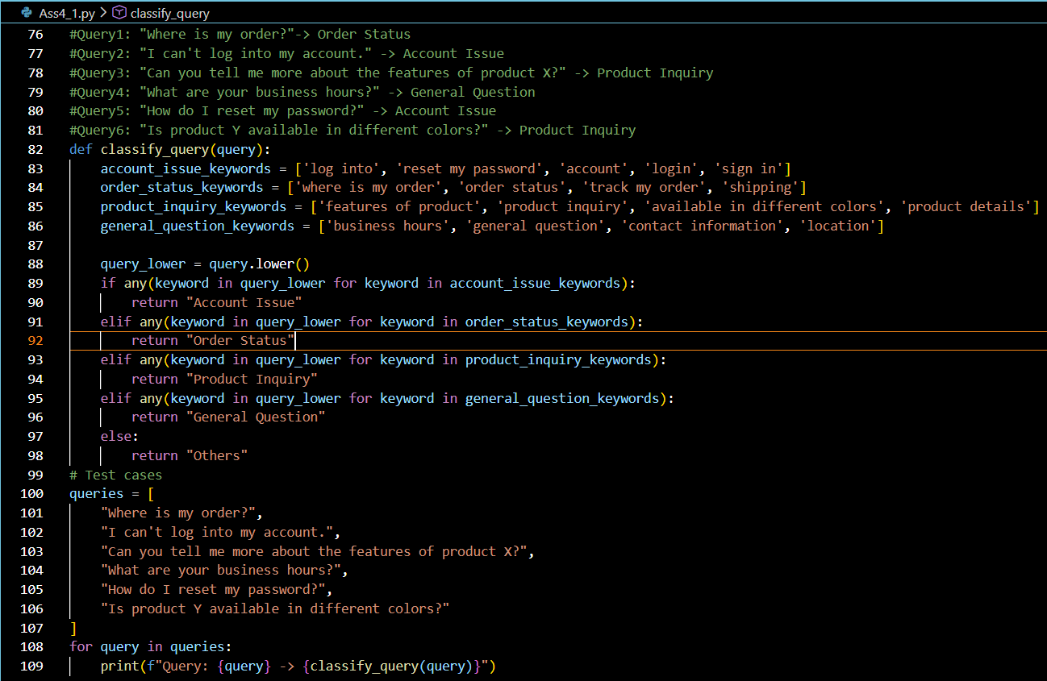
- Zero-shot Prompting-
Design a prompt that asks the LLM to classify a user query into the given intent categories without examples.
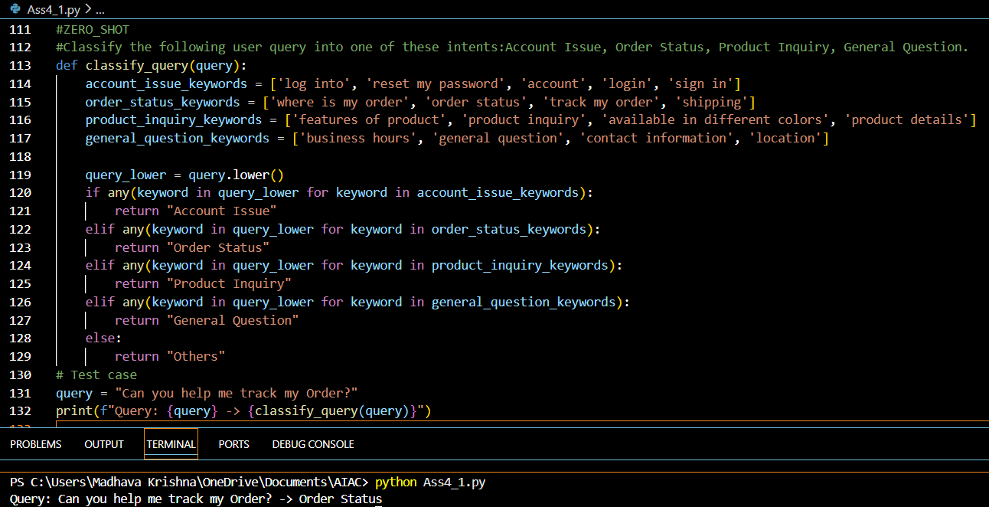
3. One-shot Prompting-
Provide one labeled query in the prompt before classifying a new query.
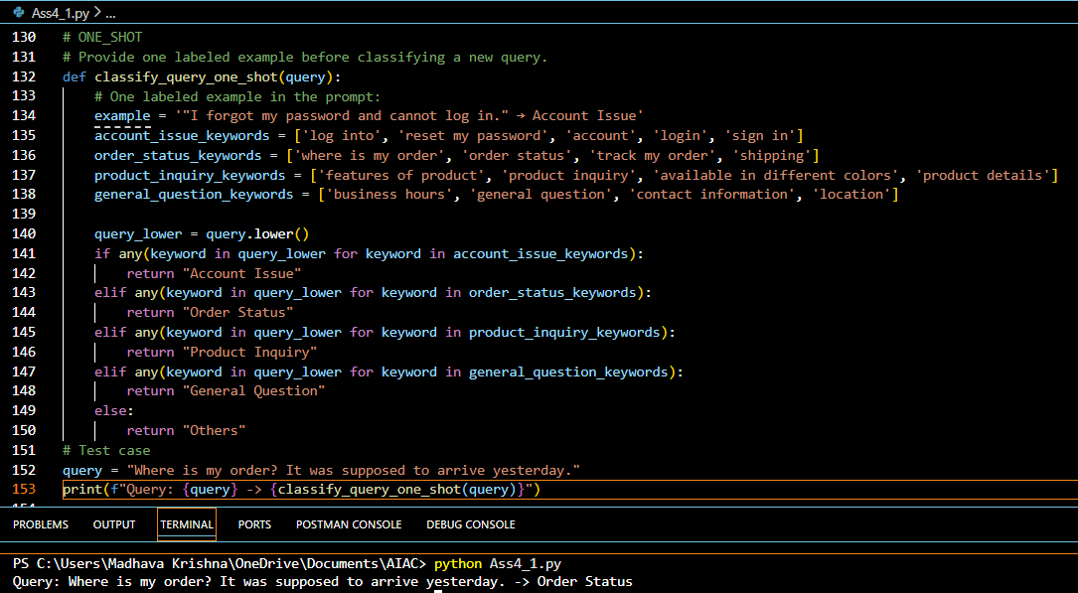
4. Few-shot Prompting-
Include 3–5 labeled intent examples to guide the LLM before classifying a new query.
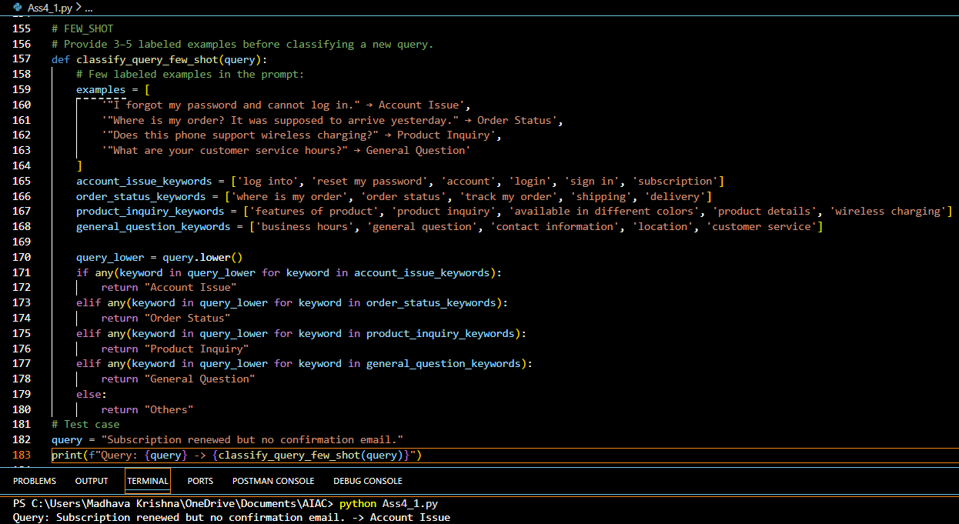
5. Evaluation
Apply all three techniques to the same set of test queries and document differences in performance.
Technique | Test Query Example | Output | Performance Notes
Zero-Shot | “Can you help me track my Order?” | Order Status | Works because “track my order” matches keywords. But if query wording is unusual (e.g., “Where’s my package?”), it may fail.
One-Shot | “Where is my order? It was supposed to arrive yesterday.” | Order Status | Correctly classified. The single example sets context, but accuracy depends heavily on that one example.
Few-Shot | “Subscription renewed but no confirmation email.” | Account Issue | Correctly classified. Multiple examples anchor categories, so the model learns distinctions and avoids misclassification. Most consistent.

Problem Statement 3- Student Feedback Analysis
- Write a Zero-shot prompt to classify feedback sentiment.
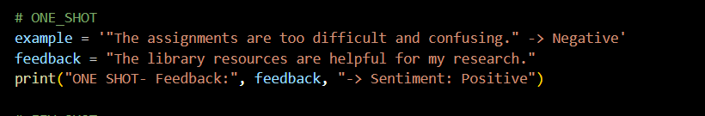
- Provide a One-shot prompt with one feedback example.
- Create a Few-shot prompt using multiple labeled feedback samples.
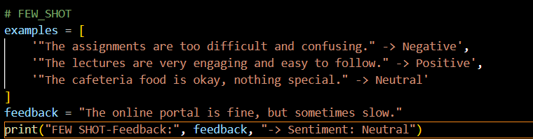
OUTPUT:
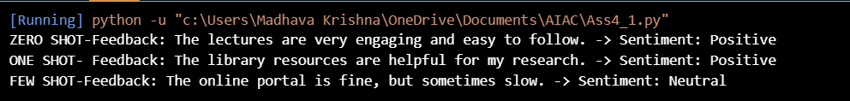
- Explain how examples improve sentiment classification accuracy.
Examples improve accuracy because they provide context, demonstrate the classification style, and help the model
generalize better to varied feedback. Few-shot prompting is the most effective technique, ensuring consistent and reliable sentiment analysis.

Problem -Statement 4- Course Recommendation System
a) Write a Zero-shot prompt to classify learner queries.
b) Create a One-shot prompt with one example query.
c) Develop a Few-shot prompt with multiple labeled queries.
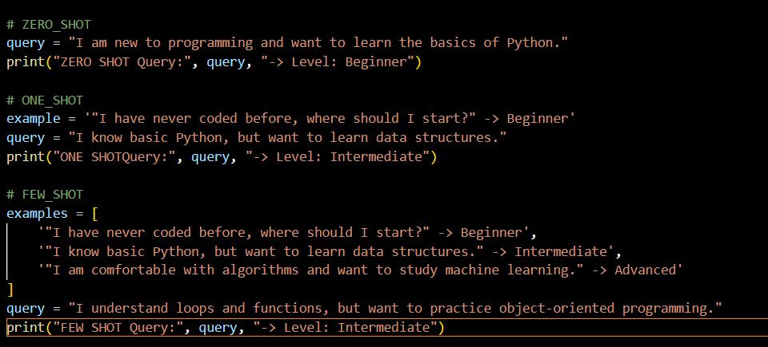
OUTPUT:
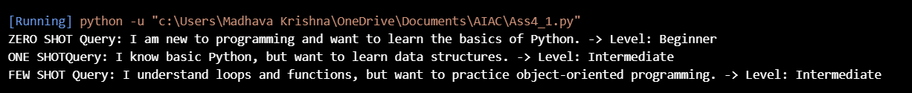

Problem Statement 5- Social Media Post Moderation
a) Write a Zero-shot prompt for post moderation.
b) Convert it into a One-shot prompt.
c) Design a Few-shot prompt using multiple examples.
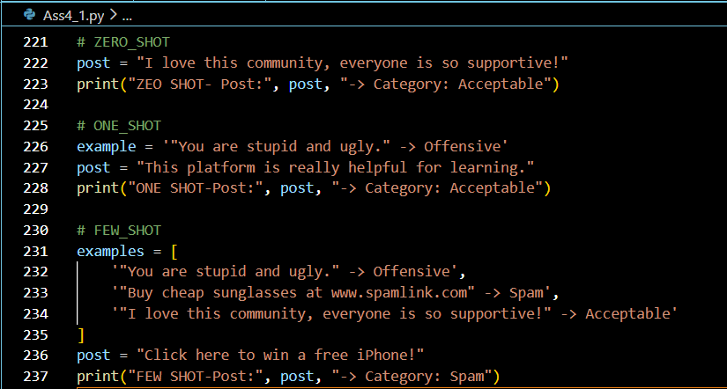
OUTPUT:
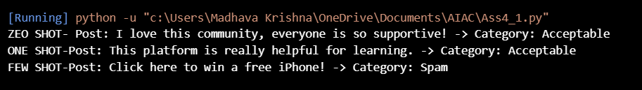
- Explain the challenges of Zero-shot prompting in content moderation.
Technique | Example Post | Output | Notes
Zero-Shot | “I love this community, everyone is so supportive!” | Acceptable | Works because the wording is clearly positive.
One-Shot | “This platform is really helpful for learning.” | Acceptable | Guided by one example (“You are stupid and ugly” → Offensive), so the model understands the format and classifies correctly.
Few-Shot | “Click here to win a free iPhone!” | Spam | Multiple examples (Offensive, Spam, Acceptable) anchor categories, so the model learns distinctions and avoids misclassification.

