AI Assisted Coding
Assignment- 5.1
P. Abhigna
2303A54069
Batch- 48

Task 1 (Privacy in API Usage):
CODE:
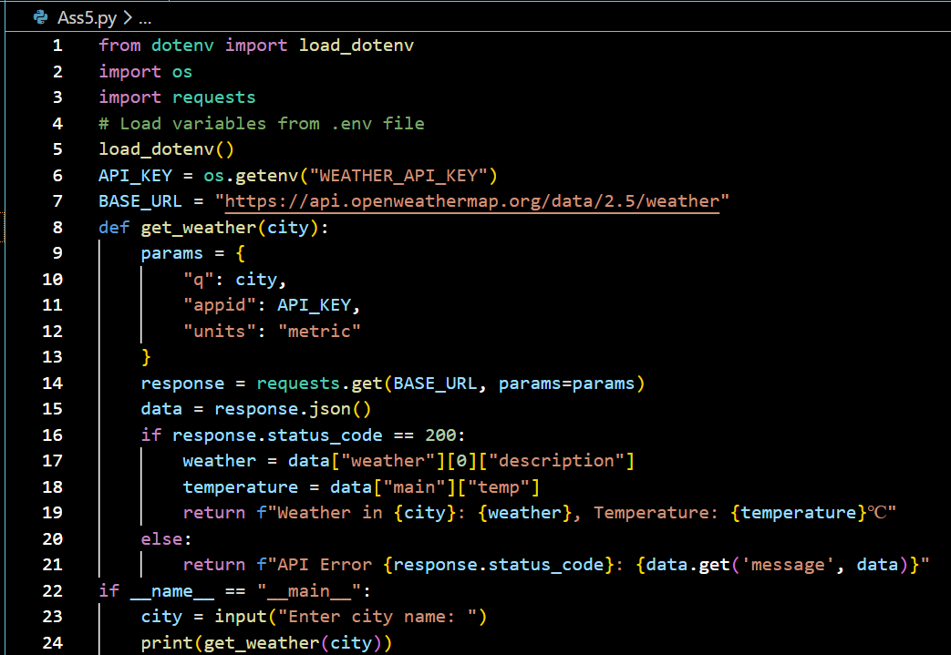
OUTPUT:

Task 2 (Privacy & Security in File Handling):
CODE:
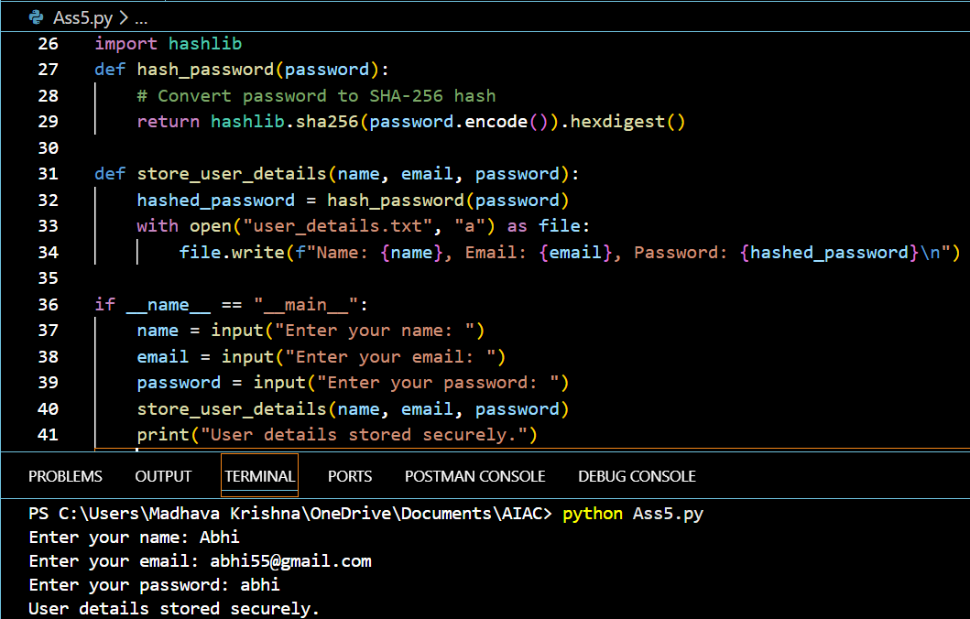
EXPLANATION:
AI-generated code initially stored passwords in plain text, creating a privacy risk. The
revised version uses hashing to store passwords securely, ensuring sensitive information is protected.

Task 3 (Transparency in Algorithm Design):
PROMPT: Generate an Armstrong number checking function with comments and
explanations and explain the code line by line ,compare the explanation with full code functionality.
CODE:
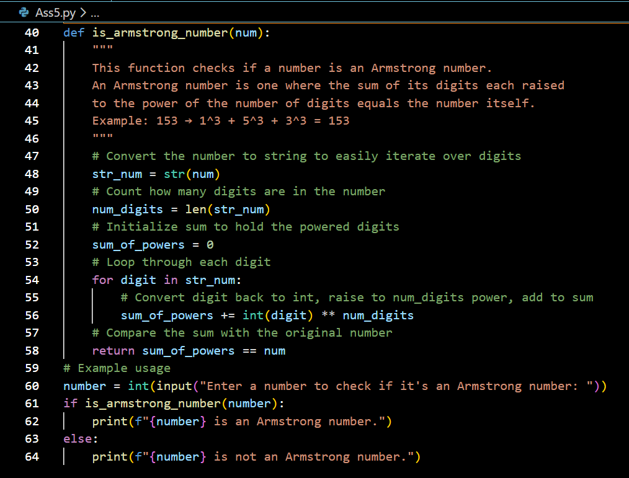
OUTPUT:
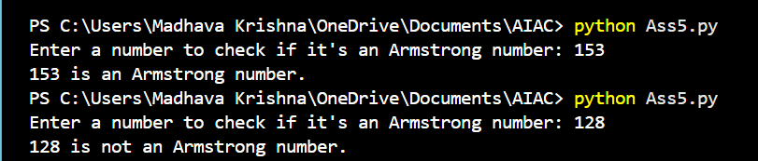
EXPLANATION:
Armstrong number: A number equals the sum of its digits each raised to the power of total digit
count. Here my Code grabs each digit, powers it correctly and also adds them up, then checks if that matches the original.

Task 4 (Transparency in Algorithm Comparison):
CODE:
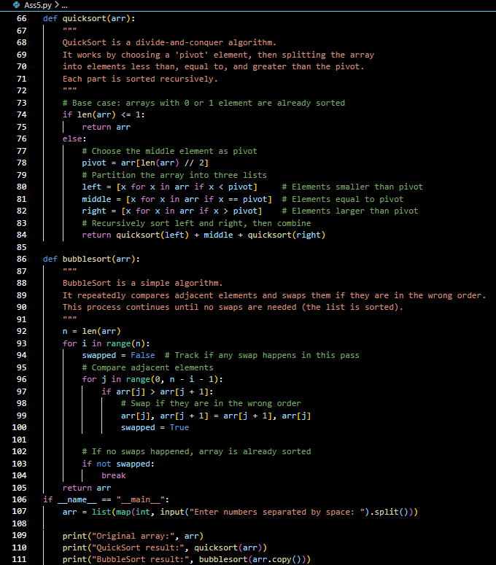
OUTPUT:
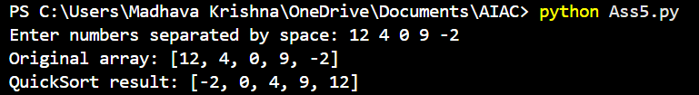
EXPLANATION:
BubbleSort slowly swaps neighbor pairs until none needed simple but crawls on big lists.
whereas,QuickSort picks middle value, splits smaller/larger sides, repeats divide fast splitter for real work.

Task 5 (Transparency in AI Recommendations):
CODE:
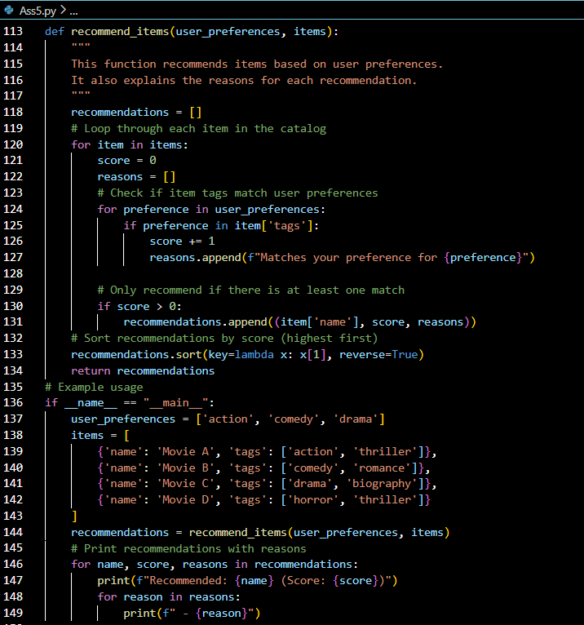
OUTPUT:
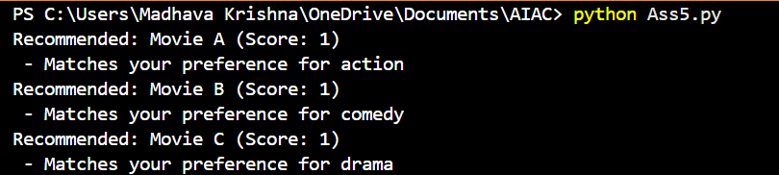
EXPLANATION:
Recommendation system scans other users' tastes matching ours, then they suggest the matches
according to our preferences and tastes so that every person can watch their own genre or taste preferences.

