Rural Health Companion: A Service-Oriented Platform for Connected Rural Healthcare

Devaansh Sai(2420030787)
Department of CSE
Koneru Lakshmaiah Education Foundation
Bowrampet, Hyderabad, Telangana, India
Bhuvan(2420030767)
Department of CSE
Koneru Lakshmaiah Education Foundation
Bowrampet, Hyderabad, Telangana, India
Abhignan(2420030731)
Department of CSE
Koneru Lakshmaiah Education Foundation
Bowrampet, Hyderabad, Telangana, India

Under the guidance of Dr. Neelima Gogineni
Abstract— Rural and semi-urban communities may face fragmented access to remote consultation, medication follow-up, pharmacy services, and emergency coordination. This paper presents Rural Health Companion (RHC), an academic web platform that links these activities through role-specific workflows and service-owned data. A Next.js App Router client reaches ten Spring Boot business services through a Spring Cloud API Gateway; Eureka supports discovery, MySQL stores domain records, and Kafka carries notification events. The implementation connects doctor discovery, appointments, symptom submission, consultations, diagnoses, finalized prescriptions, medication schedules, pharmacy inventory and orders, and GPS-based ambulance assignment. JWT authentication and role/ownership checks protect records; transactional operations address appointment, stock, and vehicle conflicts. The analysis is based on repository structure, API definitions, and test assets rather than a clinical study or fresh quantitative performance run. Provider-based pharmacy search and Firebase push delivery depend on external configuration. Prescription-image OCR is not available in the current checkout and remains future work. RHC is an academic prototype and is not a certified medical or emergency-dispatch system.
Index Terms— digital health, telemedicine, microservices, medication adherence, pharmacy workflow, emergency coordination

I. INTRODUCTION
Access to care involves more than a remote consultation. A patient may need to submit symptoms before a visit, retain a diagnosis and prescription afterward, follow a multi-dose schedule, locate a pharmacy, or request help during an emergency. Digital health depends on organizational and technical capacity as well as software [1]. In India, telemedicine guidance addresses practitioner responsibility, patient interaction, consent, records, privacy, and security [2]. Implementation reviews also identify connectivity, device access, digital literacy, service integration, and provider training as practical constraints [3].
Rural Health Companion (RHC) is an academic web platform that connects these tasks in one patient journey. Patients discover doctors, review availability, book appointments, and submit symptoms. Doctors see assigned work, record consultation notes and diagnoses, and finalize prescriptions. The system then links prescriptions to medication schedules and adherence history. Separate modules support nearby-pharmacy discovery, prescription-linked orders, and location-based ambulance coordination.
This paper describes the architecture, persisted workflows, and current implementation limits. Its contribution is a connected service-oriented prototype, not a clinical trial or evidence of improved health outcomes. The software does not automate diagnosis or treatment decisions. Emergency detection and dispatch are academic simulations and are not certified emergency services.
The project takes workflow continuity as its design objective. It aims to reduce the separation between consultation and follow-up by keeping appointment, clinical, medication, pharmacy, and emergency records addressable through authenticated services. Its scope is software orchestration: clinical decisions remain with the doctor, medication actions remain patient-recorded, and an emergency request is an academic simulation rather than a guaranteed dispatch. This boundary is important because telemedicine guidance places professional judgment and patient context at the center of remote care [2].

II. RELATED WORK
The World Health Organization's Global Strategy on Digital Health treats digital health as a coordinated health-system capability [1]. India's Telemedicine Practice Guidelines describe principles for practitioner-patient interaction, consent, documentation, privacy, and security [2]. RHC encodes parts of these concerns in authentication and record-access workflows, but it is not an accredited clinical platform and does not establish regulatory compliance.
Arora et al.'s scoping review of telemedicine implementation in India reports challenges that include digital literacy, device access, reliable connectivity, provider training, service integration, and data security [3]. These findings make network resilience and usability important evaluation topics, but this project has not been evaluated with rural users. Pahl and Jamshidi map research on microservices and identify open questions in this evolving architecture area [4]. RHC applies service boundaries to healthcare domains; it does not measure scalability or claim architectural superiority.
These sources motivate a system-level integration question: how can a patient-facing workflow preserve role boundaries while crossing several independently deployed domains? RHC addresses that question in its repository through service-owned persistence, token-based identity, controlled state changes, and event-based notifications. The comparison is architectural, not a benchmark against existing platforms; no adoption, access, clinical-quality, or cost advantage is claimed.

III. METHODOLOGY
The system is described through inspection of the repository, service configuration, and existing test assets. The browser client uses Next.js 16.3.0, React 19.2.8, and TypeScript with App Router pages [8]. Backend modules use Java 21, Spring Boot 3.4.2, and Spring Cloud 2024.0.0. Spring Cloud Gateway provides the client entry point, while Eureka registers service instances for discovery [7]. Docker Compose defines the local service environment [9].
A. Service Architecture
Ten business services cover authentication, user profiles, doctor records, appointments, consultations, prescriptions, medication, pharmacy operations, ambulance coordination, and notifications. The Gateway and Eureka are infrastructure components rather than business data owners. Each domain persists to a separate MySQL 8 schema and uses REST or OpenFeign calls when a workflow crosses service boundaries. Kafka carries asynchronous notification events on the rhc.notification.events topic [6], [9].
B. Identity and Data Security
Registration and sign-in use email one-time codes through Supabase. After verification, the authentication service maps the Supabase identity to an application account and issues the application's JWT. Spring Security filters validate tokens and apply role and ownership checks. Patient access is scoped to the patient's records, doctors to assigned consultations, pharmacies to their inventory and orders, and ambulance operators to assigned emergencies. The repository contains these authorization paths and related tests, but this paper does not claim a new penetration test. Email delivery depends on external Supabase and SMTP configuration [9].
C. Integrated Workflows
The patient care path connects doctor search and appointment booking to symptom submission, an authorized consultation, clinical notes and diagnosis, and a doctor-finalized prescription. The patient cannot edit finalized clinical content. Finalized prescriptions can generate medicine schedules; patients record taken or skipped doses and review adherence history. Pharmacy orders validate prescription items and reserve database inventory to prevent overselling. Nearby search uses a configurable provider after the patient explicitly requests location access, rather than a static pharmacy list.
The emergency module accepts user-triggered GPS requests, ranks available vehicles by Haversine distance, and uses transactional reservation for assignment. Backend rules constrain emergency-state transitions, while operator clients submit location updates that are shown to the patient. A separate sensor prototype evaluates combinations of motion and orientation signals, presents a wellbeing prompt, and provides a cancellation countdown before an automatic SOS. Authenticated WebSocket signaling supports browser WebRTC; Spring Boot does not carry media. Prescription-image scanning is not included in the current checkout and remains future work.
D. Repository Review Protocol
The paper uses a descriptive implementation review. The service count and technology versions were read from the Maven and frontend manifests; workflow responsibilities were checked against the API map, controllers, domain entities, and service configuration. Existing JUnit and Playwright test files are treated as test assets, not as proof that a test suite passed during this paper revision. No new load test, usability study, clinical evaluation, or live third-party delivery test was performed. Accordingly, the figures below describe repository structure and designed state paths, not measured system performance [9].
IV. IMPLEMENTATION AND EVALUATION
Table I groups the services by responsibility. Figure 1 shows how browser roles reach the domain services and how service-owned MySQL schemas, Eureka, Kafka, and external providers participate in the application [9].
A. Data Ownership and Consistency Boundaries
Service ownership defines the platform’s consistency boundaries. A patient journey moves through records held by separate services: an appointment identifies its patient and doctor; symptom submission and consultation refer to that visit; the prescription belongs to the consultation; medication schedules refer to finalized prescription items; pharmacy orders refer to the patient, selected pharmacy, and requested products; and an emergency record refers to the caller and to an ambulance when assignment succeeds. APIs carry these resource identifiers across service boundaries, while the owning service must validate the caller’s role and relationship to each record. This keeps domain authority near its data owner, but it makes identifier validation essential at every boundary. The frontend may combine these service responses into a dashboard; the persisted record in the owning service remains the source of truth.
Concurrency controls are local to the service that owns a contested resource. Appointment booking protects a selected time slot, pharmacy ordering reserves requested stock transactionally, and emergency assignment reserves an available vehicle. These operations address races in which multiple requests compete for the same slot, last item, or ambulance. They do not create one transaction across a complete patient journey. Prescription finalization, schedule generation, order creation, and notification delivery can commit at different times and fail independently. The current architecture therefore needs explicit recovery behavior for partial completion; service boundaries alone do not provide rollback across databases. A production-grade extension should define idempotency keys, retryable versus permanent errors, reconciliation procedures, and audit records for each cross-service transition, then verify those rules under delayed messages and service restarts.
TABLE I
Service Domains and Data Responsibilities
Domain | Services | Responsibility
Care | Auth, User, Doctor, Appointment, Consultation, Prescription | Identity, provider data, booking, symptoms, clinical records, and prescriptions.
Medication and pharmacy | Medicine, Pharmacy | Schedules, adherence, location-based search, inventory, and order fulfillment.
Emergency | Ambulance | GPS requests, nearest-vehicle assignment, permitted status changes, and operator location.
Notifications | Notification | Device registration and Kafka events; Firebase push is optional and configuration-dependent.

The repository contains persisted entities and API paths for accounts, profiles, appointments, symptoms, consultations, prescriptions, medicine reminders, pharmacy inventory and orders, emergency assignments, and notifications. The backend includes JUnit and Spring integration tests; the frontend includes a unit test and Playwright end-to-end suites [9]. This paper reports their presence in source, not a fresh test run, pass count, latency measurement, user study, or clinical outcome.
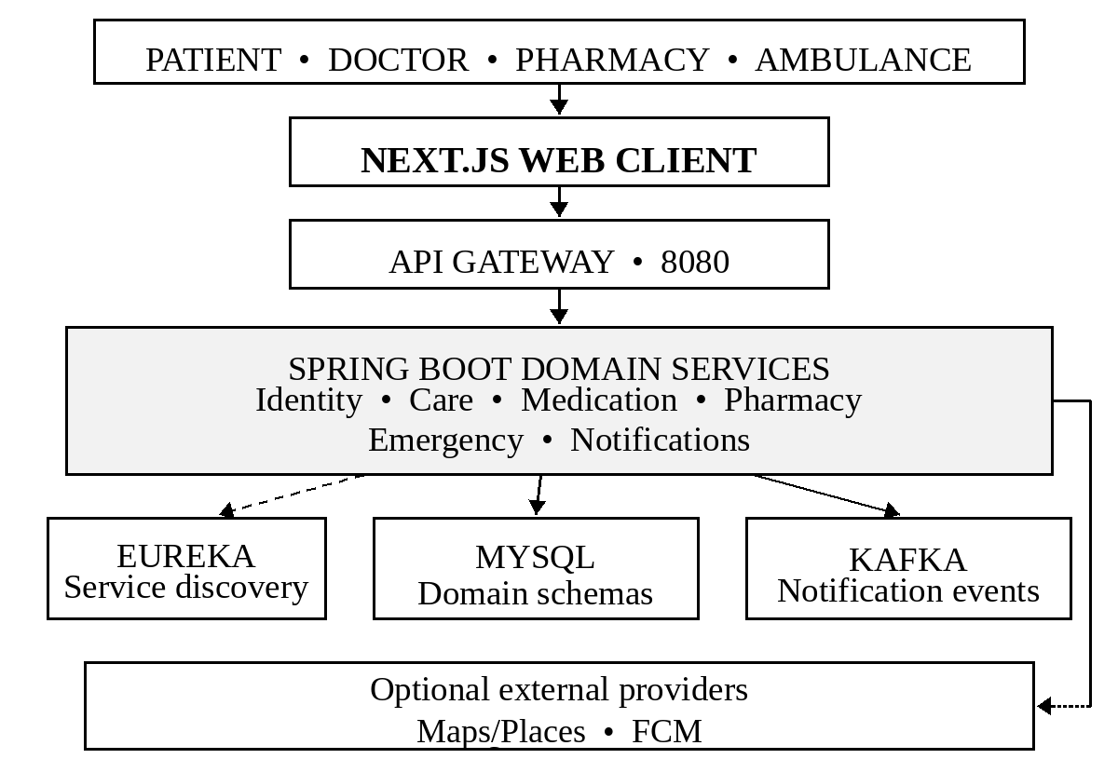
Fig. 1. Rural Health Companion architecture and notification path.
B. Service Portfolio
Table I and Fig. 1 summarize the service boundaries. Figure 2 counts the ten business-service modules by functional group: six care and identity services (Auth, User, Doctor, Appointment, Consultation, and Prescription), two medication and pharmacy services (Medicine and Pharmacy), one Ambulance service, and one Notification service [9]. Eureka and the API Gateway are excluded because they provide infrastructure rather than domain records. These counts are a static repository inventory; they do not measure request volume, staffing, reliability, quality, or health outcomes.
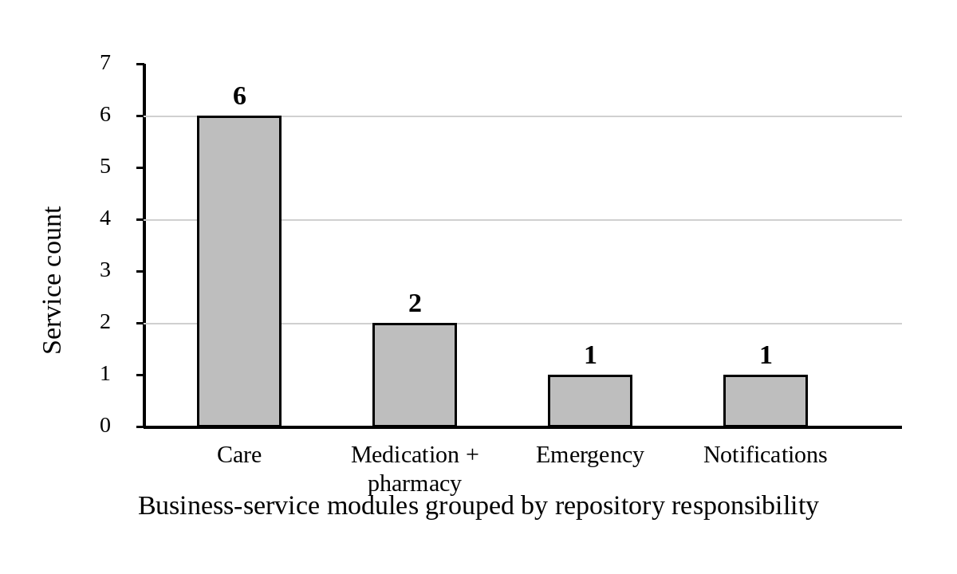
Fig. 2. Business-service modules grouped by repository responsibility.
C. Patient Care and Medication Workflow
Figure 3 follows the patient journey across the service boundary. After sign-in, the patient uses doctor and availability records to choose a visit. The appointment service stores the booking and assignment; the patient then submits symptoms for that visit. The assigned doctor reviews the appointment and symptom record before starting a consultation, adding notes and diagnosis, and finalizing a prescription. Finalization is the transition that makes the prescription available to the patient and allows the medicine service to derive dose schedules. The patient records each dose as taken or skipped; the adherence view is based on persisted reminder events rather than a locally generated schedule. This chain makes the related records navigable but does not show whether a patient followed medical instructions.
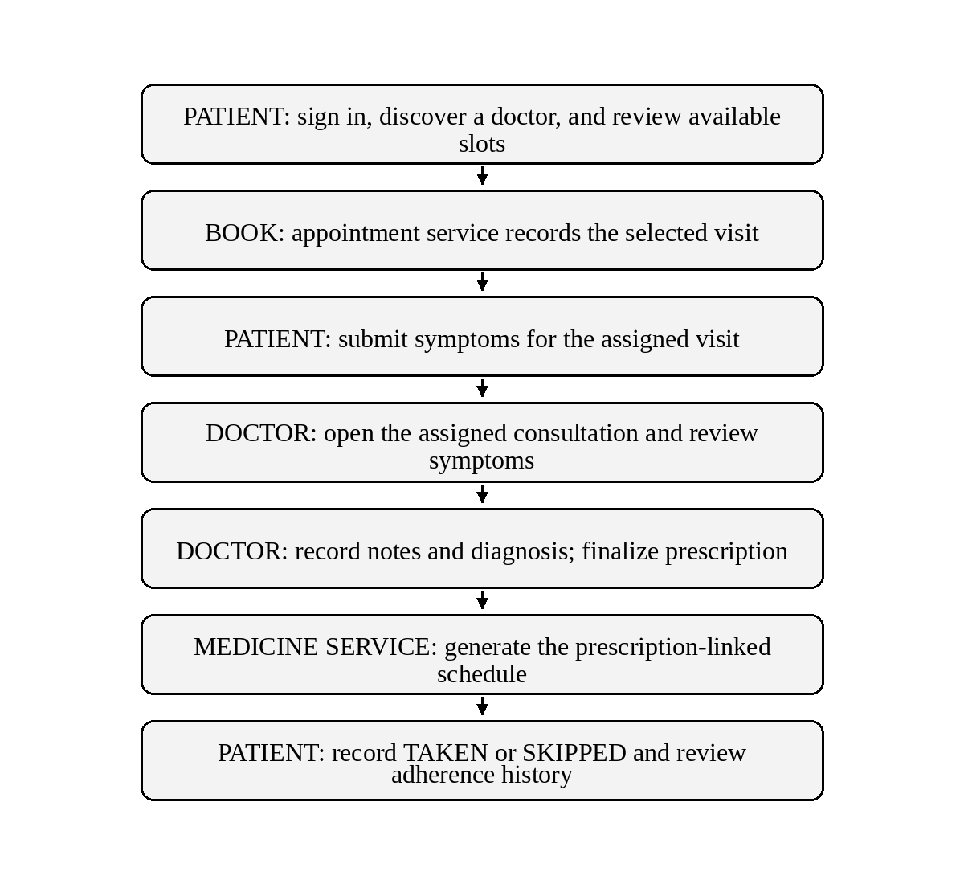
Fig. 3. Patient journey from doctor discovery to medication adherence.
D. Prescription-Linked Pharmacy Fulfillment
The pharmacy workflow begins with a finalized prescription and a patient-selected pharmacy. Before creating the order, the pharmacy service checks that the prescription belongs to the requesting patient, is finalized, and contains each requested medicine. Inventory is authoritative for price and availability. A conditional database update reserves stock within the order transaction; a failed reservation rejects the order instead of allowing a negative quantity. The pharmacy account processes its own orders through the persisted lifecycle, while the patient dashboard reads the same order record. Reserved quantities are consumed on delivery or released when an allowed cancellation succeeds. Nearby discovery is provider-backed: OpenStreetMap Overpass is the default adapter and Google Places can be selected through server configuration. GPS is requested after an explicit user action, and provider outages or incomplete map records can affect results [9].
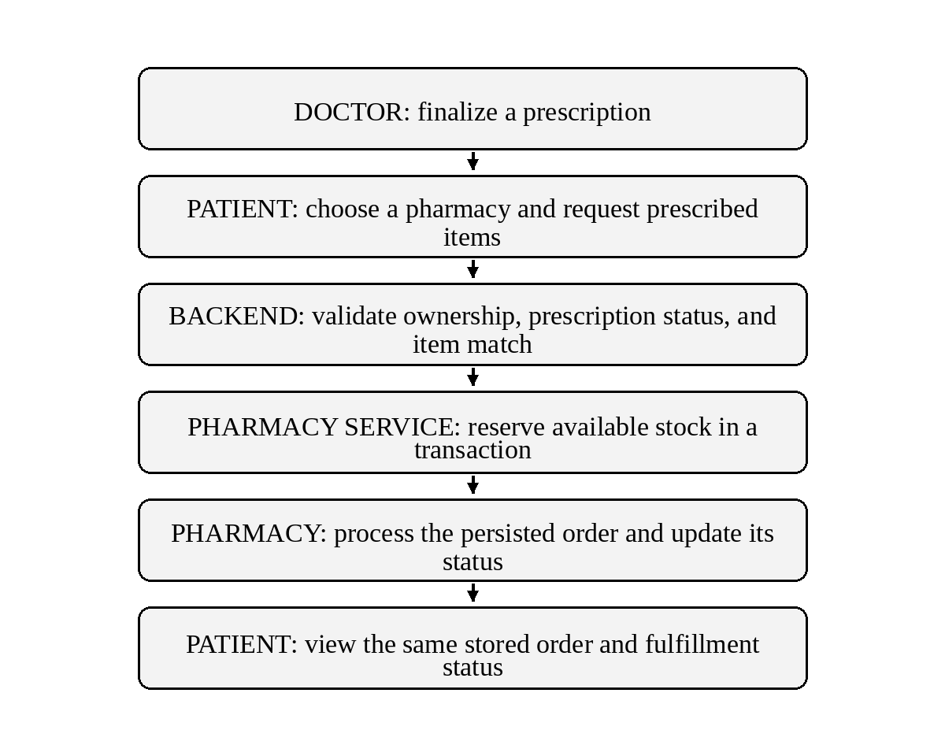
Fig. 4. Prescription validation, stock reservation, and pharmacy order visibility.
E. Emergency Coordination and Notifications
Figure 5 separates the manual emergency path from the optional sensor prototype. A manual request explicitly asks for the patient’s current location; the emergency service persists a request, ranks available ambulances using Haversine distance, and reserves one through a database state transition. If no available vehicle can be reserved, the request remains visible as REQUESTED. The operator updates only valid states—ASSIGNED, EN_ROUTE, ARRIVED, PATIENT_PICKED, HOSPITAL_REACHED, and COMPLETED—and submits the vehicle’s actual coordinates. The patient view reads the stored emergency and location information. The sensor prototype combines motion, orientation, and subsequent inactivity rules; one sensor spike is insufficient. A wellbeing prompt and cancellation path precede automatic SOS. The notification contract publishes events to Kafka topic rhc.notification.events, where the Notification service records the event and can attempt Firebase Cloud Messaging when credentials and active device tokens are configured. The local in-app record and push delivery are separate outcomes; an unconfigured sender leaves delivery pending rather than reporting success [6], [9].
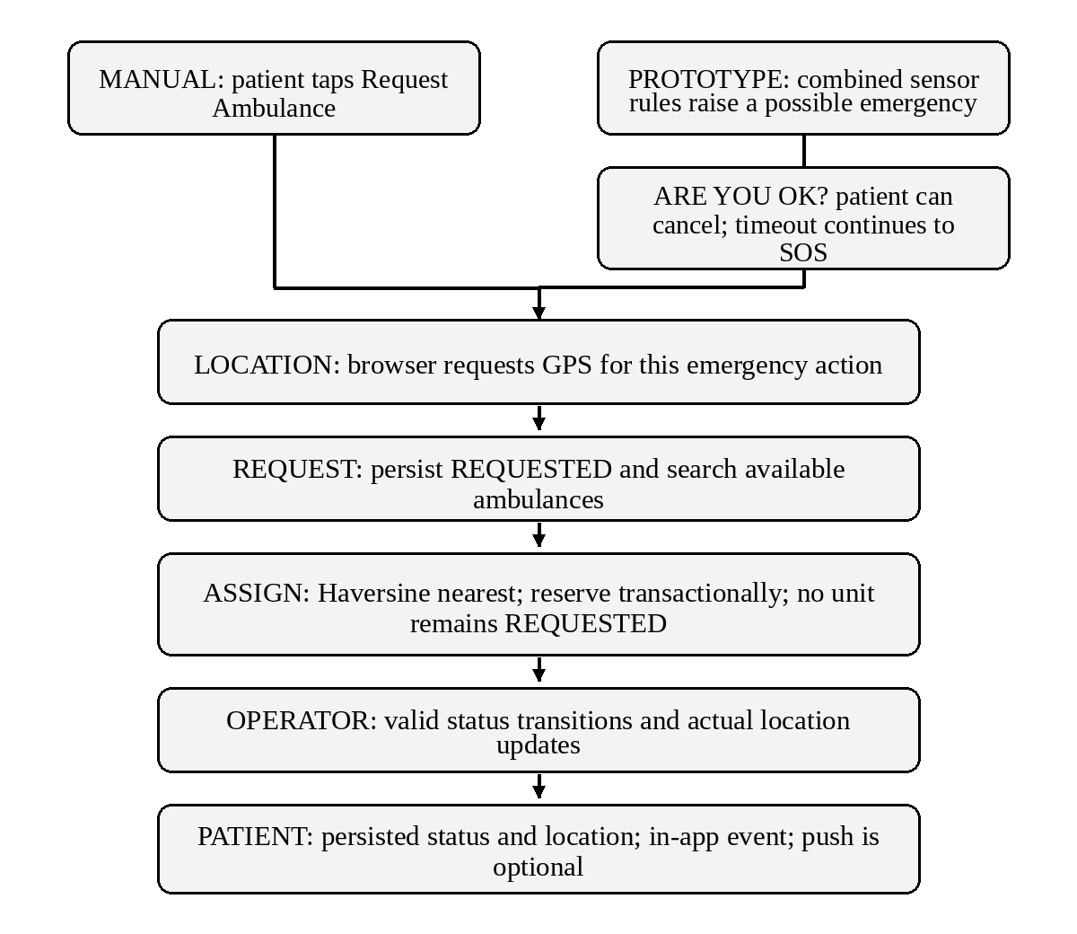
Fig. 5. Manual emergency assignment and patient-visible status path.
F. Evaluation Boundary
The implementation review identifies persistent domain entities, API paths, security checks, and automated test sources in the repository. Those artifacts define what can be exercised, but they are not presented as results from an executed test run. This paper therefore reports a service inventory and workflow design analysis only. It includes no latency, throughput, uptime, pharmacy-result accuracy, OCR accuracy, FCM delivery rate, video quality, sensor sensitivity, false-alert rate, or user-satisfaction score. A valid future evaluation must capture these measures from controlled runs and state the environment, input data, sample size, and failure conditions.
G. Operational Readiness and Evaluation Plan
The local deployment combines the API Gateway, Eureka registry, MySQL, Kafka, and the business services in Docker Compose. This arrangement makes the service graph reproducible for development, but container startup is not evidence that each workflow is ready: database initialization, broker health, registration with Eureka, and gateway route convergence must all be checked before a browser journey is attempted. The repository’s test files are inputs to a future verification run; their presence does not establish current pass rates. The project should be evaluated with controlled patient, doctor, pharmacy, and operator accounts, known database records, captured service logs, and repeatable environment configuration.
A useful validation sequence begins with authorization and data integrity, then exercises complete workflows and failure recovery. It should confirm that patients see only their records, doctors only assigned consultations, pharmacies only their own inventory and orders, and operators only assigned emergencies. Concurrent trials should attempt to book one slot twice, reserve the final medicine unit twice, and assign one ambulance to two requests; exactly one competing operation should win in each case. Duplicate notification events should not duplicate business effects. Separate runs should disable MySQL, Kafka, map-provider credentials, and push credentials to confirm that the user interface reports unavailable services without presenting false success. Measures should include workflow completion rate, API latency percentiles, recovery time, order reservation outcomes, map-result coverage, notification delivery, and sensor false-alert frequency. Results must state sample sizes, versions, deployment topology, and network conditions.
External integrations introduce consent and availability boundaries. The browser requests GPS only after a patient action; pharmacy discovery then depends on the configured provider and the completeness of its returned places. Firebase Cloud Messaging is an optional delivery channel whose result depends on valid server credentials, device registration, and network availability; a persisted in-app notification is not proof of phone delivery. Consultation signaling authenticates room participation while browsers exchange media directly, so camera permissions, peer connectivity, and network traversal affect the call. Prescription OCR endpoints are absent from this checkout and are not part of the implemented workflow. These limits should be visible in user-facing states and in any evaluation report. The platform remains an academic software prototype until usability, reliability, privacy, safety, and external-provider behavior are measured in an approved setting.

V. RESULTS AND DISCUSSION
Service separation gives each domain a clear data owner, but it also adds network and deployment dependencies. A patient journey may cross several services, so its completion depends on working APIs, MySQL, Eureka, Kafka, and provider configuration. Transactional locking addresses selected races within appointment, inventory, and ambulance workflows; it does not make the entire multi-service journey one global transaction. No throughput, availability, or low-bandwidth measurements are reported here.
The repository inventory shows that the patient journey crosses several service owners rather than a single monolithic database. This separation makes ownership visible and allows a domain such as medication scheduling to evolve independently. It also introduces network, discovery, broker, and database dependencies. A failure between two services can interrupt a workflow even when each service is healthy by itself; the architecture does not provide one global transaction across all domains. The three concurrency-sensitive paths use local database coordination for appointment slots, pharmacy stock, and ambulance reservation. That protects the relevant records from selected races but does not replace a complete distributed-systems test under service restart, broker delay, or partial failure.
Privacy and safety constrain any future deployment. Health and location records require careful authorization, consent, secure transport, retention rules, and operational review; this academic prototype does not establish regulatory compliance. Nearby-pharmacy search depends on the selected external provider and user-granted GPS. Push delivery depends on Firebase credentials, registered device tokens, and network availability. WebRTC media depends on browser camera and microphone permission and peer connectivity. No third-party delivery or field-quality result is claimed. The current checkout does not expose prescription scan or OCR endpoints. If OCR is reintroduced, its output should remain a reviewable draft and require explicit patient confirmation before it can affect an order. The sensor-based emergency prototype also needs controlled false-alert evaluation, clear cancellation, and accessible manual alternatives.
VI. REPRODUCIBLE VALIDATION ROADMAP
A future evaluation can make the repository-level claims testable through a staged protocol. The first stage should freeze the source revision, record the Java, Spring Boot, Node.js, and browser versions, and start a clean development environment with documented configuration. Controlled patient, doctor, pharmacy, ambulance-operator, and administrator accounts should be created with separate ownership. Each run should record request and response identifiers, service logs, and the relevant persisted row changes; personal or production health information is not required for this academic validation. A route-level test should capture the expected success and rejection behavior for each role, including missing tokens, expired tokens, invalid transitions, unknown identifiers, and resources owned by another account.
The second stage should follow one patient record through the clinical workflow. Book an available slot, reload the patient and doctor views, submit symptoms, start the assigned consultation, save notes and diagnosis, and finalize a prescription. The patient view should then load that same finalized record after a fresh request. Generate its medication schedule, record a dose action, reload adherence history, place an order against seeded test inventory, and confirm that the pharmacy and patient read the same stored order state. The evidence should include database identifiers and before/after quantities, so a screen update alone is not mistaken for persistence.
Concurrency and fault injection should be run separately from the ordinary workflow. Two requests should target one appointment slot, one remaining pharmacy unit, and one available ambulance; the database must retain the winning result without duplicate assignment or negative stock. Replaying a notification event should be checked for duplicate business effects. Database, broker, service-discovery, and provider interruptions should then be introduced one at a time to document whether a request fails, remains pending, or can be retried. This distinguishes a controlled rejection from a partial workflow that requires manual reconciliation.
The final stage should evaluate external behavior and human factors rather than infer them from code. Measure API latency and workflow completion under stated connectivity conditions; report pharmacy-result coverage, push delivery only when valid Firebase credentials and registered devices are used, and WebRTC connection outcomes only from real browser peers. Sensor-based emergency evaluation should report false alerts and cancellation time, with a manual request always available. A supervised usability study should include accessibility and low-bandwidth scenarios and should not ask participants to rely on the prototype for urgent clinical care. Until these observations are collected, implementation status and measured quality must remain separate claims.

VII. CONCLUSION AND FUTURE SCOPE
Rural Health Companion links doctor discovery, appointments, symptoms, consultations, diagnosis, prescriptions, medication schedules, pharmacy fulfillment, and emergency coordination through a Next.js client and ten Spring Boot business services. The reviewed repository shows service discovery, service-owned MySQL schemas, JWT-based access control, Kafka notification events, transactional inventory reservation, and location-based ambulance assignment. The evidence in this paper is architectural and source-based; it is not evidence of clinical effectiveness or production readiness.
Next steps are to run and publish reproducible end-to-end tests across all roles, exercise database and Kafka failures, and measure performance and recovery under constrained connectivity. External integrations—including pharmacy-provider coverage and Firebase push delivery—must be tested with project credentials and real device tokens before describing them as operational. Future work may restore prescription OCR as a draft-only, human-reviewed path, assess accessibility and low-bandwidth behavior with users, and evaluate the automated emergency prototype for false alerts and cancellation usability. Any clinical or emergency deployment would require qualified stakeholder review and separate regulatory and operational assessment. A staged evaluation should first verify gateway routes, service health, and role mapping in a nonproduction environment. It should then trace controlled records from appointment through consultation and finalized prescription, checking both patient and doctor views against persisted identifiers. Separate scenarios can evaluate reminder actions, inventory reservation, ambulance status progression, and the freshness of operator-submitted location updates. External providers should be activated one at a time after credentials, rate limits, cost, and failure messaging are reviewed. Before any study uses real patient information, project owners should define data retention, access review, incident response, and rollback responsibilities. These steps create a clear boundary between a software demonstration and a service suitable for broader field evaluation.
A field-readiness study should examine the experience on representative low-cost phones and variable cellular connections before the system is recommended for rural use. It can measure OTP delivery and retry behavior, page loading, GPS acquisition, recovery from dropped connections, and completion of each role-specific task. Usability sessions should check whether consent, medication status, and emergency cancellation messages are understood across supported languages and accessibility needs. Researchers should use synthetic health records unless an approved study explicitly requires otherwise, and report outcomes by device, connection, and task. Technical review should separately assess data minimization, retention, credential rotation, audit trails, and recovery after database or broker interruption. Pharmacy and push providers should be assessed for geographic coverage, rate limits, delivery delay, and cost. If OCR is restored, extraction errors across image quality and the human confirmation step need separate evaluation; if video consultation remains in scope, call setup and interruption recovery should be measured apart from signaling authorization. These measures can guide a staged pilot decision, but no user, field, clinical, or provider-performance study has been conducted for this paper.

ACKNOWLEDGMENT
The authors thank Dr. Neelima Gogineni, SOA faculty and project guide, for her academic guidance during the design and development of Rural Health Companion.

REFERENCES
[1] World Health Organization, Global Strategy on Digital Health 2020–2027. Geneva, Switzerland: WHO, 2025. [Online]. Available: https://www.who.int/publications/i/item/9789240116870. [Accessed: Oct. 26, 2026].
[2] Board of Governors in supersession of the Medical Council of India, Telemedicine Practice Guidelines: Enabling Registered Medical Practitioners to Provide Healthcare Using Telemedicine. New Delhi, India, Mar. 25, 2020. [Online]. Available: https://www.mohfw.gov.in/pdf/Telemedicine.pdf. [Accessed: Oct. 26, 2026].
[3] S. Arora, R. K. Huda, S. Verma, M. Khetan, and R. K. Sangwan, "Challenges, Barriers, and Facilitators in Telemedicine Implementation in India: A Scoping Review," Cureus, vol. 16, no. 8, Art. no. e67388, Aug. 2024, doi: 10.7759/cureus.67388.
[4] C. Pahl and P. Jamshidi, "Microservices: A Systematic Mapping Study," in Proc. 6th Int. Conf. Cloud Computing and Services Science (CLOSER 2016), vol. 1, Rome, Italy, 2016, pp. 137–146, doi: 10.5220/0005785501370146.
[5] H. Alvestrand, "Overview: Real-Time Protocols for Browser-Based Applications," RFC 8825, Internet Engineering Task Force, Jan. 2021, doi: 10.17487/RFC8825. [Online]. Available: https://www.rfc-editor.org/rfc/rfc8825.html. [Accessed: Oct. 26, 2026].
[6] Apache Software Foundation, Apache Kafka 3.9 Documentation. [Online]. Available: https://kafka.apache.org/39/documentation.html. [Accessed: Oct. 26, 2026].
[7] VMware, Inc., Spring Cloud Netflix Reference Documentation, Service Discovery with Eureka. [Online]. Available: https://docs.spring.io/spring-cloud-netflix/reference/index.html. [Accessed: Oct. 26, 2026].
[8] Vercel, Inc., Next.js App Router Documentation. [Online]. Available: https://nextjs.org/docs/app. [Accessed: Oct. 26, 2026].
[9] Rural Health Companion, Rural Health Companion source repository. GitHub, 2026. [Online]. Available: https://github.com/abhignan39202/2420030731-SOAP-project. [Accessed: Oct. 26, 2026].

