**CI/CD using GITHUB actions to execute python Project**

1. Create and push python source files, test files and requirements.txt files on git hub using git commands.

2. Go to actions on the task bar and add a new workflow. Select python application workflow template.

3. Edit the workflow.yml file as per the requirements to run on self-hosted runner.

4. Add a self-hosted runner in the actions tab

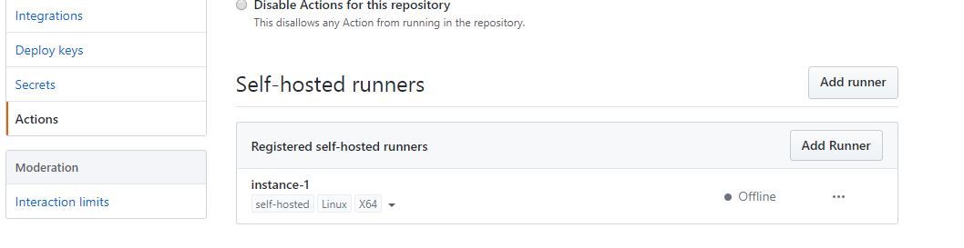

5. Use command cd add-runner, ./run.sh to start your session in you GCP VM instance.

6. Run your workflows by committing and pushing code the workflow will run and test code on the VM instance and result is thus obtained.