**Assignment – 3**

**Section 1: Multiple Choice**

**1. What is the primary function of a router in a computer network?**

**🡪**Forwarding data packets between networks

**2. What is DNS's (Domain Name System) purpose in a computer network?**

🡪 Converting domain names to IP addresses

**3. What network topology uses a centralized hub or switch to connect all devices?**

**🡪** Star

**4. Which network protocol is commonly used for securely accessing and transferring files over a network?**

**🡪FTP**

**Section 2: True or False**

**5. True or False: A firewall is a hardware or software-based security system**

**that monitors and controls incoming and outgoing network traffic based**

**on predetermined security rules.**

**🡪**true

**6. True or False: DHCP (Dynamic Host Configuration Protocol) assigns**

**static IP addresses to network devices automatically.**

**🡪false**

**7. True or False: VLANs (Virtual Local Area Networks) enable network**

**segmentation by dividing a single physical network into multiple logical**

**networks.**

**🡪true**

**Section 3: Short Answer**

**8. Explain the difference between a hub and a switch in a computer network**.

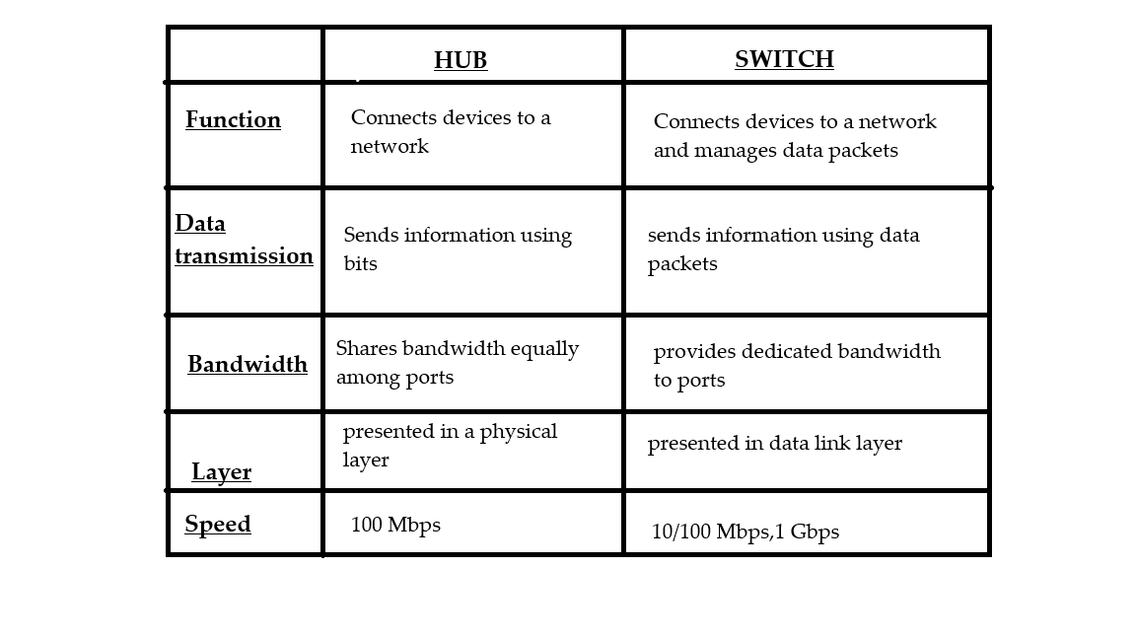

**9. Describe the process of troubleshooting network connectivity issues.**

* **Check Physical Connections**
* **Verify Network Status**
* **Restart Devices**
* **Check IP Configuration**
* **Ping and Traceroute Tests**
* **Check DNS Settings**
* **Disable Firewall or Security Software Temporarily**
* **Reset Network Settings**
* **Contact ISP or Network Administrator**

**Section 4: Practical Application**

10. Demonstrate how to configure a wireless router's security settings to enhance network security.

* **Open Router Settings** – Connect to Wi-Fi, open a web browser, and type **192.168.1.1** (or similar) to log in using the default username and password.
* **Change Router Login Details** – Set a new, strong username and password to prevent others from accessing your router.
* **Create a Strong Wi-Fi Password** – Choose **WPA3 or WPA2** security and make a password using letters, numbers, and special characters.
* **Change Your Wi-Fi Name (SSID)** – Use a unique name but avoid personal details like your name or address.
* Turn Off WPS – This feature can make your network easier to hack, so disable it.
* **Enable Encryption** – Set security to **WPA3-Personal** or **WPA2 with AES encryption** to keep your data safe.
* **Disable Remote Access** – Turn off remote management so no one can change settings from outside your home.
* **Update Your Router Software** – Check for updates regularly to fix security issues.
* **Use a Guest Network** – Create a separate Wi-Fi for visitors to keep your main network private.
* **Reduce Wi-Fi Signal Range (Optional)** – Lower the signal strength so people outside your home can’t easily connect.

**Section 5: Essay**

11. Discuss the importance of network documentation and provide examples of information that should be documented.

Maintaining thorough network documentation is crucial for effective management, troubleshooting, and scalability. It provides IT teams with a structured reference, allowing them to address issues efficiently while ensuring smooth network operations. Proper documentation enhances security, reduces downtime, and fosters better collaboration among IT personnel.

**Advantages of Network Documentation:**

1. **Facilitates Troubleshooting** – Enables quick identification and resolution of network issues.
2. **Enhances Security** – Helps track network configurations, access, and potential vulnerabilities.
3. **Boosts Efficiency** – Saves time by offering an organized overview of network settings and components.
4. **Supports Growth** – Simplifies network expansions and upgrades without causing disruptions.
5. **Aids Compliance** – Assists organizations in meeting industry regulations and best practices.

**Essential Information to Document:**

* **Network Topology** – Visual representations of physical and logical connections between network devices.
* **IP Address Allocations** – A record of assigned IP addresses and subnet details.
* **Hardware Inventory** – Information on routers, switches, firewalls, and servers, including model and serial numbers.
* **Configuration Backups** – Stored copies of router, switch, and firewall settings.
* **Access Control Details** – Documentation of user roles, login credentials, and network permissions.
* **Service Agreements** – Information on internet service providers, support contracts, and warranties.
* **Change History** – Logs of modifications, updates, and maintenance performed on the network.