OBE IMPLEMENTATION: UNIVERSITY SETTING

By

**G. ABHINAY [AP23110011114]**

**T. SWETHA PRIYA [AP23110011116]**

**A. MANOJ [AP23110011118]**

**G. VISHNU VARDHAN [AP23110011138]**

A report for the CSE204: Design and Analysis of Algorithm project



DEPARTMENT OF COMPUTER SCIENCE AND ENGINEERING

SRM UNIVERSITY AP:: AMARAVATI

**INDEX**

**Introduction**

Project Module

**Architecture Diagram**

**Module Description**

Programming Details naming conventions to be used:

Field/table details: University

Algorithm Details:

(i)Sorting

(ii)Searching

(ii) Storing the details in a text file

**Source Code**

**Comparison of Sorting Algorithms**

**Comparison of Searching Algorithms**

**Screen Shots**

**Conclusion**

**Introduction**

Our university (herewith considered as SRM-AP) is going to implement OBE (Outcome Based Education) in the university and assigned in the project to develop an application with any programming Language and well versed and supposed to do searching and sorting using learned algorithms, comparing sorting algorithm with anyone of existing algorithm, displaying the time complexity of both algorithms and explaining

advantages and disadvantages of the algorithm.

**Project Module:** University

**Architecture Diagram**

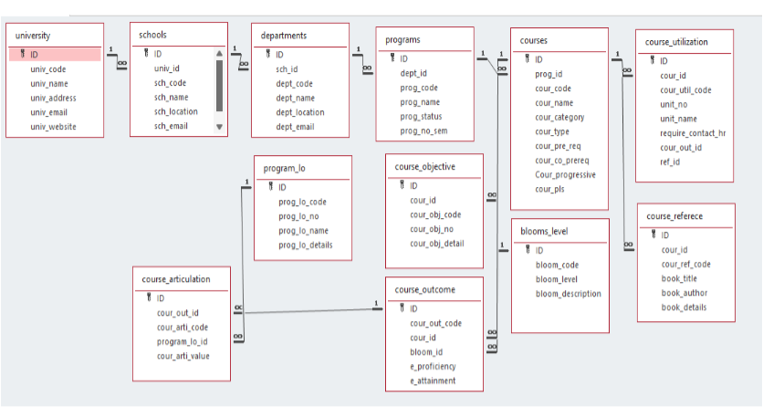

**Module Description**

Module Name: university

This module is used to Create, Update, Retrieve, Delete(hereafter known as CURD) details of the module and storing the details in the text file.

Programming Details naming conventions to be used:

* **File name:** university
* **Function/method name**
* **Create:** university_create
* **Update:** university_update
* **Retrieve:** university_retrieve
* **Delete:** university_delete
* **Sorting:** university_mergesort

university_quicksort

* **Searching:**university_linearsearch university_binary search
* **Storing:** university_storing
* **Comparison (both searching and sorting):**
* For Searching-

university_compare_linearsearch

university_compare_binarysearch

* For Sorting-

university_compare_quicksort

university_compare_mergesort

* **Time complexity (both searching and sorting):**
* For searching-

university_complexity_linearsearch

university_complexity_binarysearch

* For sorting-

university_complexity_mergesort

university_complexity_quicksort

* **Algorithm Details (pseudocode or steps) (both searching and sorting):**
* For searching-

university_algo_linearsearch

university_algo_binarysearch

* For sorting-

university_algo_quicksort

university_algo_mergesort

* **File name (for storing the details):** university_setting.txt

Field/table details: university

|  |  |
| --- | --- |
| Field Name | Data Type |
| id | integer |
| univ_code | integer |
| univ_name | String |
| univ_address | String |
| univ_email | String |
| univ_website | String |

Algorithm Details:

1. Sorting : We used quick sort and merge sort for this code
2. Searching : We used linear search and binary search for this code
3. Storing the details in a text file

* Storing the details in the text file once details are entered.
* Delete the detail from the text file once details are deleted.
* Update the text file once details are updated.

**Source Code**

**#include <stdio.h>**

**#include <stdlib.h>**

**#include <string.h>**

**#include <time.h>**

**#define MAX_UNIVERSITIES 100**

**#define MAX_STRING_LENGTH 100**

**// Define the structure for university records**

**typedef struct {**

**int id;**

**char univ_code[MAX_STRING_LENGTH];**

**char univ_name[MAX_STRING_LENGTH];**

**char univ_address[MAX_STRING_LENGTH];**

**char univ_email[MAX_STRING_LENGTH];**

**char univ_website[MAX_STRING_LENGTH];**

**} University;**

**// Function prototypes**

**void university_create(University universities[], int *count);**

**void university_update(University universities[], int count);**

**void university_retrieve(University universities[], int count);**

**void university_delete(University universities[], int *count);**

**void university_mergesort(University universities[], int left, int right);**

**void merge(University universities[], int left, int mid, int right);**

**void university_quicksort(University universities[], int low, int high);**

**int partition(University universities[], int low, int high);**

**int university_linearsearch(University universities[], int count, int id);**

**int university_binarysearch(University universities[], int left, int right, int id);**

**void university_storing(University universities[], int count);**

**void university_compare_linearsearch(University universities[], int count, int id);**

**void university_compare_binarysearch(University universities[], int count, int id);**

**void university_compare_quicksort(University universities[], int count);**

**void university_compare_mergesort(University universities[], int count);**

**void university_complexity_linearsearch(int n);**

**void university_complexity_binarysearch(int n);**

**void university_complexity_mergesort(int n);**

**void university_complexity_quicksort(int n);**

**void writeToFile(University universities[], int count);**

**int main() {**

**University universities[MAX_UNIVERSITIES];**

**int count = 0;**

**int choice;**

**do {**

**printf("\nUniversity Management System\n");**

**printf("1. Create University\n");**

**printf("2. Update University\n");**

**printf("3. Retrieve Universities\n");**

**printf("4. Delete University\n");**

**printf("5. Sort Universities (Merge Sort)\n");**

**printf("6. Sort Universities (Quick Sort)\n");**

**printf("7. Search University (Linear Search)\n");**

**printf("8. Search University (Binary Search)\n");**

**printf("9. Store Universities to File\n");**

**printf("10. Exit\n");**

**printf("Enter your choice: ");**

**scanf("%d", &choice);**

**switch (choice) {**

**case 1:**

**university_create(universities, &count);**

**break;**

**case 2:**

**university_update(universities, count);**

**break;**

**case 3:**

**university_retrieve(universities, count);**

**break;**

**case 4:**

**university_delete(universities, &count);**

**break;**

**case 5:**

**university_compare_mergesort(universities, count);**

**break;**

**case 6:**

**university_compare_quicksort(universities, count);**

**break;**

**case 7: {**

**int id;**

**printf("Enter university ID to search: ");**

**scanf("%d", &id);**

**university_compare_linearsearch(universities, count, id);**

**break;**

**}**

**case 8: {**

**int id;**

**printf("Enter university ID to search: ");**

**scanf("%d", &id);**

**university_compare_binarysearch(universities, count, id);**

**break;**

**}**

**case 9:**

**university_storing(universities, count);**

**break;**

**case 10:**

**printf("Exiting...\n");**

**break;**

**default:**

**printf("Invalid choice! Please try again.\n");**

**}**

**} while (choice != 10);**

**return 0;**

**}**

**// Function implementations**

**void university_create(University universities[], int *count) {**

**if (*count >= MAX_UNIVERSITIES) {**

**printf("Cannot add more universities.\n");**

**return;**

**}**

**University u;**

**printf("Enter ID: ");**

**scanf("%d", &u.id);**

**printf("Enter University Code: ");**

**scanf("%s", u.univ_code);**

**printf("Enter University Name: ");**

**scanf(" %[^\n]", u.univ_name); // To read string with spaces**

**printf("Enter University Address: ");**

**scanf(" %[^\n]", u.univ_address);**

**printf("Enter University Email: ");**

**scanf("%s", u.univ_email);**

**printf("Enter University Website: ");**

**scanf("%s", u.univ_website);**

**universities[*count] = u;**

**(*count)++;**

**printf ("University added successfully!\n");**

**}**

**void university_update(University universities[], int count) {**

**int id, found = 0;**

**printf("Enter ID of the university to update: ");**

**scanf("%d", &id);**

**for (int i = 0; i < count; i++) {**

**if (universities[i].id == id) {**

**found = 1;**

**printf("Updating details for ID %d:\n", id);**

**printf("Enter new University Code: ");**

**scanf("%s", universities[i].univ_code);**

**printf("Enter new University Name: ");**

**scanf(" %[^\n]", universities[i].univ_name);**

**printf("Enter new University Address: ");**

**scanf(" %[^\n]", universities[i].univ_address);**

**printf("Enter new University Email: ");**

**scanf("%s", universities[i].univ_email);**

**printf("Enter new University Website: ");**

**scanf("%s", universities[i].univ_website);**

**printf("University updated successfully!\n");**

**break;**

**}**

**}**

**if (!found) {**

**printf("University with ID %d not found.\n", id);**

**}**

**}**

**void university_retrieve(University universities[], int count) {**

**printf("List of Universities:\n");**

**for (int i = 0; i < count; i++) {**

**printf("ID: %d, Code: %s, Name: %s, Address: %s, Email: %s, Website: %s\n",**

**universities[i].id, universities[i].univ_code, universities[i].univ_name,**

**universities[i].univ_address, universities[i].univ_email, universities[i].univ_website);**

**}**

**}**

**void university_delete(University universities[], int *count) {**

**int id, found = 0;**

**printf("Enter ID of the university to delete: ");**

**scanf("%d", &id);**

**for (int i = 0; i < *count; i++) {**

**if (universities[i].id == id) {**

**found = 1;**

**for (int j = i; j < *count - 1; j++) {**

**universities[j] = universities[j + 1];**

**}**

**(*count)--;**

**printf("University with ID %d deleted successfully!\n", id);**

**break;**

**}**

**}**

**if (!found) {**

**printf("University with ID %d not found.\n", id);**

**}**

**}**

**void university_mergesort(University universities[], int left, int right) {**

**if (left < right) {**

**int mid = left + (right - left) / 2;**

**university_mergesort(universities, left, mid);**

**university_mergesort(universities, mid + 1, right);**

**merge(universities, left, mid, right);**

**}**

**}**

**void merge(University universities[], int left, int mid, int right) {**

**int i, j, k;**

**int n1 = mid - left + 1;**

**int n2 = right - mid;**

**University *L = (University *)malloc(n1 * sizeof(University));**

**University *R = (University *)malloc(n2 * sizeof(University));**

**for (i = 0; i < n1; i++)**

**L[i] = universities[left + i];**

**for (j = 0; j < n2; j++)**

**R[j] = universities[mid + 1 + j];**

**i = 0;**

**j = 0;**

**k = left;**

**while (i < n1 && j < n2) {**

**if (L[i].id <= R[j].id) {**

**universities[k] = L[i];**

**i++;**

**} else {**

**universities[k] = R[j];**

**j++;**

**}**

**k++;**

**}**

**while (i < n1) {**

**universities[k] = L[i];**

**i++;**

**k++;**

**}**

**while (j < n2) {**

**universities[k] = R[j];**

**j++;**

**k++;**

**}**

**free(L);**

**free(R);**

**}**

**void university_quicksort(University universities[], int low, int high) {**

**if (low < high) {**

**int pi = partition(universities, low, high);**

**university_quicksort(universities, low, pi - 1);**

**university_quicksort(universities, pi + 1, high);**

**}**

**}**

**int partition(University universities[], int low, int high) {**

**int pivot = universities[high].id;**

**int i = (low - 1);**

**for (int j = low; j < high; j++) {**

**if (universities [j].id < pivot) {**

**i++;**

**University temp = universities[i];**

**universities[i] = universities[j];**

**universities[j] = temp;**

**}**

**}**

**University temp = universities[i + 1];**

**universities[i + 1] = universities[high];**

**universities[high] = temp;**

**return (i + 1);**

**}**

**int university_linearsearch(University universities[], int count, int id) {**

**for (int i = 0; i < count; i++) {**

**if (universities[i].id == id) {**

**return i; // Return the index if found**

**}**

**}**

**return -1; // Return -1 if not found**

**}**

**int university_binarysearch(University universities[], int left, int right, int id) {**

**while (left <= right) {**

**int mid = left + (right - left) / 2;**

**if (universities[mid].id == id) {**

**return mid; // Return the index if found**

**}**

**if (universities[mid].id < id) {**

**left = mid + 1; // Search in the right half**

**} else {**

**right = mid - 1; // Search in the left half**

**}**

**}**

**return -1; // Return -1 if not found**

**}**

**void university_storing(University universities[], int count) {**

**writeToFile(universities, count);**

**}**

**void writeToFile(University universities[], int count) {**

**FILE *file = fopen("university_setting.txt", "w");**

**if (file == NULL) {**

**printf("Error opening file!\n");**

**return;**

**}**

**for (int i = 0; i < count; i++) {**

**fprintf(file, "ID: %d, Code: %s, Name: %s, Address: %s, Email: %s, Website: %s\n",**

**universities[i].id, universities[i].univ_code, universities[i].univ_name,**

**universities[i].univ_address, universities[i].univ_email, universities[i].univ_website);**

**}**

**fclose(file);**

**printf("Data stored successfully in university_setting.txt\n");**

**}**

**void university_compare_linearsearch(University universities[], int count, int id) {**

**clock_t start = clock();**

**int index = university_linearsearch(universities, count, id);**

**clock_t end = clock();**

**if (index != -1) {**

**printf("University found at index %d\n", index);**

**} else {**

**printf("University with ID %d not found.\n", id);**

**}**

**university_complexity_linearsearch(count);**

**double time_taken = ((double)(end - start)) / CLOCKS_PER_SEC;**

**printf("Linear Search Time: %f seconds\n", time_taken);**

**}**

**void university_compare_binarysearch(University universities[], int count, int id) {**

**university_quicksort(universities, 0, count - 1); // Ensure the array is sorted**

**clock_t start = clock();**

**int index = university_binarysearch(universities, 0, count - 1, id);**

**clock_t end = clock();**

**if (index != -1) {**

**printf("University found at index %d\n", index);**

**} else {**

**printf("University with ID %d not found.\n", id);**

**}**

**university_complexity_binarysearch(count);**

**double time_taken = ((double)(end - start)) / CLOCKS_PER_SEC;**

**printf("Binary Search Time: %f seconds\n", time_taken);**

**}**

**void university_compare_quicksort(University universities[], int count) {**

**clock_t start = clock();**

**university_quicksort(universities, 0, count - 1);**

**clock_t end = clock();**

**printf("Universities sorted using Quick Sort.\n");**

**university_complexity_quicksort(count);**

**double time_taken = ((double)(end - start)) / CLOCKS_PER_SEC;**

**printf("Quick Sort Time: %f seconds\n", time_taken);**

**}**

**void university_compare_mergesort(University universities[], int count) {**

**clock_t start = clock();**

**university_mergesort(universities, 0, count - 1);**

**clock_t end = clock();**

**printf("Universities sorted using Merge Sort.\n");**

**university_complexity_mergesort(count);**

**double time_taken = ((double)(end - start)) / CLOCKS_PER_SEC;**

**printf("Merge Sort Time: %f seconds\n", time_taken);**

**}**

**void university_complexity_linearsearch(int n) {**

**printf("Time Complexity of Linear Search: O(n)\n");**

**}**

**void university_complexity_binarysearch(int n) {**

**printf("Time Complexity of Binary Search: O(log n )\n");**

**}**

**void university_complexity_mergesort(int n) {**

**printf("Time Complexity of Merge Sort: O(n log n)\n");**

**}**

**void university_complexity_quicksort(int n) {**

**printf("Time Complexity of Quick Sort: O(n log n) on average, O(n^2) in the worst case\n");**

**}**

**Comparison of Sorting Algorithms**

**#include <stdio.h>**

**#include <stdlib.h>**

**#include <time.h>**

**#include <string.h>**

**#define SIZE 10000**

**struct University {**

**int id;**

**int univ_code;**

**char univ_name[100];**

**char univ_address[200];**

**char univ_email[100];**

**char univ_website[100];**

**};**

**// Function prototypes ```c**

**void university_algo_quicksort(struct University universities[], int low, int high);**

**void university_algo_mergesort(struct University universities[], int left, int right);**

**void generate_random_universities(struct University universities[], int n);**

**void copy_array(struct University source[], struct University destination[], int n);**

**void print_results(int quicksort_time, int mergesort_time, int quicksort_space, int mergesort_space);**

**int main() {**

**struct University original_array[SIZE];**

**struct University quicksort_array[SIZE];**

**struct University mergesort_array[SIZE];**

**// Step 1: Generate random universities**

**generate_random_universities(original_array, SIZE);**

**// Step 2: Copy original array to both sorting arrays**

**copy_array(original_array, quicksort_array, SIZE);**

**copy_array(original_array, mergesort_array, SIZE);**

**// Step 3: Measure time for Quick Sort**

**clock_t start = clock();**

**university_algo_quicksort(quicksort_array, 0, SIZE - 1);**

**clock_t end = clock();**

**int quicksort_time = (int)((end - start) * 1000 / CLOCKS_PER_SEC);**

**// Step 4: Measure time for Merge Sort**

**start = clock();**

**university_algo_mergesort(mergesort_array, 0, SIZE - 1);**

**end = clock();**

**int mergesort_time = (int)((end - start) * 1000 / CLOCKS_PER_SEC);**

**// Step 5: Output the results**

**print_results(quicksort_time, mergesort_time, sizeof(quicksort_array), sizeof(mergesort_array));**

**return 0;**

**}**

**void generate_random_universities(struct University universities[], int n) {**

**for (int i = 0; i < n; i++) {**

**universities[i].id = rand() % 10000; // Random ID**

**universities[i].univ_code = rand() % 1000; // Random university code**

**snprintf(universities[i].univ_name, sizeof(universities[i].univ_name), "University %d", i);**

**snprintf(universities[i].univ_address, sizeof(universities[i].univ_address), "Address %d", i);**

**snprintf(universities[i].univ_email, sizeof(universities[i].univ_email), "email%d@example.com", i);**

**snprintf(universities[i].univ_website, sizeof(universities[i].univ_website), "www.university%d.com", i);**

**}**

**}**

**void copy_array(struct University source[], struct University destination[], int n) {**

**memcpy(destination, source, n * sizeof(struct University));**

**}**

**void print_results(int quicksort_time, int mergesort_time, int quicksort_space, int mergesort_space) {**

**printf("Quick Sort Time: %d milliseconds\n", quicksort_time);**

**printf("Merge Sort Time: %d milliseconds\n", mergesort_time);**

**printf("Quick Sort Space Complexity: %d bytes\n", quicksort_space);**

**printf("Merge Sort Space Complexity: %d bytes\n", mergesort_space);**

**}**

**Comparison of Searching Algorithms**

**FUNCTION compare_search_algorithms()**

**// Step 1: Generate a random array of universities**

**INTEGER n = 10000 // Size of the array**

**DECLARE ARRAY universities[n]**

**generate_random_universities(universities, n)**

**// Step 2: Sort the array for binary search**

**sort_universities_by_id(universities, n) // Use any sorting algorithm (e.g., Quick Sort)**

**// Step 3: Choose a target ID to search for**

**INTEGER target_id = universities[RANDOM_INDEX(n)].id // Randomly select an ID from the array**

**// Step 4: Measure time for Linear Search**

**START_TIMER()**

**INTEGER linear_search_result = university_algo_linearsearch(universities, n, target_id)**

**END_TIMER()**

**INTEGER linear_search_time = GET_ELAPSED_TIME()**

**// Step 5: Measure time for Binary Search**

**START_TIMER()**

**INTEGER binary_search_result = university_algo_binarysearch(universities, 0, n - 1, target_id)**

**END_TIMER()**

**INTEGER binary_search_time = GET_ELAPSED_TIME()**

**// Step 6: Output the results**

**PRINT "Linear Search Time: " + linear_search_time + " milliseconds"**

**PRINT "Binary Search Time: " + binary_search_time + " milliseconds"**

**PRINT "Linear Search Result Index: " + linear_search_result**

**PRINT "Binary Search Result Index: " + binary_search_result**

**END FUNCTION**

**Screen Shots**

**QUICK SORT (university_algo_quicksort).**

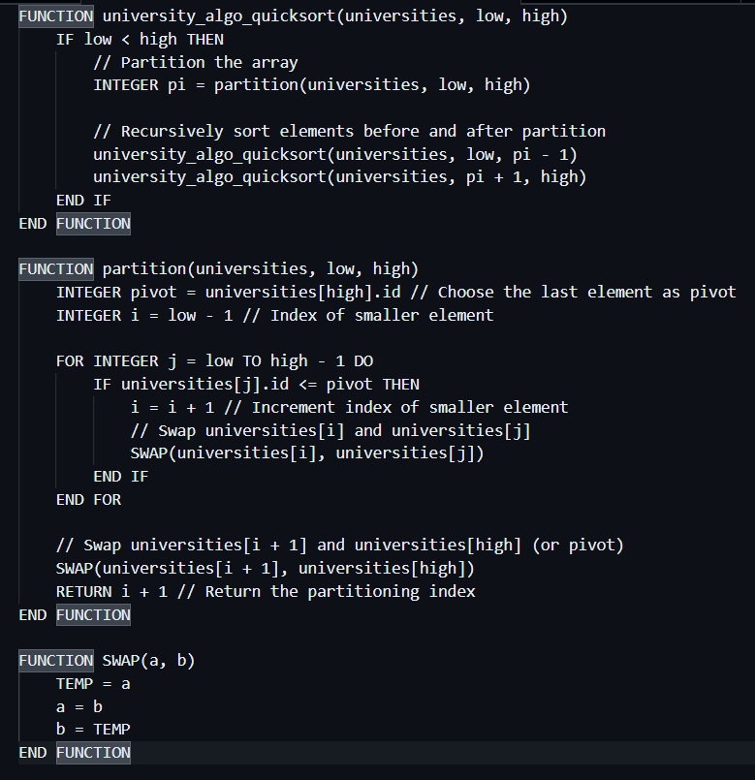

**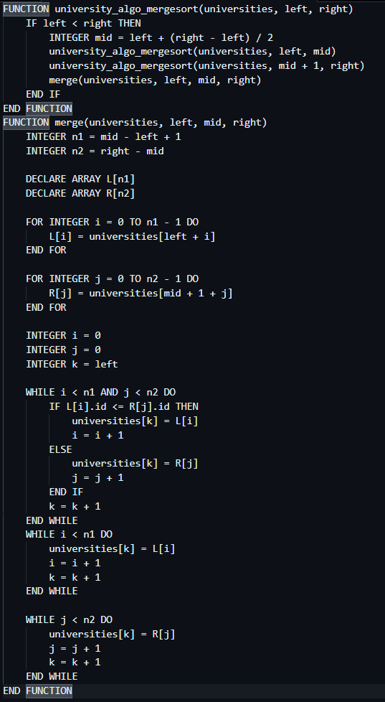  
MERGE SORT (university_algo_mergesort).**

LINEAR SEARCH & BINARY SEARCH

(university_algo_linearsearch

university_algo_binarysearch)

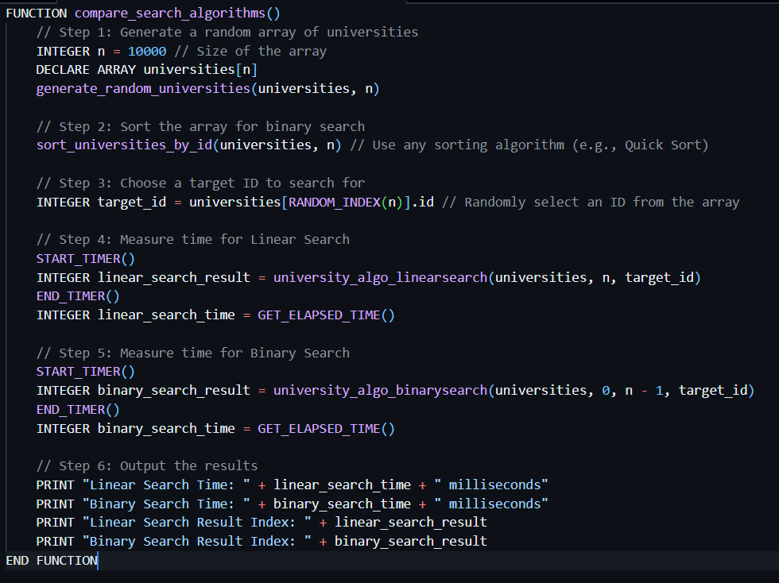

**CONCLUSION**

The University Management System project represents a significant step forward in the digital transformation of university operations. By leveraging technology to enhance administrative efficiency and improve the overall educational experience, the UMS positions the university to better serve its students and faculty in an increasingly competitive academic environment. The successful implementation of this system not only meets current needs but also lays the groundwork for future innovations in university management.