Modelling Glacier Dynamics and Sea Level Rise for Future Projections in the Gulf of Alaska
Harsh Mahanti  Amity Institute of Information Technology  Amity University Jharkhand  Ranchi, India  mahantiharsh@gmail.com | Swayam Gupta  Amity Institute of Information Technology  Amity University Jharkhand  Ranchi, India  swayamgupta5698@gmail.com | Roumo Kundu  SAP TLL VT India BLR  SAP Labs BLR  Bangalore, India  rjroumo@gmail.com
Tannisha Kundu
Amity Institute of Information Technology
Amity University Jharkhand
Ranchi, India
tkundu@rnc.amity.edu

Abstract
In the last few years, there has been a significant change in the sea level of Alaska by the melting of glaciers, due to which the flora and fauna in the coastal region have been endangered. Accurate prediction and analysis of change in sea level is crucial for the policymakers and protective agencies to take proper measures against the change. Existing studies don’t properly predict the changes in the glacier mass, glacier health or the changes in the sea level. The main problem lies in the unavailability of data. This research provides a deep analysis of glacier mass change from 1985-2021 extracted from a remote sensing timelapse video, and it predicts the changes in glacier health and sea level from 2021-2026. This solution uses various image processing techniques to extract data from the video's image sequence and uses the LSTM and RNN models ensembled together to predict future changes with an accuracy of 80%. This prediction provides a solution for various policy-building organisations to be ready for a change in habitat.
Introduction
Glaciers play a crucial role in the Earth's climate system and significantly contribute to global sea level rise. Recent studies have highlighted the alarming rate of glacier mass loss worldwide, with substantial implications for sea level rise, freshwater resources, and regional hydrology. The Intergovernmental Panel on Climate Change (IPCC) has projected a likely global mean sea level rise of between 0.43 m and 0.84 m by 2100 under a high emission scenario (RCP 8.5) (IPCC, 2021) [2]. This rise poses significant threats to coastal communities, infrastructure, and ecosystems worldwide.
From 2019 to 2023, global glaciers experienced a significant mass loss of approximately −331.68 ± 59.07 Gt/yr, contributing to a sea level rise of 0.916 ± 0.163 mm/yr [1]. Notably, Alaska emerged as the foremost contributor to global glacier mass change, with a substantial mass balance loss of approximately −57.11 ± 7.68 Gt/yr [1]. This deceleration in mass loss contrasts with the accelerated mass loss observed in other regions, such as the southern Canadian Arctic and the southern Greenland Periphery. The Gulf of Alaska (GOA) stands as an ideal research site because it contains diverse terrain features together with both heavy rainfall and significant ice coverage, which is visualized in Figure 1 [4].
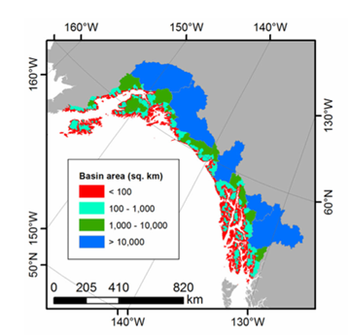
Figure 1. Map of the individual coastal watersheds in the GOA, color-coded by area.
To understand and quantify changes in glacier mass, four main methods are commonly used: glaciological, digital elevation model (DEM) differencing, altimetry, and gravimetry. Repeat observations from optical and radar DEMs provide detailed glacier elevation data at high temporal and spatial resolution. The IPCC’s sixth assessment report (AR6) complemented glaciological observations with global glacier mass balance from DEM differencing, using results from gravimetry for evaluation [2]. Furthermore, a broad range of mass balance estimates exists within the literature, emphasizing the challenges inherent in accurately measuring and modeling glacier dynamics, the major runoff sequences for GOA is shown in Figure 2 [6].
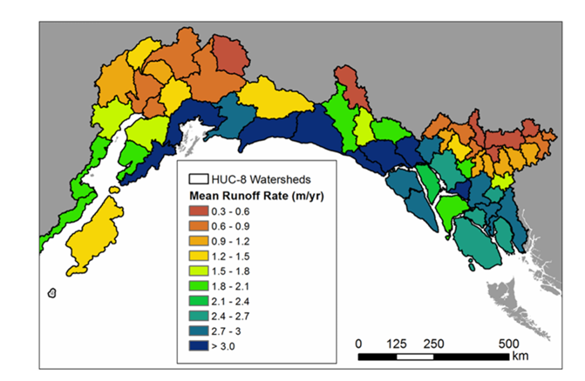
Figure 2. .Map of mean annual runoff rate (in m yr21)
The Kenai Peninsula in south-central Alaska has experienced significant glacier mass loss, with a 12% area shrinkage between 1986 and 2016. The region-wide mass-balance rate between 2005 and 2014 was −0.94 ± 0.12 m w.e. a−1, indicating an acceleration in glacier mass loss.[3] This region's glaciers contribute significantly to global sea level rise and freshwater input into the Gulf of Alaska. The current state of GOA glaciers reflects a complex interaction of various factors. Globally, glacier mass loss is accelerating [1], with Alaska playing a substantial role for whose a historical trend pattern is plotted for the 4 Major Glaciers of Alaska in Figure 3 [10].
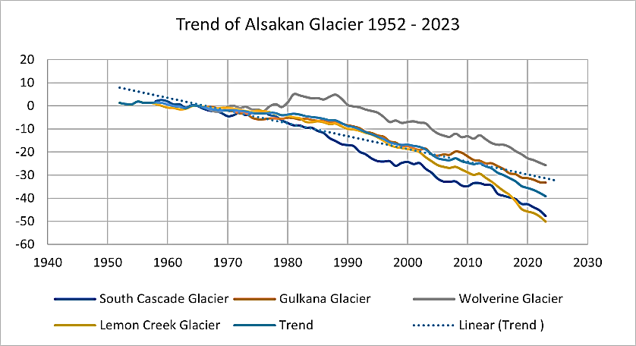
Figure 3. Mass balance trends of Alaskan glaciers (1952-2023)
This research aims to develop a robust pipeline for processing images, extracting meaningful features, generating datasets, analyzing data, and deploying models to study glacier mass balance changes. The research begins with extracting frames from glacier timelapse and segmenting them into 300 individual frames, which then undergo image processing to enhance quality and identify key features through segmentation. 9 Statistical features are derived from these processed frames, complementing data acquired from existing research, including geographical facts about the glaciers. The dataset represents the glacier's characteristics over 36 years, with each row corresponding to a specific year from 1986 to 2021. This combined dataset is then pre-processed, analyzed, and normalised to prepare it for modelling.
Following image processing, the extracted features are used to generate datasets for training and testing machine learning models. Data analytics is performed to gain insights into the datasets and prepare them for model training. Different machine learning models, including ensemble models, Long Short-Term Memory (LSTM) networks, and Recurrent Neural Networks (RNNs), are tested to evaluate their performance and suitability for the given task. The best-performing models are then prepared for deployment.
The results from these two models were then ensembled to obtain optimized forecasts for the years 2022 to 2026. Additionally, linear regression is utilized to establish a relationship between the extracted statistical features and real-world glacier trends. estimate the glacier's mass balance and sea level contribution, which are crucial indicators of the glacier's health and the region's environmental changes.
This comprehensive workflow showcases the integration of image processing, machine learning, and data analytics to solve complex problems effectively. By providing a detailed methodology for developing and deploying machine learning models for image processing tasks, this research aims to contribute to the field and serve as a valuable reference for future studies and applications in related domains.
Literature Study
Recent studies highlight the alarming rate of glacier mass loss, significantly contributing to global sea level rise. From 2019 to 2023, global glaciers lost approximately −331.68 ± 59.07 Gt/yr, equating to a sea level rise of 0.916 ± 0.163 mm/yr. Alaska was the foremost contributor, with a mass balance loss of −57.11 ± 7.68 Gt/yr [1].
Four main methods are used to quantify glacier mass changes: glaciological, digital elevation model (DEM) differencing, altimetry, and gravimetry. The IPCC’s sixth assessment report (AR6) complemented glaciological observations with global glacier mass balance from DEM differencing, using gravimetry for evaluation [1].
Alaska has been a significant focus due to its substantial contribution to global sea level rise. The region-wide mass-balance rate between 2005 and 2014 was −0.94 ± 0.12 m w.e. a−1, indicating an acceleration in glacier mass loss. Alaskan glaciers account for approximately 12% of the total global glacierized area, excluding the Greenland and Antarctica ice sheets [3].
The Kenai Peninsula experienced a 12% area shrinkage between 1986 and 2016. The region-wide mass-balance rate between 2005 and 2014 was −0.94 ± 0.12 m w.e. a−1, indicating an acceleration in glacier mass loss [3]. The glaciers have experienced widespread recession since the Little Ice Age [7].
Glacier mass loss in Alaska impacts global sea level rise and freshwater resources. Annual runoff is partitioned into 63% snowmelt, 17% glacier ice melt, and 20% rainfall. Glacier runoff was 38% of the total seasonal runoff [4].
Climate models predict that the Gulf of Alaska (GOA) will become warmer and wetter, significantly reducing snowpack and glacier extent. For RCP 4.5, reductions in glacier volume and area resulted in a 30% decrease in annual glacier runoff between 2003–2022 and 2080–2099 [6].
Ice flow plays a fundamental role in glacier dynamics and hazards. In Alaska, glacier speeds are 50% greater in spring than the annual mean. Lake-terminating and tidewater glaciers flow faster than land-terminating glaciers. Glacier Lake Outburst Floods (GLOFs) can cause significant speed-ups in glacier flow [7].

Methodology
The workflow structure and implementations of the study have been mentioned below in the sections discussed in the sections ahead. The procedure starts with the extraction of frames from glacial timelapse, followed by the segmentation into 300 distinct frames, which subsequently undergo image processing to improve quality and discover essential elements using segmentation. Statistical characteristics are extracted from these processed frames, augmenting data obtained from prior studies, including geographical information on the glaciers.
The integrated dataset is subsequently pre-processed, analyzed, and normalized to facilitate modeling. Two hybrid models, a Long Short-Term Memory (LSTM) network and a Recurrent Neural Network (RNN), are trained, and their outputs are ensembled for improved prediction. The results from these two models are then ensembled to obtain optimised forecasts for the years 2022 to 2026. Additionally, linear regression is utilized to establish a relationship between the extracted statistical features and real-world glacier trends, estimating the glacier's mass balance and sea level contribution. The proposed architecture is described in Figure 4.
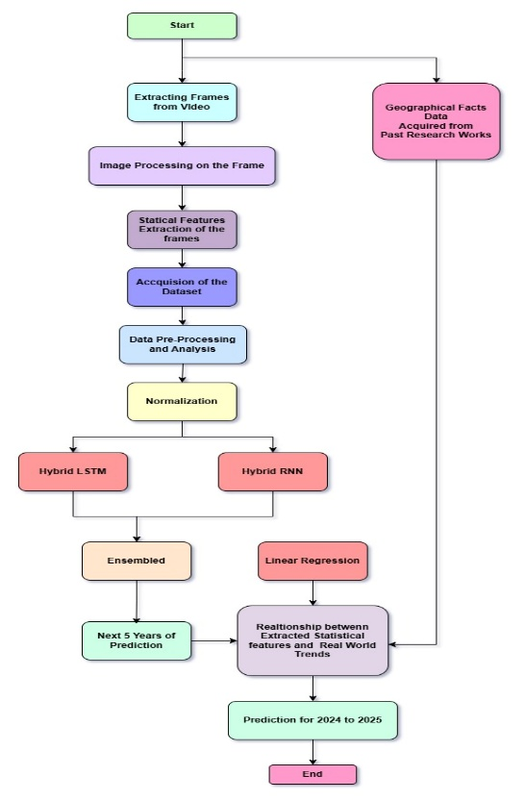
Figure 4. Workflow Algorithm of the Proposition
Data Acquisition and Analysis
The numerical and statistical features of the dataset, used for projections, were extracted over from the Timelapse footage of 300 frames, constituting 300 rows and 9 features, respectively. The details of the extracted features are described as follows,
- Feature_1 - Processes an image to compute the percentage of pixels that have a high intensity, based on a dynamic threshold and the frequency of pixel intensities
- Feature_2 - The Frobenius norm is calculated for the grayscale version of an image, providing a numerical value that represents the overall intensity magnitude of the image.
- Feature_3 - Detects the largest region, computes its convex hull, crops the image, and applies Frobenius Norm on it.
- Feature_4 – Calculates the diagonal length of the cropped image by applying the Pythagorean theorem.
- Feature_5 – Calculates the Width of the cropped image by applying the Pythagorean theorem.
- Feature_6 – Calculates the Height of the cropped image by applying the Pythagorean theorem.
- Feature_7 - Compute the percentage of pixels that have the lowest intensity based on a dynamic threshold and the frequency of pixel intensities.
- Feature_8 - Calculate the ratio of white family pixels to black family pixels.
- Feature_9 – Calculates Pixel rate Change with Subsequence Subtraction of Images.
These 9 features’ characteristics are computed in Table 1, the data reveals that Feature 1 and Feature 8 exhibit small ranges together with minimal standard deviations indicating small variations. The large values combined with higher standard deviations of Feature 2 and Feature 3 indicate notable variations across the study parameters. Data from Feature 4, Feature 5, and Feature 6 demonstrate average size values while containing significant variations of moderate scope. Feature7 demonstrates stability across a narrow range yet Feature9 reveals substantial differences between its lowest point (0) and highest point (11.55) along with high standard deviation levels due to occasional extreme fluctuations.
Table 1. Characteristics of the Features
 | min | max | mean | std
Feature1 | 0.1121 | 0.190300 | 0.152698 | 0.020580
Feature2 | 83528.1779 | 108193.522600 | 96826.305201 | 6497.177463
Feature3 | 80950.3309 | 103158.110500 | 92651.430769 | 5500.413412
Feature4 | 1156.8513 | 1293.431100 | 1215.729927 | 42.300775
Feature5 | 412.0000 | 592.000000 | 466.726667 | 37.045465
Feature6 | 1080.0000 | 1174.000000 | 1122.213333 | 34.962682
Feature7 | 0.7294 | 0.789700 | 0.758105 | 0.012816
Feature8 | 0.1298 | 0.239900 | 0.184671 | 0.028877
Feature9 | 0.0000 | 11.550129 | 0.752736 | 2.131414

The Interquartile Range (IQR) detects outliers by locating values that exceed 1.5 times the IQR above Q1 and below Q3. The outlier box plot is shown in Figure 5, except Feature 9. Outlier analysis reveals substantial outlier numbers in Feature3 (12), Feature5 (52) and Feature9 (44) which could represent unusual data points or distribution variation. The distribution patterns for all other features remain within standard ranges which indicates their relative stability. Feature5 and Feature9 display high outlier numbers which suggests distribution anomalies or extreme values that warrant further examination.
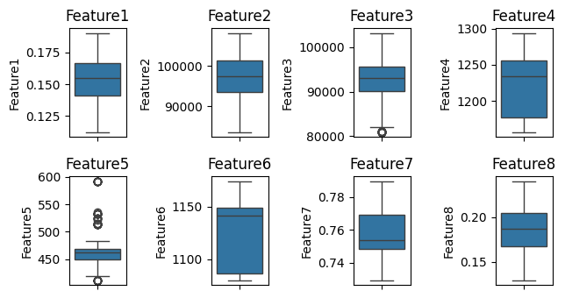
Figure 5. Probable Outlier Detection for the Dataset
The correlation matrix in Figure 6, reveals strong positive relationships among many features, especially between Features 1, 2, and 8, indicating they likely capture similar patterns. Features 3 and 4 also show a strong positive correlation. Feature 7, however, exhibits moderate negative correlations with several other features, suggesting an inverse relationship or a unique role in the dataset. Feature 9 remains largely uncorrelated with different features, indicating it varies independently. Overall, the dataset appears to have highly interrelated features, with some, like Feature 7, displaying contrasting behaviour. These insights suggest potential redundancy among features.
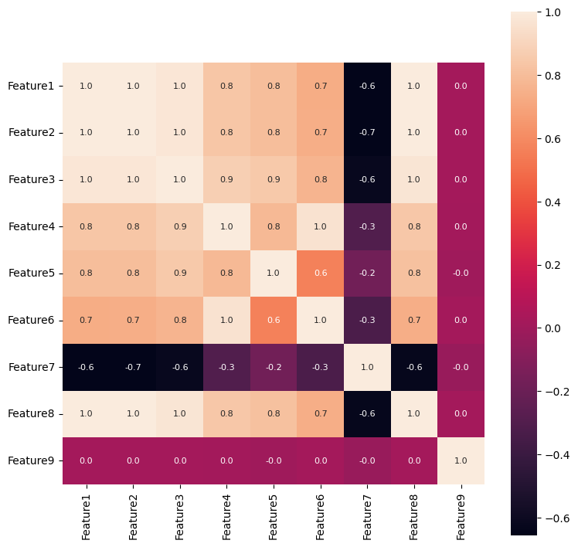
Figure 6. Correlation Matrix for the Features
To test the variability and use case ; One Way ANOVA was implemented, to determine if there are significant differences between multiple groups of data in the dataset,
$$NullHypothesis\left(H^{0}\right): μ_{1}=μ_{2}=…=μ_{k}$$
$$AlternativeHypothesis\left(H^{1}\right): \text{At least one }μ_{i}≠μ_{j} \text{for some }i,j∈\{1,2,…,k\}$$
$$F=\frac{\text{Between-group variance}}{\text{Within-group variance}}=\frac{\frac{1}{k-1}\sum_{i=1}^{k}{n_{i}{\left(\overline{X_{i}}-\overline{X}\right)}^{2}}}{\frac{1}{N-k}\sum_{i=1}^{k}{\sum_{j=1}^{n_{i}}{{\left(X_{ij}-\overline{X_{i}}\right)}^{2}}}}$$ | (1)

The p-value and t-value are both used to assess statistical significance. The t-value measures the difference between group means in relation to variability within the groups, whereas the p-value indicates the probability of observing such a difference (or more extreme) under the null hypothesis. The alpha value (typically 0.05) sets the threshold for significance ; if the p-value is less than alpha, the null hypothesis is rejected, suggesting a significant difference between groups.
In this case ANOVA test for all the Features results in an F-value of 63114.40 and a p-value of 0.0000, the result is highly significant, indicating strong evidence against the null hypothesis and suggesting that there are significant differences between the groups. All pairs of features demonstrate statistically meaningful differences according to the pairwise ANOVA test whose p-values amount to 0.000000e+00 which surpasses the standard alpha value of 0.05. Statistical results show that it was best to reject the null hypothesis for each feature pair comparison thereby confirming significant differences between the feature means.
To validate the study that found that the glacial melt and runoff decelerated between 2019 and 2023 than in the previous decade. To validate the claim of deceleration in glacial melt and runoff from 2019 to 2023, we analyze the year-over-year changes for the chosen features (representing glacial melt and runoff) over two periods: 2009-2018 and 2019-2023. The year-over-year change for any given feature F(t) is computed as,
$$ΔF\left(t\right)=F\left(t\right)-F\left(t-1\right)$$ | (2)
Where ΔF(t) represents the year-over-year difference for the feature at year t. Next, we calculate the average annual rate of change for both periods as follows;
For the previous decade (2009 to 2018),
$$\text{Average Annual Rate of Change (2009-2018)}=\frac{1}{N_{before}}\sum_{t=2009}^{2018}{ΔF\left(t\right)}$$ | (3)
For the recent period (2019 to 2023) ,
$$\text{Average Annual Rate of Change (2019-2023)}=\frac{1}{N_{after}}\sum_{t=2019}^{2023}{ΔF\left(t\right)}$$ | (4)

For this analysis Features 1 and 8 were selected as these two resonate closely with Glacial Health overall. The change of average annual rate of change in Feature1 and Feature8 from 2002-2019 to 2019-2021 is analyzed and it is found that both features grew from -0.0002 to 0.0008 for Feature 1 and from -0.0003 to 0.0010 for Feature 8. A Feature termed “Health of the Glacier” was formulated for ease of study which was mean value corresponded with Feature 1 and 8 , shown in Figure 7.
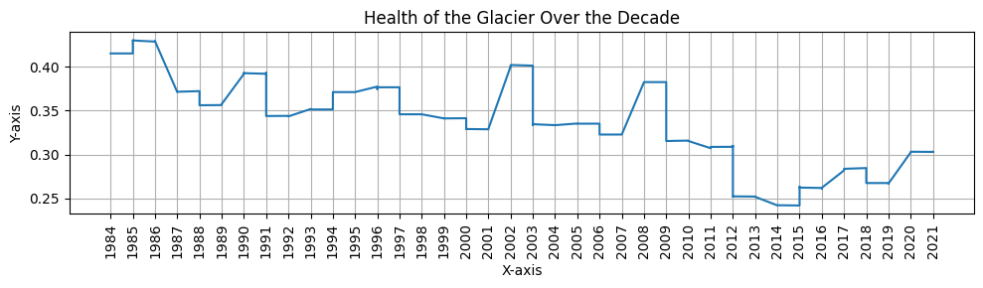
Figure 7. Glacier Health over The Decade
On “Health of the Glacier” it Calculates the rate of change (slope) of a glacial health metric over two periods, 2002-2019 and 2019-2021, by fitting a linear regression model to the data for each period. The slope of the regression line represents the rate of change.
$$y = m ⋅x + c$$ | (5)
$$m=\frac{\sum_{i=1}^{n}{\left(x_{i}-\overline{x}\right)\left(y_{i}-\overline{y}\right)}}{\sum_{i=1}^{n}{{\left(x_{i}-\overline{x}\right)}^{2}}}$$ | (6)
Where x are the years, y are the corresponding glacial health values, xˉ and yˉ​ are the means of the years and glacial health values, respectively, and n is the number of data points. The slope mmm indicates whether the glacial health metric is improving or declining over the period in (6) .
In the rate of change in glacial pixels, two distinct trends are seen between the two periods. The negative rate of change −0.0016 from 2002 to 2019 is indicative of a decreasing trend in glacial pixels (degradation in glacier health) likely owing to an increase in melt and loss of ice. Yet, from 2019 to 2021, the rate of change 0.0089 is positive, implying that glacial pixels are increasing and possibly indicating stabilization or even improvement in glacier health in this latter period.
A t-test is then performed to compare the slopes of the two periods to determine if there is a statistically significant difference. If the p-value from the t-test is less than 0.05, the difference in slopes is significant, indicating a change in the glacial health metric between the two periods.
$$t=\frac{S_{1}-S_{2}}{\sqrt{\frac{s_{1}^{2}}{n_{1}}+\frac{s_{2}^{2}}{n_{2}}}}$$ | (7)

Both Feature1 and Feature8 show significant changes between 2002-2019 and 2019-2021, as indicated by the results of the t-test. The t-statistic of 3.8126 and the p-value of 0.0003 for Feature1 imply a strong statistical difference in the slopes, indicating a sharp change in glacial health within these two periods. Feature8 has also shown a t-statistic of 3.9771 and p-value of 0.0002, indicating a significant shift between the two period. The observed deceleration in glacial melt and runoff is therefore corroborated by the change in glacial dynamics, as quantified by both features, between earlier and more recent years. Combined with these highly significant p values (far below the usual bar of 0.05), the results do not suggest random variation through time, but rather indicate real changes in the glacial processes. A similar test was opted for the entire Feature set of the Extraction Shown in Figure 8 ,
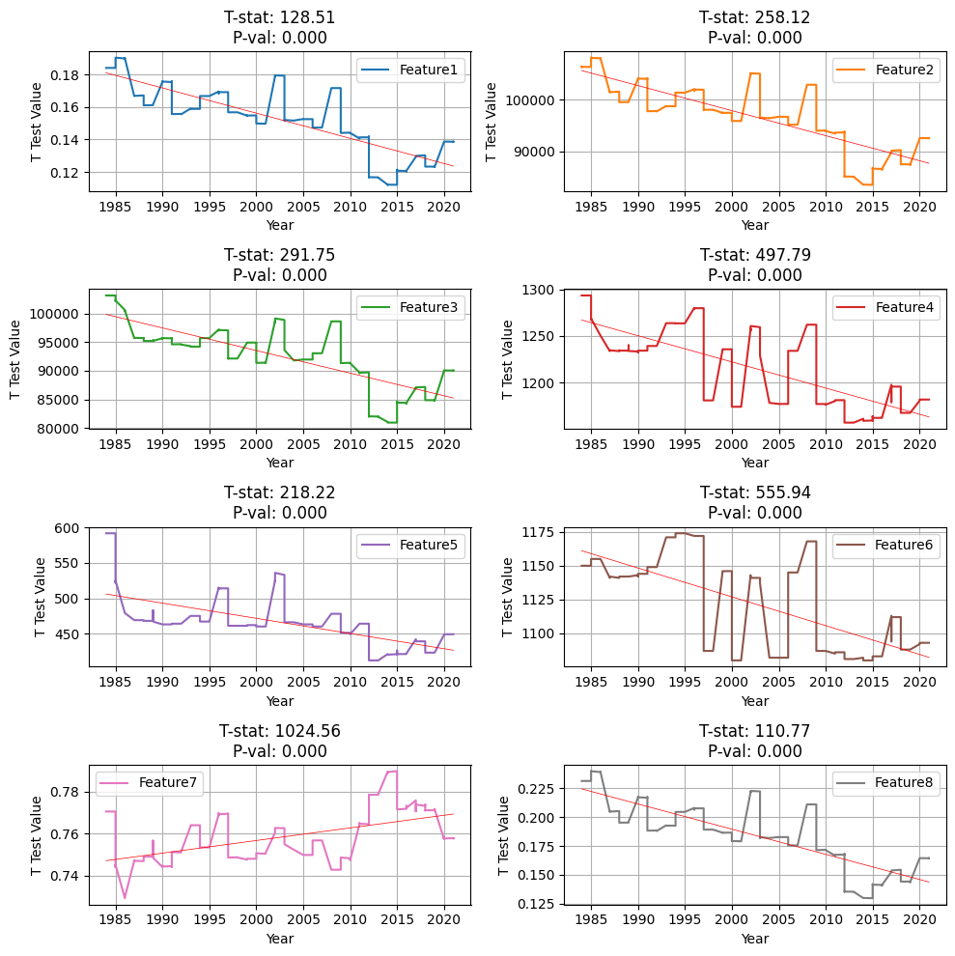
Figure 8. t-tests for each feature against a hypothetical population mean
Results of the t-test strongly reject the null hypothesis, each feature is statistically significantly different from the hypothetical population mean, with p values extremely small. Feature7 with the highest t statistics shows the most substantial deviation from the mean, while others such as Feature1 and Feature8, although they have lower t statistics, still have strong significance. The results indicate that all features are meaningful and that they include a lot of information that is not centered on the population mean of 0. Validating the acquisition of the Feature Extraction.
To establish a quantitative relationship between glacier mass loss and sea level rise, statistical analysis was conducted using Pearson correlation and multiple linear regression. Correlation results show an extremely strong positive correlation 0.9964 between Glacial Mass and Sea Level Rise. This relationship is further confirmed by regression analysis, where R-squared values ranging close to 1.000 imply that the changes in glacier mass vary strongly with changes in sea level.
Highly significant F statistics 4.668e+29 and corresponding p-value 0.025 confirm the robustness of the model. The high condition number, however, suggests there might be multicollinearity among the predictor variables and so may affect the stability of coefficient estimates. Taken together, these findings indicate that glacier mass loss directly impacts sea level rise while others should investigate additional climatic and glaciological factors involved.
Mathematical Implementation
Phase 1 (Image Processing Techniques for Segmentation)
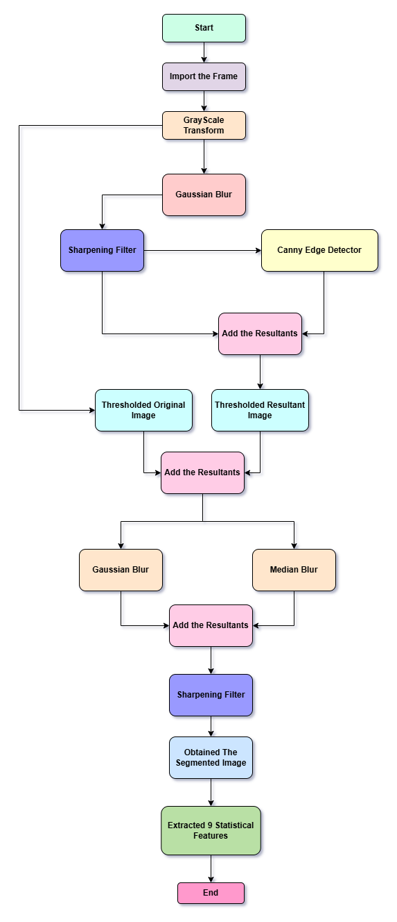
Figure 9. Algorithm for the Proposed Feature Segmentation
The experimentation as described in Figure 9 , starts with Grayscale Conversion of the Frame , the input image I in the RGB color space is converted to a grayscale image I_{g}​ using the weighted sum of its color channels ,
$$I_{g}\left(x,y\right)=0.299R\left(x,y\right)+0.587G\left(x,y\right)+0.114B\left(x,y\right)$$ | (8)
A Gaussian blur is applied to smooth the image, reducing noise and fine details. The filtered image I_{d}​ is computed using a Gaussian kernel,
$$I_{d}\left(x,y\right)=\sum_{i=-k}^{k}{\sum_{j=-k}^{k}{I_{g}\left(x+i,y+j\right)}}⋅G\left(i,j\right)$$ | (9)
where G(i,j) is the Gaussian kernel with kernel size of 15 ,
$$G\left(i,j\right)=\frac{1}{2πσ^{2}}e^{-\frac{i^{2}+j^{2}}{2σ^{2}}}$$ | (10)
In mathematical terms, image sharpening using 2D convolution applies a sharpening kernel K_{s}​ to an image I_{d}​, producing a sharpened image Is​. The convolution operation can be defined as,
$$I_{s}\left(x,y\right)=\sum_{i=-1}^{1}{\sum_{j=-1}^{1}{K_{s}\left(i,j\right)}}⋅I_{d}\left(x+i,y+j\right)$$ | (11)
where K_{s}​ is the sharpening kernel,
$$K_{s}=\left[\begin{matrix}-1 & -1 & -1 \\ -1 & 9 & -1 \\ -1 & -1 & -1\end{matrix}\right]$$ | (12)
Edges are detected using the Canny edge detector, which computes gradients using Sobel filters to compute intensity gradients in the x and y directions with lower and upper threshold of 100 and 200,
$$G_{x}=I_{s}*\left[\begin{matrix}-1 & 0 & 1 \\ -2 & 0 & 2 \\ -1 & 0 & 1\end{matrix}\right],$$ | (13)
$$G_{y}=I_{s}*\left[\begin{matrix}-1 & -2 & -1 \\ 0 & 0 & 0 \\ 1 & 2 & 1\end{matrix}\right],$$ | (14)
The gradient magnitude is,
$$G=\sqrt{G_{x}^{2}+G_{y}^{2}}$$ | (15)
The gradient magnitude is calculated as,
$$θ=\tan^{-1}\left(\frac{G_{y}}{G_{x}}\right)$$ | (16)
The resultant is applied with Laplacian Filter, which is computed by applying a kernel to the image. The kernel for the discrete Laplacian in 2D is,
$$L=∇^{2}I_{s}=\frac{∂^{2}I_{s}}{∂x^{2}}+\frac{∂^{2}I_{s}}{∂y^{2}}$$ | (17)
where the Laplacian kernel is,
$$K_{L}=\left[\begin{matrix}0 & 1 & 0 \\ 1 & -4 & 1 \\ 0 & 1 & 0\end{matrix}\right]$$ | (18)

The resultants of the Laplacian and Canny Edges are combined using element-wise addition, with a binary thresholding operation applied on to it, where T is 140,
$$I_{th}\left(x,y\right)=\left\{255,\text{ if }I_{added}\left(x,y\right)>T\text{ else }0\right\}$$ | (19)

This added resultant is applied with Median Blurring to remove salt and pepper noise, to replace each pixel with the median value of the pixels in its neighbourhood,
$$I_{M}\left(x,y\right)=\text{median}\left(I_{th}\left(x+i,y+j\right)\right), i,j∈W$$ | (20)
where W is a neighbourhood window.
On the Original Grayscale Image (8) and the Added image for the filters, Thresholding is applied as in (19) with a value of 140 to 255, and Added these two resultants. The resultant is then applied with Gaussian Blur in (9) . This gaussian Blurred image is Added up with Median Blurred Image resultant, this is specifically done to highlight the specific Glacial region and probable Runoff areas. This resulted the Segmented Glacial areas of the frames.
The Segmentation procedure was validated over a manually selected 50 frames out of the 300 frames. Mathematically, image segmentation performance can be described with a confusion matrix, a 2x2 matrix listing TP, FN, FP and TN values. The confusion matrix will help us determine the segmentation accuracy and precision.
$$\text{Accuracy}=\frac{\text{TP}+\text{TN}}{\text{Total Predictions}}$$ | (21)
$$\text{Precision}=\frac{\text{TP}}{\text{TP}+\text{FN}}$$ | (22)

Phase 3 (Ensembled Hybrid {LSTM + RNN})
Then out of these segmentate images 9 numerical features are to be extracted,
Here's a breakdown of the features and their corresponding functions:

Feature 1 represents the Percentage of high-intensity pixels , Feature 2 is the Frobenius normalization of the image , Feature 3 is the Frobenius norm of the cropped image , Feature 4 is Diagonal length of the cropped image ,Feature 5 is Width of the cropped image , Feature 6 is Height of the cropped image Feature 7 gives Percentage of low-intensity pixels and Feature 8 is Ratio of white to black pixels . Then the last feature contains the information about the date we have taken 8 frames per year for this data.
The study gather additional relevant information, including historical data on the glacier's past behaviour (size, mass balance, flow rate), climate data encompassing temperature and precipitation patterns that influence glacier dynamics, and topographic data, potentially in the form of Digital Elevation Models (DEMs), providing crucial context about the glacier's environment. Critically, this step also involves the acquisition of "Geographical Facts" derived from past study, suggesting the integration of existing knowledge about the specific glacier or region into the model.

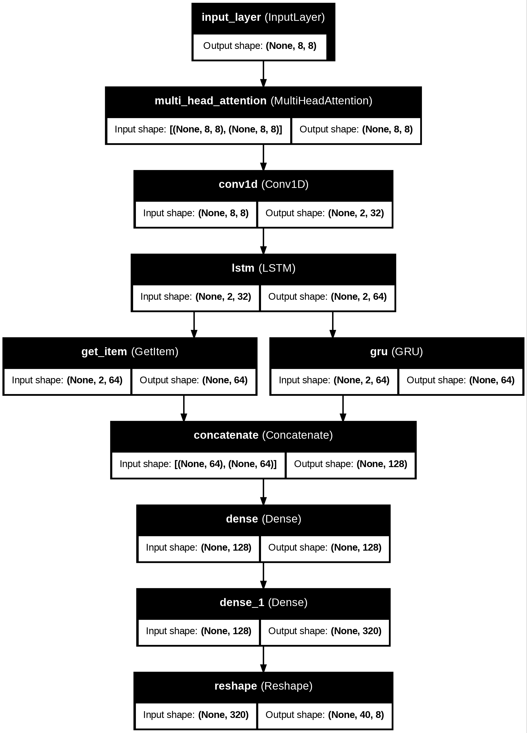

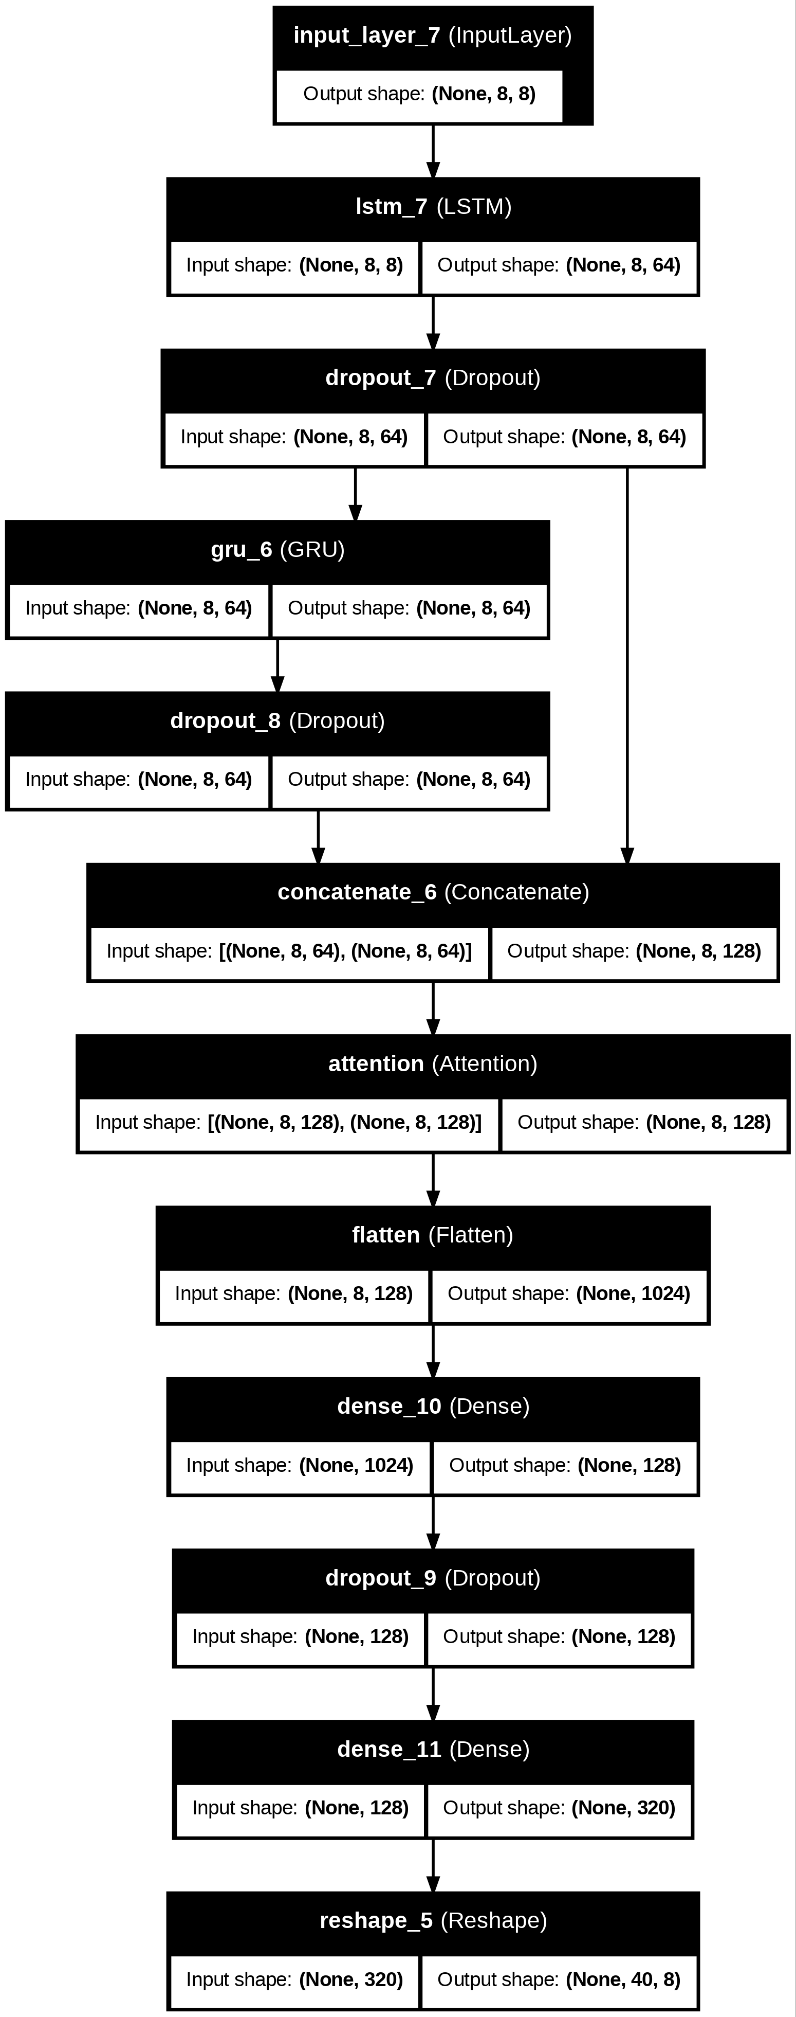
Results and Discussions
Phase 1 (Image Processing Techniques for Segmentation)
Phase 2 ( Ensembled Hybrid {LSTM + RNN} )

