Pattern Recognition

Assignment – 1

Bayes classifier

Pratyush Gaurav (B16026)

Shashwat Garg (B16034)

Abhigyan Khaund (B16082)

Group – 11

September 14, 2018

**Contents**

1. **Objective**
2. **Procedure**
3. **Observations**
   1. Case 1 - *∑ = σ2 I*
      1. Linear Data
      2. Non-Linear Data
      3. Real World Data
      4. Inferences
   2. Case 2 - *∑i = ∑*
      1. Linear Data
      2. Non-Linear Data
      3. Real World Data
      4. Inferences
   3. Case 3 - *∑i*  is a diagonal matrix
      1. Linear Data
      2. Non-Linear Data
      3. Real World Data
      4. Inferences
   4. Case 4 - *∑i* is unique
      1. Linear Data
      2. Non-Linear Data
      3. Real World Data
      4. Inferences
4. **Conclusion**

**1 Objective:**

1. To build a Bayes Classifier, and use it classify:
   1. Linearly Separable 2D Dataset
   2. Non Linearly Separable 2D Dataset
   3. Real world 2D Dataset
2. Plot Decision Regions for all pairs of classes, and one for all classes combined.
3. Plot Contour Regions for all pairs of classes, and one for all classes combined.
4. Calculate Accuracy, Precision, Mean Recall, F-measure and confusion matrix.

**2 Procedure:**

1. Each dataset was partitioned into 75% training data and 25% testing data.
2. Data from each set was assumed to come from Gaussian distribution.
3. In Case 1 ( *∑ = σ2 I*), mean of all the covariance matrices was calculated, and the off-diagonal terms for the resulting matrix were assumed 0.
4. In Case 2 (*∑i = ∑*), mean of the covariance matrices of all classes was calculated, and used for further calculations.
5. In Case 3 (*∑i*  is a diagonal matrix), off-diagonal terms of covariance matrices of all classes were considered 0.
6. In Case 4(*∑i* is unique), no assumptions were made.
7. Based on assumptions for each case, the discriminant function (*gi(x)*) was calculated for each class, using which, the Decision region and Contour plot were made.
8. The remaining 25% data was used for analysis on each case.

**3 Observations:**

**3.1 Case 1 - *∑ = σ2 I***

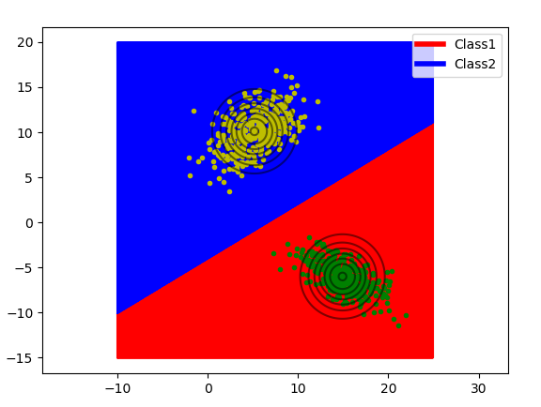**3.1.1 Linear Data:**

Figure 1. Decision Boundary and Contour Plot for Case 1 with Linear Data for class1 and class2

**Accuracy = 100%**

Confusion Matrix Analysis

|  |  |  |
| --- | --- | --- |
|  | **class1** | **class2** |
| **class1** | 125 | 0 |
| **class2** | 0 | 125 |

|  |  |  |
| --- | --- | --- |
|  | **class1** | **class2** |
| **Precision** | 1.0 | 1.0 |
| **Recall** | 1.0 | 1.0 |
| **F-measure** | 0.5 | 0.5 |

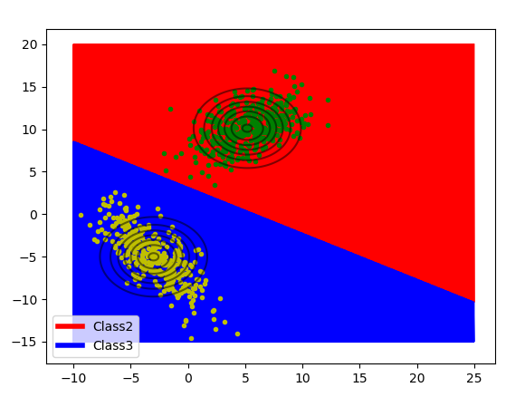_____________________________________________________________

Figure 2. Decision Boundary and Contour Plot for Case 1 with Linear Data for class2 and class3

**Accuracy = 100%**

Confusion Matrix Analysis

|  |  |  |
| --- | --- | --- |
|  | **class2** | **class3** |
| **class2** | 125 | 0 |
| **class3** | 0 | 125 |

|  |  |  |
| --- | --- | --- |
|  | **class2** | **class3** |
| **Precision** | 1.0 | 1.0 |
| **Recall** | 1.0 | 1.0 |
| **F-measure** | 0.5 | 0.5 |

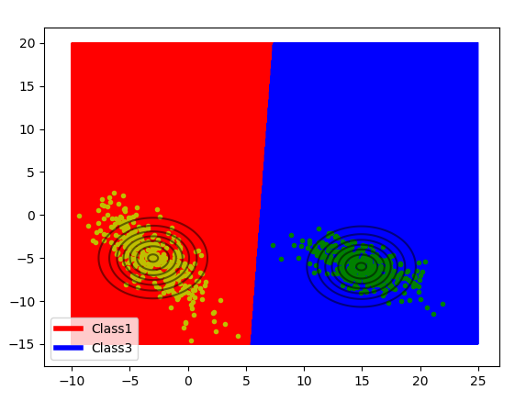_____________________________________________________________

Figure 3. Decision Boundary and Contour Plot for Case 1 with Linear Data for class1 and class3

**Accuracy = 100%**

Confusion Matrix Analysis

|  |  |  |
| --- | --- | --- |
|  | **class1** | **class3** |
| **class1** | 125 | 0 |
| **class3** | 0 | 125 |

|  |  |  |
| --- | --- | --- |
|  | **class1** | **class3** |
| **Precision** | 1.0 | 1.0 |
| **Recall** | 1.0 | 1.0 |
| **F-measure** | 0.5 | 0.5 |

_____________________________________________________________

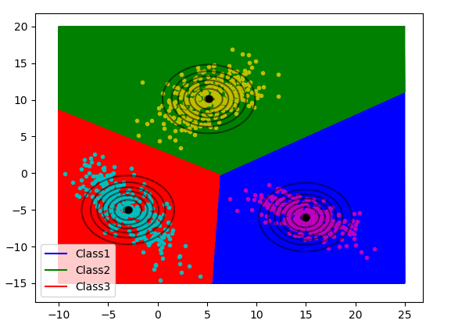

Figure 4. Decision Boundary and Contour Plot for Case 1 with Linear Data for all classes

**Accuracy = 100%**

Confusion Matrix Analysis

|  |  |  |  |
| --- | --- | --- | --- |
|  | **class1** | **class2** | **class3** |
| **class1** | 125 | 0 | 0 |
| **class2** | 0 | 125 | 0 |
| **class3** | 0 | 0 | 125 |

|  |  |  |  |
| --- | --- | --- | --- |
|  | **class1** | **class2** | **class3** |
| **Precision** | 1.0 | 1.0 | 1.0 |
| **Recall** | 1.0 | 1.0 | 1.0 |
| **F-measure** | 0.5 | 0.5 | 0.5 |

**3.1.2 Non Linear Data:**

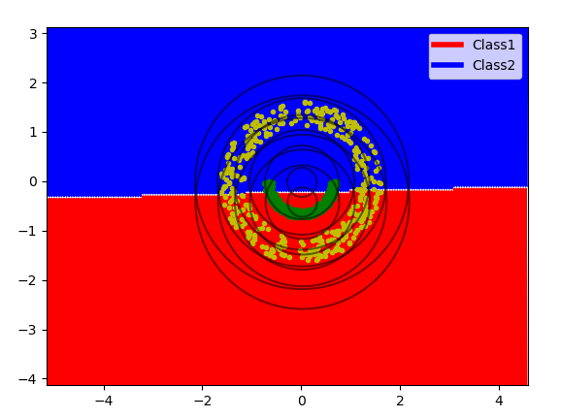

Figure 5. Decision Boundary and Contour Plot for Case 1 with Non Linear Data for class1 and class2

**Accuracy = 62.8%**

Confusion Matrix Analysis

|  |  |  |
| --- | --- | --- |
|  | **class1** | **class2** |
| **class1** | 87 | 38 |
| **class2** | 55 | 70 |

|  |  |  |
| --- | --- | --- |
|  | **class1** | **class2** |
| **Precision** | 0.6127 | 0.6482 |
| **Recall** | 0.696 | 0.56 |
| **F-measure** | 0.3258 | 0.3004 |

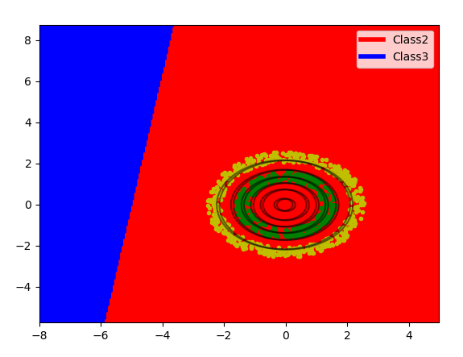_____________________________________________________________

Figure 6. Decision Boundary and Contour Plot for Case 1 with Non Linear Data for class2 and class3

**Accuracy = 41.67%**

Confusion Matrix Analysis

|  |  |  |
| --- | --- | --- |
|  | **class2** | **class3** |
| **class2** | 125 | 0 |
| **class3** | 175 | 0 |

|  |  |  |
| --- | --- | --- |
|  | **class2** | **class3** |
| **Precision** | 0.4167 | 0.0 |
| **Recall** | 1.0 | 0.0 |
| **F-measure** | 0.2941 | 0.0 |

_____________________________________________________________

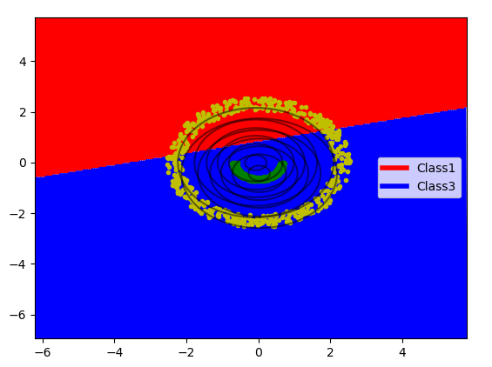Figure 7. Decision Boundary and Contour Plot for Case 1 with Non Linear Data for class1 and class3

**Accuracy = 66.33%**

Confusion Matrix Analysis

|  |  |  |
| --- | --- | --- |
|  | **class1** | **class3** |
| **class1** | 125 | 0 |
| **class3** | 101 | 74 |

|  |  |  |
| --- | --- | --- |
|  | **class1** | **class3** |
| **Precision** | 0.5531 | 1.0 |
| **Recall** | 1.0 | 0.4229 |
| **F-measure** | 0.3561 | 0.2972 |

_____________________________________________________________

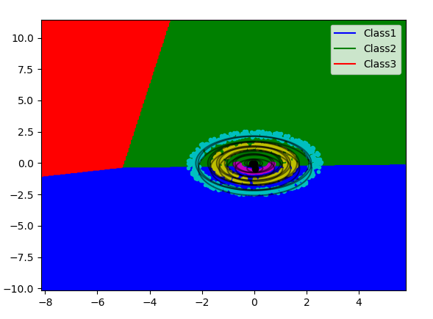

Figure 8. Decision Boundary and Contour Plot for Case 1 with Non Linear Data for all classes

**Accuracy = 36.94%**

Confusion Matrix Analysis

|  |  |  |  |
| --- | --- | --- | --- |
|  | **class1** | **class2** | **class3** |
| **class1** | 87 | 38 | 0 |
| **class2** | 55 | 70 | 0 |
| **class3** | 71 | 104 | 0 |

|  |  |  |  |
| --- | --- | --- | --- |
|  | **class1** | **class2** | **class3** |
| **Precision** | 0.4084 | 0.3302 | 0.0 |
| **Recall** | 0.696 | 0.56 | 0.0 |
| **F-measure** | 0.2574 | 0.2077 | 0.0 |

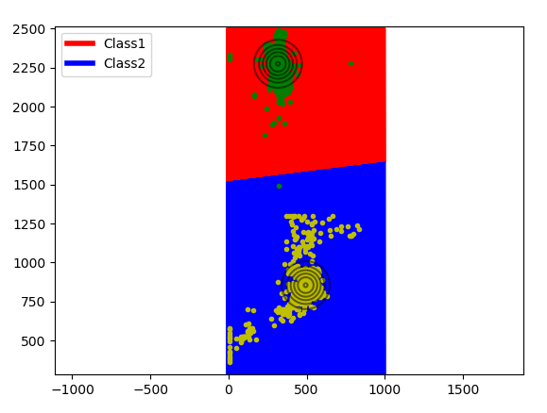**3.1.3 Real World Data:**

Figure 9. Decision Boundary and Contour Plot for Case 1 with Real World Data for class1 and class2

**Accuracy = 99.67%**

Confusion Matrix Analysis

|  |  |  |
| --- | --- | --- |
|  | **class1** | **class2** |
| **class1** | 593 | 4 |
| **class2** | 0 | 614 |

|  |  |  |
| --- | --- | --- |
|  | **class1** | **class2** |
| **Precision** | 1.0 | 0.9935 |
| **Recall** | 0.9933 | 1.0 |
| **F-measure** | 0.4983 | 0.4984 |

_____________________________________________________________

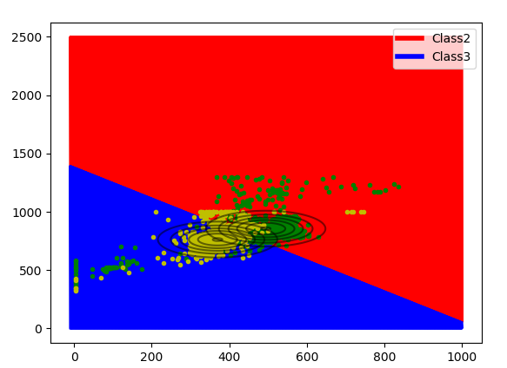

Figure 10. Decision Boundary and Contour Plot for Case 1 with Real World Data for class2 and class3

**Accuracy = 82.28%**

Confusion Matrix Analysis

|  |  |  |
| --- | --- | --- |
|  | **class2** | **class3** |
| **class2** | 445 | 169 |
| **class3** | 50 | 572 |

|  |  |  |
| --- | --- | --- |
|  | **class2** | **class3** |
| **Precision** | 0.8990 | 0.7719 |
| **Recall** | 0.7248 | 0.9196 |
| **F-measure** | 0.4013 | 0.4197 |

_____________________________________________________________

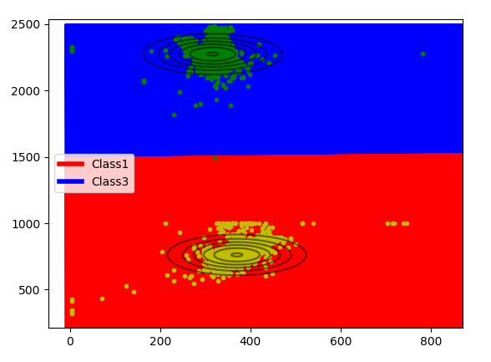

Figure 11. Decision Boundary and Contour Plot for Case 1 with Real World Data for class1 and class3

**Accuracy = 99.75%**

Confusion Matrix Analysis

|  |  |  |
| --- | --- | --- |
|  | **class1** | **class3** |
| **class1** | 594 | 3 |
| **class3** | 0 | 622 |

|  |  |  |
| --- | --- | --- |
|  | **class1** | **class3** |
| **Precision** | 1.0 | 0.9952 |
| **Recall** | 0.9950 | 1.0 |
| **F-measure** | 0.4987 | 0.4988 |

_____________________________________________________________

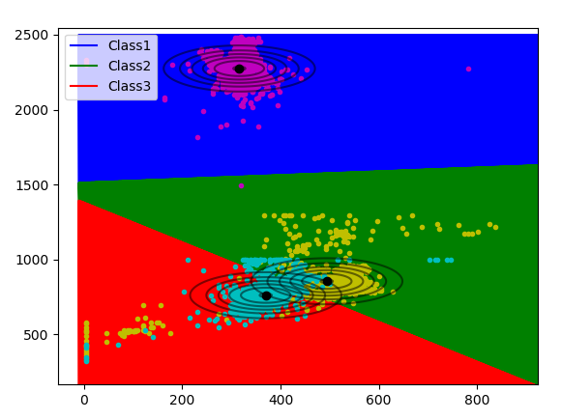

Figure 12. Decision Boundary and Contour Plot for Case 1 with Real World Data for all classes

**Accuracy = 87.83%**

Confusion Matrix Analysis

|  |  |  |  |
| --- | --- | --- | --- |
|  | **class1** | **class2** | **class3** |
| **class1** | 593 | 1 | 3 |
| **class2** | 0 | 445 | 169 |
| **class3** | 0 | 50 | 572 |

|  |  |  |  |
| --- | --- | --- | --- |
|  | **class1** | **class2** | **class3** |
| **Precision** | 1.0 | 0.8972 | 0.7688 |
| **Recall** | 0.9933 | 0.7248 | 0.9196 |
| **F-measure** | 0.4983 | 0.4009 | 0.4187 |

__________________________________________________________________

**3.1.4 Inferences:**

1. The Decision Surface is linear in nature, as can be seen from the plots.
2. The assumption in this case works well for linearly separable data, but gives poor results for non-linearly separable data and the real world data.
3. The nature of the contour is circular, since we have taken *∑ = σ2 I*

**3.2 Case 2 - *∑i = ∑***

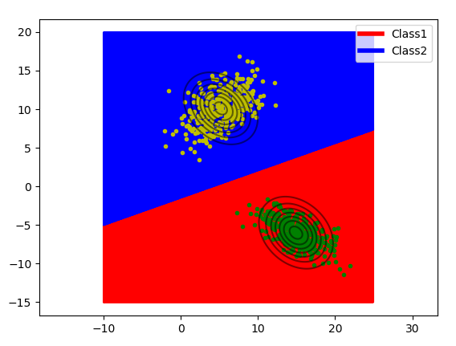**3.2.1 Linear Data:**

Figure 13. Decision Boundary and Contour Plot for Case 2 with Linear Data for class1 and class2

**Accuracy = 100%**

Confusion Matrix Analysis

|  |  |  |
| --- | --- | --- |
|  | **class1** | **class2** |
| **class1** | 125 | 0 |
| **class2** | 0 | 125 |

|  |  |  |
| --- | --- | --- |
|  | **class1** | **class2** |
| **Precision** | 1.0 | 1.0 |
| **Recall** | 1.0 | 1.0 |
| **F-measure** | 0.5 | 0.5 |

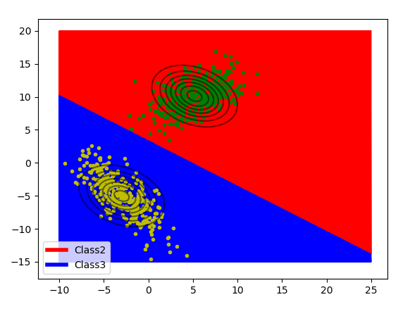_____________________________________________________________

Figure 14. Decision Boundary and Contour Plot for Case 2 with Linear Data for class2 and class3

**Accuracy = 100%**

Confusion Matrix Analysis

|  |  |  |
| --- | --- | --- |
|  | **class2** | **class3** |
| **class2** | 125 | 0 |
| **class3** | 0 | 125 |

|  |  |  |
| --- | --- | --- |
|  | **class2** | **class3** |
| **Precision** | 1.0 | 1.0 |
| **Recall** | 1.0 | 1.0 |
| **F-measure** | 0.5 | 0.5 |

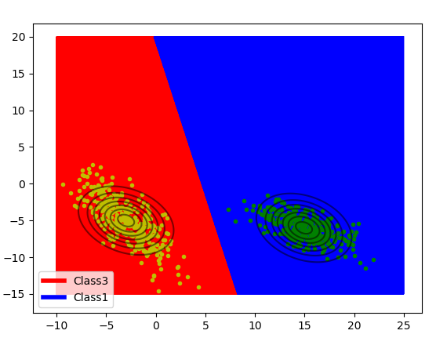_____________________________________________________________

Figure 15. Decision Boundary and Contour Plot for Case 2 with Linear Data for class1 and class3

**Accuracy = 100%**

Confusion Matrix Analysis

|  |  |  |
| --- | --- | --- |
|  | **class1** | **class3** |
| **class1** | 125 | 0 |
| **class3** | 0 | 125 |

|  |  |  |
| --- | --- | --- |
|  | **class1** | **class3** |
| **Precision** | 1.0 | 1.0 |
| **Recall** | 1.0 | 1.0 |
| **F-measure** | 0.5 | 0.5 |

_____________________________________________________________

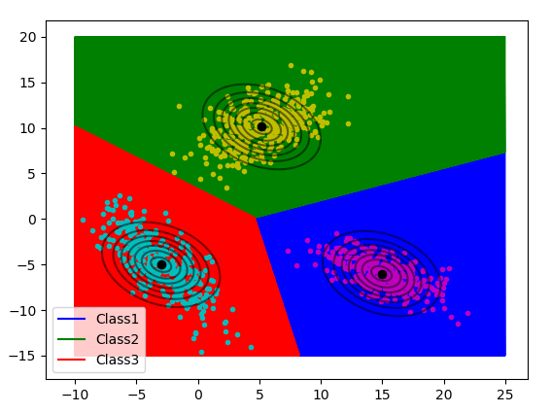

Figure 16. Decision Boundary and Contour Plot for Case 2 with Linear Data for all classes

**Accuracy = 100%**

Confusion Matrix Analysis

|  |  |  |  |
| --- | --- | --- | --- |
|  | **class1** | **class2** | **class3** |
| **class1** | 125 | 0 | 0 |
| **class2** | 0 | 125 | 0 |
| **class3** | 0 | 0 | 125 |

|  |  |  |  |
| --- | --- | --- | --- |
|  | **class1** | **class2** | **class3** |
| **Precision** | 1.0 | 1.0 | 1.0 |
| **Recall** | 1.0 | 1.0 | 1.0 |
| **F-measure** | 0.5 | 0.5 | 0.5 |

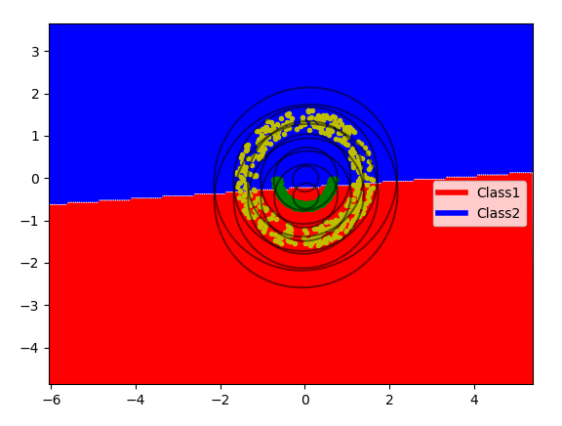**3.2.2 Non Linear Data:**

Figure 17. Decision Boundary and Contour Plot for Case 2 with Non Linear Data for class1 and class2

**Accuracy = 63.6%**

Confusion Matrix Analysis

|  |  |  |
| --- | --- | --- |
|  | **class1** | **class2** |
| **class1** | 89 | 36 |
| **class2** | 55 | 70 |

|  |  |  |
| --- | --- | --- |
|  | **class1** | **class2** |
| **Precision** | 0.6181 | 0.6604 |
| **Recall** | 0.712 | 0.56 |
| **F-measure** | 0.3309 | 0.3030 |

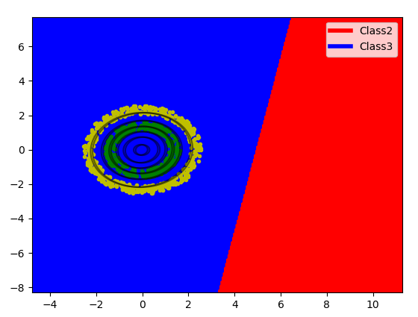_____________________________________________________________

Figure 18. Decision Boundary and Contour Plot for Case 2 with Non Linear Data for class2 and class3

**Accuracy = 58.33%**

Confusion Matrix Analysis

|  |  |  |
| --- | --- | --- |
|  | **class2** | **class3** |
| **class2** | 0 | 125 |
| **class3** | 0 | 175 |

|  |  |  |
| --- | --- | --- |
|  | **class2** | **class3** |
| **Precision** | 0.0 | 0.5833 |
| **Recall** | 0.0 | 1.0 |
| **F-measure** | 0.0 | 0.3684 |

_____________________________________________________________

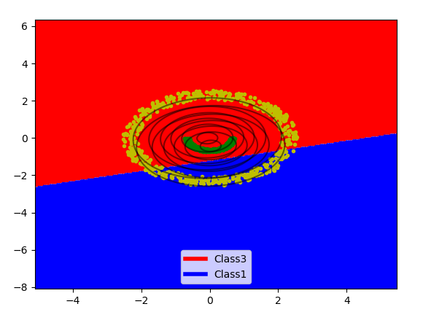

Figure 19. Decision Boundary and Contour Plot for Case 2 with Non Linear Data for class1 and class3

**Accuracy = 40.67%**

Confusion Matrix Analysis

|  |  |  |
| --- | --- | --- |
|  | **class1** | **class3** |
| **class1** | 0 | 125 |
| **class3** | 53 | 122 |

|  |  |  |
| --- | --- | --- |
|  | **class1** | **class3** |
| **Precision** | 0.0 | 0.4939 |
| **Recall** | 0.0 | 0.6971 |
| **F-measure** | 0.0 | 0.2891 |

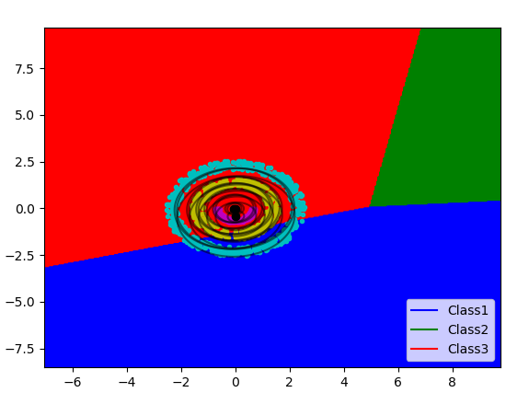_____________________________________________________________

Figure 20. Decision Boundary and Contour Plot for Case 2 with Non Linear Data for all classes

**Accuracy = 28.71%**

Confusion Matrix Analysis

|  |  |  |  |
| --- | --- | --- | --- |
|  | **class1** | **class2** | **class3** |
| **class1** | 0 | 0 | 125 |
| **class2** | 10 | 0 | 115 |
| **class3** | 53 | 0 | 122 |

|  |  |  |  |
| --- | --- | --- | --- |
|  | **class1** | **class2** | **class3** |
| **Precision** | 0.0 | 0.0 | 0.3370 |
| **Recall** | 0.0 | 0.0 | 0.6971 |
| **F-measure** | 0.0 | 0.0 | 0.2272 |

**3.2.3 Real World Data:**

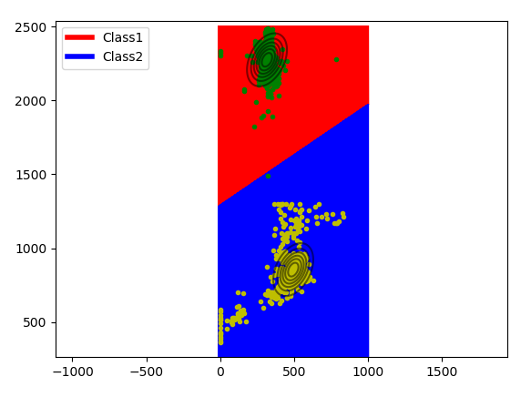

Figure 21. Decision Boundary and Contour Plot for Case 2 with Real World Data for class1 and class2

**Accuracy = 98.68%**

Confusion Matrix Analysis

|  |  |  |
| --- | --- | --- |
|  | **class1** | **class2** |
| **class1** | 581 | 16 |
| **class2** | 0 | 614 |

|  |  |  |
| --- | --- | --- |
|  | **class1** | **class2** |
| **Precision** | 1.0 | 0.9746 |
| **Recall** | 0.9732 | 1.0 |
| **F-measure** | 0.4932 | 0.4936 |

_____________________________________________________________

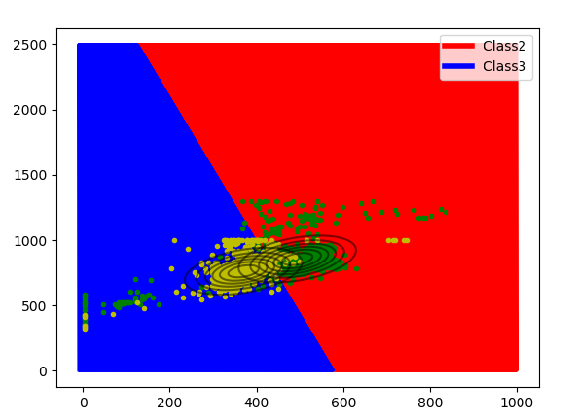

Figure 22. Decision Boundary and Contour Plot for Case 2 with Real World Data for class2 and class3

**Accuracy = 82.12%**

Confusion Matrix Analysis

|  |  |  |
| --- | --- | --- |
|  | **class2** | **class3** |
| **class2** | 423 | 191 |
| **class3** | 30 | 592 |

|  |  |  |
| --- | --- | --- |
|  | **class2** | **class3** |
| **Precision** | 0.9338 | 0.7561 |
| **Recall** | 0.6889 | 0.9518 |
| **F-measure** | 0.3964 | 0.4214 |

_____________________________________________________________

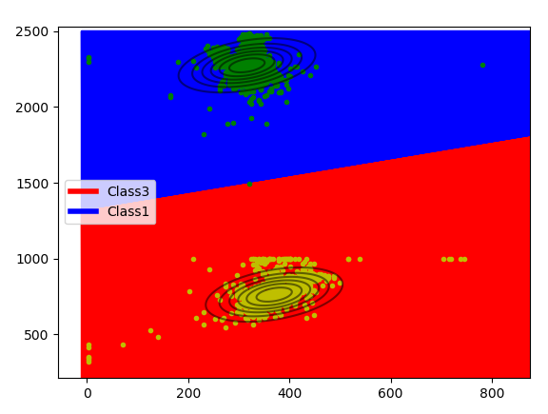

Figure 23. Decision Boundary and Contour Plot for Case 2 with Real World Data for class1 and class3

**Accuracy = 98.93%**

Confusion Matrix Analysis

|  |  |  |
| --- | --- | --- |
|  | **class1** | **class3** |
| **class1** | 584 | 13 |
| **class3** | 0 | 622 |

|  |  |  |
| --- | --- | --- |
|  | **class1** | **class3** |
| **Precision** | 1.0 | 0.9795 |
| **Recall** | 0.9782 | 1.0 |
| **F-measure** | 0.4945 | 0.4948 |

_____________________________________________________________

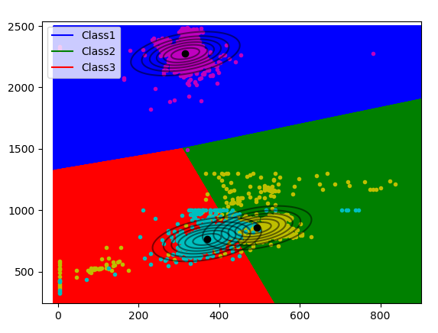

Figure 24. Decision Boundary and Contour Plot for Case 2 with Real World Data for all classes

**Accuracy = 87.07%**

Confusion Matrix Analysis

|  |  |  |  |
| --- | --- | --- | --- |
|  | **class1** | **class2** | **class3** |
| **class1** | 581 | 13 | 3 |
| **class2** | 0 | 423 | 191 |
| **class3** | 0 | 30 | 592 |

|  |  |  |  |
| --- | --- | --- | --- |
|  | **class1** | **class2** | **class3** |
| **Precision** | 1.0 | 0.9077 | 0.7532 |
| **Recall** | 0.9732 | 0.6889 | 0.9518 |
| **F-measure** | 0.4932 | 0.3917 | 0.4204 |

__________________________________________________________________

* + 1. **Inferences:**

1. The Decision Surface is linear in nature, as can be seen from the plots.
2. The assumption in this case works well for linearly separable data, but gives poor results for non-linearly separable data and real world data.
3. The nature of the contour is elliptical, since we have taken *∑i =∑* (where *∑* is found by taking mean of the *∑* of the three classes.

**3.3 Case 3 - *∑i = ∑***

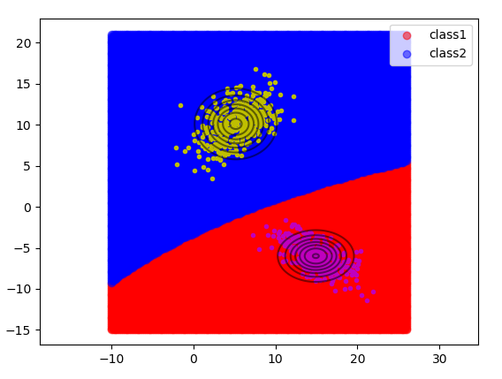**3.3.1 Linear Data:**

Figure 25. Decision Boundary and Contour Plot for Case 3 with Linear Data for class1 and class2

**Accuracy = 100%**

Confusion Matrix Analysis

|  |  |  |
| --- | --- | --- |
|  | **class1** | **class2** |
| **class1** | 125 | 0 |
| **class2** | 0 | 125 |

|  |  |  |
| --- | --- | --- |
|  | **class1** | **class2** |
| **Precision** | 1.0 | 1.0 |
| **Recall** | 1.0 | 1.0 |
| **F-measure** | 0.5 | 0.5 |

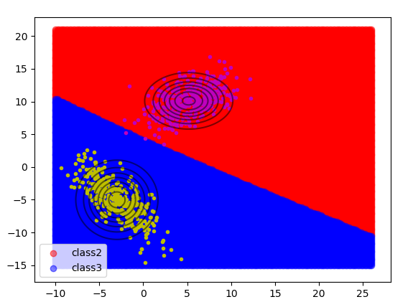_____________________________________________________________

Figure 26. Decision Boundary and Contour Plot for Case 3 with Linear Data for class2 and class3

**Accuracy = 100%**

Confusion Matrix Analysis

|  |  |  |
| --- | --- | --- |
|  | **class2** | **class3** |
| **class2** | 125 | 0 |
| **class3** | 0 | 125 |

|  |  |  |
| --- | --- | --- |
|  | **class2** | **class3** |
| **Precision** | 1.0 | 1.0 |
| **Recall** | 1.0 | 1.0 |
| **F-measure** | 0.5 | 0.5 |

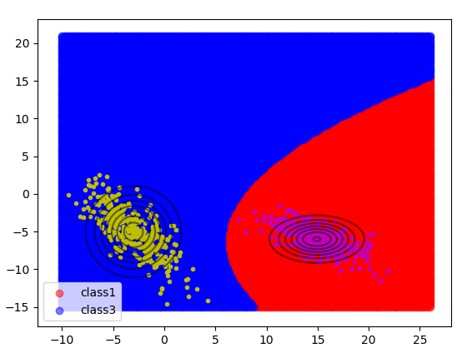_____________________________________________________________

Figure 27. Decision Boundary and Contour Plot for Case 3 with Linear Data for class1 and class3

**Accuracy = 100%**

Confusion Matrix Analysis

|  |  |  |
| --- | --- | --- |
|  | **class1** | **class3** |
| **class1** | 125 | 0 |
| **class3** | 0 | 125 |

|  |  |  |
| --- | --- | --- |
|  | **class1** | **class3** |
| **Precision** | 1.0 | 1.0 |
| **Recall** | 1.0 | 1.0 |
| **F-measure** | 0.5 | 0.5 |

_____________________________________________________________

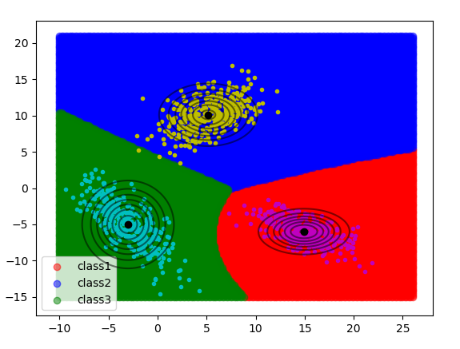

Figure 28. Decision Boundary and Contour Plot for Case 3 with Linear Data for all classes

**Accuracy = 100%**

Confusion Matrix Analysis

|  |  |  |  |
| --- | --- | --- | --- |
|  | **class1** | **class2** | **class3** |
| **class1** | 125 | 0 | 0 |
| **class2** | 0 | 125 | 0 |
| **class3** | 0 | 0 | 125 |

|  |  |  |  |
| --- | --- | --- | --- |
|  | **class1** | **class2** | **class3** |
| **Precision** | 1.0 | 1.0 | 1.0 |
| **Recall** | 1.0 | 1.0 | 1.0 |
| **F-measure** | 0.5 | 0.5 | 0.5 |

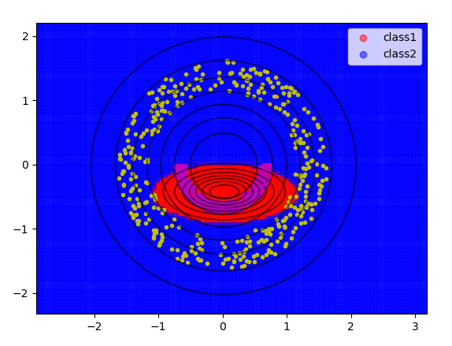**3.3.2 Non Linear Data:**

Figure 29. Decision Boundary and Contour Plot for Case 3 with Non Linear Data for class1 and class2

**Accuracy = 97.2%**

Confusion Matrix Analysis

|  |  |  |
| --- | --- | --- |
|  | **class1** | **class2** |
| **class1** | 120 | 5 |
| **class2** | 2 | 123 |

|  |  |  |
| --- | --- | --- |
|  | **class1** | **class2** |
| **Precision** | 0.9836 | 0.9609 |
| **Recall** | 0.96 | 0.984 |
| **F-measure** | 0.4858 | 0.4862 |

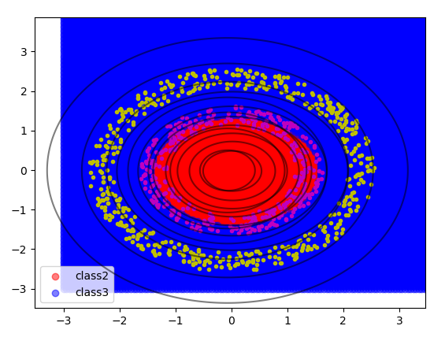

_____________________________________________________________

Figure 30. Decision Boundary and Contour Plot for Case 3 with Non Linear Data for class2 and class3

**Accuracy = 83.33%**

Confusion Matrix Analysis

|  |  |  |
| --- | --- | --- |
|  | **class2** | **class3** |
| **class2** | 75 | 50 |
| **class3** | 0 | 175 |

|  |  |  |
| --- | --- | --- |
|  | **class2** | **class3** |
| **Precision** | 1.0 | 0.7778 |
| **Recall** | 0.6 | 1.0 |
| **F-measure** | 0.375 | 0.4375 |

_____________________________________________________________

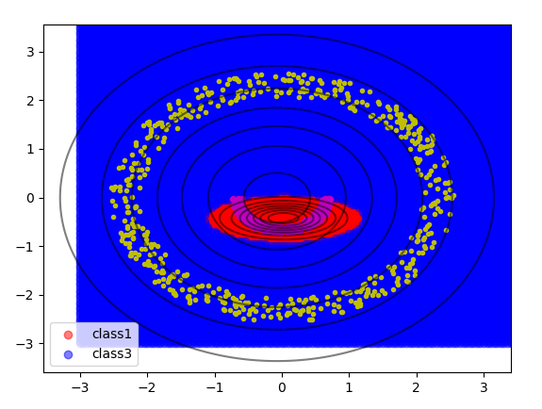

Figure 31. Decision Boundary and Contour Plot for Case 3 with Non Linear Data for class1 and class3

**Accuracy = 100%**

Confusion Matrix Analysis

|  |  |  |
| --- | --- | --- |
|  | **class1** | **class3** |
| **class1** | 125 | 0 |
| **class3** | 0 | 175 |

|  |  |  |
| --- | --- | --- |
|  | **class1** | **class3** |
| **Precision** | 1.0 | 1.0 |
| **Recall** | 1.0 | 1.0 |
| **F-measure** | 0.5 | 0.5 |

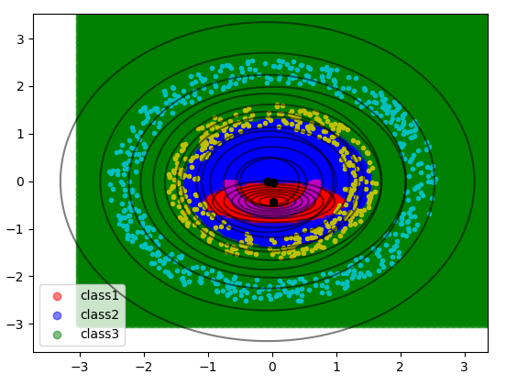_____________________________________________________________

Figure 32. Decision Boundary and Contour Plot for Case 3 with Non Linear Data for all classes

**Accuracy = 86.59%**

Confusion Matrix Analysis

|  |  |  |  |
| --- | --- | --- | --- |
|  | **class1** | **class2** | **class3** |
| **class1** | 120 | 5 | 0 |
| **class2** | 2 | 73 | 50 |
| **class3** | 0 | 0 | 175 |

|  |  |  |  |
| --- | --- | --- | --- |
|  | **class1** | **class2** | **class3** |
| **Precision** | 0.9836 | 0.9359 | 0.7778 |
| **Recall** | 0.96 | 0.584 | 1.0 |
| **F-measure** | 0.4858 | 0.3596 | 0.4375 |

**3.3.3 Real World Data:**

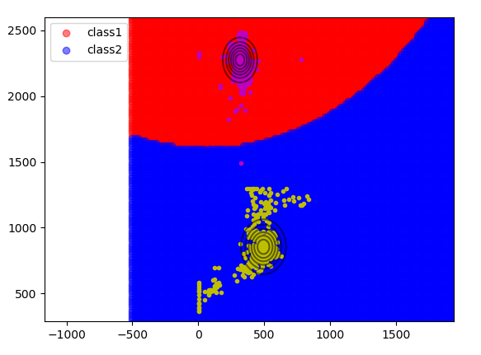

Figure 33. Decision Boundary and Contour Plot for Case 3 with Real World Data for class1 and class2

**Accuracy = 99.67%**

Confusion Matrix Analysis

|  |  |  |
| --- | --- | --- |
|  | **class1** | **class2** |
| **class1** | 594 | 3 |
| **class2** | 1 | 613 |

|  |  |  |
| --- | --- | --- |
|  | **class1** | **class2** |
| **Precision** | 0.9983 | 0.9951 |
| **Recall** | 0.9950 | 0.9984 |
| **F-measure** | 0.4983 | 0.4984 |

_____________________________________________________________

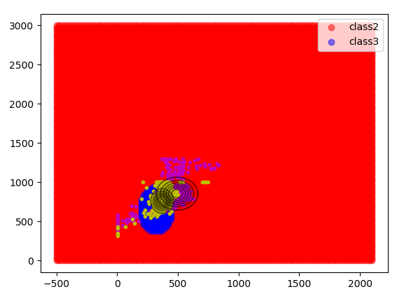

Figure 34. Decision Boundary and Contour Plot for Case 3 with Real World Data for class2 and class3

**Accuracy = 86.33%**

Confusion Matrix Analysis

|  |  |  |
| --- | --- | --- |
|  | **class2** | **class3** |
| **class2** | 505 | 109 |
| **class3** | 60 | 562 |

|  |  |  |
| --- | --- | --- |
|  | **class2** | **class3** |
| **Precision** | 0.8938 | 0.8376 |
| **Recall** | 0.8225 | 0.9035 |
| **F-measure** | 0.4283 | 0.4346 |

_____________________________________________________________

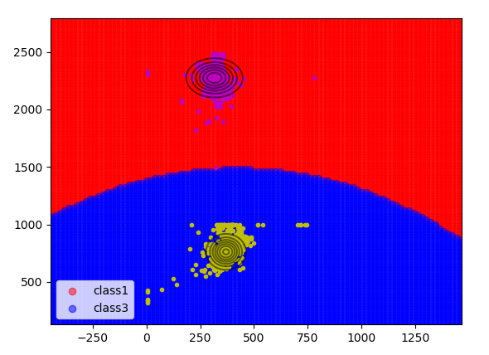

Figure 35. Decision Boundary and Contour Plot for Case 3 with Real World Data for class1 and class3

**Accuracy = 99.75%**

Confusion Matrix Analysis

|  |  |  |
| --- | --- | --- |
|  | **class1** | **class3** |
| **class1** | 594 | 3 |
| **class3** | 0 | 622 |

|  |  |  |
| --- | --- | --- |
|  | **class1** | **class3** |
| **Precision** | 1.0 | 0.9952 |
| **Recall** | 0.9950 | 1.0 |
| **F-measure** | 0.4987 | 0.4988 |

_____________________________________________________________

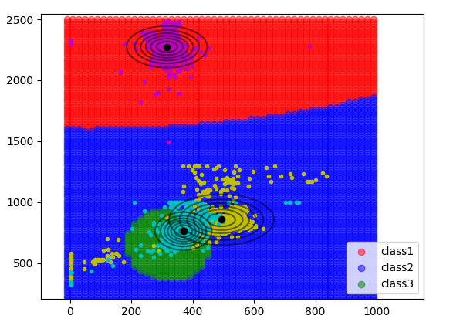

Figure 36. Decision Boundary and Contour Plot for Case 3 with Real World Data for all classes

**Accuracy = 90.56%**

Confusion Matrix Analysis

|  |  |  |  |
| --- | --- | --- | --- |
|  | **class1** | **class2** | **class3** |
| **class1** | 594 | 0 | 3 |
| **class2** | 1 | 504 | 109 |
| **class3** | 0 | 60 | 562 |

|  |  |  |  |
| --- | --- | --- | --- |
|  | **class1** | **class2** | **class3** |
| **Precision** | 0.9983 | 0.8936 | 0.8338 |
| **Recall** | 0.9950 | 0.8208 | 0.9035 |
| **F-measure** | 0.4983 | 0.4278 | 0.4336 |

__________________________________________________________________

**3.3.4 Inferences:**

1. The Decision Surface is non-linear in nature, as can be seen from the plots.
2. The assumption in this case works well for linearly separable data, and good (but not as good as linearly separable data) for other sorts of data.
3. The nature of the contour is elliptical and is different for each class, but is oriented horizontally.

**3.4 Case 4 - *∑i* is unique**

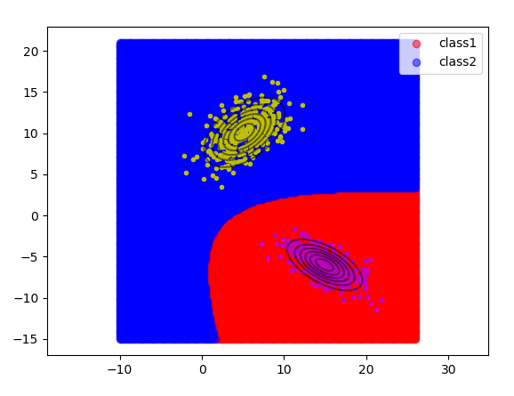**3.4.1 Linear Data:**

Figure 37. Decision Boundary and Contour Plot for Case 4 with Linear Data for class1 and class2

**Accuracy = 100%**

Confusion Matrix Analysis

|  |  |  |
| --- | --- | --- |
|  | **class1** | **class2** |
| **class1** | 125 | 0 |
| **class2** | 0 | 125 |

|  |  |  |
| --- | --- | --- |
|  | **class1** | **class2** |
| **Precision** | 1.0 | 1.0 |
| **Recall** | 1.0 | 1.0 |
| **F-measure** | 0.5 | 0.5 |

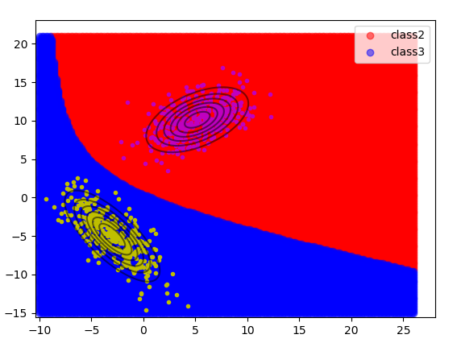_____________________________________________________________

Figure 38. Decision Boundary and Contour Plot for Case 4 with Linear Data for class2 and class3

**Accuracy = 100%**

Confusion Matrix Analysis

|  |  |  |
| --- | --- | --- |
|  | **class2** | **class3** |
| **class2** | 125 | 0 |
| **class3** | 0 | 125 |

|  |  |  |
| --- | --- | --- |
|  | **class2** | **class3** |
| **Precision** | 1.0 | 1.0 |
| **Recall** | 1.0 | 1.0 |
| **F-measure** | 0.5 | 0.5 |

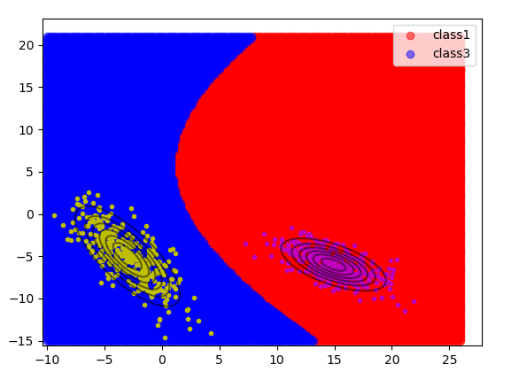_____________________________________________________________

Figure 39. Decision Boundary and Contour Plot for Case 4 with Linear Data for class1 and class3

**Accuracy = 100%**

Confusion Matrix Analysis

|  |  |  |
| --- | --- | --- |
|  | **class1** | **class3** |
| **class1** | 125 | 0 |
| **class3** | 0 | 125 |

|  |  |  |
| --- | --- | --- |
|  | **class1** | **class3** |
| **Precision** | 1.0 | 1.0 |
| **Recall** | 1.0 | 1.0 |
| **F-measure** | 0.5 | 0.5 |

_____________________________________________________________

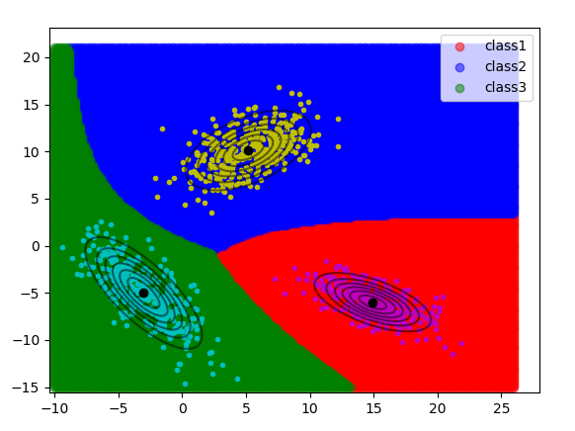

Figure 40. Decision Boundary and Contour Plot for Case 4 with Linear Data for all classes

**Accuracy = 100%**

Confusion Matrix Analysis

|  |  |  |  |
| --- | --- | --- | --- |
|  | **class1** | **class2** | **class3** |
| **class1** | 125 | 0 | 0 |
| **class2** | 0 | 125 | 0 |
| **class3** | 0 | 0 | 125 |

|  |  |  |  |
| --- | --- | --- | --- |
|  | **class1** | **class2** | **class3** |
| **Precision** | 1.0 | 1.0 | 1.0 |
| **Recall** | 1.0 | 1.0 | 1.0 |
| **F-measure** | 0.5 | 0.5 | 0.5 |

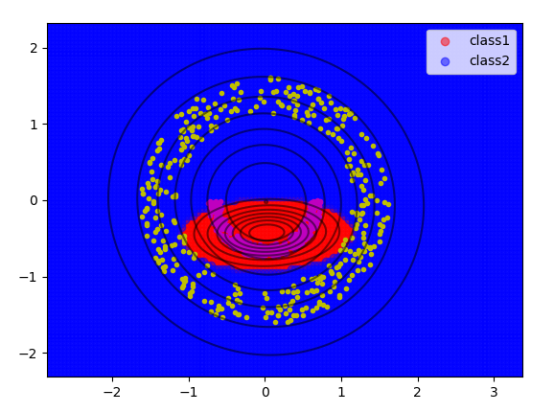**3.4.2 Non Linear Data:**

Figure 41. Decision Boundary and Contour Plot for Case 4 with Non Linear Data for class1 and class2

**Accuracy = 97.2%**

Confusion Matrix Analysis

|  |  |  |
| --- | --- | --- |
|  | **class1** | **class2** |
| **class1** | 120 | 5 |
| **class2** | 2 | 123 |

|  |  |  |
| --- | --- | --- |
|  | **class1** | **class2** |
| **Precision** | 0.9836 | 0.9609 |
| **Recall** | 0.96 | 0.984 |
| **F-measure** | 0.4858 | 0.4862 |

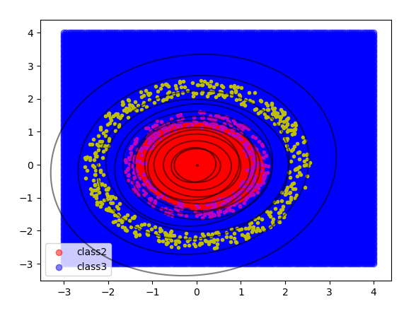_____________________________________________________________

Figure 42. Decision Boundary and Contour Plot for Case 4 with Non Linear Data for class2 and class3

**Accuracy = 83.33%**

Confusion Matrix Analysis

|  |  |  |
| --- | --- | --- |
|  | **class2** | **class3** |
| **class2** | 75 | 50 |
| **class3** | 0 | 175 |

|  |  |  |
| --- | --- | --- |
|  | **class2** | **class3** |
| **Precision** | 1.0 | 0.7778 |
| **Recall** | 0.6 | 1.0 |
| **F-measure** | 0.375 | 0.4375 |

_____________________________________________________________

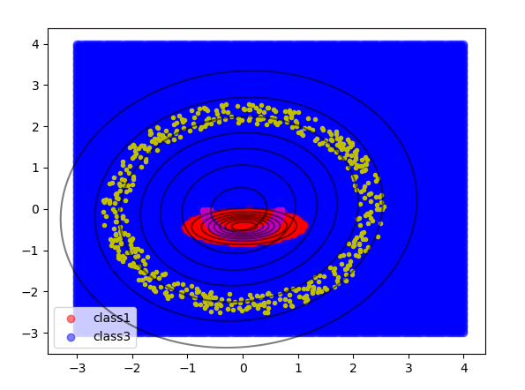

Figure 43. Decision Boundary and Contour Plot for Case 4 with Non Linear Data for class1 and class3

**Accuracy = 100%**

Confusion Matrix Analysis

|  |  |  |
| --- | --- | --- |
|  | **class1** | **class3** |
| **class1** | 125 | 0 |
| **class3** | 0 | 175 |

|  |  |  |
| --- | --- | --- |
|  | **class1** | **class3** |
| **Precision** | 1.0 | 1.0 |
| **Recall** | 1.0 | 1.0 |
| **F-measure** | 0.5 | 0.5 |

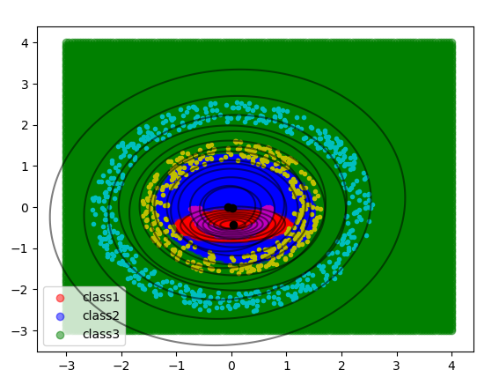_____________________________________________________________

Figure 44. Decision Boundary and Contour Plot for Case 4 with Non Linear Data for all classes

**Accuracy = 86.59%**

Confusion Matrix Analysis

|  |  |  |  |
| --- | --- | --- | --- |
|  | **class1** | **class2** | **class3** |
| **class1** | 120 | 5 | 0 |
| **class2** | 2 | 73 | 50 |
| **class3** | 0 | 0 | 175 |

|  |  |  |  |
| --- | --- | --- | --- |
|  | **class1** | **class2** | **class3** |
| **Precision** | 0.9836 | 0.9359 | 0.7778 |
| **Recall** | 0.96 | 0.584 | 1.0 |
| **F-measure** | 0.4858 | 0.3596 | 0.4375 |

**3.4.3 Real World Data:**

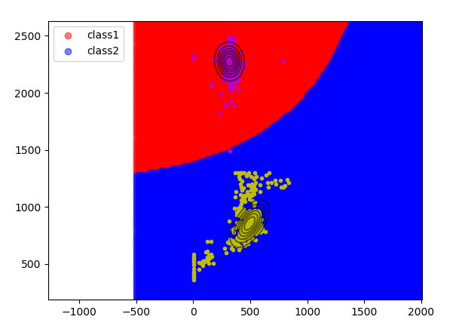

Figure 45. Decision Boundary and Contour Plot for Case 4 with Real World Data for class1 and class2

**Accuracy = 99.67%**

Confusion Matrix Analysis

|  |  |  |
| --- | --- | --- |
|  | **class1** | **class2** |
| **class1** | 594 | 3 |
| **class2** | 1 | 613 |

|  |  |  |
| --- | --- | --- |
|  | **class1** | **class2** |
| **Precision** | 0.9983 | 0.9951 |
| **Recall** | 0.9950 | 0.9984 |
| **F-measure** | 0.4983 | 0.4983 |

_____________________________________________________________

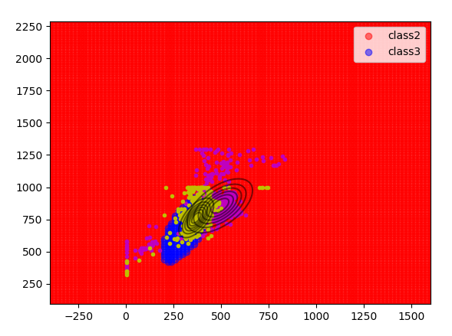

Figure 46. Decision Boundary and Contour Plot for Case 4 with Real World Data for class2 and class3

**Accuracy = 86.33%**

Confusion Matrix Analysis

|  |  |  |
| --- | --- | --- |
|  | **class2** | **class3** |
| **class2** | 505 | 109 |
| **class3** | 60 | 562 |

|  |  |  |
| --- | --- | --- |
|  | **class2** | **class3** |
| **Precision** | 0.8938 | 0.8376 |
| **Recall** | 0.8225 | 0.9035 |
| **F-measure** | 0.4283 | 0.4346 |

_____________________________________________________________

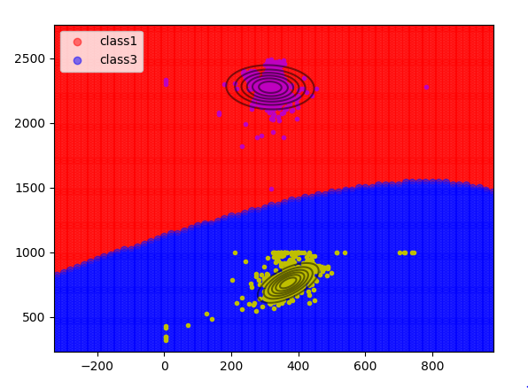

Figure 47. Decision Boundary and Contour Plot for Case 4 with Real World Data for class1 and class3

**Accuracy = 99.75%**

Confusion Matrix Analysis

|  |  |  |
| --- | --- | --- |
|  | **class1** | **class3** |
| **class1** | 594 | 3 |
| **class3** | 0 | 622 |

|  |  |  |
| --- | --- | --- |
|  | **class1** | **class3** |
| **Precision** | 1.0 | 0.9952 |
| **Recall** | 0.9950 | 1.0 |
| **F-measure** | 0.4987 | 0.4988 |

_____________________________________________________________

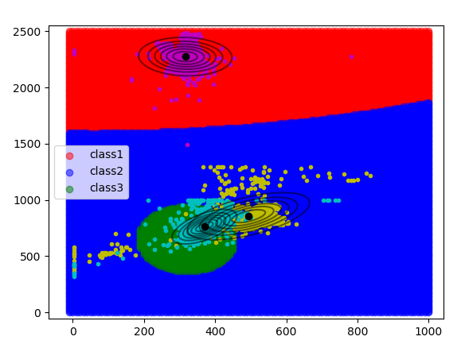

Figure 48. Decision Boundary and Contour Plot for Case 4 with Real World Data for all classes

**Accuracy = 90.56%**

Confusion Matrix Analysis

|  |  |  |  |
| --- | --- | --- | --- |
|  | **class1** | **class2** | **class3** |
| **class1** | 594 | 0 | 3 |
| **class2** | 1 | 504 | 109 |
| **class3** | 0 | 60 | 562 |

|  |  |  |  |
| --- | --- | --- | --- |
|  | **class1** | **class2** | **class3** |
| **Precision** | 0.9983 | 0.8936 | 0.8338 |
| **Recall** | 0.9950 | 0.8208 | 0.9035 |
| **F-measure** | 0.4983 | 0.4278 | 0.4336 |

__________________________________________________________________

**3.4.4 Inferences:**

1. The Decision Surface is non-linear in nature, as can be seen from the plots.
2. The assumption in this case works very well for linearly separable data, but gives not so good results for other sorts of data.
3. The nature of the contour is elliptical, different for each class, and oriented randomly.

**4. Conclusion**

* + 1. Bayes Classifier works well for Linearly separable data in all cases with high accuracy but fails for Non linearly separable data with poor accuracy.
    2. In case of Real World Data, the data is overlapping and thus results in lesser accuracy.
    3. In first two cases, the decision boundary comes out to be straight line whereas in last two cases, the decision boundary is quadratic due to different covariance matrix chosen.