PATTERN RECOGNITION ASSIGNMENT-3
REPORT

07^{h} November 2018

GROUP - 11

ABHIGYAN KHAUND PRATYUSH GAURAV SHASHWAT GARG
B16082 B16026 B16034

Faculty
Dr. A.D Dileep
Indian Institute of Technology, Mandi

Table of Contents

- Introduction……………………………………………………………………..3
- Vector Quantization……………………………………………………………4
- Experimental Observations
3.1 K-Nearest Neighbours Method
3.1.1. K = 4 ..…................................................................................4
3.1.2. K = 8 …..................................................................................5
3.1.3. K = 16 …................................................................................6
3.1.4. K = 32 …................................................................................8
2.2 Real World Dataset
2.2.1. 1 cluster..................................................................................13
2.2.2. 2 clusters................................................................................14
2.2.3. 4 clusters................................................................................15
2.2.4. 8 clusters................................................................................16
2.2.5. 16 clusters..............................................................................17
2.3 Image Dataset
2.3.1 Color coded Histograms
2.3.1.1. 1 cluster....................................................................19
2.3.1.2. 2 clusters..................................................................20
2.3.1.3. 4 clusters..................................................................21
2.3.1.4. 8 clusters..................................................................22
2.3.1.5. 16 clusters................................................................23
2.3.1.6. 32 clusters................................................................24
2.3.1.7. 64 clusters................................................................24
2.3.2 Bag of Visual Words
2.3.2.1. 1 cluster....................................................................25
2.3.2.2. 2 clusters..................................................................26
2.3.2.3. 4 clusters..................................................................27
2.3.2.4. 8 clusters..................................................................28
2.3.2.5. 16 clusters................................................................29
2.3.2.6. 32 clusters................................................................30
2.3.2.7. 64 clusters................................................................31
2.4 Cell Dataset………………………………………………………………..32
3. Conclusion and Observations....................................................................35

1. Introduction

K-Nearest Neighbour:

The K-Nearest Neighbour method is a non-parametric classification method in pattern recognition.
Algorithm: First we find out the distance of a test sample from all the train sample we have. From these distances the smallest k distances are chosen. Each train sample has a class label associated with it. for the nearest k samples chosen, the most frequent class label is also assigned to the test sample, classifying it into that class. We have used Dynamic Time Warping(DTW) algorithm to calculate distances in this assignment. DTW is a dynamic programming algorithm which is used to measure the similarity between two sequences which may vary in length, speed etc. Both the time and space complexity of this algorithm are of O(nm), where n and m are the lengths of sequences. The value of k also affects the result. for a very large k, all the K samples contribute equally to the classification, hence even the train samples far away from the test sample, but in the region bounded by smallest hypersphere enveloping all the k points, will affect the classification. If we take k equal to the number of train samples, all the test samples gets classified into class with maximum train samples in it. Whereas for a very small k, the effect of noise will be high. For example, if a test sample belonging to class A is present near some samples of class B, It will get classified into class B, though it belongs to class A. This is due to the very small number of nearest neighbours affecting the classification.

Discrete Hidden Markov Model:

A Markov process is a process in which the future is independent of the past given the present. That is the future state depends only on the current state and not on the previous states. Hidden Markov model is a Markov model in which the system being modeled is assumed to be Markov process with hidden/unknown states.

Data Set :
The type of data consist of speech data divided into 3 classes – ka, kha, kA. In each class the test samples and train samples consists of many 39 dimensional feature vectors.

Vector Quantization

The Observation Sequence consists of different observations, each of 39 dimensions for speech. In Vector Quantization,M no of clusters are formed using k-means clustering. Then each observation of a certain Observation Sequence is assigned a cluster. Thus, each observation is represented using only one value representing its cluster. Thus, the number of possible Observations becomes finite and equal to M.

Experimental Observations

3.1 K-Nearest Neighbours Method
Train and test samples are classified into 3 classes. Each class contains samples of particular sounds. Class 1 contains files which have feature vectors representing sound ’ka’, class 2 contains files which have feature vectors representing sound ’kha’ and class 3 contains files which have feature vectors representing sound ’kA’.
3.1.1 K = 4

Classification Accuracy (%) | 74.37
Precision for Class 1  Precision for Class 2  Precision for Class 3 | 0.782  0.750  0.724
Mean Precision | 0.752
Recall for Class 1  Recall for Class 2  Recall for Class 3 | 0.635  0.2  0.889
Mean Recall | 0.575
F-measure for Class 1  F-measure for Class 2  F-measure for Class 3 | 0.701  0.315  0.798
Mean F-measure | 0.605

Confusion Matrix :
C =
3.1.2 K = 8

Classification Accuracy (%) | 71.42
Precision for Class 1  Precision for Class 2  Precision for Class 3 | 0.777  1.0  0.684
Mean Precision | 0.820
Recall for Class 1  Recall for Class 2  Recall for Class 3 | 0.510  0.266  0.921
Mean Recall | 0.566
F-measure for Class 1  F-measure for Class 2  F-measure for Class 3 | 0.616  0.616  0.785
Mean F-measure | 0.607

Confusion Matrix :
C =
3.1.3 K=16

Classification Accuracy (%) | 67.22
Precision for Class 1  Precision for Class 2  Precision for Class 3 | 0.775  0.666  0.645
Mean Precision | 0.695
Recall for Class 1  Recall for Class 2  Recall for Class 3 | 0.395  0.133  0.944
Mean Recall | 0.491
F-measure for Class 1  F-measure for Class 2  F-measure for Class 3 | 0.524  0.222  0.766
Mean F-measure | 0.504

Confusion Matrix :
C =

3.1.4 K=32

Classification Accuracy (%) | 63.44
Precision for Class 1  Precision for Class 2  Precision for Class 3 | 0.783  0  0.606
Mean Precision | 0.463
Recall for Class 1  Recall for Class 2  Recall for Class 3 | 0.302  0.0  0.960
Mean Recall | 0.420
F-measure for Class 1  F-measure for Class 2  F-measure for Class 3 | 0.436  0  0.743
Mean F-measure | 0.393

Confusion Matrix :
C =
Overall Observations:
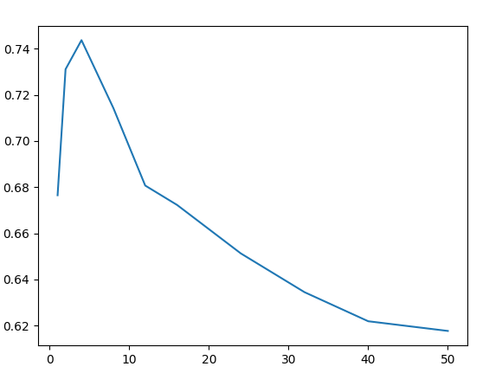
Illustration 1: Variation of accuracy w.r.t. k

- The way accuracy, precision and recall vary with k depends on the distribution of the data.
- We can see that initially with low value of k, the value of accuracy is less. This is due to noise being much more impactive at lower value of k. As k increases till about k=4, Accuracy increases up till a point, as noise becomes less and less contributing.
- After achieving a peak value, accuracy decreases again with further increase in k . As the value of k increases, almost all the train sample come into the role of contributing to the classification of a test point. Thus misclassification increases due to higher number of train samples in a class overpowering other factors.
- For class 2(kha), the number of training samples is very small as compared to other classes. For small values of k, most of its nearest neighbours belong to the same class, but as k increases, most of the nearest neighbours will come from Class 3 (kA). Thus, for sufficiently large values of k most of its test samples point will get classified into the Class 3.
- For very large values of k, the accuracy of classifier is solely due to the number of test samples of class into which entire data was classified.
- Confusion matrix for K = 50 -

2.2 Real World dataset

2.2.1 1 cluster
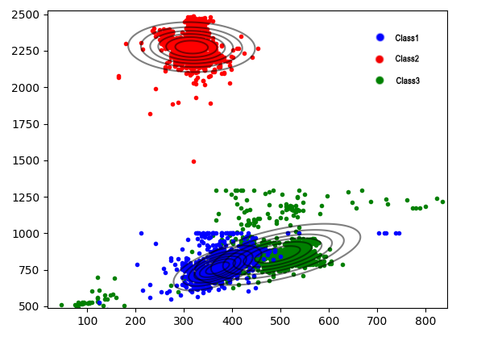
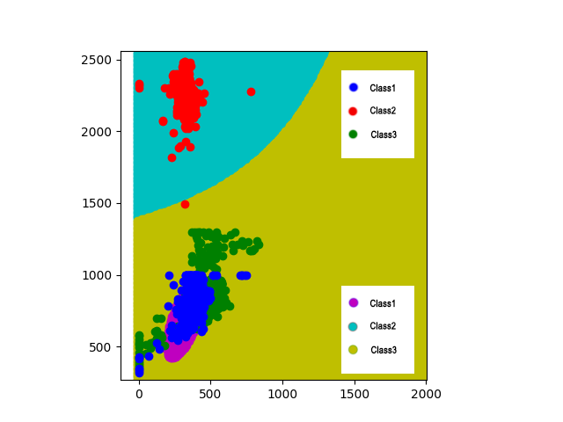

K = 1
Classification Accuracy (%) | 82.815%
Precision for Class 1  Precision for Class 2  Precision for Class 3 | 1.0  0.794  0.717
Mean Precision | 0.837
Recall for Class 1  Recall for Class 2  Recall for Class 3 | 0.973  0.661  0.854
Mean Recall | 0.829
F-measure for Class 1  F-measure for Class 2  F-measure for Class 3 | 0.986  0.722  0.779
Mean F-measure | 0.829

Confusion Matrix :
C =

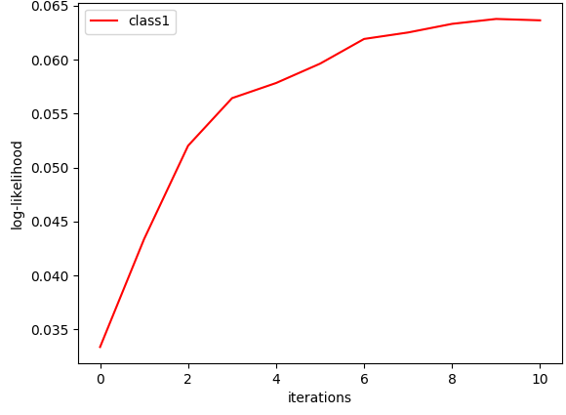
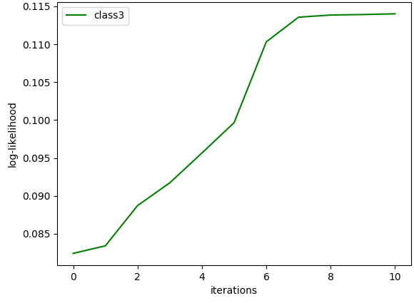
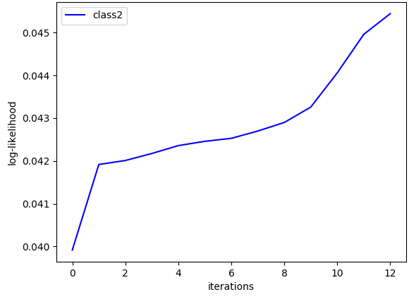

Log-likelihood vs Iterations graphs for K=1 on real world dataset

2.2.2 2 clusters
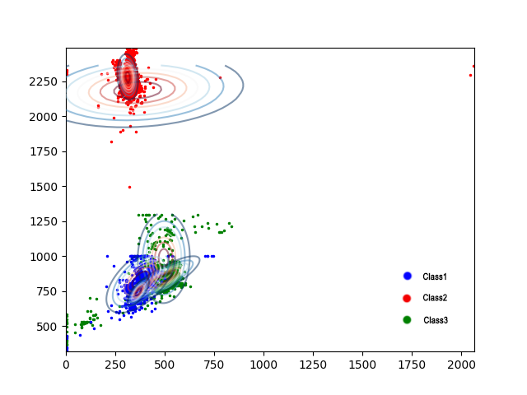
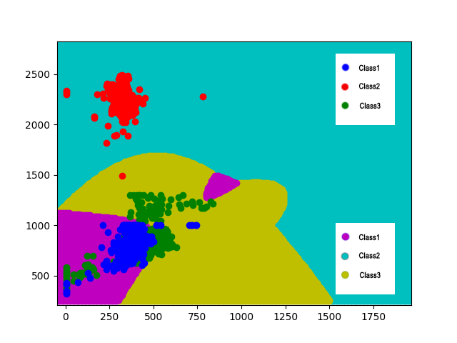

For K = 2

Classification Accuracy (%) | 85.543%
Precision for Class 1  Precision for Class 2  Precision for Class 3 | 0.998  0.884  0.730
Mean Precision | 0.871
Recall for Class 1  Recall for Class 2  Recall for Class 3 | 0.995  0.658  0.916
Mean Recall | 0.856
F-measure for Class 1  F-measure for Class 2  F-measure for Class 3 | 0.997  0.754  0.812
Mean F-measure | 0.834

Confusion Matrix :
C =

Log-likelihood vs Iterations graphs for K=2 on real world dataset

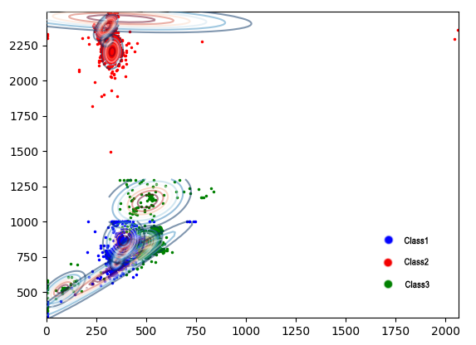
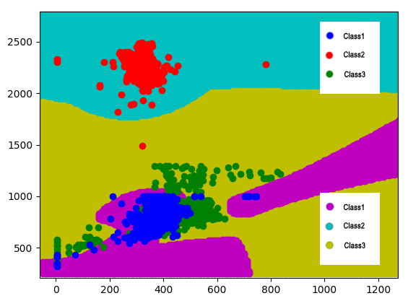
2.2.3 4 clusters

For K = 4

Classification Accuracy (%) | 84.070%
Precision for Class 1  Precision for Class 2  Precision for Class 3 | 1.0  0.877  0.706
Mean Precision | 0.861
Recall for Class 1  Recall for Class 2  Recall for Class 3 | 0.987  0.616  0.923
Mean Recall | 0.842
F-measure for Class 1  F-measure for Class 2  F-measure for Class 3 | 0.993  0.723  0.8
Mean F-measure | 0.839

Confusion Matrix :
C =
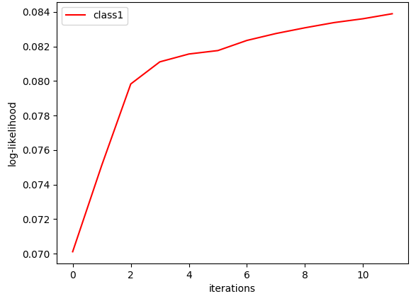
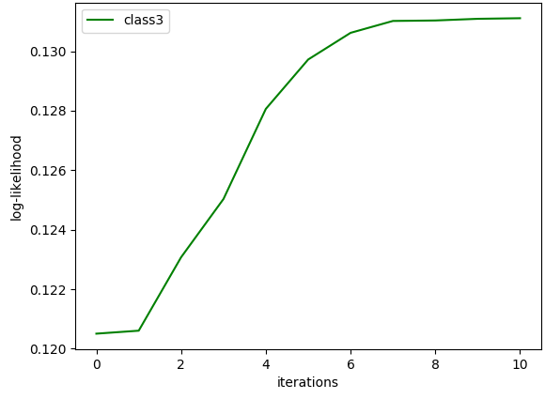
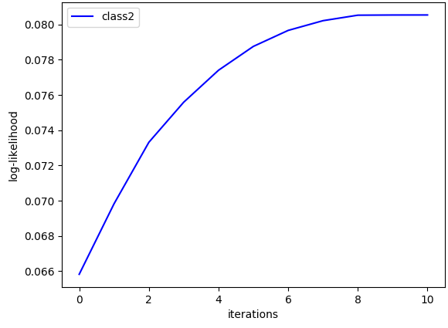
Log-likelihood vs Iterations graphs for K=4 on real world dataset

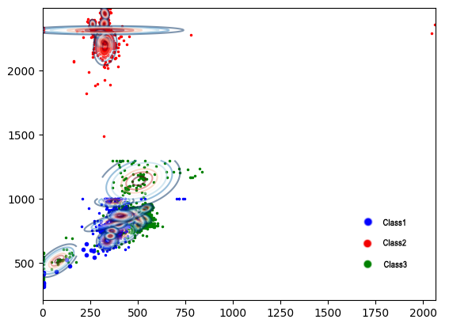
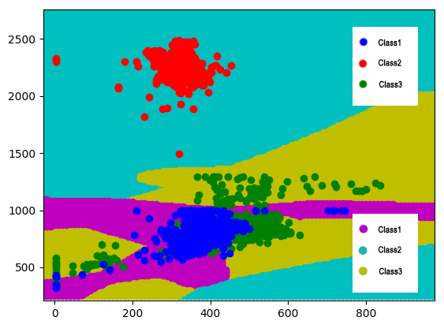
2.2.4 8 clusters
For K = 8

Classification Accuracy (%) | 85.870%
Precision for Class 1  Precision for Class 2  Precision for Class 3 | 0.998  0.918  0.726
Mean Precision | 0.881
Recall for Class 1  Recall for Class 2  Recall for Class 3 | 0.990  0.640  0.948
Mean Recall | 0.860
F-measure for Class 1  F-measure for Class 2  F-measure for Class 3 | 0.994  0.754  0.822
Mean F-measure | 0.857

Confusion Matrix :
C =
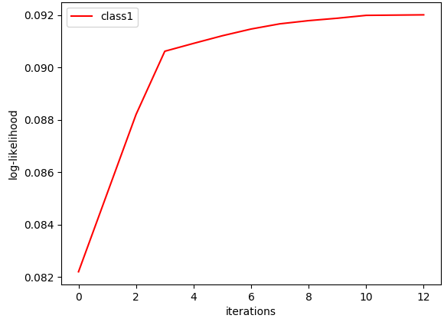
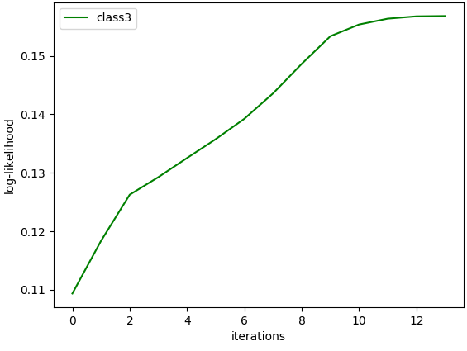
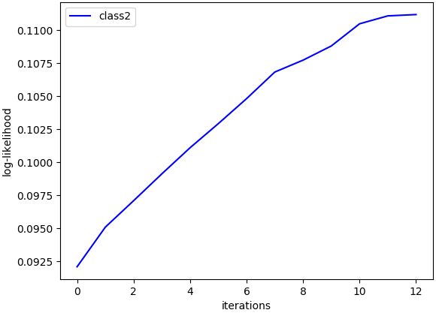

Log-likelihood vs Iterations graphs for K=8 on real world dataset

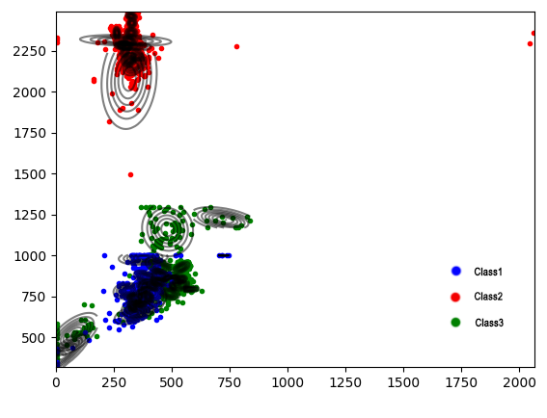
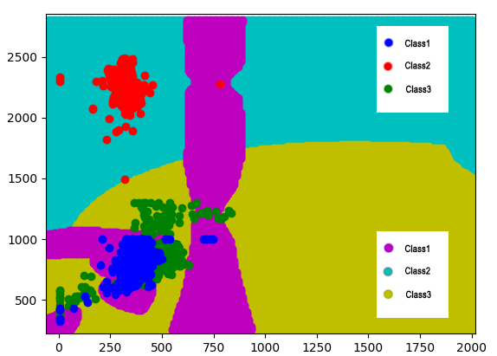
2.2.5 16 clusters

For K = 16

Classification Accuracy (%) | 46.645%
Precision for Class 1  Precision for Class 2  Precision for Class 3 | 1.0  0.968  0.388
Mean Precision | 0.785
Recall for Class 1  Recall for Class 2  Recall for Class 3 | 0.244  0.147  0.995
Mean Recall | 0.462
F-measure for Class 1  F-measure for Class 2  F-measure for Class 3 | 0.393  0.255  0.559
Mean F-measure | 0.402

Confusion Matrix :
C =
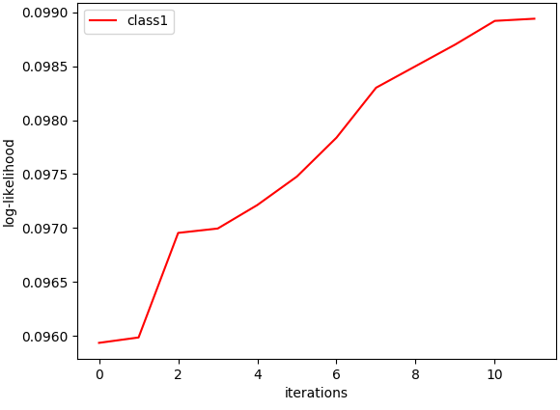
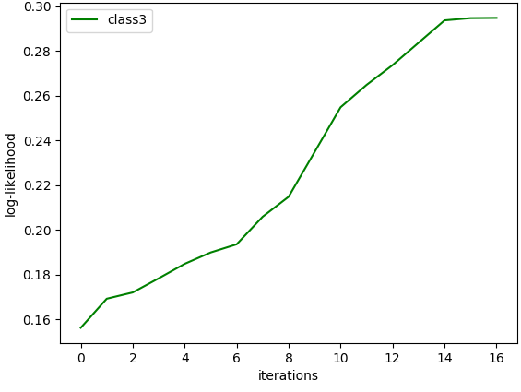
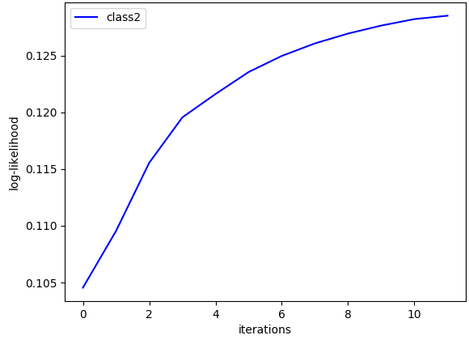
Log-likelihood vs Iterations graphs for K=16 on real world dataset

Observations :
- From K=1 to K=8 accuracy marginally increases from 82.8 %to 85.8% as the increasing clusters doesn’t better depicts the data distribution by much.
- From K = 8 to K = 16 over clustering leads to less accuracy as more data points get misclassified.
- Maximum accuracy in unimodal Gaussian case is a bit more than the highest accuracy obtained in GMM.

2.3 Image Dataset

2.3.1 Color Coded Histogram

2.3.1.1 1 cluster

K = 1
Classification Accuracy (%) | 56%
Precision for Class 1  Precision for Class 2  Precision for Class 3 | 0.654  0.479  0.627
Mean Precision | 0.587
Recall for Class 1  Recall for Class 2  Recall for Class 3 | 0.34  0.7  0.64
Mean Recall | 0.56
F-measure for Class 1  F-measure for Class 2  F-measure for Class 3 | 0.447  0.569  0.634
Mean F-measure | 0.550

Confusion Matrix :
C =

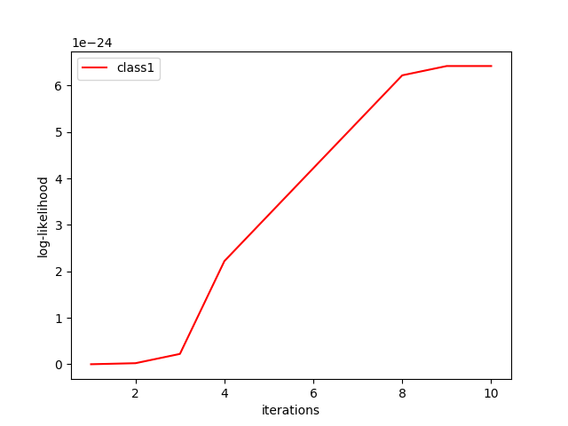
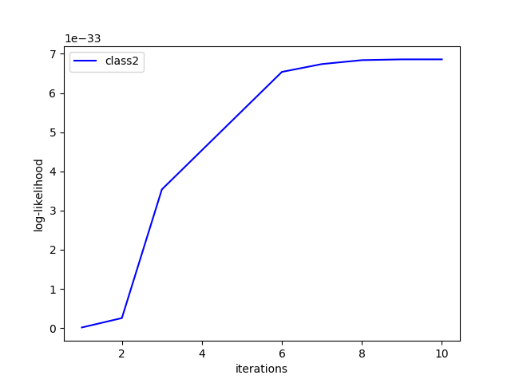
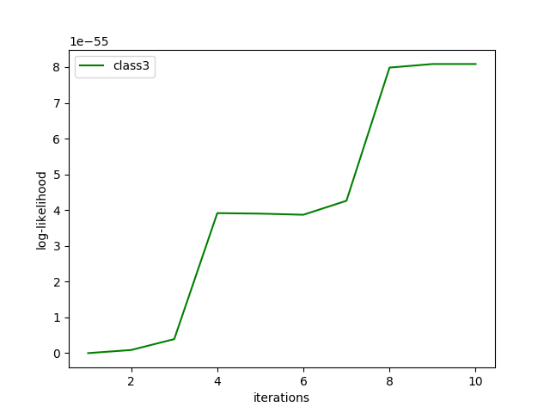
Log-likelihood vs Iterations graphs for K=1

2.3.1.2 2 clusters

K = 2
Classification Accuracy (%) | 62%
Precision for Class 1  Precision for Class 2  Precision for Class 3 | 0.724  0.514  0.706
Mean Precision | 0.648
Recall for Class 1  Recall for Class 2  Recall for Class 3 | 0.42  0.72  0.72
Mean Recall | 0.62
F-measure for Class 1  F-measure for Class 2  F-measure for Class 3 | 0.532  0.6  0.713
Mean F-measure | 0.614

Confusion Matrix :
C =

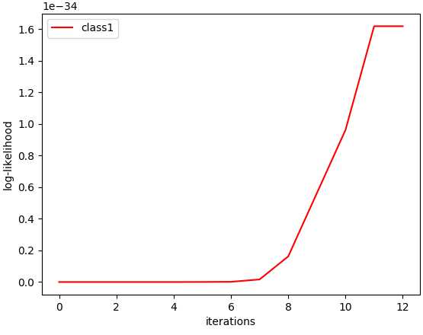
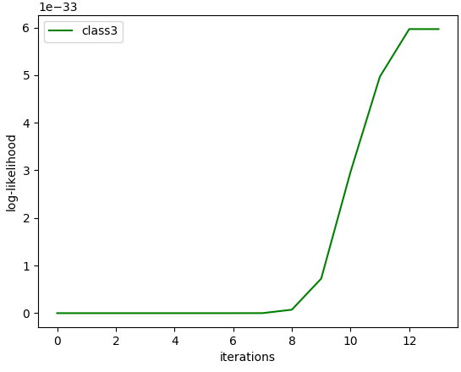
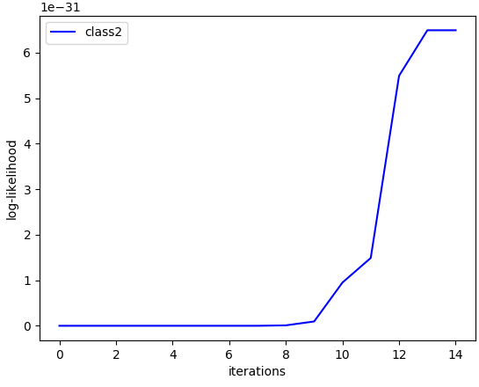

Log-likelihood vs Iterations graphs for K=2

2.3.1.3 4 clusters

K = 4
Classification Accuracy (%) | 62.333%
Precision for Class 1  Precision for Class 2  Precision for Class 3 | 0.629  0.532  0.692
Mean Precision | 0.618
Recall for Class 1  Recall for Class 2  Recall for Class 3 | 0.55  0.70  0.71
Mean Recall | 0.633
F-measure for Class 1  F-measure for Class 2  F-measure for Class 3 | 0.550  0.591  0.717
Mean F-measure | 0.620

Confusion Matrix :
C =

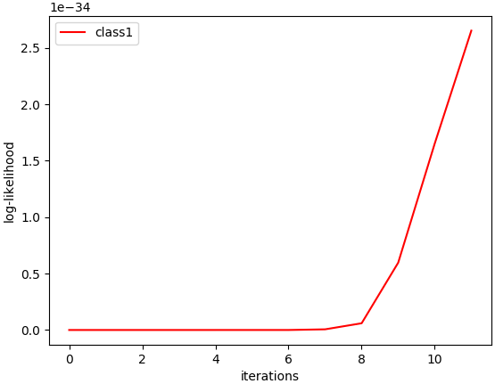
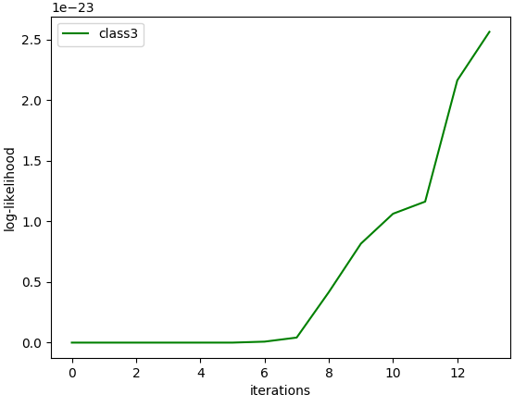
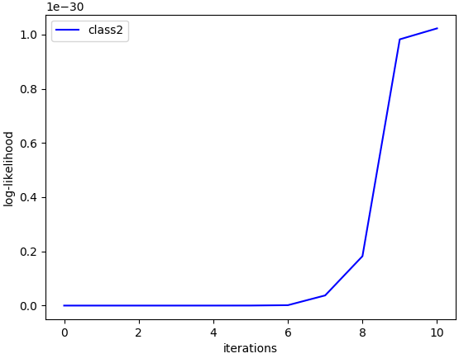
Log-likelihood vs Iterations graphs for K=4

2.3.1.4 8 clusters

K = 8
Classification Accuracy (%) | 62%
Precision for Class 1  Precision for Class 2  Precision for Class 3 | 0.605  0.542  0.729
Mean Precision | 0.625
Recall for Class 1  Recall for Class 2  Recall for Class 3 | 0.52  0.64  0.7
Mean Recall | 0.62
F-measure for Class 1  F-measure for Class 2  F-measure for Class 3 | 0.559  0.587  0.714
Mean F-measure | 0.620

Confusion Matrix :
C =

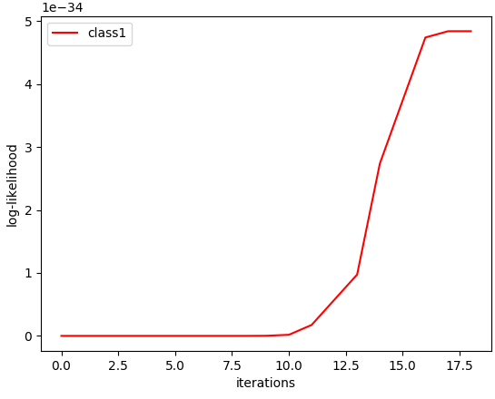
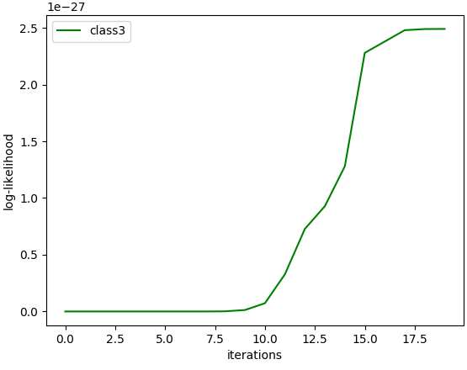
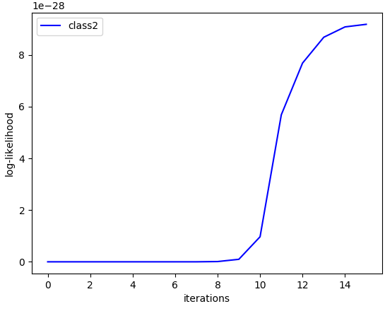

Log-likelihood vs Iterations graphs for K=8

2.3.1.5 16 clusters

K = 16
Classification Accuracy (%) | 64.667%
Precision for Class 1  Precision for Class 2  Precision for Class 3 | 0.623  0.58  0.769
Mean Precision | 0.657
Recall for Class 1  Recall for Class 2  Recall for Class 3 | 0.76  0.58  0.6
Mean Recall | 0.647
F-measure for Class 1  F-measure for Class 2  F-measure for Class 3 | 0.657  0.647  0.323
Mean F-measure | 0.646

Confusion Matrix :
C =

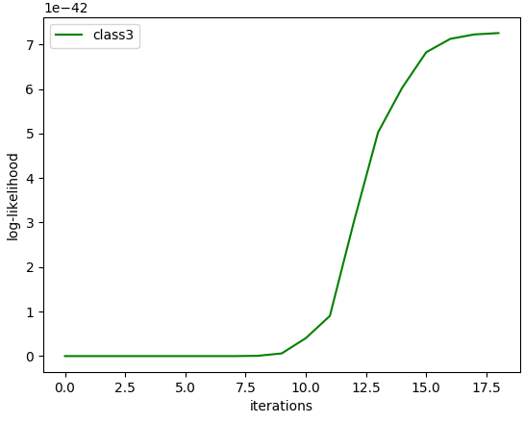
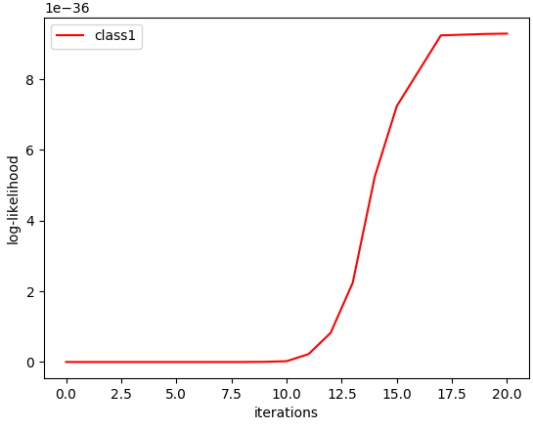
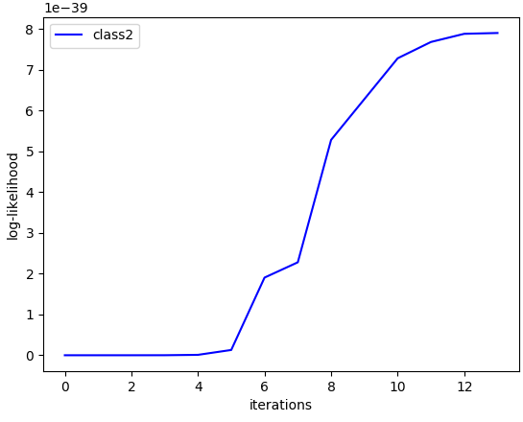
Log-likelihood vs Iterations graphs for K=16

2.3.1.6 32 clusters

K = 32
Classification Accuracy (%) | 63.333%
Precision for Class 1  Precision for Class 2  Precision for Class 3 | 0.610  0.547  0.778
Mean Precision | 0.645
Recall for Class 1  Recall for Class 2  Recall for Class 3 | 0.5  0.7  0.7
Mean Recall | 0.633
F-measure for Class 1  F-measure for Class 2  F-measure for Class 3 | 0.549  0.614  0.737
Mean F-measure | 0.633

Confusion Matrix :
C =

2.3.1.7 64 clusters

K = 64
Classification Accuracy (%) | 60%
Precision for Class 1  Precision for Class 2  Precision for Class 3 | 0.590  0.527  0.735
Mean Precision | 0.618
Recall for Class 1  Recall for Class 2  Recall for Class 3 | 0.72  0.58  0.5
Mean Recall | 0.6
F-measure for Class 1  F-measure for Class 2  F-measure for Class 3 | 0.649  0.552  0.595
Mean F-measure | 0.598

Confusion Matrix :
C =

Observations :
- The maximum accuracy of 65% is obtained at K = 16 clusters per class and decreases thereafter.
- The classification accuracy of the image dataset is highly dependent on the feature extraction process.
- In this case, every image is represented by 32 fixed size blocks and each block was a feature vector set of 24-dimentional color histogram feature vectors.

2.3.2 Bag of Visual Words

2.3.2.1 1 cluster

K = 1
Classification Accuracy (%) | 70.667%
Precision for Class 1  Precision for Class 2  Precision for Class 3 | 0.656  0.718  0.766
Mean Precision | 0.713
Recall for Class 1  Recall for Class 2  Recall for Class 3 | 0.84  0.56  0.72
Mean Recall | 0.707
F-measure for Class 1  F-measure for Class 2  F-measure for Class 3 | 0.737  0.629  0.742
Mean F-measure | 0.702

Confusion Matrix :
C =

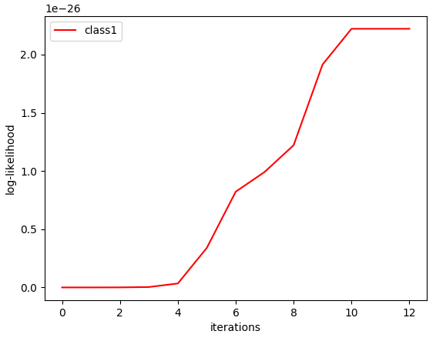
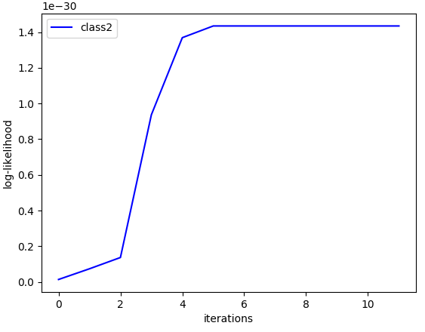
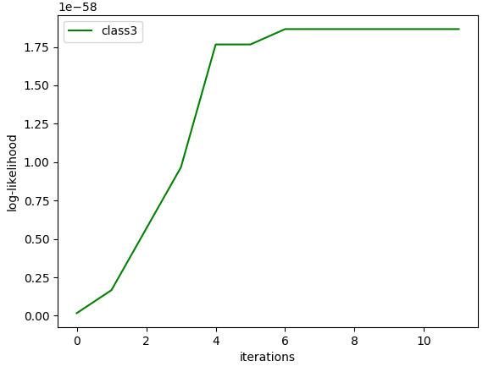

Log-likelihood vs Iterations graphs for K=1

2.3.2.2 2 clusters

K = 2
Classification Accuracy (%) | 64.667%
Precision for Class 1  Precision for Class 2  Precision for Class 3 | 0.566  0.68  0.786
Mean Precision | 0.677
Recall for Class 1  Recall for Class 2  Recall for Class 3 | 0.94  0.34  0.66
Mean Recall | 0.647
F-measure for Class 1  F-measure for Class 2  F-measure for Class 3 | 0.707  0.453  0.717
Mean F-measure | 0.625

Confusion Matrix :
C =

Log-likelihood vs Iterations graphs for K=2

2.3.2.3 4 clusters

K = 4
Classification Accuracy (%) | 61.333%
Precision for Class 1  Precision for Class 2  Precision for Class 3 | 0.56  0.6  0.691
Mean Precision | 0.617
Recall for Class 1  Recall for Class 2  Recall for Class 3 | 0.84  0.24  0.76
Mean Recall | 0.613
F-measure for Class 1  F-measure for Class 2  F-measure for Class 3 | 0.672  0.343  0.724
Mean F-measure | 0.579

Confusion Matrix :
C =

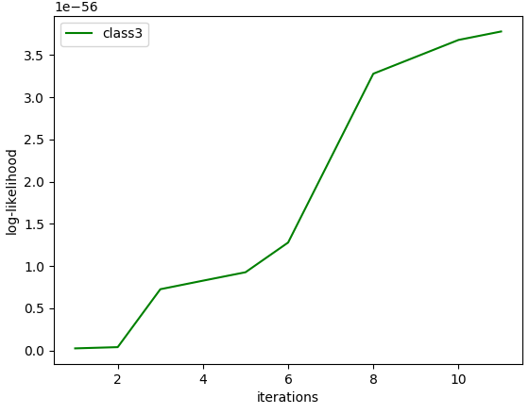
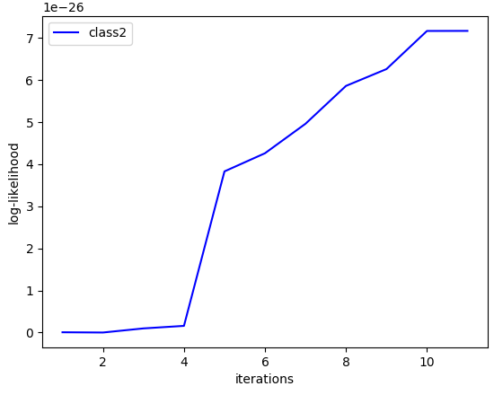
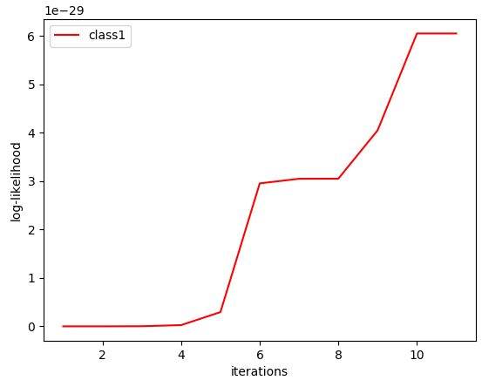

Log-likelihood vs Iterations graphs for K=4

2.3.2.4 8 clusters

K = 8
Classification Accuracy (%) | 66%
Precision for Class 1  Precision for Class 2  Precision for Class 3 | 0.702  0.646  0.636
Mean Precision | 0.661
Recall for Class 1  Recall for Class 2  Recall for Class 3 | 0.66  0.62  0.7
Mean Recall | 0.66
F-measure for Class 1  F-measure for Class 2  F-measure for Class 3 | 0.680  0.633  0.667
Mean F-measure | 0.659

Confusion Matrix :
C =

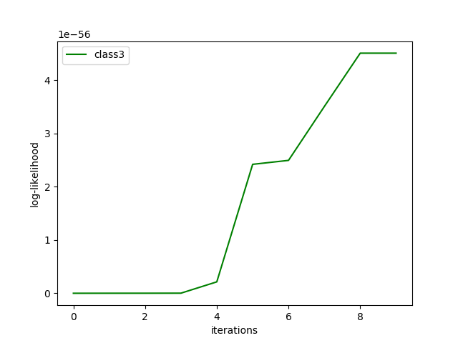
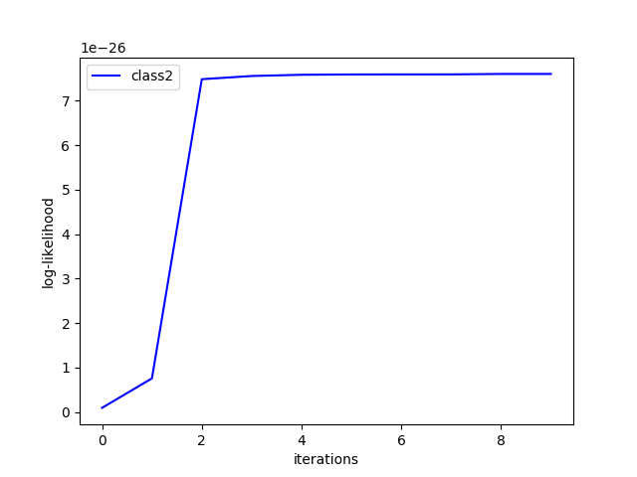
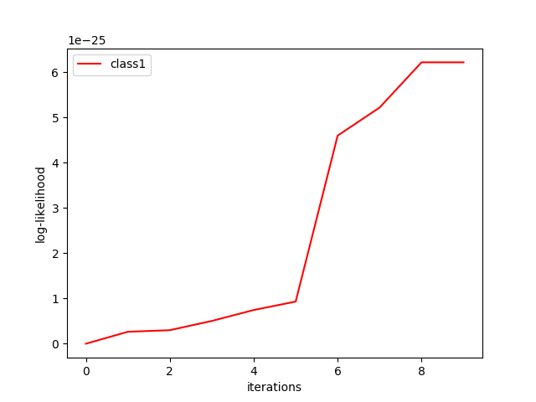

Log-likelihood vs Iterations graphs for K=8

2.3.2.5 16 clusters

K = 16
Classification Accuracy (%) | 60.667%
Precision for Class 1  Precision for Class 2  Precision for Class 3 | 0.529  0.619  0.75
Mean Precision | 0.633
Recall for Class 1  Recall for Class 2  Recall for Class 3 | 0.9  0.26  0.66
Mean Recall | 0.607
F-measure for Class 1  F-measure for Class 2  F-measure for Class 3 | 0.667  0.366  0.702
Mean F-measure | 0.578

Confusion Matrix :
C =

Log-likelihood vs Iterations graphs for K=16

2.3.2.6 32 clusters

K = 32
Classification Accuracy (%) | 70.667%
Precision for Class 1  Precision for Class 2  Precision for Class 3 | 0.690  0.667  0.766
Mean Precision | 0.707
Recall for Class 1  Recall for Class 2  Recall for Class 3 | 0.8  0.6  0.72
Mean Recall | 0.707
F-measure for Class 1  F-measure for Class 2  F-measure for Class 3 | 0.741  0.632  0.742
Mean F-measure | 0.704

Confusion Matrix :
C =

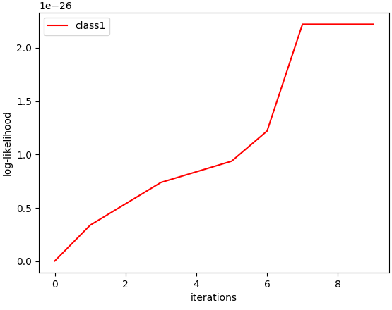
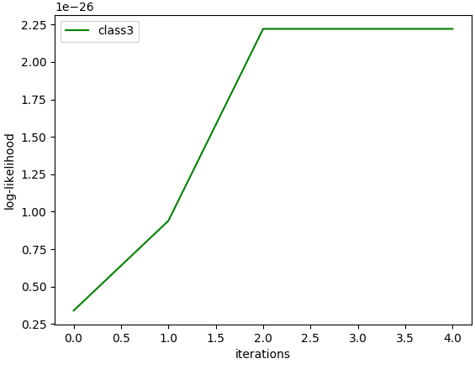
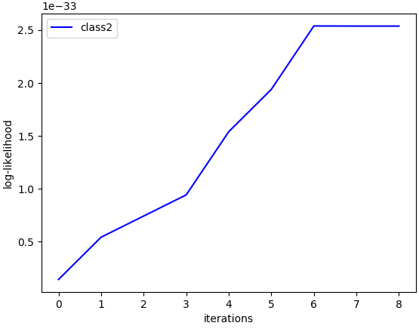

Log-likelihood vs Iterations graphs for K=32

2.3.2.7 64 clusters

K = 64
Classification Accuracy (%) | 66.667%
Precision for Class 1  Precision for Class 2  Precision for Class 3 | 0.618  0.703  0.711
Mean Precision | 0.677
Recall for Class 1  Recall for Class 2  Recall for Class 3 | 0.84  0.52  0.64
Mean Recall | 0.667
F-measure for Class 1  F-measure for Class 2  F-measure for Class 3 | 0.712  0.598  0.674
Mean F-measure | 0.660

Confusion Matrix :
C =
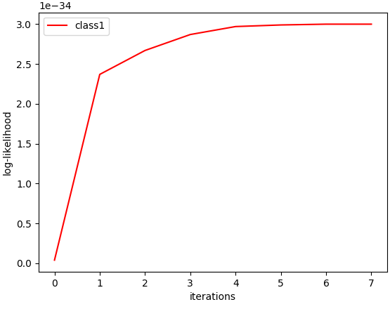
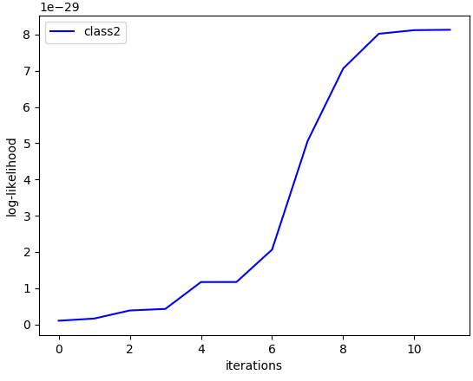

Log-likelihood vs Iterations graphs for K=64

Observations :
- The maximum accuracy of 70.667% is obtained at K = 1 clusters per class.
- In this case, every image is represented by 32 dimentional Bag-of-vitual-words (BoVW) obtained by 32 clustering of the colour coded histograms.
- The accuracy in case of BoVW representation is better than that obtained by colour histogram feature vector.

2.3 Cell Dataset
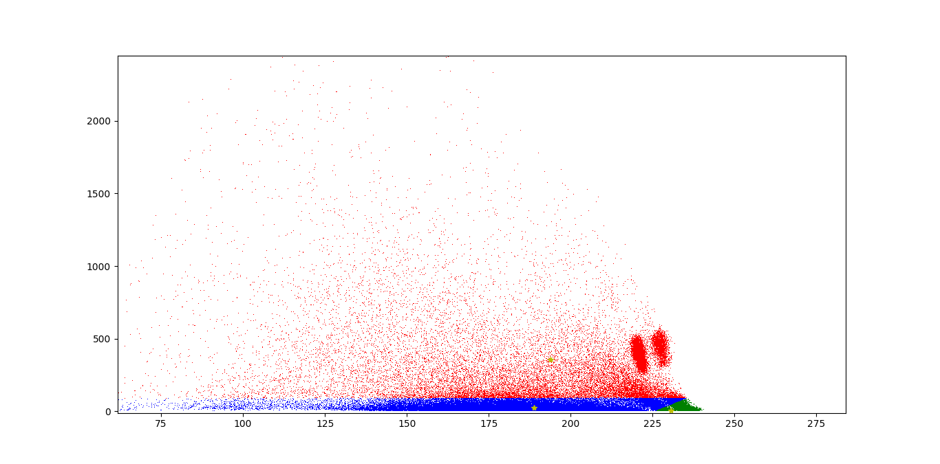

K-Means Clustering Scatter Plot

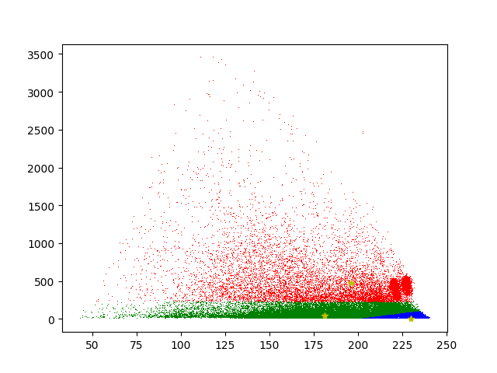
Clustering using GMM Scatter Plot

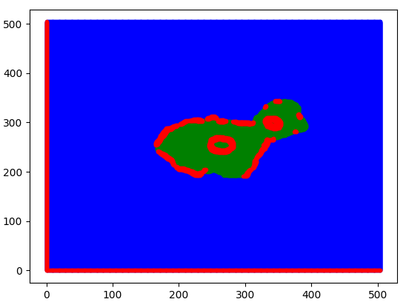
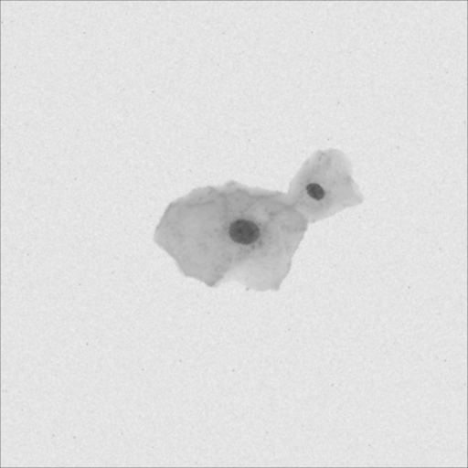
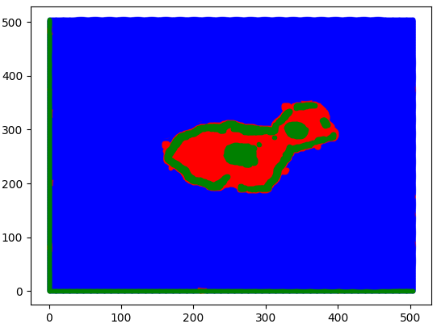

Cell Image K Means GMM

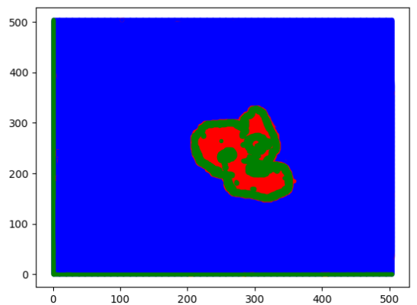
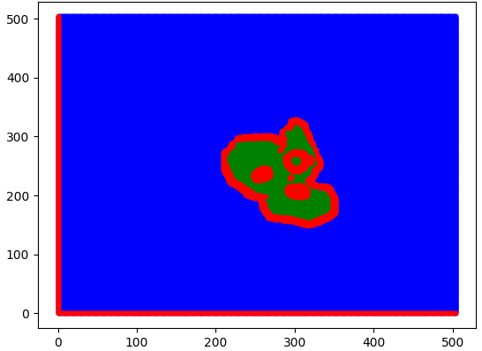
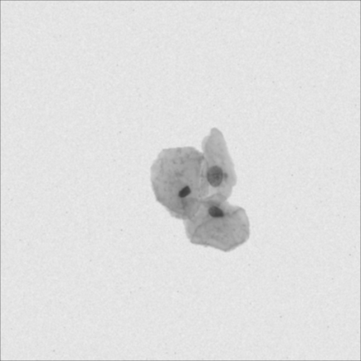

Cell Image K Means GMM

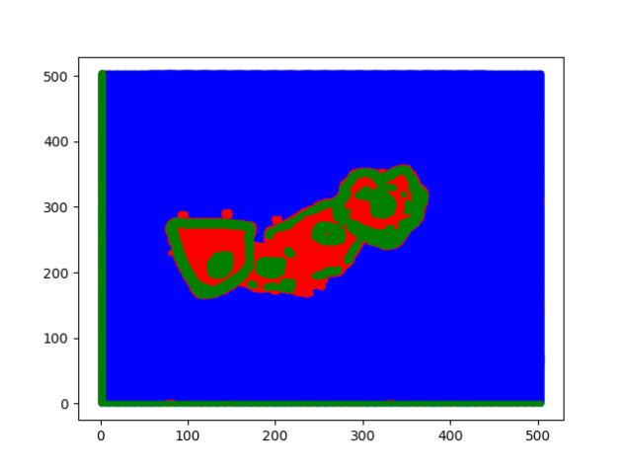
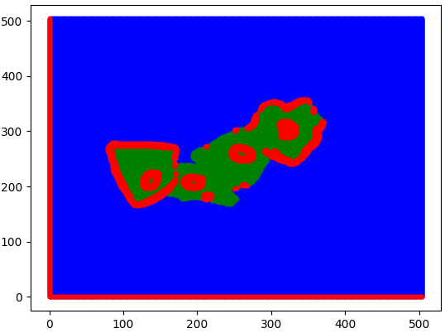
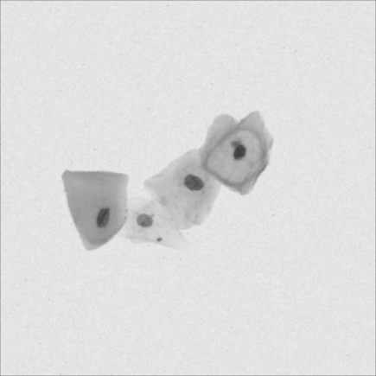

Cell Image K Means GMM

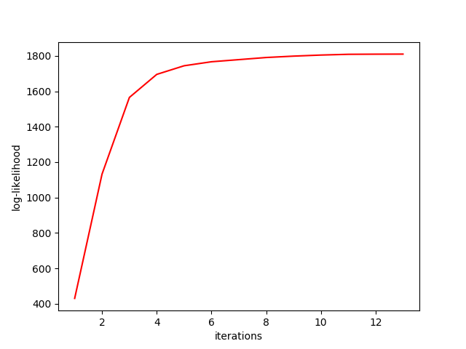
Log likelihood vs Iterations graph:

Observations :
- Better segmentation is observed in case of GMM as compared to that of Kmeans clustering.
- GMM allows non linear decision boundary therefore better segmenting between the three parts.
- Clustering accuracy depends on the way image feature vectors are extracted. In this case 7x7 non overlapping patches were used to form feature vectors of stack 2 dimentional feature vectors of mean and variance of the patch of the training set.
- The test images were represented by overlapping 7x7 such patches.

3 Conclusion and Observations:

- The decision boundaries are more precise when the data is modeled using mixture of multiple Gaussians as compared to unimodal Gaussian.
- Different classification accuracies are obtained when number of clusters K are varied.
- Although the accuracy tends to increase with the number of clusters assumed for a class, but due to overlapping data, over clustering may cause the class to cover non-belonging points as well, this is evident in the real world data.
- The boundary between 2 clusters in K-Means is linear because distance measure used in K-means classification is Euclidean distance.
- As the number of iterations increase, cluster assignment of the data points changes and approaches convergence.
- The accuracies obtained for the nonlinear datasets are far better than that obtained in unimodal case. Accuracies for real dataset are behind that obtained in unimodal case.
- The value of log likelihood increases with the number of iterations till it reaches the local / global optima.

