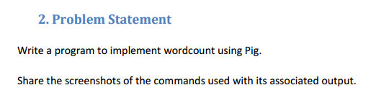

Input file :

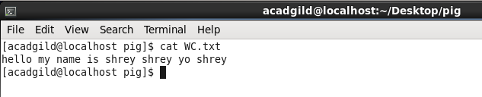

Commands on grunt shell :

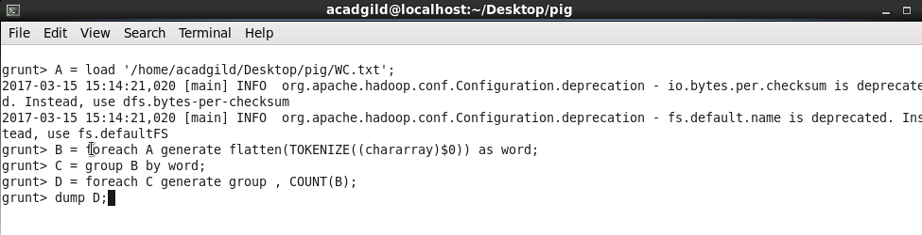

Dump result :

