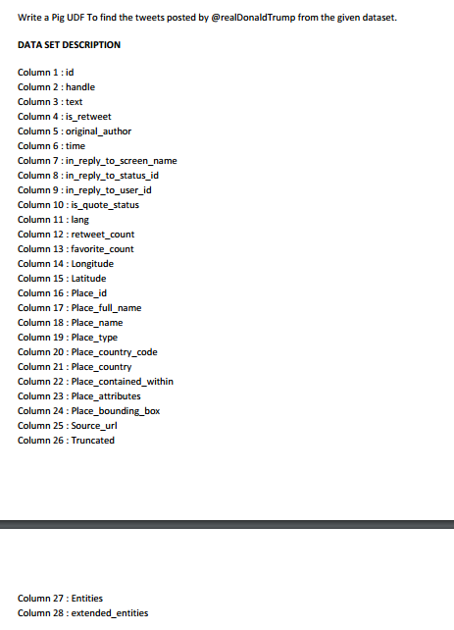

**UDF**

**LOGIC USED UDF TO FILTER THE TWEETS BY DONALD TRUMP AS SHOWN AND MADE A COUNT**

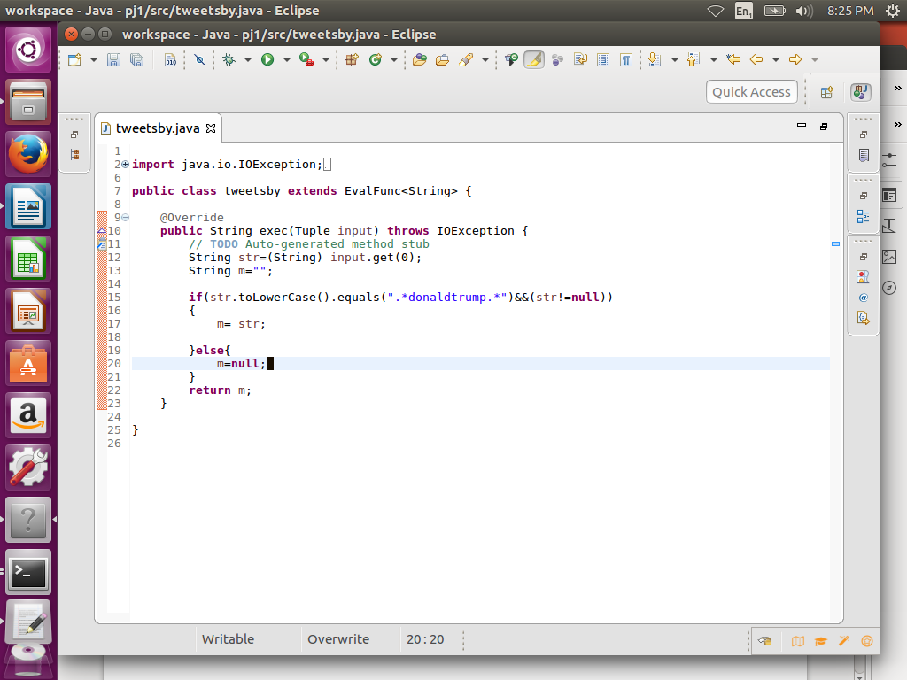

**PIG COMMANDS**

**LOGIC:load the data and then used tweetby function of udf (Step d) to filter tweets by trump**

**STEP1:REGISTER UDF**

**Step2:load a using schema as shown**

**Step3:foreach A generating tweetsby(handle) which will perform filtration accoding to udf**

**Step :group by Donald trump and made a count**

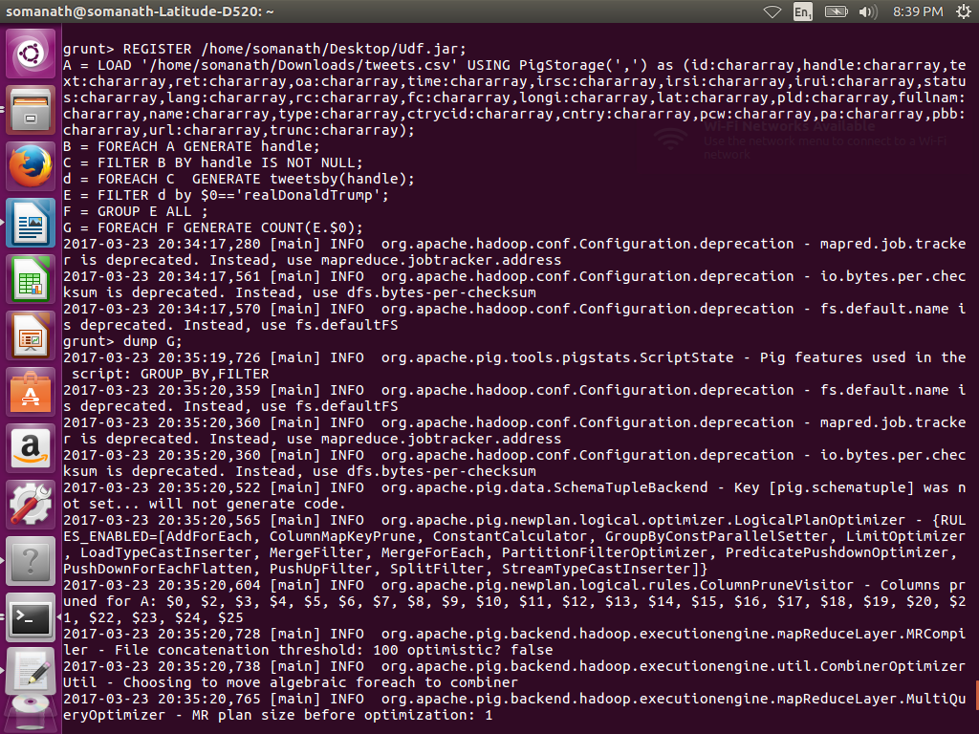

**OUTPUT**

**3218**

