

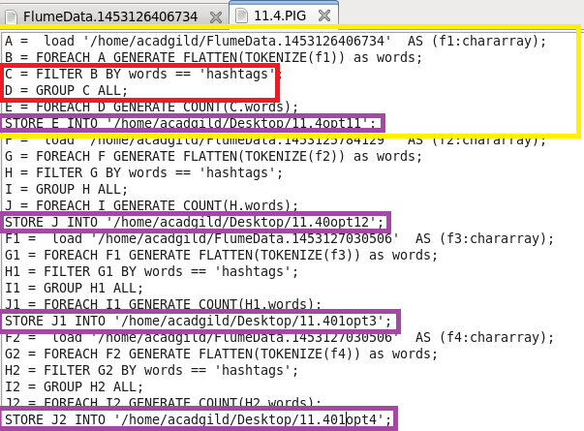

**RUNNING PIG**

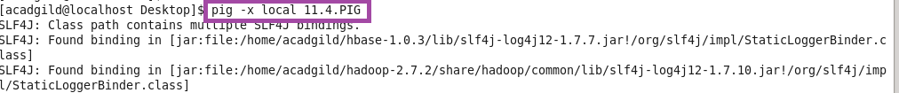

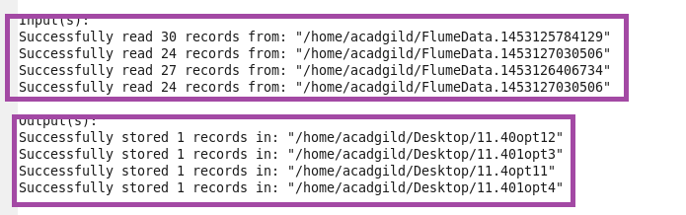

**OTPT**

