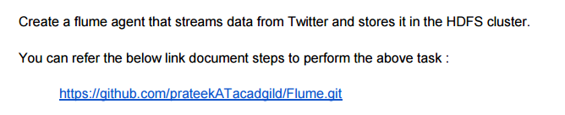

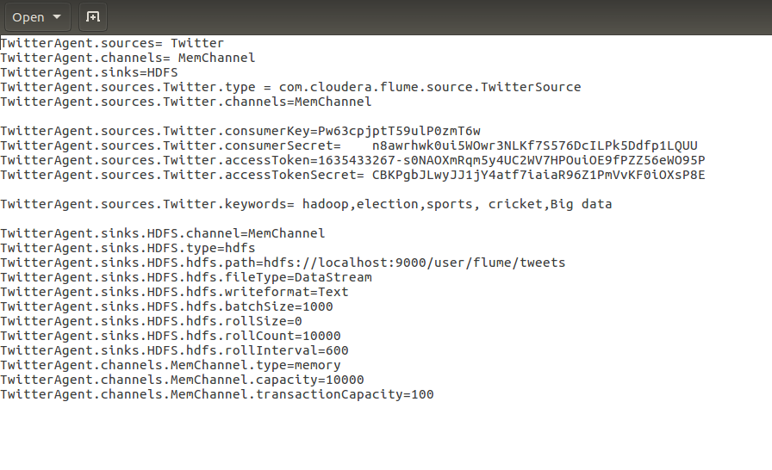

Creating the **twitter app**.

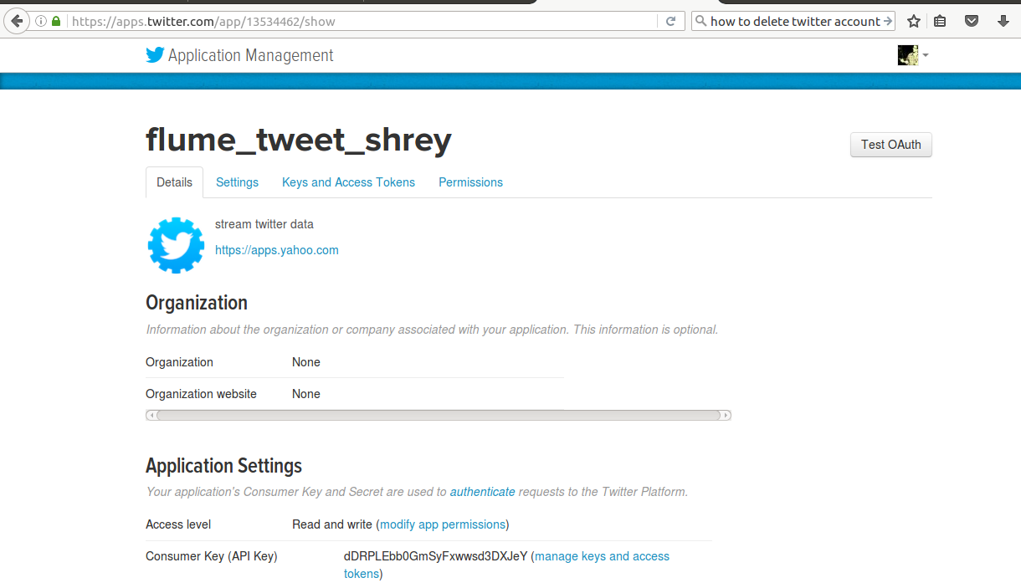

Running the flume agent :

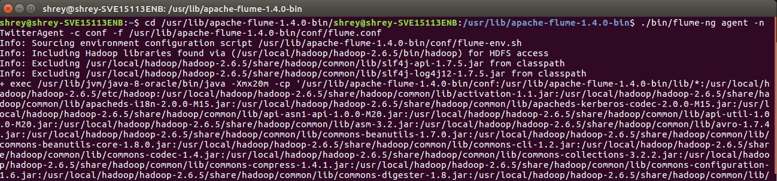

Checking on HDFS :

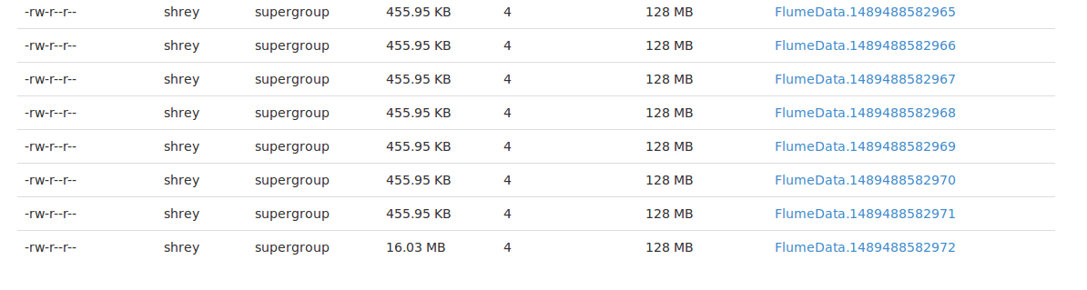

On opening the FlumeData file we can see that DATA STREAMING has started and the keeps on happening until and unless the the streaming is stopped (CTRL + C).

FlumeData file on HDFS:

