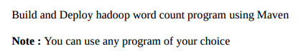

**Input file**



**Step1:We wil create a maven project by file->new ->maven project and maven project is created in the explorer window as highlighted**

**Driver class**

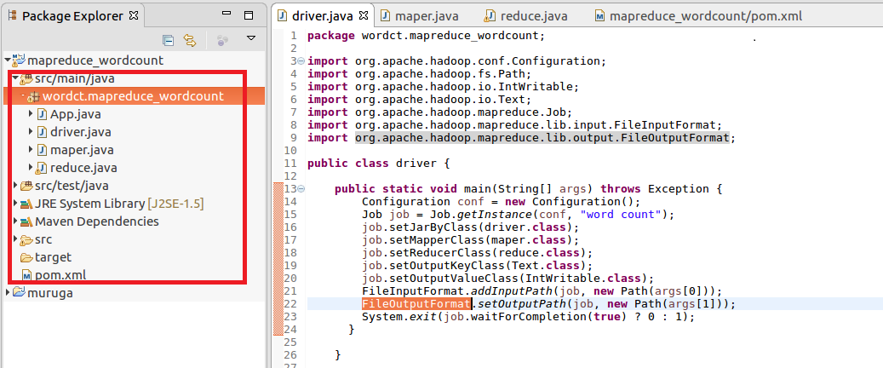

**Mapper:**

In mapper splitting the data by space and sending the word as Key and a count of 1 as value which will be added in reducer

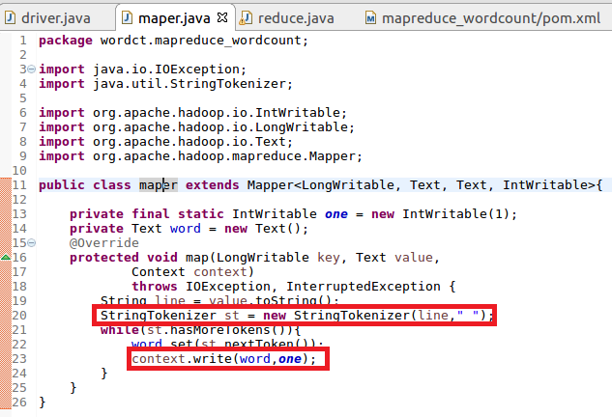

**Reducer**

**In reduce the count of words are made**

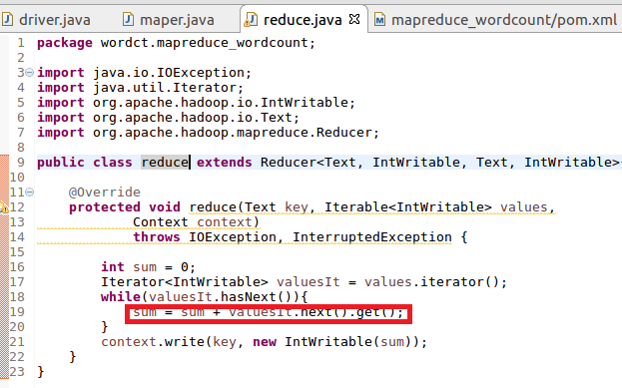

**Step2: Configuring Pom.xml file :**

**Here the necessary dependencies (commonand client) along with basic dependencies (java)is added**

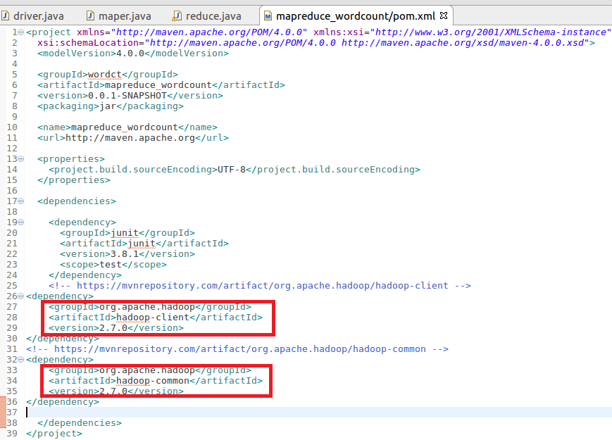

**Step3:Build maven project**

**Maven project is build by maven clean command**

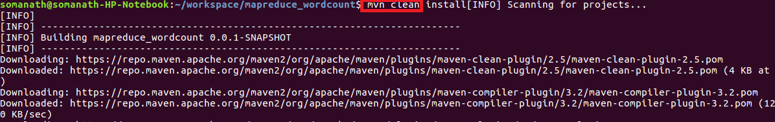

**Build successful**

**After successful completion of the building of project success message will be displayed and a jar file will be created in target folder**

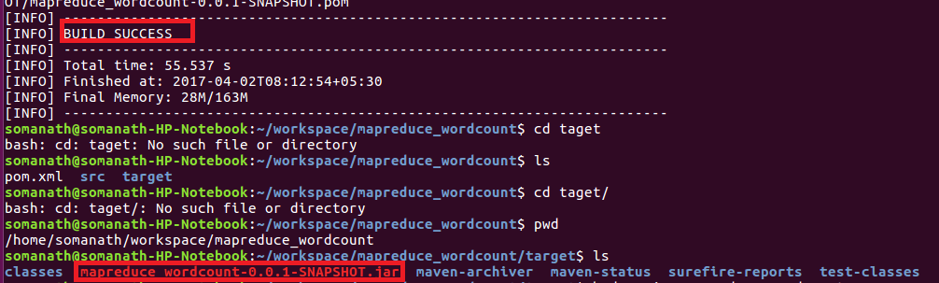

**Step4:Running Maven jar**

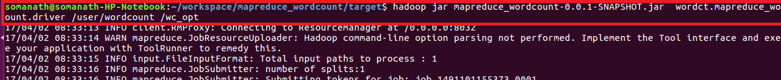

**Maven output**

