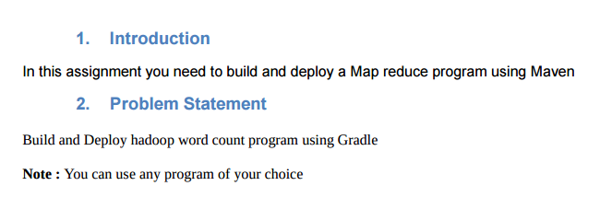

**Input file**

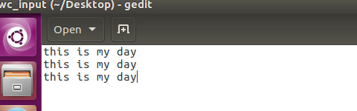

**USE GRADLE BUILD TO build the Gradle project**

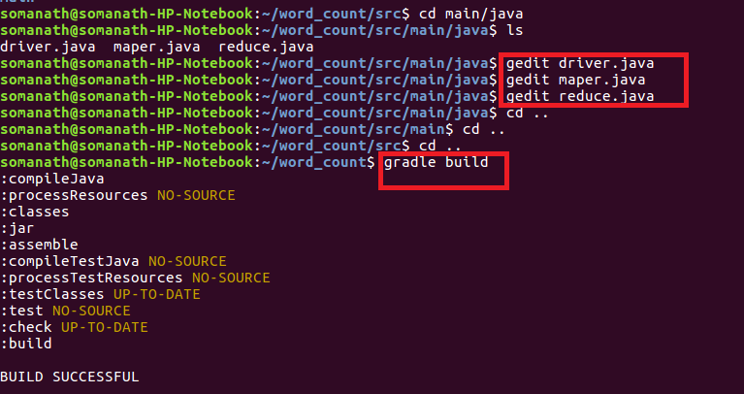

**Step3:Used Gradle eclipse to build the project and classpath that are required for eclipse**

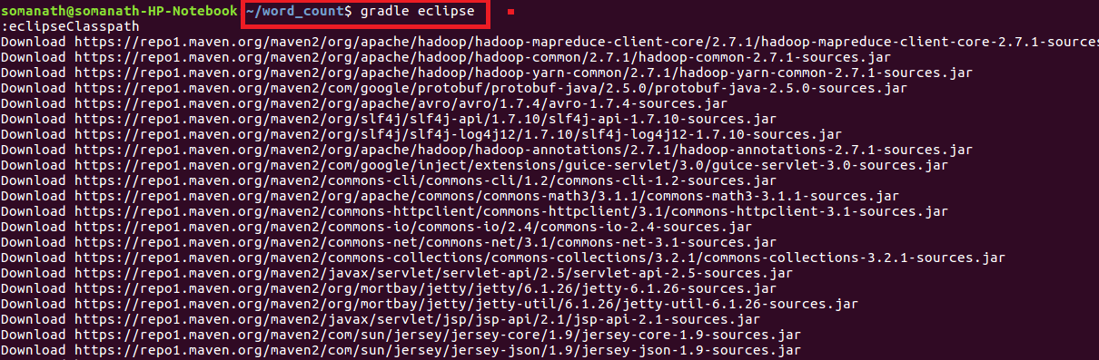

**Build Success: build successful will be displayed and word count jar file will be created in libs**

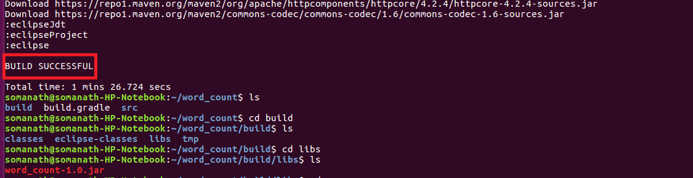**Step4:Importing project into Eclipse**

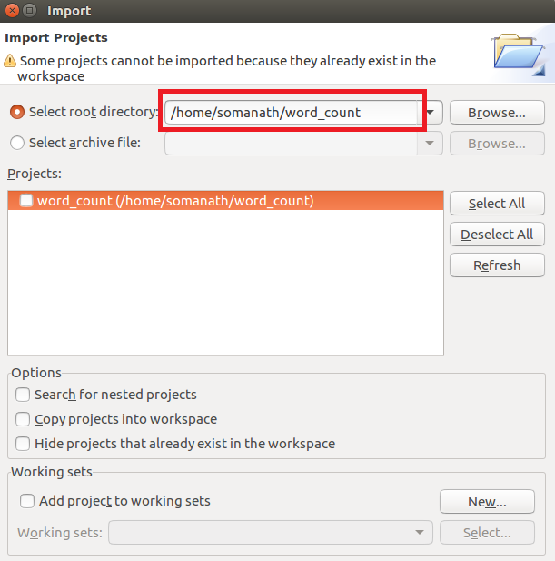

NOW WE CAN SEE IN PROJECT EXPLORER THE WORDCOUNT PROJECT IS CONVERTED TO GRADLE PROJECT INSIDE ECLIPSE

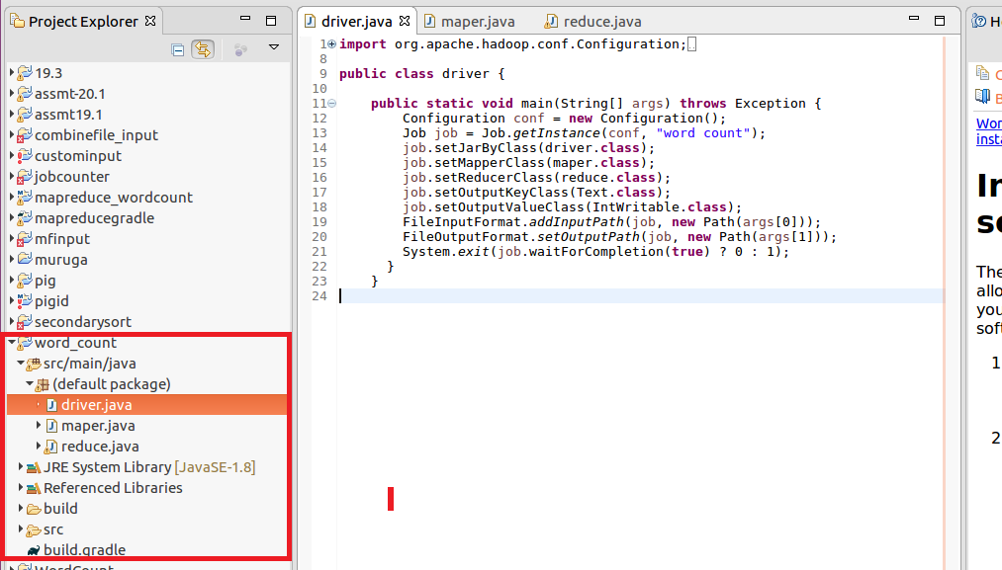

**Mapper:**

In mappersplit the words by space and send word as key and count of 1 as value

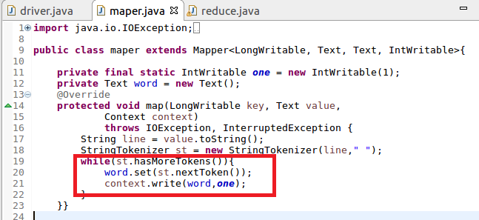

**Reducer**

Count the total occurrence of words

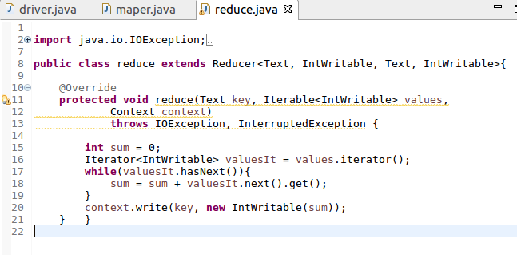

**Build.gradle**

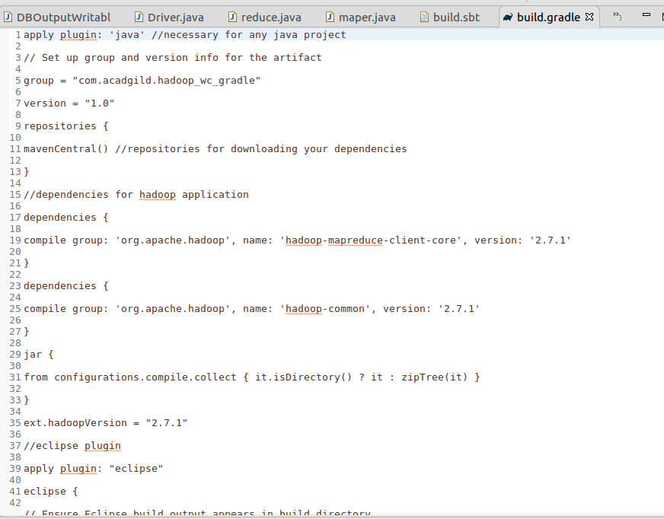

**Step5:Running jar file create d by gradle**

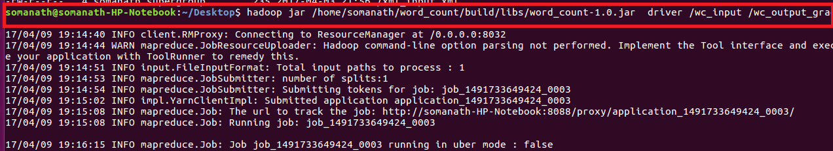

Output

