**Assignment 20.2**

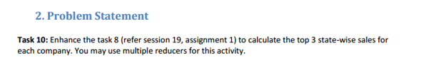

**DATASET:**

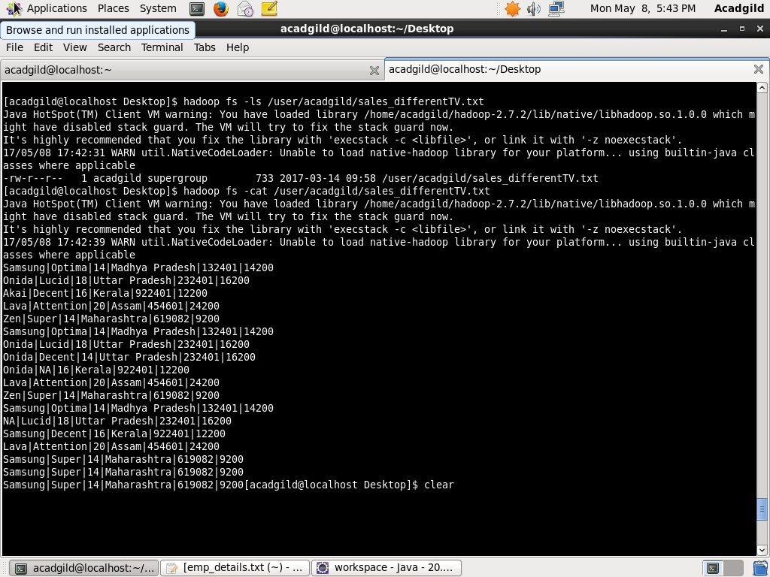

**We will use the above database for which we need to find out the top-3 state wise sales for each company.**

**PROGRAM:**

**DRIVER CLASS**

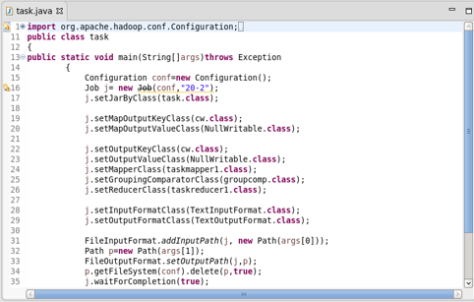

**MAPPER CLASS**

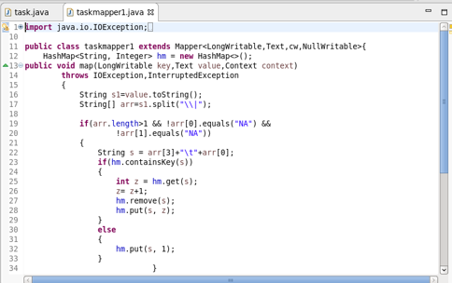

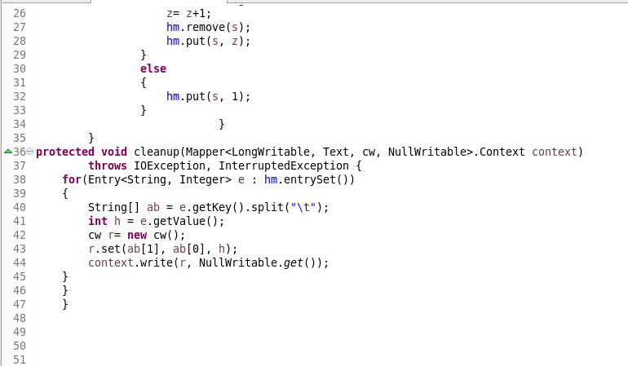

**CUSTOM_KEY CLASS**

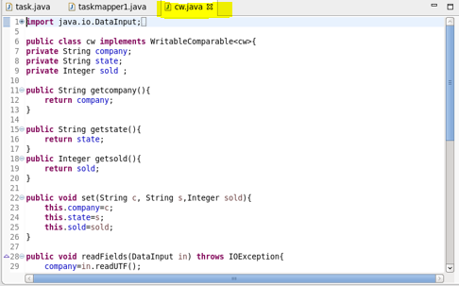

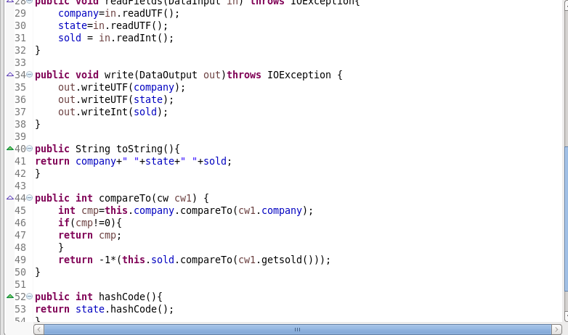

**GROUP COMPARATOR CLASS**

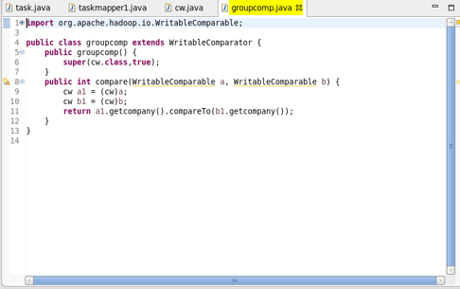

**PARTITIONER CLASS**

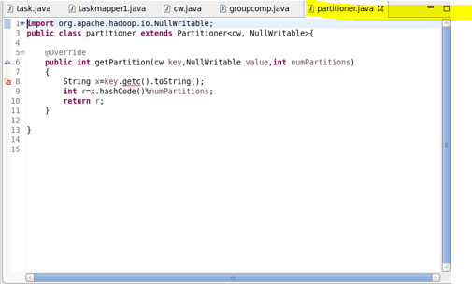

**REDUCER CLASS**

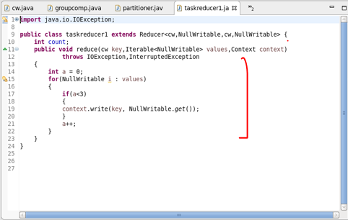

**OUTPUT:**

