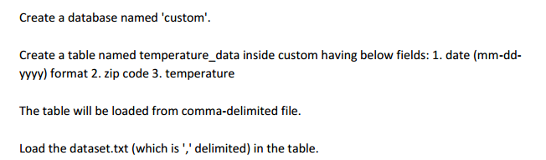

**Input file**

10-01-1990,123112,10

14-02-1991,283901,11

10-03-1990,381920,15

10-01-1991,302918,22

12-02-1990,384902,9

10-01-1991,123112,11

14-02-1990,283901,12

10-03-1991,381920,16

10-01-1990,302918,23

12-02-1991,384902,10

10-01-1993,123112,11

14-02-1994,283901,12

10-03-1993,381920,16

10-01-1994,302918,23

12-02-1991,384902,10

10-01-1991,123112,11

14-02-1990,283901,12

10-03-1991,381920,16

10-01-1990,302918,23

12-02-1991,384902,10

**Hive commands**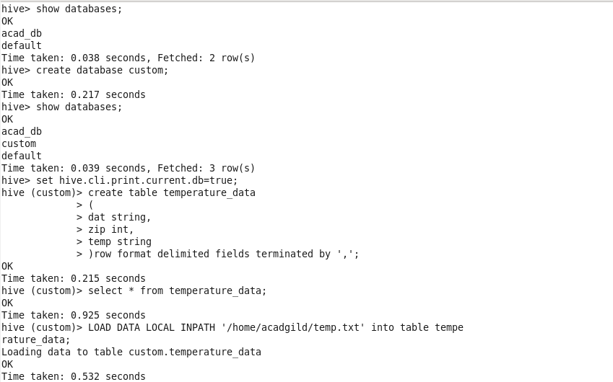

**Output**

