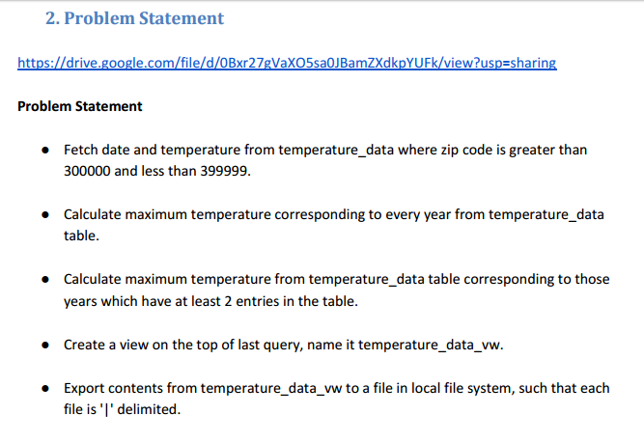

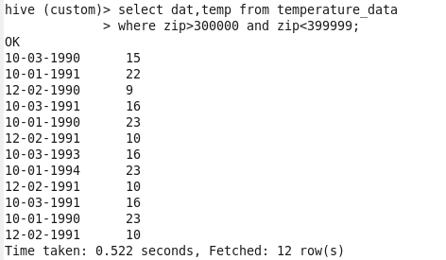

**Calculate maximum temperature corresponding to every year from temperature_data table.**

**C:\Users\613000\Pictures\hive\4.PNG**

output

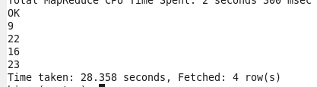

**Calculate maximum temperature from temperature_data table corresponding to those years which have at least 2 entries in the table.**

**C:\Users\613000\Pictures\hive\6.PNG**

output

O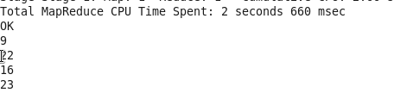

**Create a view on the top of last query, name it temperature_data_vw.**



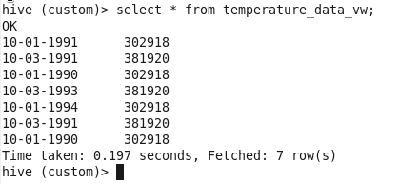

**Export contents from temperature_data_vw to a file in local file system, such that each file is '|' delimited.**

**C:\Users\613000\Pictures\hive\10.PNG**

hi.txt file contents

