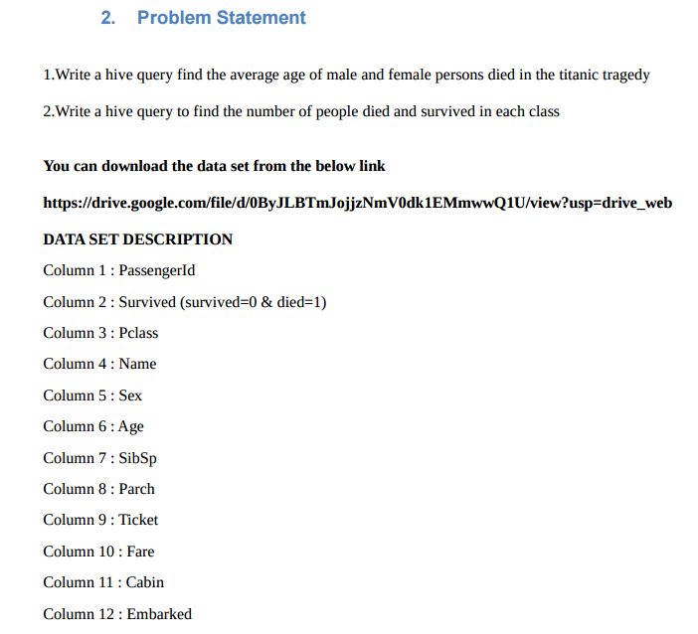

* First creating the table ‘titanic’ and then loading the given dataset into it.

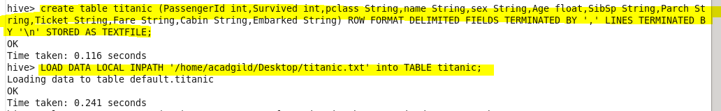

* Here, finding the average age of male and female who died in the titanic tragedy using avg function.

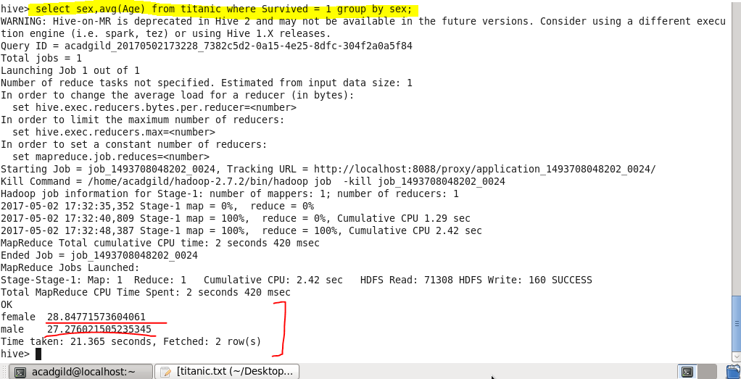

* Here, finding the no. of people died and survived using count function.

Using select command we will select the pclass, servived status and then we will count all corresponding to the other two class and servived status and then will group by class and servived.

