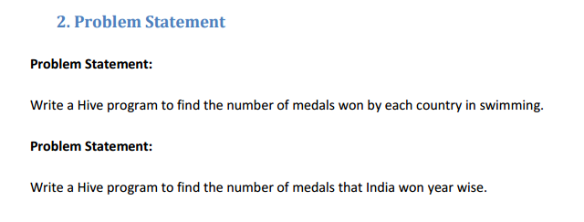

**Que 1**

**Commands:**

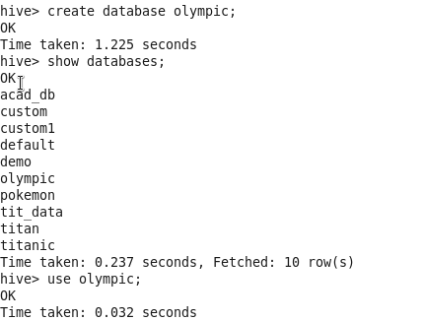

**Create table:**

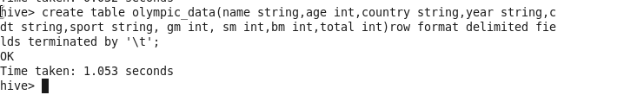

**Load dataset:**

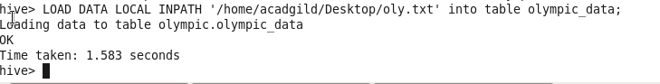

**Select country,count(total) from Olympic_data where sport=”Swimming” group by country;**

**Output:**

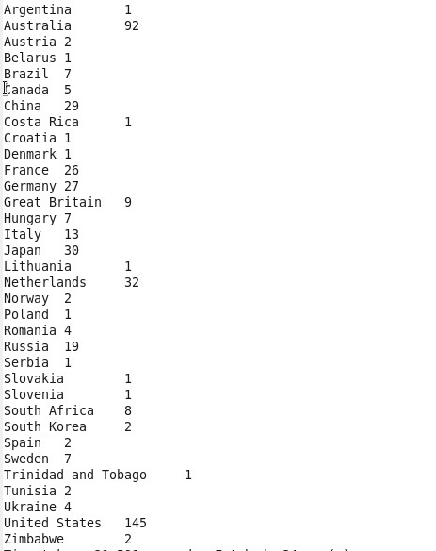

**Que 2**

