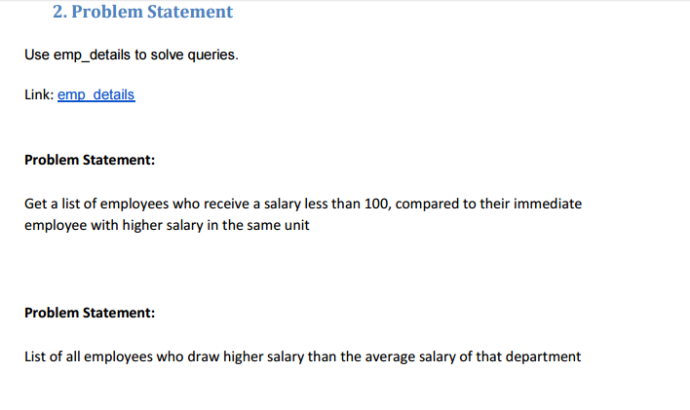

Part 1

* For above problem statement we will use lag function so as to check if subtraction of employee salary and lagged value that is previous salary or salary from previous employee if it is less than 100 than only it will display.

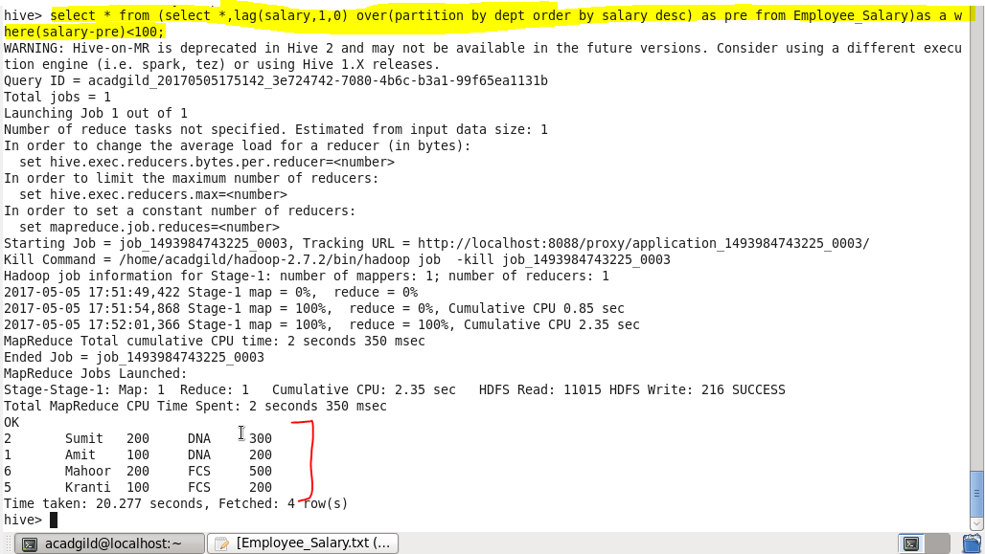

Part 2

* In this particular problem we will check for the employees whose salary is greater than average salary of that department using avg function for that we will select name from a subquery I that we will select name,salary and average salary from the same table and will filter by salary should greater than average salary.

