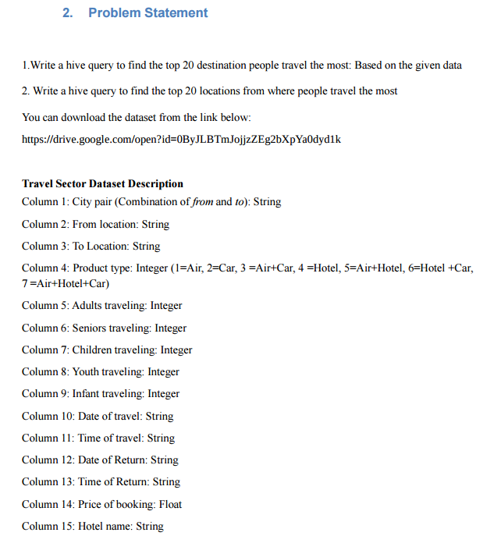

**Display database:-**

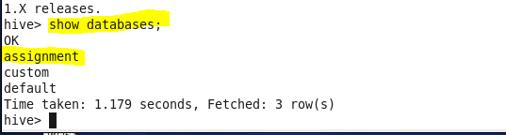

**Create table:-**

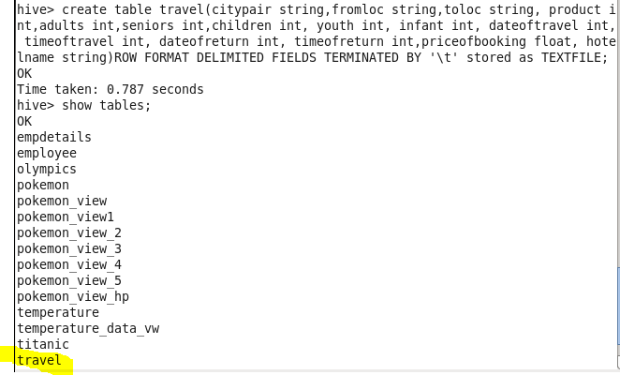

**Load data:-**

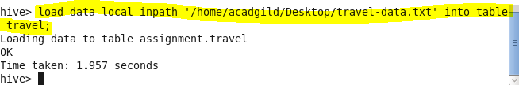

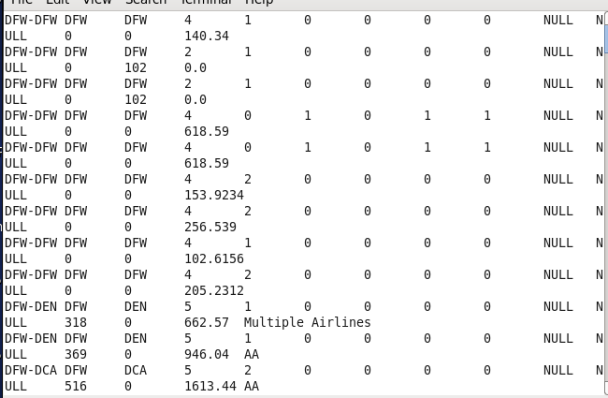

* **Write a hive query to find the top 20 destination people travel the most: Based on the given data**

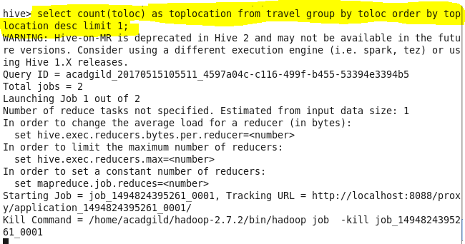

**Output:-**

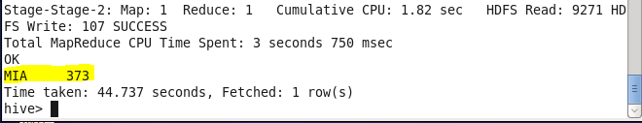

* **Write a hive query to find the top 20 locations from where people travel the most**

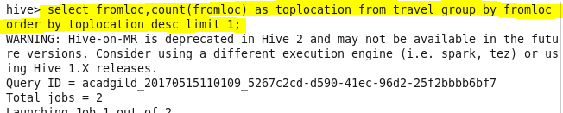

**Output:-**

