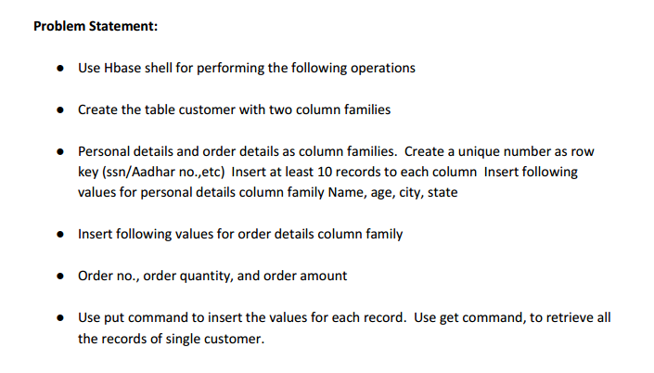

**Create the table customer with two column families**

In this customer table is created with two column families, that is, personal details and order details.

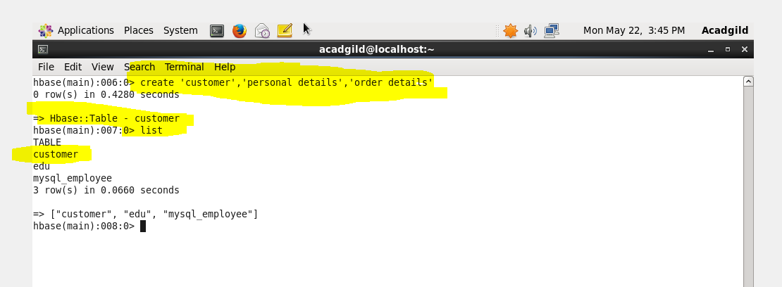

**Use put command to insert the values for each record**.

Personal details and order details as column families. Create a unique number as row key (ssn/Aadhar no.,etc)

Following values for personal details column family Name, age, city, state

Following values for order details column family Order no., order quantity, and order amount

In this adahar number is taken as a key

**PERSONAL DETAILS**

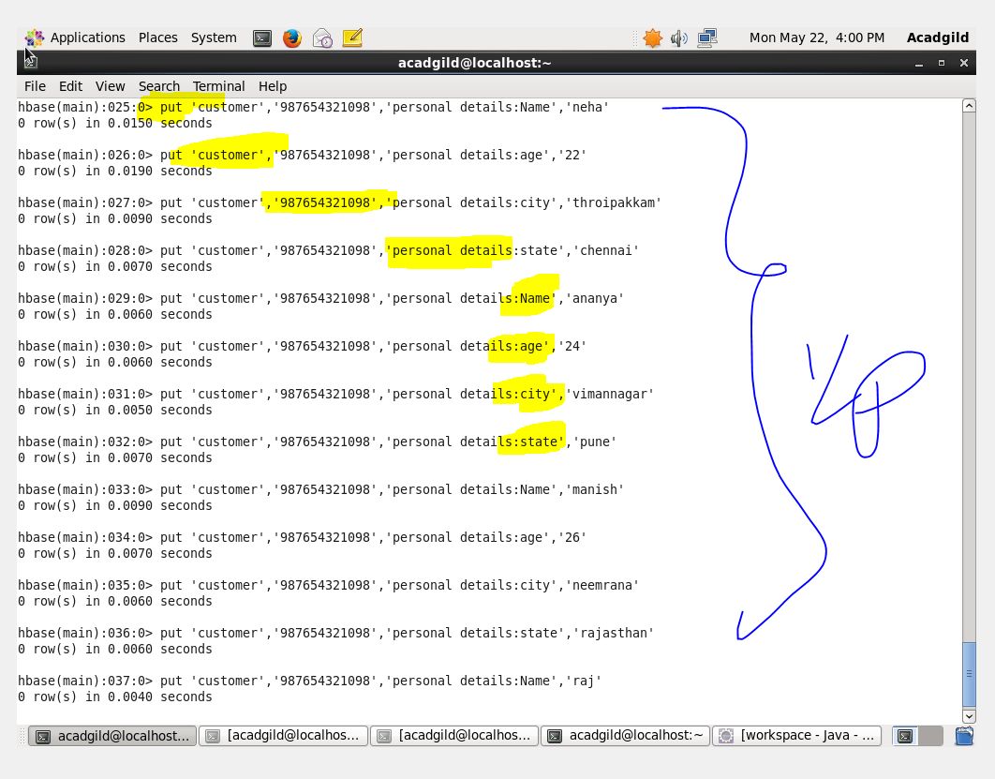

**ORDER DETAILS**

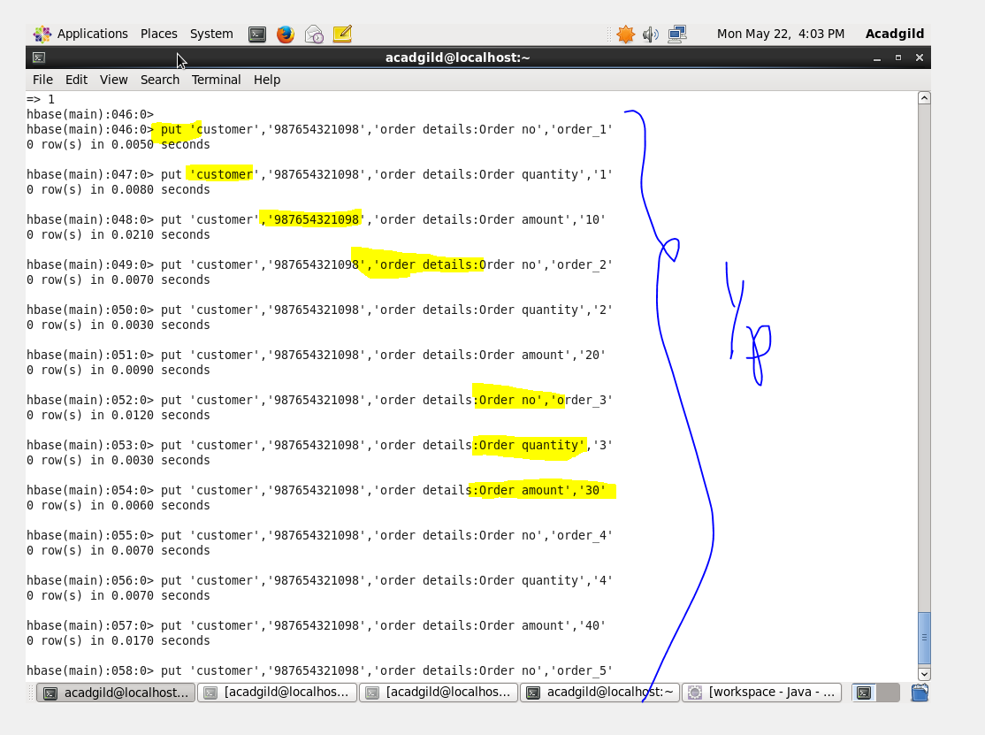

**Use get command, to retrieve all the records of single customer.**

**OUTPUT**

