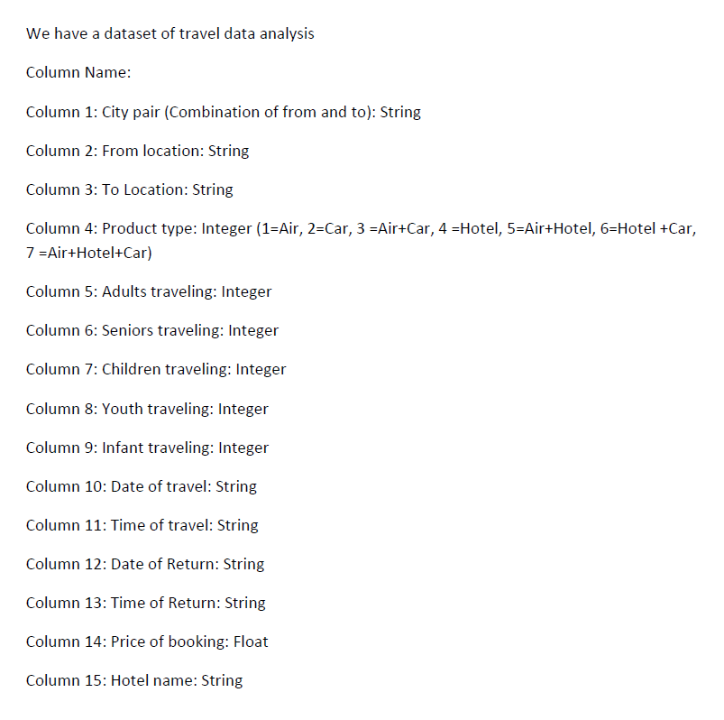

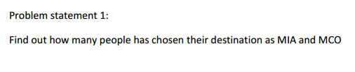

Java program to find out how many people have chosen their destination as YYZ and YYC

Sample input:

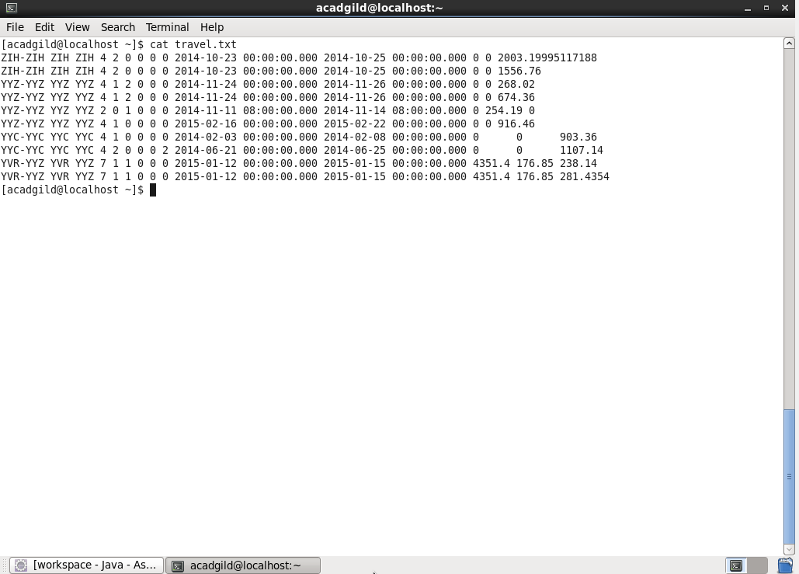

Driver class:

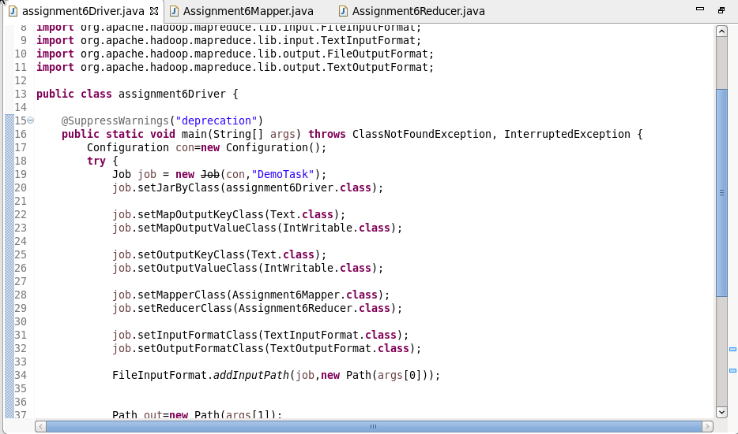

Mapper class:

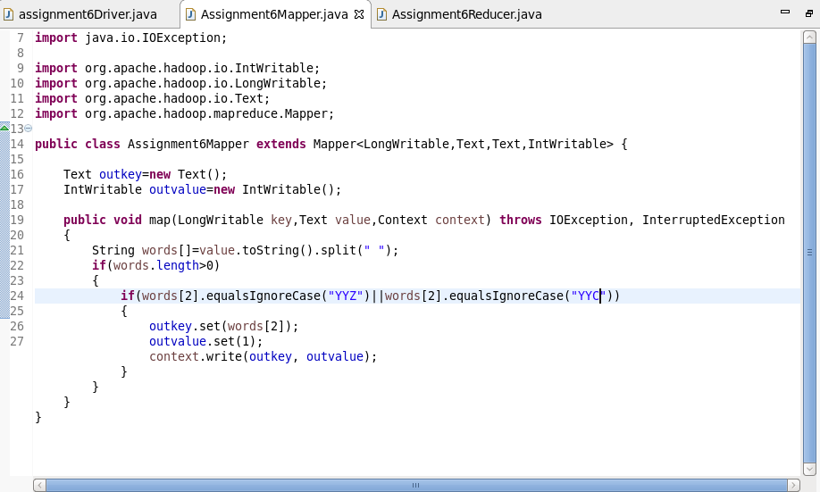

Reducer class:

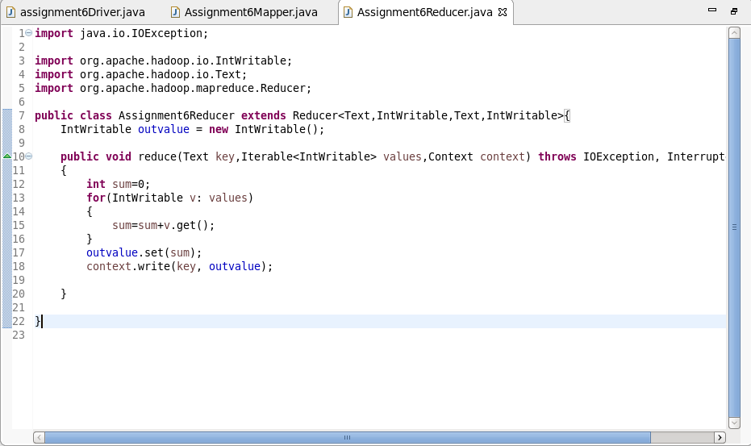

Output:

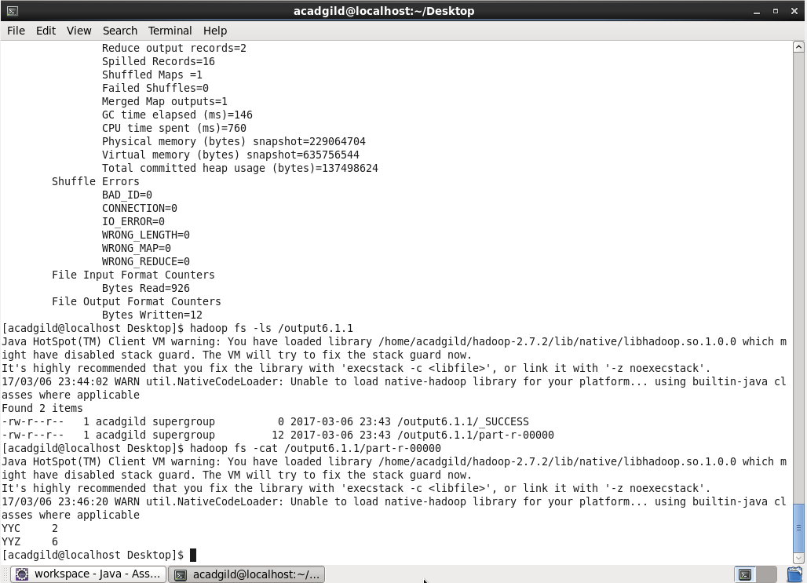

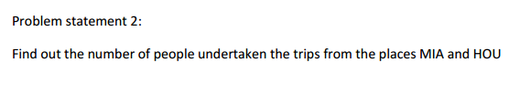

Java program to find out how many people have undertaken their trip from YYZ and YYC

Sample input:



Driver class:



Mapper class:

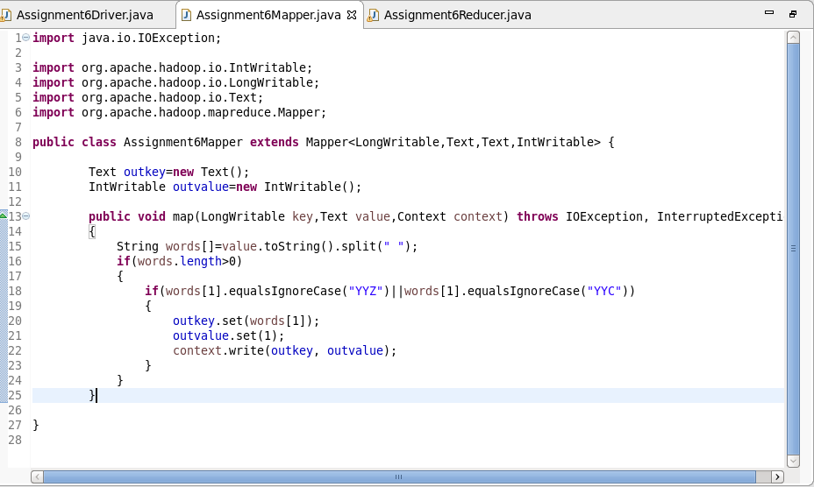

Reducer class:



Output:

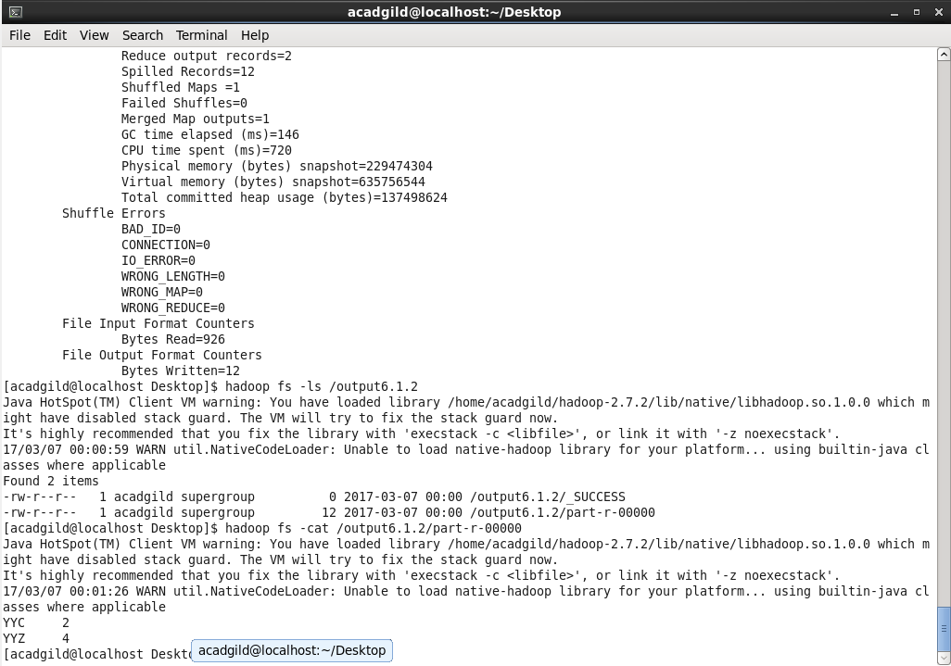

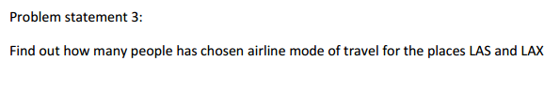 Java program to find out how many people has chosen airline mode of travel from YYZ and YYC

Sample input:



Driver class:



Mapper class:

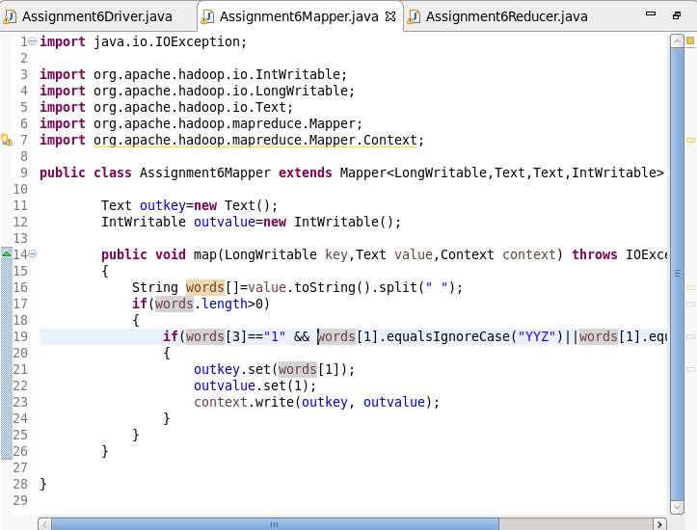

Reducer class:



Output:

