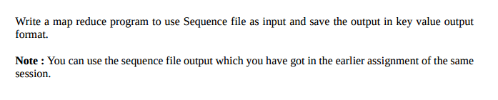

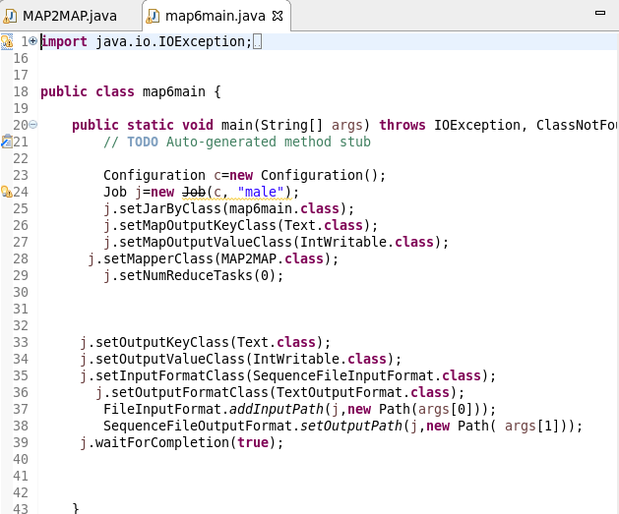

MAPPER CLASS

Used to read input from sequence file

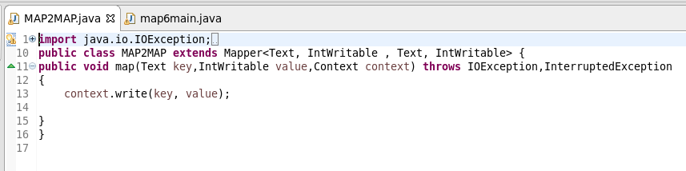

Running jar

INPUT:6.5 assmt sequence file is taken as Input

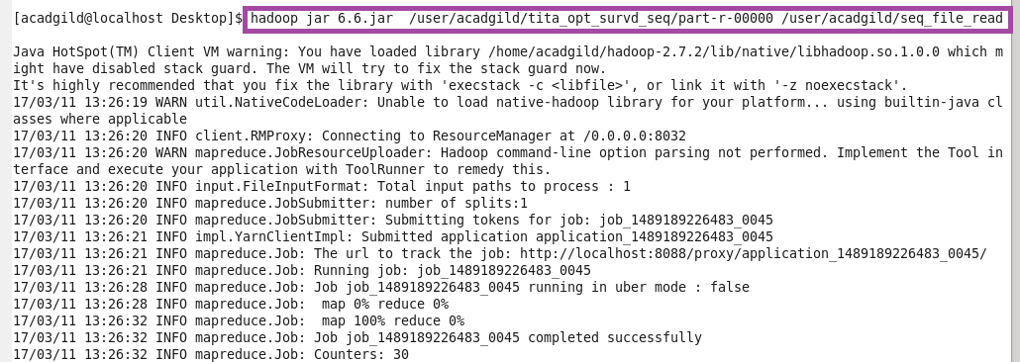

OTPT

