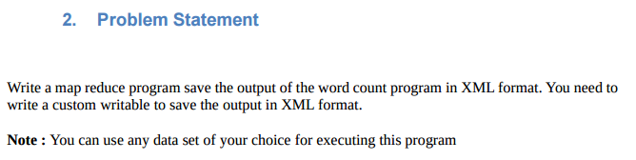

**DRIVER**

**Set output format class as XMLOutputFormat.class**

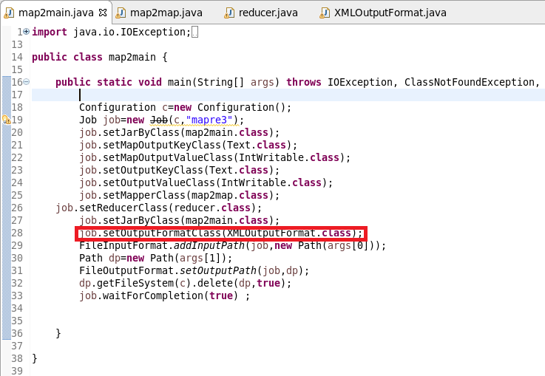

**MAPPER**

**sending company name as Key and a count of 1 as value after filtering “NA”**

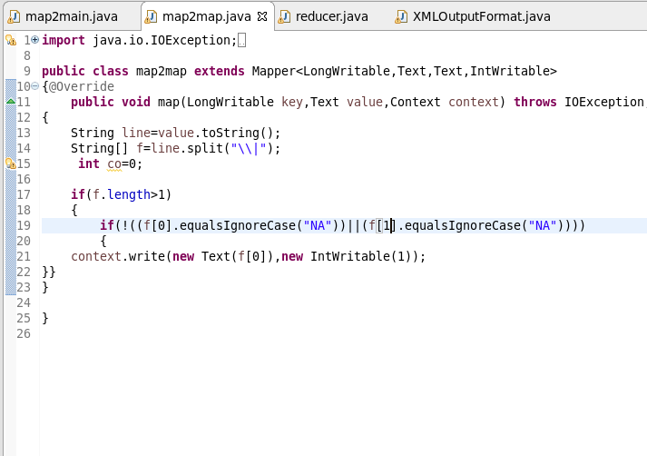

REDUCER

MADE THE TOTAL COUNT

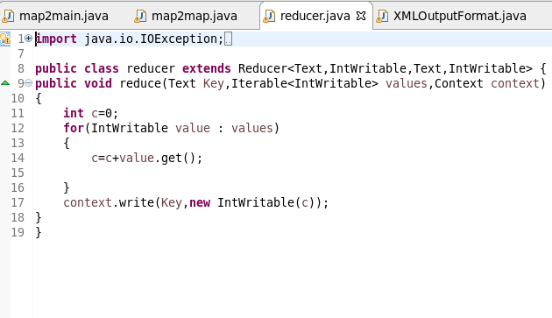

XMLOUTPUTFORMATCLASS

STEP1:EXTENDING FILEOUTPUT FORMAT AND OVERRIDE RECORDWRITER METHOD FOR WRITING THE OUTPUT FROM RECORD WRITERSET EXTENSION TYPE AS XML

STEP2:EXTENDING RECORDWRITER CLASS AND OVERRIDE WRITE METHOD TO WRITE THE KEY AND VALUE AS XML LIKE FORMAT AND THEN USED CLOSED METHOD TO CLOSE

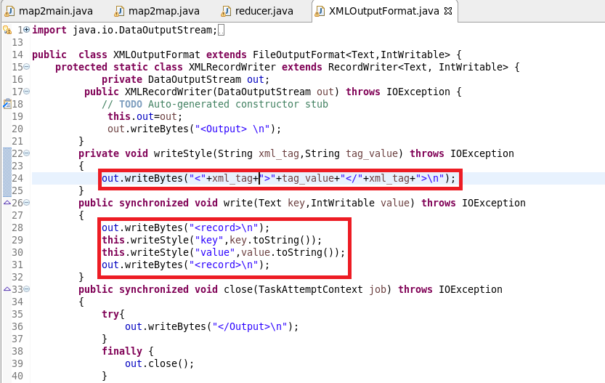

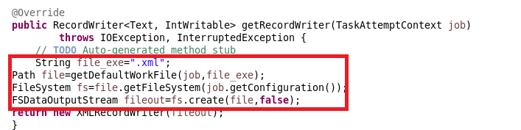

RUNNING JAR

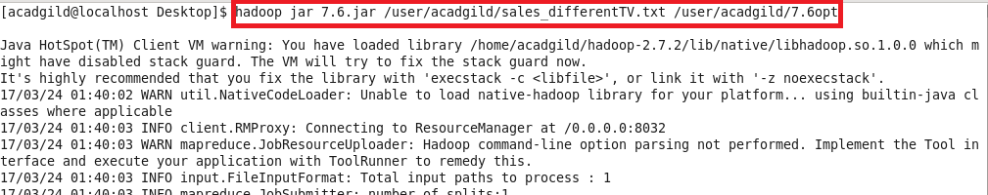

OTPT

