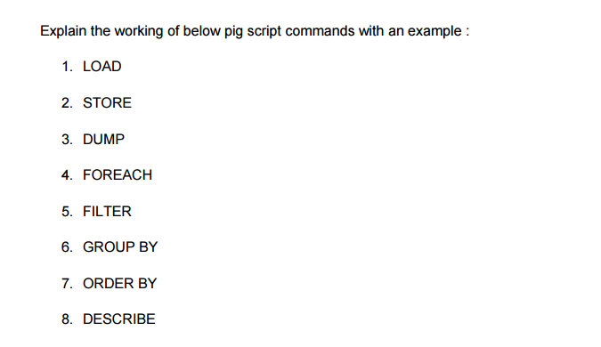

**LOAD**

To Load the data from the file system (local/HDFS) into a relation.

a = load '/hadoopdata/pig/A.txt' using PigStorage(',') as (a1:int, a2:int, a3:int);

**STORE**

To save a relation to the file system (local/HDFS).

STORE l INTO '/pigoutput';

**DUMP**

To print the contents of a relation on the console.

Dump a ;

**FOREACH**

To generate data transformations based on columns of data.

l = FOREACH c GENERATE a1, a2, a2*a3;

**FILTER**

To remove unwanted rows from a relation.

f = FILTER c by $1 > 3;

**GROUP BY**

To group the data in a single relation.

g = GROUP c by $2;

g = GROUP c by ($0,$1);

h = GROUP c ALL;

**ORDER BY**

To arrange a relation in a sorted order based on one or more fields (ascending or descending).

f = order c by a1 desc ;

**DESCRIBE**

To describe the schema of a relation.

describe f;