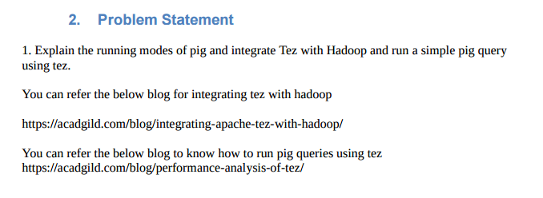

**Tez Execution Mode :**

**Tez runs in 2 modes**

1.Local mode

2.hdfs mode

**Local Mode :**

In local mode the pig commands are executed on local system while the tez framework is responsible for the logical execution like scheduling which run over yarn and optimizes the execution of pig querries as a result of which the time required for running the same querry will be less

**It can be executed by pig –x tez-local wc.pig;**

**Hdfs Mode:**

Here the pig commands are executed in Hdfs Mode and the files should be present in Hdfs cluster

It is started by the command **pig -x tez wc.pig;**

**Pig Execution Modes**

**Pig runs in 2 modes**

1.Local mode

2.hdfs mode

**Local Mode:**

**In local mode pig querry is executed in local mode accessing the local file system.**

**It can be executed by pig –x local wc.pig;**

**Hdfs Mode**

Here the pig commands are executed in Hdfs Mode and the files should be present in Hdfs cluster

It is started by the command **pig wc.pig;**

**Efficiency performance**

**EXECUTED Querry**

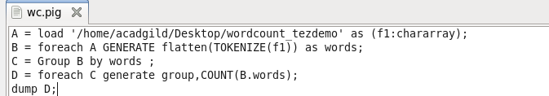

**Using Pig(Yarn)**

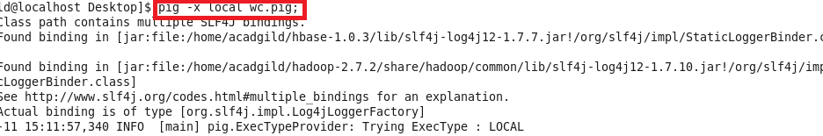

**Inference :task completed in 6.526 milliseconds**

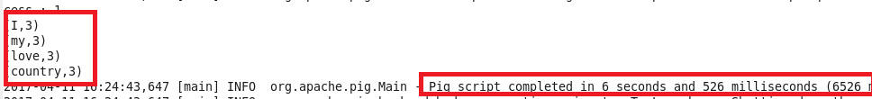

**Using Tez**

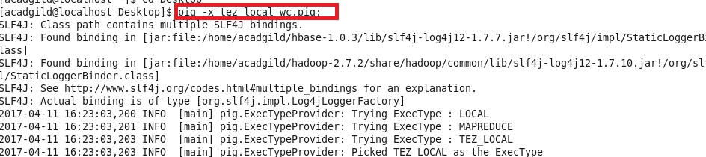

**Inference :task completed in 3.585 milliseconds**

