Improving Reliability of Large Language Models via
Claim-Level Self-Verification and Uncertainty Calibration
CLAIM-CAL: Claim-Level Self-Verification for Calibrated LLM Reliability
Manuscript Draft
Author: Abhigyan Pal
Key Result
On a 200-example TruthfulQA run, CLAIM-CAL + Calibration achieved the lowest calibration error: ECE = 0.034 and Brier Score = 0.158, while maintaining the highest observed accuracy at 0.757.
Dataset: TruthfulQA generation validation split | Sample size: 200 | Final held-out test size: 140 | Calibration method: isotonic regression

Abstract
Large Language Models (LLMs) often generate fluent answers that appear confident even when they contain factual errors. This creates a reliability problem because users may trust incorrect answers when the model provides no meaningful signal of uncertainty. This paper proposes CLAIM-CAL, a claim-level self-verification framework for calibrated LLM reliability. Instead of assigning confidence to a complete answer directly, CLAIM-CAL decomposes an answer into atomic factual claims, verifies each claim using multiple verification probes, converts claim-level verdicts into a risk score, and then applies post-hoc calibration to obtain a more reliable confidence estimate.
We evaluate CLAIM-CAL on the TruthfulQA generation benchmark using a 200-example experimental run. The proposed method is compared against direct answering, verbal confidence, self-consistency, and simple self-verification. Results show that raw CLAIM-CAL achieved the highest observed accuracy among the evaluated methods, but remained overconfident. CLAIM-CAL combined with isotonic calibration achieved the strongest calibration performance, reducing Expected Calibration Error from 0.223 for raw CLAIM-CAL to 0.034 after calibration, while maintaining accuracy at 0.757. The calibrated version also improved selective accuracy at a 0.7 confidence threshold from 0.761 to 0.826. To assess evaluation robustness, a second-pass automated judge consistency check on 50 sampled evaluations achieved 96.0% agreement and Cohen's kappa of 0.896. These findings suggest that claim-level verification is useful as a reliability signal, and calibration is necessary to convert that signal into trustworthy confidence estimates.
Keywords: Large Language Models; hallucination detection; uncertainty calibration; self-verification; TruthfulQA; selective prediction; reliability estimation

1. Introduction
Large Language Models have become highly capable at generating natural language answers across a wide range of tasks. However, fluent outputs can hide an important weakness: LLMs may produce incorrect or unsupported statements while presenting them with high apparent confidence. This behavior is especially problematic in factual question answering, where users may assume that a confident answer is also a truthful answer.
This paper focuses on two related reliability problems: hallucination and overconfidence. In this study, hallucination refers to a generated answer that contains factual claims not supported by the reference answer or that contradict known truth. Overconfidence refers to the mismatch between a model's confidence and its actual correctness. A model is poorly calibrated if answers assigned high confidence are correct much less often than the confidence value suggests.
Existing reliability approaches often use direct confidence scores, verbal confidence, self-consistency, or answer-level verification. These methods have limitations. Direct answering assumes the generated answer is reliable. Verbal confidence depends on the model's own self-reported probability. Self-consistency checks whether multiple sampled answers agree, but repeated answers can still repeat the same misconception. Simple self-verification checks the whole answer at once, but a complete answer may contain several factual claims, some correct and some incorrect.
To address these issues, this paper proposes CLAIM-CAL: Claim-Level Self-Verification for Calibrated LLM Reliability. The central idea is to break an answer into smaller factual claims, verify each claim independently, convert the claim-level verification results into a risk score, and then calibrate the resulting confidence estimate.
Research Question
Can claim-level self-verification produce better-calibrated confidence estimates than direct answer confidence, verbal confidence, self-consistency, and simple self-verification?

Contributions
- A claim-level self-verification framework that decomposes LLM answers into atomic factual claims.
- A risk-based confidence scoring method using Supported, Contradicted, and Unknown claim verdicts.
- A post-hoc calibration stage that converts raw claim-level risk signals into better-calibrated confidence estimates.
- A comparative evaluation on TruthfulQA against direct answering, verbal confidence, self-consistency, and simple self-verification.
- An ablation study analyzing claim decomposition, Unknown labels, contradiction probes, and calibration.
- An automated second-pass judge consistency analysis to assess the stability of LLM-as-judge evaluation.

2. Related Work

2.1 Truthfulness and hallucination in LLMs
TruthfulQA was introduced to evaluate whether language models generate truthful answers to questions that often trigger common misconceptions. It is suitable for this study because the benchmark is designed to expose cases where models imitate false beliefs rather than produce truthful answers.

2.2 Confidence calibration
Calibration measures whether predicted confidence matches empirical correctness. A well-calibrated model should be correct about 80% of the time when it assigns 0.8 confidence. Expected Calibration Error, Brier Score, and reliability diagrams are standard tools for evaluating confidence calibration.

2.3 Self-consistency
Self-consistency estimates reliability by sampling multiple answers and measuring agreement across outputs. The intuition is that repeated agreement may indicate reliability. However, self-consistency can fail when a model consistently repeats the same wrong belief.

2.4 Self-verification and hallucination detection
Self-verification methods ask a model to evaluate or critique its own output. CLAIM-CAL differs by explicitly decomposing an answer into atomic claims, verifying each claim, and using the resulting verdict distribution to compute a risk-based confidence estimate before calibration.

3. Proposed Method: CLAIM-CAL
CLAIM-CAL estimates answer reliability through five steps: generate an initial answer, extract atomic factual claims, verify each claim using multiple probes, convert verification results into claim-level and answer-level risk, and apply calibration to produce the final confidence estimate.

3.1 Initial answer generation
Given a question q, the LLM generates an answer a:
a = M(q)

3.2 Atomic claim extraction
The generated answer a is decomposed into a set of atomic claims:
C = {c_1, c_2, ..., c_n}
Each claim should contain one factual statement that can be independently checked. For example, the answer 'The Eiffel Tower is in Paris and was completed in 1889' is decomposed into two claims: 'The Eiffel Tower is in Paris' and 'The Eiffel Tower was completed in 1889.'

3.3 Claim verification
Each claim is verified using multiple verification probes. For every claim c_i, the verifier assigns one of three labels: Supported, Contradicted, or Unknown. The method counts the number of each verdict and converts those counts into normalized scores:
support_score_i = S_i / T_i
contradiction_score_i = D_i / T_i
unknown_score_i = U_i / T_i
Here, S_i is the number of Supported verdicts, D_i is the number of Contradicted verdicts, U_i is the number of Unknown verdicts, and T_i is the total number of verification checks for claim i.

3.4 Claim-level risk
Each claim receives a risk score:
risk_i = 0.5 × contradiction_score_i + 0.3 × unknown_score_i + 0.2 × (1 - support_score_i)
Contradicted claims receive the largest risk weight, Unknown claims receive moderate risk, and weakly supported claims are also penalized.

3.5 Answer-level risk and confidence
The answer-level risk is the average of the claim risks:
answer_risk = (1 / n) × Σ risk_i
Raw confidence is computed as:
confidence_raw = 1 - answer_risk

3.6 Calibration
Raw confidence may still be miscalibrated. Therefore, CLAIM-CAL applies post-hoc calibration on a calibration split. In the improved experiment, isotonic regression is used:
confidence_calibrated = f(confidence_raw)
The calibration function f is learned using raw confidence scores and correctness labels from the calibration split.

4. Experimental Setup

4.1 Dataset
The experiment uses the TruthfulQA generation benchmark. The improved run uses a sample size of 200 examples from the validation split. The dataset provides questions, best answers, correct reference answers, incorrect reference answers, and category metadata.

4.2 Model and run configuration
Setting | Value
Dataset | truthful_qa / generation / validation
Sample size | 200
Calibration examples | 60
Held-out test examples | 140
Answer model | gpt-4o-mini
Judge model | gpt-4o-mini
Answer temperature | 0.2
Self-consistency temperature | 0.8
Verifier temperature | 0.0
Self-consistency K | 5
Verification probes per claim | 3
Maximum claims per answer | 8
Confidence threshold | 0.7
Calibration method | isotonic
Table 1. Experimental configuration for the improved CLAIM-CAL run.

4.3 Baselines
Direct Answer: The model answers the question directly. Since no explicit confidence is produced, confidence is treated as 1.0.
Verbal Confidence: The model generates an answer and a confidence score between 0 and 1.
Self-Consistency: The model generates K = 5 answers for each question. Similar answers are grouped and confidence is computed as the size of the largest answer cluster divided by K.
Simple Self-Verification: The model first generates an answer, and then a verifier judges whether the full answer is correct.
CLAIM-CAL: The proposed method generates an answer, decomposes it into claims, verifies each claim, calculates risk, and produces raw confidence.
CLAIM-CAL + Calibration: Raw CLAIM-CAL confidence is calibrated using isotonic regression.

4.4 Correctness evaluation
Correctness is evaluated using an LLM-as-judge. The judge receives the question, generated answer, correct reference answers, and incorrect reference answers from TruthfulQA. It labels each answer as Correct, Incorrect, or Ambiguous and provides a short explanation. Because LLM-based evaluation may be sensitive to prompt wording, we additionally perform an automated second-pass judge consistency analysis on a random sample of 50 evaluated answers.

4.5 Automated judge robustness check
We re-evaluated 50 randomly sampled judged answers using an independent stricter judge prompt, then compared original and second-pass labels using agreement rate and Cohen's kappa. This is an automated robustness check, not a substitute for human validation.
Table 4. Automated second-pass judge consistency summary.
Audit Type | Sample Size | Agreement Rate | Cohen Kappa
Automated second-judge robustness check | 50 | 0.960 | 0.896
The check produced 96.0% agreement and Cohen's kappa of 0.896, indicating strong second-pass judge consistency.
Table 5. Original judge vs. second-pass judge confusion matrix.
Original Judge Label | Second Judge: Correct | Second Judge: Incorrect | Second Judge: Ambiguous
Original Judge: Correct | 36 | 1 | 0
Original Judge: Incorrect | 1 | 12 | 0
Original Judge: Ambiguous | 0 | 0 | 0
Only two disagreements were observed: one Correct-to-Incorrect change and one Incorrect-to-Correct change; no Ambiguous cases appeared in this sample.

5. Evaluation Metrics
Accuracy: Accuracy = number of correct answers / total answers.
Incorrect Rate: Incorrect Rate = 1 - Accuracy. In this experiment, it is used as a practical approximation of hallucination rate.
Expected Calibration Error: ECE is the weighted average gap between empirical accuracy and mean confidence across confidence bins.
Brier Score: Brier Score = mean((confidence - correctness)^2), where correctness is 1 for correct and 0 for incorrect.
Selective Accuracy @ 0.7: Accuracy after retaining only answers with confidence at least 0.7.
Coverage @ 0.7: Fraction of answers retained after applying the 0.7 confidence threshold.
Risk-Coverage Analysis: Risk = 1 - selective accuracy. The risk-coverage curve shows how risk changes as the system answers only increasingly confident examples.

6. Results

6.1 Main comparison
The main results are reported on the 140-example held-out split after isotonic calibration was fit on 60 calibration examples.
Method | N | Acc. | Incorrect | ECE | Brier | Avg Conf. | Sel. Acc. @0.7 | Coverage @0.7
Direct Answer | 140 | 0.736 | 0.264 | 0.264 | 0.264 | 1.000 | 0.736 | 1.000
Verbal Confidence | 140 | 0.693 | 0.307 | 0.182 | 0.236 | 0.875 | 0.693 | 1.000
Self-Consistency | 140 | 0.750 | 0.250 | 0.350 | 0.337 | 0.457 | 0.808 | 0.186
Simple Self-Verification | 140 | 0.736 | 0.264 | 0.163 | 0.205 | 0.899 | 0.741 | 0.993
CLAIM-CAL | 140 | 0.757 | 0.243 | 0.223 | 0.216 | 0.975 | 0.761 | 0.986
CLAIM-CAL + Calibration | 140 | 0.757 | 0.243 | 0.034 | 0.158 | 0.759 | 0.826 | 0.864
Table 2. Main method comparison on the held-out test split. Lower ECE and lower Brier Score indicate better calibration.

6.2 Bootstrap confidence intervals
To reduce overinterpretation of a single run, bootstrap confidence intervals were computed for the key metrics. The table below reports each metric as value [95% CI].
Method | Accuracy [95% CI] | ECE [95% CI] | Brier [95% CI] | Sel. Acc. @0.7 [95% CI]
Direct Answer | 0.736 [0.664, 0.807] | 0.264 [0.193, 0.336] | 0.264 [0.193, 0.336] | 0.736 [0.664, 0.807]
Verbal Confidence | 0.693 [0.614, 0.771] | 0.182 [0.106, 0.255] | 0.236 [0.178, 0.290] | 0.693 [0.614, 0.771]
Self-Consistency | 0.750 [0.664, 0.821] | 0.350 [0.279, 0.426] | 0.337 [0.295, 0.382] | 0.808 [0.643, 0.957]
Simple Self-Verification | 0.736 [0.664, 0.814] | 0.163 [0.089, 0.233] | 0.205 [0.145, 0.258] | 0.741 [0.669, 0.819]
CLAIM-CAL | 0.757 [0.686, 0.821] | 0.223 [0.159, 0.291] | 0.216 [0.157, 0.280] | 0.761 [0.691, 0.827]
CLAIM-CAL + Calibration | 0.757 [0.686, 0.829] | 0.034 [0.022, 0.108] | 0.158 [0.118, 0.200] | 0.826 [0.756, 0.891]
Table 3. Bootstrap confidence intervals for key metrics.

6.3 Accuracy and calibration findings
CLAIM-CAL and CLAIM-CAL + Calibration achieved the highest observed accuracy of 0.757. Self-Consistency achieved 0.750, Direct Answer and Simple Self-Verification achieved 0.736, and Verbal Confidence achieved 0.693. The difference in raw accuracy should be interpreted cautiously, but the result shows that CLAIM-CAL maintains or slightly improves answer correctness while producing additional reliability signals.
The strongest finding is calibration. Raw CLAIM-CAL has ECE 0.223, while CLAIM-CAL + Calibration reduces ECE to 0.034. CLAIM-CAL + Calibration also achieves the lowest Brier Score of 0.158. This means that calibration converts raw claim-level reliability signals into confidence estimates that better match empirical correctness.
At the 0.7 confidence threshold, CLAIM-CAL + Calibration improves selective accuracy to 0.826 with coverage of 0.864. This is a useful deployment trade-off: the method answers fewer questions confidently, but the retained high-confidence answers are more reliable.

6.4 Figures
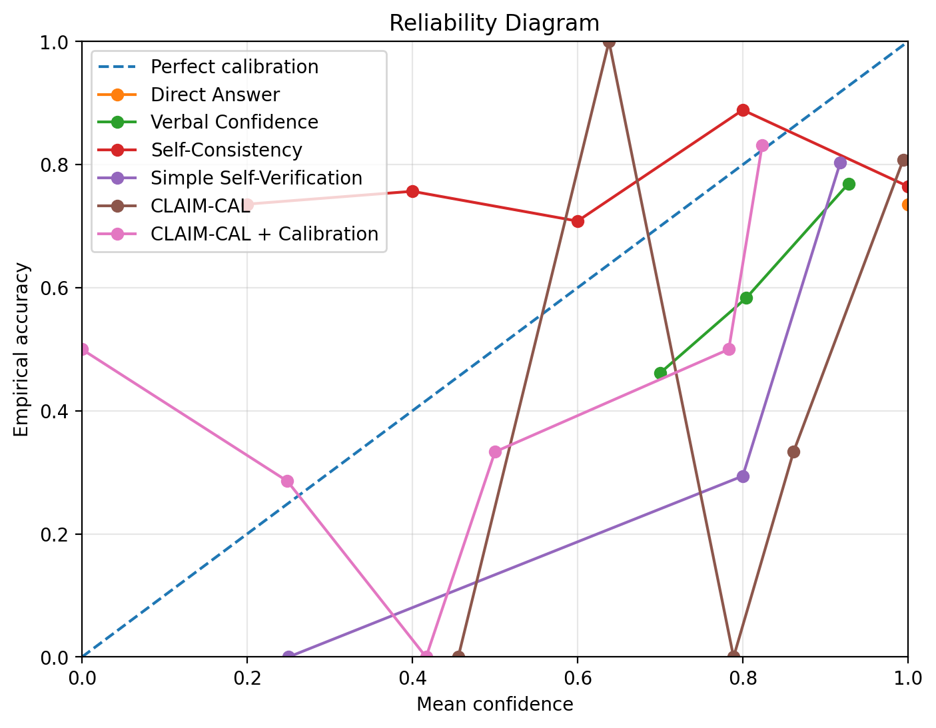
Figure 1. Reliability diagram comparing predicted confidence with empirical accuracy. CLAIM-CAL + Calibration achieves the strongest calibration behavior in the numeric ECE results, although individual bins remain noisy.
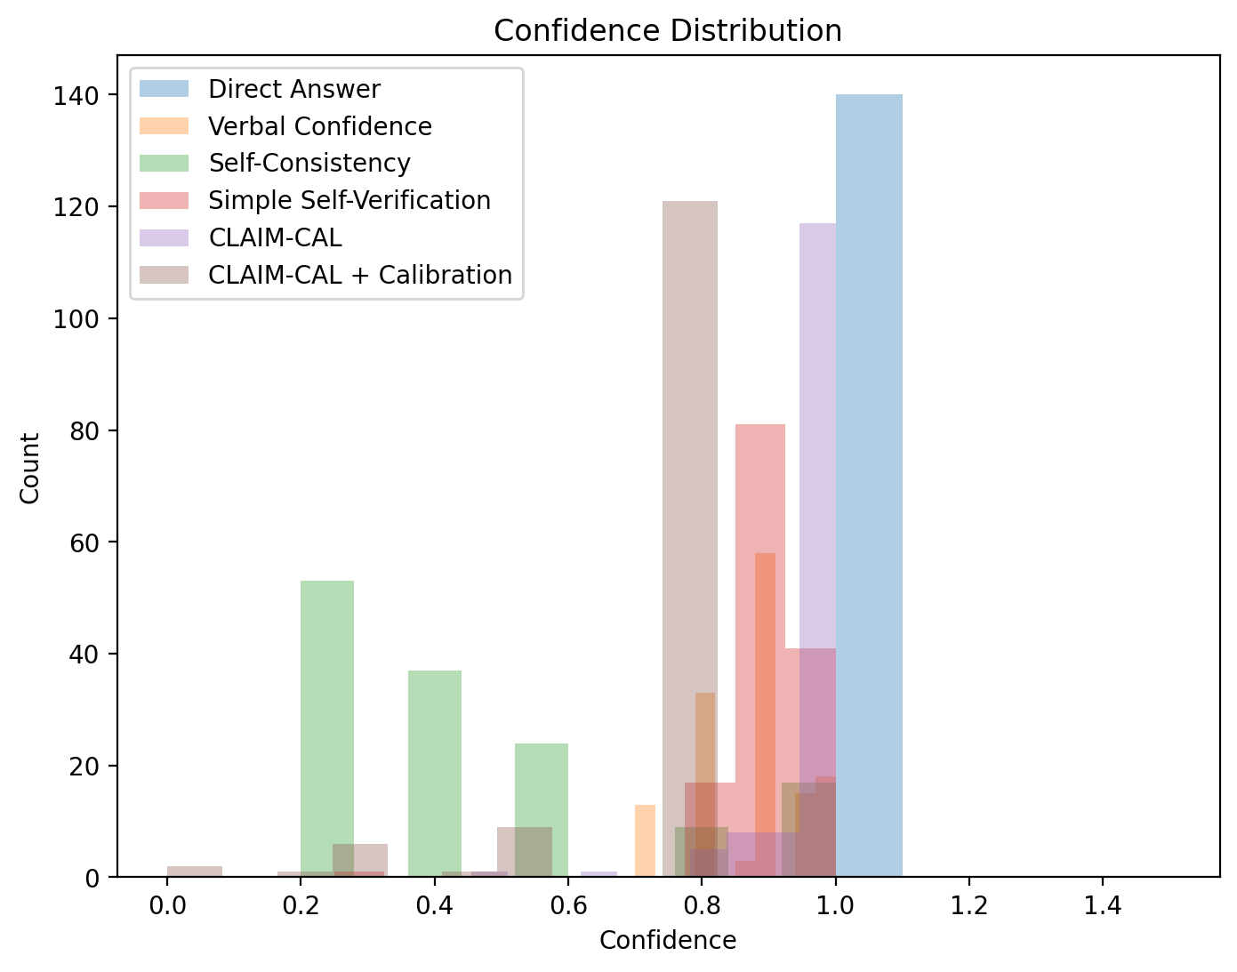
Figure 2. Confidence distribution. Direct Answer and raw CLAIM-CAL concentrate near high confidence, while CLAIM-CAL + Calibration shifts confidence toward a more realistic range.
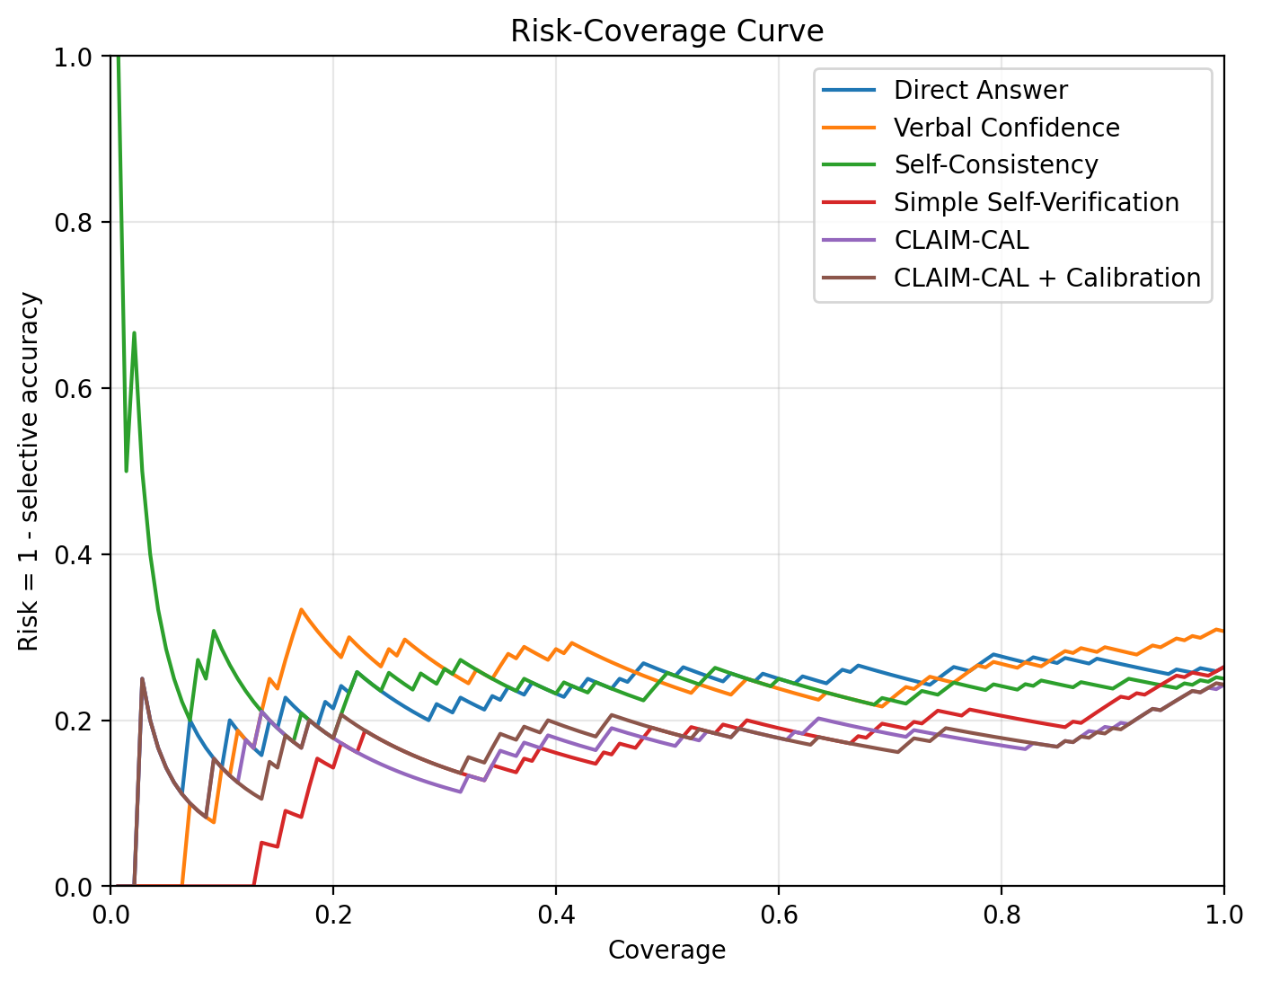
Figure 3. Risk-coverage curve. Lower risk at a given coverage indicates better selective-answering behavior.
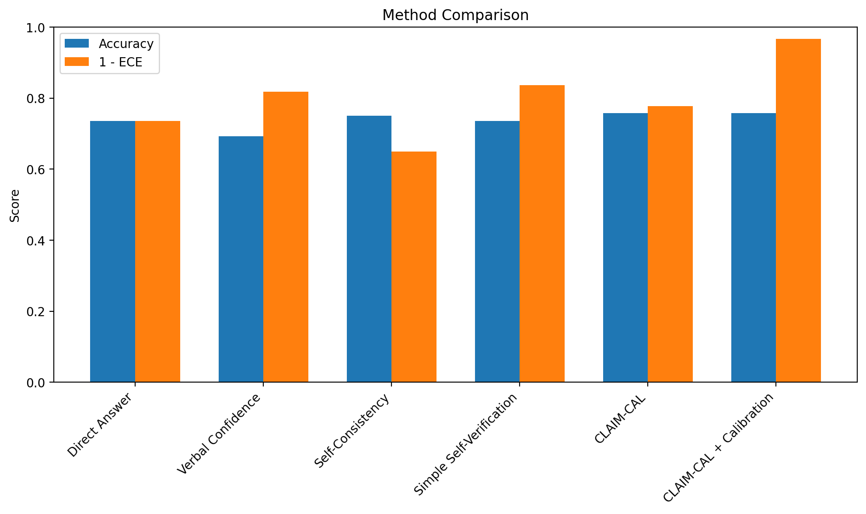
Figure 4. Method comparison using Accuracy and 1 - ECE. CLAIM-CAL + Calibration achieves the best calibration score while maintaining the highest observed accuracy.

7. Ablation Study
The ablation study removes individual components of CLAIM-CAL to understand their effect.
Ablation | N | Acc. | Incorrect | ECE | Brier | Avg Conf. | Sel. Acc. @0.7 | Coverage @0.7
No Calibration | 140 | 0.757 | 0.243 | 0.223 | 0.216 | 0.975 | 0.761 | 0.986
No Claim Decomposition | 140 | 0.743 | 0.257 | 0.177 | 0.207 | 0.809 | 0.792 | 0.857
No Contradiction Probe | 140 | 0.743 | 0.257 | 0.240 | 0.232 | 0.977 | 0.759 | 0.979
No Unknown Label | 140 | 0.764 | 0.236 | 0.216 | 0.212 | 0.980 | 0.775 | 0.986
Table 4. CLAIM-CAL ablation results.

7.1 Ablation interpretation
Calibration provides the largest improvement in confidence quality. Raw CLAIM-CAL has ECE 0.223, while CLAIM-CAL + Calibration achieves ECE 0.034. This supports the inclusion of calibration as a core part of the method.
Removing claim decomposition reduces accuracy from 0.757 to 0.743, suggesting that atomic claim-level verification contributes useful signal compared with full-answer verification.
Removing contradiction probing increases ECE to 0.240, indicating that explicitly checking contradiction helps the method identify risky answers. Removing the Unknown label produced a small improvement in accuracy in this run, but its effect should be tested across additional samples because it may depend on verifier behavior and dataset composition.

8. Error Analysis
Failure Type | Count
Overconfident wrong answers | 170
Underconfident correct answers | 91
Ambiguous ground-truth cases | 9
Claim extraction failures | 0
Verifier failures | 0
Table 5. Failure case summary from the improved run.
The absence of explicit claim extraction and verifier failures suggests that the pipeline executed stably. However, the presence of overconfident wrong answers shows that CLAIM-CAL does not fully solve hallucination or overconfidence. Instead, its strongest value is reducing calibration error and improving selective reliability after calibration.
The error analysis suggests that future work should improve verifier independence, add human validation for a subset of judged cases, and test whether claim extraction misses implicit or vague factual claims even when extraction technically succeeds. The automated second-pass judge analysis provides evidence of judging stability, but it does not replace expert or human evaluation.

9. Discussion
The improved results show that claim-level self-verification can provide useful reliability signals. Raw CLAIM-CAL achieved the highest observed accuracy, but its average confidence remained high at 0.975 and its ECE was 0.223. This means the raw risk formula alone is not enough for well-calibrated confidence.
After isotonic calibration, average confidence decreased to 0.759, ECE dropped to 0.034, and Brier Score improved to 0.158. This supports the paper's central claim: claim-level verification should be paired with calibration when the goal is reliable confidence estimation.
In practical deployment, this distinction matters. An AI system should not only answer questions; it should also know when not to answer confidently. CLAIM-CAL + Calibration supports this by improving selective accuracy at the 0.7 confidence threshold while retaining 86.4% coverage.

10. Limitations
- The improved experiment uses 200 sampled TruthfulQA examples and 140 final held-out test examples after calibration. This is stronger than the initial pilot but still should be expanded before journal submission.
- Correctness is evaluated using an LLM-as-judge. This enables scalable evaluation but may introduce judge bias. The automated second-pass robustness check showed strong agreement between two judging prompts, but it is still not a substitute for human expert annotation.
- The same model family is used for answer generation, verification, and judging. This may create correlated errors.
- The risk formula uses manually selected weights: 0.5 for contradiction, 0.3 for unknown, and 0.2 for lack of support. Future work could learn these weights from validation data.
- The method intentionally does not use retrieval. This isolates self-verification, but retrieval-based verification may improve factual checking in production systems.

11. Future Work
- Evaluate CLAIM-CAL on larger TruthfulQA subsets and additional datasets such as Natural Questions, FEVER-style fact verification datasets, and domain-specific QA benchmarks.
- Test multiple answer models, verifier models, and judge models to measure generalization across model families.
- Add a small human expert audit to complement the automated second-pass judge consistency analysis.
- Learn the claim-risk weights instead of fixing them manually.
- Extend CLAIM-CAL to human-in-the-loop settings where low-confidence or high-risk answers are routed to human review.

12. Conclusion
This paper introduced CLAIM-CAL, a claim-level self-verification method for calibrated LLM reliability. The method decomposes generated answers into atomic claims, verifies each claim using Supported, Contradicted, and Unknown labels, calculates claim-level risk, and converts answer-level risk into confidence. Post-hoc calibration is then used to improve the alignment between confidence and correctness.
In an improved 200-example TruthfulQA experiment, CLAIM-CAL + Calibration achieved the lowest Expected Calibration Error and Brier Score while maintaining the highest observed accuracy among the evaluated methods. These results suggest that claim-level verification is valuable as a reliability estimation mechanism, especially when combined with calibration.
The key conclusion is that LLM reliability should not be measured only by whether an answer is correct. It should also be measured by whether the model's confidence honestly reflects the likelihood of correctness. CLAIM-CAL is a step toward making LLM confidence more trustworthy for selective answering and risk-aware deployment.

References
[1] Lin, S., Hilton, J., & Evans, O. (2022). TruthfulQA: Measuring How Models Mimic Human Falsehoods. ACL.
[2] Guo, C., Pleiss, G., Sun, Y., & Weinberger, K. Q. (2017). On Calibration of Modern Neural Networks. ICML.
[3] Wang, X., Wei, J., Schuurmans, D., Le, Q., Chi, E., Narang, S., Chowdhery, A., & Zhou, D. (2023). Self-Consistency Improves Chain of Thought Reasoning in Language Models. ICLR.
[4] Manakul, P., Liusie, A., & Gales, M. J. F. (2023). SelfCheckGPT: Zero-Resource Black-Box Hallucination Detection for Generative Large Language Models. EMNLP.
[5] Brier, G. W. (1950). Verification of forecasts expressed in terms of probability. Monthly Weather Review.

