**Compiler for Go Langauge**

Presented by : - Abhilash ( Roll no: 1 , D-1)

- Shivam Varshney ( Roll no: 17 , D-1)

- Nihal Pereira ( Roll no: 19 , D-1)



1. **Objective** : The objective of our project is to make a compiler in Flex/Bison for the programming language Go ( by Google) . The functionalities that we are including in the compiler are :

- Generation of tokens

- Error Detection

- Producing the Symbol Table

- Showing the line number where error occurs

1. **Grammar :**

program-> PackageClause S | PackageClause Import S

PackageClause-> PACKAGE PackageName

PackageName-> ID

Import-> ImportDecl Import | ;

ImportDecl-> IMPORT ImportSpec

ImportSpec-> DOT ImportPath | PackageName ImportPath | ImportPath ;

ImportPath-> DOUBLE_QUOTE pp DOUBLE_QUOTE

pp-> ID pp | CO pp | NUMBER pp | MOD pp | ;

S-> Statement_list S | ;

VarDecl-> VAR VarSpec ;

VarSpec-> identifier_list Type | identifier_list Type EQUAL ExprList | identifier_list EQUAL ExprList

Type-> TYPE | TypeLit | TypeName | OPEN_BRAC Type CLOSE_BRAC

TypeLit-> ArrayType | FunctionType | StructType

TypeName-> ID | QualifiedIdent

QualifiedIdent-> ID DOT ID

ArrayType-> SQUA_OPEN expn SQUA_CLOSE Type

StructType-> STRUCT OPEN_FLOW FieldDecl CLOSE_FLOW

FieldDecl-> identifier_list Type FieldDecl | ID FieldDecl | MUL TypeName FieldDecl | ;

FunctionType-> FUNC Signature

Signature-> Parameters | Parameters Result

Result-> Parameters | Type

TypeDecl-> TYP VarSpec

Parameters-> OPEN_BRAC Parameter_List CO CLOSE_BRAC | OPEN_BRAC Parameter_List CLOSE_BRAC | OPEN_BRAC CLOSE_BRAC | OPEN_BRAC DOUBLE_QUOTE pp DOUBLE_QUOTE CLOSE_BRAC | OPEN_BRAC DOUBLE_QUOTE pp DOUBLE_QUOTE CO identifier_list CLOSE_BRAC

Parameter_List-> Parameter_Decl | Parameter_Decl Param

Param-> CO Parameter_Decl Param| ;

Parameter_Decl-> Type | identifier_list Type

FunctionDecl-> FUNC ID Signature | FUNC ID Function

Function-> Signature FunctionBody

FunctionBody-> Block

Block-> OPEN_FLOW Statement_list CLOSE_FLOW

Statement_list-> statement Statement_list | ;

ExprList-> expn | expn CO ExprList

identifier_list-> ID | ID CO identifier_list | ID CO identifier_list EQUAL expn

statement-> assign_stat | decision_stat | looping_stat | return_stat | break_stat | continue_stat | Declaration | Block | SimpleStmt

Declaration-> VarDecl | FunctionDecl| TypeDecl

SimpleStmt-> inDec_stat | expression_stat | assign_stat | shortvarDecl

expression_stat-> expn

shortvarDecl-> identifier_list COLEQU ExprList

assign_stat-> ExprList EQUAL ExprList | ID PLUS EQUAL expn | ID MUL EQUAL expn

expn-> simple_expn eprime | primaryexpr

index-> SQUA_OPEN expn SQUA_CLOSE

primaryexpr-> Operand | primaryexpr Arguments | primaryexpr Selector | primaryexpr index

Operand-> Literal | OperandName | OPEN_BRAC expn CLOSE_BRAC

Literal-> BasicLit | CompositeLit | FunctionLit

FunctionLit-> FUNC Signature FunctionBody

BasicLit-> NUMBER

CompositeLit-> LiteralType LiteralValue

LiteralType-> StructType | ArrayType | SQUA_OPEN NUMBER SQUA_CLOSE Type

LiteralValue-> OPEN_FLOW CLOSE_FLOW | OPEN_FLOW ElementList CLOSE_FLOW | OPEN_FLOW ElementList CO CLOSE_FLOW

ElementList-> KeyedElement | KeyedElement CO ElementList

KeyedElement-> Element | Key COLON Element

Key-> ID | expn | LiteralValue

Element-> expn | LiteralValue

OperandName-> ID | QualifiedIdent

Arguments-> OPEN_BRAC CLOSE_BRAC | OPEN_BRAC ExprList CLOSE_BRAC | OPEN_BRAC Type CLOSE_BRAC| OPEN_BRAC Type CO ExprList CLOSE_BRAC| OPEN_BRAC DOUBLE_QUOTE pp DOUBLE_QUOTE CLOSE_BRAC | OPEN_BRAC DOUBLE_QUOTE pp DOUBLE_QUOTE CO identifier_list CLOSE_BRAC

Selector-> DOT ID

eprime-> relop simple_expn | ;

simple_expn-> term seprime

seprime-> addop term seprime | ;

term-> factor tprime

tprime-> mulop factor tprime | ;

factor-> ID | NUMBER

decision_stat-> IF expn Block dprime

dprime-> ELSE Block | ELSE decision_stat | ;

looping_stat-> FOR ForClause Block | FOR Condition Block | FOR Block

ForClause-> stm l SS exprTT SS stml | ;

Condition-> expn | ;

stml-> SimpleStmt | ;

inDec_stat-> expn DPLUS | expn DMINUS

exprTT-> expn | ;

return_stat-> RETURN | RETURN ExprList

break_stat-> BREAK

continue_stat-> CONTINUE

relop-> GREATER_THAN | GREATER_THAN_EQUAL | LESSER_THAN | LESSER_THAN_EQUAL | EQUALS | NOT_EQUALS

addop-> PLUS | MINUS

mulop-> DIV | MUL | MOD

1. **Language used for implementation** : Flex, Bison
2. **Type of Parser** : Bottom up Parser
3. **Methedology :** Parsing is the process of matching grammar symbols to elements in the input data, according to the rules of the grammar. The parser obtains a sequence of tokens from the lexical analyzer, and recognizes it’s structure.

Bottom –up parser generates the parse tree bottom-up. Given the string to be parsed and the set of productions, it traces a rightmost derivation in reverse by starting with the input string and working backwards to the start symbol.

Symbol table stores the identifiers and labels when they are first encountered during parsing action.

1. User Documentation Readme.txt: C compiler for the go language. The main parser of the file is found in the a.y bison file. This has the symbol table code imported as a header. The tab.h of this file is imported in the lex file for token generation. The symbol table creates and pints the table and its entries. The symbol table code is compiled and headers are taken out. Then the bison code is compiled with bison to generate a.tab.c and a.tab.h. The header file is used in the flex file a.l. Then the lex file after flex compilation giving lex.yy.c is compiled together with the header file of the bison, a.tab.c.

Commands

* bison -d a.y
* flex a.l

gcc lex.yy.c a.tab.c -o a

1. Code

* Symbol table
* #include <stdio.h>
* #include <string.h>
* #include <stdlib.h>
* #include <ctype.h>
* #define TableLength 30
* int row=1,col;
* char ca,cb,buf[10];int i=0;
* FILE *fp,*fout;
* char *keywords[]={"break","default","func","interface","select","case","defer","go","map","struct","chan","else","goto","package","switch","const","fallthrough","if","range","type","continue","for","import","return","var"};
* char *datatypes[]={"bool","byte","complex64","complex128","float32","float64","int","int8","int16","int32","int64","rune","uint","uint8","uint16","uint32","uint64"};
* int sizes[]={1,1,8,16,4,8,8,1,2,4,8,4,8,1,2,4,8};
* int recDTindex = 0;
* int globalScope = 1;
* typedef struct token{
* char name[10];
* char type[10];
* int size;
* char scope;
* int nargs;
* char args[20];
* char returnType[10];
* }token;
* token te[5];
* int ct=0;
* int i;
* int sizeArr=1;
* struct ListElement{
* token tok;
* struct ListElement *next;
* };
* struct ListElement *TABLE[TableLength];
* void Initialize(){
* for( i=0;i<TableLength;i++){TABLE[i] = NULL;}
* }
* int HASH(char *str){
* int x=0;
* for( i=0;str[i]!='\0';i++) x += str[i];
* x %= TableLength;
* return x;
* }
* int SEARCH(char *str){
* int val = HASH(str);
* struct ListElement * ele= TABLE[val];
* while(ele!=NULL){
* if(strcmp(ele->tok.name,str)==0) break;
* ele = ele->next;
* }
* if(ele == NULL) return 0;
* return 1;
* }
* void INSERT(token tk){
* if(SEARCH(tk.name)==1){return;}
* int val = HASH(tk.name);
* struct ListElement* cur = (struct ListElement*)malloc(sizeof(struct ListElement));
* cur->tok = tk;
* cur->next = NULL;
* if(TABLE[val]==NULL){
* TABLE[val] = cur;
* }
* else{
* struct ListElement * ele= TABLE[val];
* while(ele->next!=NULL){
* ele = ele->next;
* }
* ele->next = cur;}
* }
* int getVal(char s[]){
* int res = 0;
* for( i=0;s[i]!='\0';i++){
* res *= 10;
* res += s[i]-'0';
* }
* return res;
* }
* int getType(char buf[],int len){
* if(strcmp(buf,"package")==0)
* {
* while(ca != '\n') ca = getc(fp);
* return 0;
* }
* for( i=0;i<25;i++) {if(strcmp(buf,keywords[i])==0) return 0;}
* for( i=0;i<17;i++) {if(strcmp(buf,datatypes[i])==0){
* printf("GGG %s",buf);
* recDTindex = i;
* return 1;
* }
* }
* buf[len] = '\0';
* if(SEARCH(buf)) return 4;
* int i;
* for(i=0;i<len;i++) if(!isdigit(buf[i])) break;
* if(i==len) return 2;
* return 3;
* }
* void getArguments(token *t){
* token temp[10];
* int ti = 0,no_of_args=0;
* i=0;
* while(ca!=')'){
* ca = getc(fp);
* if(isalnum(ca) || ca == '_'){buf[i++] = ca;col++;}
* else{
* buf[i] = '\0';
* printf("buffer =%s ",buf);
* int type = getType(buf,i);
* if(type == 3||ca=='['){
* printf("inside type=3");
* no_of_args++;
* strcpy(te[ct].name,buf);
* strcpy(te[ct].returnType,"NONE");
* te[ct].scope = 'L';
* if(ca == '['){
* char arrsize[10]; int ai = 0;
* ca = getc(fp);
* while(ca!=']'){
* arrsize[ai++] = ca;
* ca = getc(fp);
* }
* arrsize[ai] = '\0';
* sizeArr = getVal(arrsize);
* printf("size is%d",sizeArr);
* }
* strcpy(te[ct].args,"NA");
* te[ct].nargs = 0;
* ct++;
* i=0;
* }
* if(type == 1){
* printf("inside type=1");
* printf("ct=%d ",ct);
* int z;
* for(z=0;z<ct;z++){
* strcat(t->args,strcat(te[z].name,","));
* strcpy(te[z].type,datatypes[recDTindex]);
* te[z].size = sizes[recDTindex]*sizeArr;
* INSERT(te[z]);
* i=0;
* }
* printf("done insertion");
* ct=0;
* sizeArr=1;
* }
* memset(buf,0,sizeof(buf));
* }
* printf("this is %c",ca);
* }
* memset(buf,0,sizeof(buf));
* printf("afff");
* ca = getc(fp);
* i=0;
* while(ca!='\n' && ca!='{'){
* if(isalnum(ca) || ca == '_'){buf[i++] = ca;col++; printf("buf %s\n",buf);}
* ca=getc(fp);
* }
* int type = getType(buf,i);
* strcpy(t->returnType,datatypes[recDTindex]);
* t->nargs=no_of_args;
* INSERT(*t);
* }
* int getNextToken(){
* ca = fgetc(fp);
* if (fp == NULL){printf("Cannot open file \n");exit(0);}
* while(ca!=EOF){
* if (ca=='/'){
* cb = getc(fp);
* if (cb == '/'){
* while(ca != '\n') ca = getc(fp);
* row--;
* }
* else if (cb == '*'){
* do{
* while(ca != '*')
* ca = getc(fp);
* ca = getc(fp);
* }while (ca != '/');
* row--;
* }
* else{
* buf[i++]=ca;
* buf[i++]=cb;
* col += 2;
* }
* }
* else if(ca == '#' && col == 1){
* while(ca != '\n') ca = getc(fp);
* row--;
* }
* else if(ca=='\"'){
* buf[i++]=ca;
* ca = getc(fp);
* while(ca!='\"'){
* buf[i++]=ca;
* ca = getc(fp);
* }
* buf[i++] = '\"';
* buf[i++] = '\0';
* fprintf(fout,"<%s , %d , %d , string literal >\n",buf,row,col);
* col++;
* i=0;
* return 1;
* }
* else if(isalnum(ca) || ca == '_'){buf[i++] = ca;col++;}
* else{
* buf[i] = '\0';
* if(ca=='}')
* {
* globalScope = 1;
* }
* int type = getType(buf,i);
* printf("type= %d",type);
* printf("rindex= %d",recDTindex);
* printf("at %s\n",buf);
* printf("GHJ%c\n",ca);
* if(type == 3||ca=='['){
* if(ca == '('){
* printf("ct=%d",ct);
* token te1;
* strcpy(te1.name,buf);
* strcpy(te1.type,"func");
* te1.size = -1;
* te1.scope = 'G';
* strcpy(te1.args,"");
* te1.nargs = 0;
* globalScope = 0;
* printf("callign getargs");
* getArguments(&te1);
* }else{
* strcpy(te[ct].name,buf);
* strcpy(te[ct].returnType,"NONE");
* if(globalScope) te[ct].scope = 'G'; else te[ct].scope = 'L';
* if(ca == '['){
* printf("inside [");
* char arrsize[10]; int ai = 0;
* ca = getc(fp);
* while(ca!=']'){
* arrsize[ai++] = ca;
* ca = getc(fp);
* }
* arrsize[ai] = '\0';
* sizeArr = getVal(arrsize);
* printf("size is%d",sizeArr);
* }
* strcpy(te[ct].args,"NA");
* te[ct].nargs = 0;
* ct++;
* }
* }
* if(type == 1){
* int z;
* for(z=0;z<ct;z++){
* strcpy(te[z].type,datatypes[recDTindex]);
* te[z].size = sizes[recDTindex]*sizeArr;
* INSERT(te[z]);
* }
* ct=0;
* sizeArr=1;
* }
* printf("ct=%d",ct);
* if(ca=='\n'){row++;col = 1;}
* i=0;
* return 1;
* }
* if(ca == '\n'){row++;col = 1;}
* ca = fgetc(fp);
* }
* if(ca==EOF) return 0;
* return 1;
* }
* void printSymbolTable(){
* printf("\nName Type Size Scope Arguments NArgs ReturnType\n");
* for( i=0;i<TableLength;i++){
* struct ListElement *e = TABLE[i];
* while(e!=NULL){
* token t = e->tok;
* printf("%s\t%s\t%d\t%c\t%s\t\%d\t%s\n",t.name,t.type,t.size,t.scope,t.args,t.nargs,t.returnType);
* e = e->next;
* }
* }
* }
* flex code
* %option yylineno
* %{
* #include <stdio.h>
* #include <stdlib.h>
* #include "a.tab.h"
* %}
* %%
* \n {}
* [0-9]+ {printf("%s\n", yytext); return NUMBER;}
* \[ {printf("[\n"); return SQUA_OPEN;}
* \] {printf("]\n"); return SQUA_CLOSE;}
* "++" {printf("++\n"); return DPLUS;}
* "--" {printf("--\n"); return DMINUS;}
* "-" {printf("-\n"); return MINUS;}
* "+" {printf("+\n"); return PLUS;}
* "*" {printf("*\n"); return MUL;}
* "/" {printf("/\n"); return DIV;}
* "%" {printf(" MOD\n"); return MOD;}
* ";" {printf(";\n"); return SS;}
* ":=" {printf(":=\n"); return COLEQU;}
* "," {printf(",\n"); return CO;}
* "=" {printf("=\n"); return EQUAL;}
* ">" {printf(">\n"); return GREATER_THAN;}
* ">=" {printf(">=\n"); return GREATER_THAN_EQUAL;}
* "<" {printf("<\n"); return LESSER_THAN;}
* "<=" {printf("<=\n"); return LESSER_THAN_EQUAL;}
* "==" {printf("==\n"); return EQUALS;}
* "!=" {printf("!=\n"); return NOT_EQUALS;}
* "(" {printf("(\n"); return OPEN_BRAC;}
* ")" {printf(")\n"); return CLOSE_BRAC;}
* "{" {printf("{\n"); return OPEN_FLOW;}
* "}" {printf("}\n"); return CLOSE_FLOW;}
* "." {printf(".\n"); return DOT;}
* ":" {printf(":\n"); return COLON;}
* \" {printf("DC\n"); return DOUBLE_QUOTE;}
* "var" {printf("var\n"); return VAR;}
* "type" {printf("type\n"); return TYP;}
* "import" {printf("import\n"); return IMPORT;}
* "package" {printf("package\n"); return PACKAGE;}
* "func" {printf("func\n"); return FUNC;}
* "struct" {printf("struct\n"); return STRUCT;}
* "break" {printf("break\n"); return BREAK;}
* "continue" {printf("continue\n"); return CONTINUE;}
* "return" {printf("return\n"); return RETURN;}
* "int" {printf("%s\n", yytext); return TYPE;}
* "bool" {printf("%s\n", yytext); return TYPE;}
* "int64" {printf("%s\n", yytext); return TYPE;}
* "int32" {printf("%s\n", yytext); return TYPE;}
* "float32" {printf("%s\n", yytext); return TYPE;}
* "float64" {printf("%s\n", yytext); return TYPE;}
* "main" {printf("%s\n", yytext); return MAIN;}
* "while" {printf("%s\n", yytext); return WHILE;}
* "for" {printf("%s\n", yytext); return FOR;}
* "if" {printf("if\n"); return IF;}
* "else" {printf("else\n"); return ELSE;}
* [a-zA-Z][a-zA-Z0-9_]* {printf("%s\n", yytext); return ID;}
* . {}
* %%
* int yywrap(){
* return 1;
* }
* int yyerror(char *msg){
* printf("%d: %s at '%s' Invalid Expression\n",yylineno,msg,yytext);
* return 1;
* }
* bison
* %{
* #include <stdio.h>
* #include <stdlib.h>
* #include "q1.h"
* int yylex();
* int yyerror();
* extern FILE *yyin;
* %}
* %token NL PACKAGE IMPORT TYP ID COLON NUMBER DOT COLEQU DOUBLE_QUOTE VAR STRUCT FUNC RETURN BREAK CONTINUE DPLUS DMINUS IF GREATER_THAN GREATER_THAN_EQUAL LESSER_THAN LESSER_THAN_EQUAL EQUALS ELSE NOT_EQUALS SS CO OPEN_FLOW CLOSE_FLOW OPEN_BRAC CLOSE_BRAC MAIN TYPE SQUA_OPEN SQUA_CLOSE PLUS MINUS MUL DIV MOD WHILE FOR EQUAL
* %right EQUAL
* %precedence NOT_EQUALS
* %left PLUS MINUS
* %left MUL DIV
* %%
* program: PackageClause S
* | PackageClause Import S
* ;
* PackageClause: PACKAGE PackageName
* ;
* PackageName: ID
* ;
* Import: ImportDecl Import
* |
* ;
* ImportDecl: IMPORT ImportSpec
* ;
* ImportSpec: DOT ImportPath
* | PackageName ImportPath
* | ImportPath
* ;
* ImportPath: DOUBLE_QUOTE pp DOUBLE_QUOTE
* ;
* pp: ID pp
* | CO pp
* | NUMBER pp
* | MOD pp
* |
* ;
* S: Statement_list S
* |
* ;
* VarDecl: VAR VarSpec
* ;
* VarSpec: identifier_list Type
* | identifier_list Type EQUAL ExprList
* | identifier_list EQUAL ExprList
* ;
* Type: TYPE
* | TypeLit
* | TypeName
* | OPEN_BRAC Type CLOSE_BRAC
* ;
* TypeLit: ArrayType
* | FunctionType
* | StructType
* ;
* TypeName: ID
* | QualifiedIdent
* ;
* QualifiedIdent: ID DOT ID
* ;
* ArrayType: SQUA_OPEN expn SQUA_CLOSE Type
* ;
* StructType: STRUCT OPEN_FLOW FieldDecl CLOSE_FLOW
* ;
* FieldDecl: identifier_list Type FieldDecl
* | ID FieldDecl
* | MUL TypeName FieldDecl
* |
* ;
* FunctionType: FUNC Signature
* ;
* Signature: Parameters
* | Parameters Result
* ;
* Result: Parameters
* | Type
* ;
* TypeDecl: TYP VarSpec
* ;
* Parameters: OPEN_BRAC Parameter_List CO CLOSE_BRAC
* | OPEN_BRAC Parameter_List CLOSE_BRAC
* | OPEN_BRAC CLOSE_BRAC
* | OPEN_BRAC DOUBLE_QUOTE pp DOUBLE_QUOTE CLOSE_BRAC
* | OPEN_BRAC DOUBLE_QUOTE pp DOUBLE_QUOTE CO identifier_list CLOSE_BRAC
* ;
* Parameter_List: Parameter_Decl
* | Parameter_Decl Param
* ;
* Param: CO Parameter_Decl Param
* |
* ;
* Parameter_Decl: Type
* | identifier_list Type
* ;
* FunctionDecl: FUNC ID Signature
* | FUNC ID Function
* ;
* Function: Signature FunctionBody
* ;
* FunctionBody: Block
* ;
* Block: OPEN_FLOW Statement_list CLOSE_FLOW
* ;
* Statement_list: statement Statement_list
* |
* ;
* ExprList: expn
* | expn CO ExprList
* ;
* identifier_list: ID
* | ID CO identifier_list
* | ID CO identifier_list EQUAL expn
* ;
* statement: assign_stat
* | decision_stat
* | looping_stat
* | return_stat
* | break_stat
* | continue_stat
* | Declaration
* | Block
* | SimpleStmt
* ;
* Declaration: VarDecl
* | FunctionDecl
* | TypeDecl
* ;
* SimpleStmt: inDec_stat
* | expression_stat
* | assign_stat
* | shortvarDecl
* ;
* expression_stat: expn
* ;
* shortvarDecl: identifier_list COLEQU ExprList
* ;
* assign_stat: ExprList EQUAL ExprList
* | ID PLUS EQUAL expn
* | ID MUL EQUAL expn
* ;
* expn: simple_expn eprime
* | primaryexpr
* ;
* index: SQUA_OPEN expn SQUA_CLOSE
* ;
* primaryexpr: Operand
* | primaryexpr Arguments
* | primaryexpr Selector
* | primaryexpr index
* ;
* Operand: Literal
* | OperandName
* | OPEN_BRAC expn CLOSE_BRAC
* ;
* Literal: BasicLit
* | CompositeLit
* | FunctionLit
* ;
* FunctionLit: FUNC Signature FunctionBody
* ;
* BasicLit: NUMBER
* ;
* CompositeLit: LiteralType LiteralValue
* ;
* LiteralType: StructType
* | ArrayType
* | SQUA_OPEN NUMBER SQUA_CLOSE Type
* ;
* LiteralValue: OPEN_FLOW CLOSE_FLOW
* | OPEN_FLOW ElementList CLOSE_FLOW
* | OPEN_FLOW ElementList CO CLOSE_FLOW
* ;
* ElementList: KeyedElement
* | KeyedElement CO ElementList
* ;
* KeyedElement: Element
* | Key COLON Element
* ;
* Key: ID
* | expn
* | LiteralValue
* ;
* Element: expn
* | LiteralValue
* ;
* OperandName: ID
* | QualifiedIdent
* ;
* Arguments: OPEN_BRAC CLOSE_BRAC
* | OPEN_BRAC ExprList CLOSE_BRAC
* | OPEN_BRAC Type CLOSE_BRAC
* | OPEN_BRAC Type CO ExprList CLOSE_BRAC
* | OPEN_BRAC DOUBLE_QUOTE pp DOUBLE_QUOTE CLOSE_BRAC
* | OPEN_BRAC DOUBLE_QUOTE pp DOUBLE_QUOTE CO identifier_list CLOSE_BRAC
* ;
* Selector: DOT ID
* ;
* eprime: relop simple_expn
* |
* ;
* simple_expn: term seprime
* ;
* seprime: addop term seprime
* |
* ;
* term: factor tprime
* ;
* tprime: mulop factor tprime
* |
* ;
* factor: ID
* | NUMBER
* ;
* decision_stat: IF expn Block dprime
* ;
* dprime: ELSE Block
* | ELSE decision_stat
* |
* ;
* looping_stat: FOR ForClause Block
* | FOR Condition Block
* | FOR Block
* ;
* ForClause: stml SS exprTT SS stml
* |
* ;
* Condition: expn
* |
* ;
* stml: SimpleStmt
* |
* ;
* inDec_stat: expn DPLUS
* | expn DMINUS
* ;
* exprTT: expn
* |
* ;
* return_stat: RETURN
* | RETURN ExprList
* ;
* break_stat: BREAK
* ;
* continue_stat: CONTINUE
* ;
* relop: GREATER_THAN
* | GREATER_THAN_EQUAL
* | LESSER_THAN
* | LESSER_THAN_EQUAL
* | EQUALS
* | NOT_EQUALS
* ;
* addop: PLUS
* | MINUS
* ;
* mulop: DIV
* | MUL
* | MOD
* ;
* %%
* void main(){
* yyin = fopen("in.txt", "r");
* do{
* if(yyparse()){
* printf("\n Failure");
* exit(0);
* }
* }while(!feof(yyin));
* fp=fopen("in.txt","r");
* fout = fopen("out.c","w");
* col = 1;
* Initialize();
* while(getNextToken());
* printSymbolTable();
* printf("success");
* }

**Input and Output**

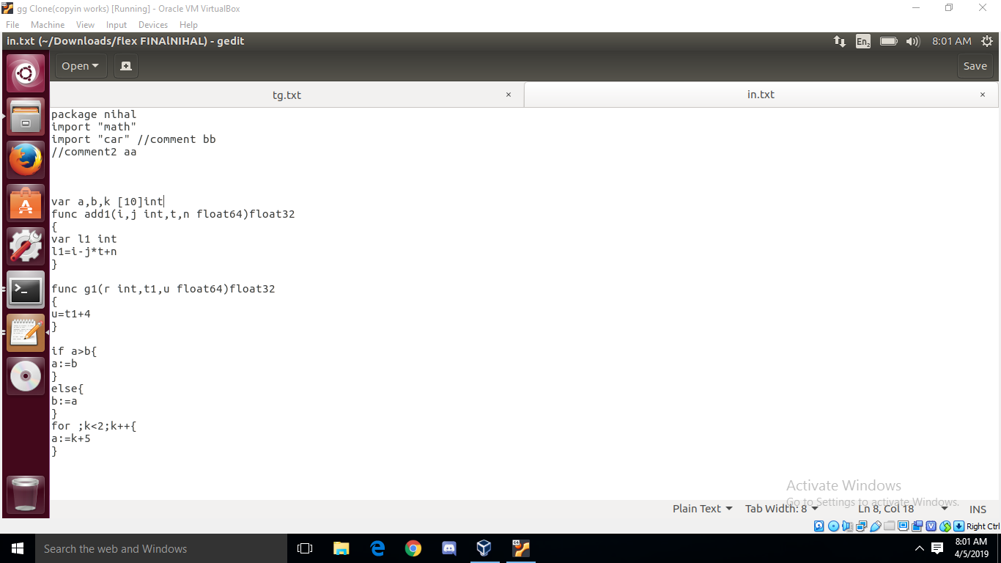

**Symbol Table**

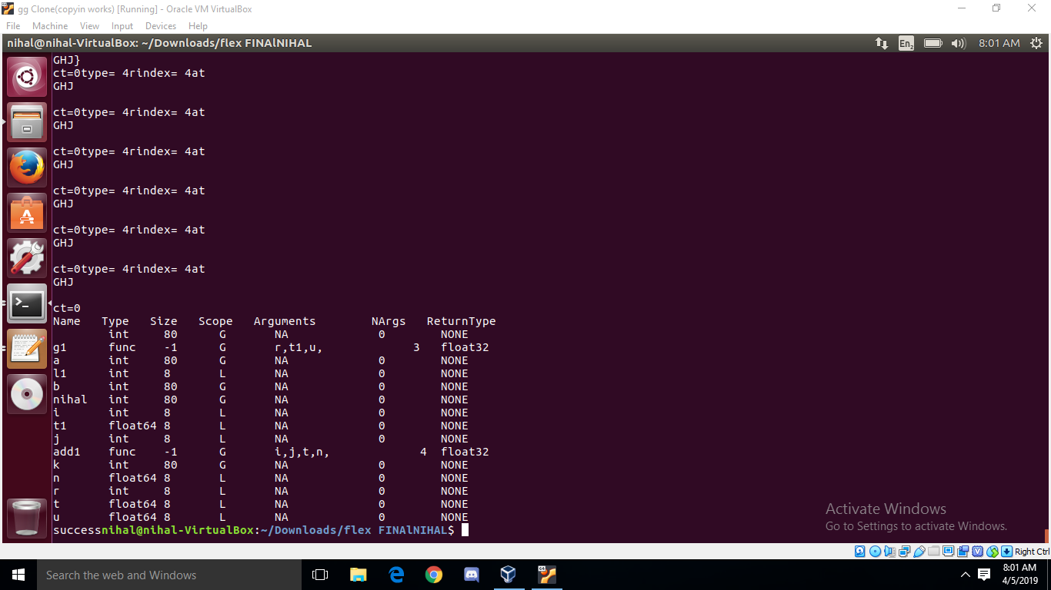

**Final Output**



