
VISVESVARAYA TECHNOLOGICAL UNIVERSITY
“JNANA SANGAMA”, BELAGAVI - 590 018

A MINI PROJECT REPORT
on

“FOOD COURT MANAGEMENT SYSTEM”
Submitted by

Abhishek 4SF24CI005 C Vikas Raju 4SF24CI041

In partial fulfillment of the requirements for the IV semester
DATABASE MANAGEMENT SYSTEMS
of
BACHELOR OF ENGINEERING
in
COMPUTER SCIENCE AND ENGINEERING
(ARTIFICIAL INTELLIGENCE AND MACHINE LEARNING)

Under the Guidance of

Mrs. Sangeetha MS
Assistant Professor, Department of CSE (AI&ML)


SAHYADRI
College of Engineering & Management An Autonomous Institution
MANGALURU
2025–26



CERTIFICATE

This is to certify that the Mini Project entitled “FOOD COURT MANAGEMENT SYSTEM” has been carried out by Abhishek (4SF24CI005) and C Vikas Raju (4SF24CI041), the bonafide students of Sahyadri College of Engineering & Management, in partial fulfillment of the requirements for the IV semester DATABASE MANAGEMENT SYSTEMS (BAI402G) of Bachelor of Engineering in Computer Science and Engineering (AI&ML) of Visvesvaraya Technological University, Belagavi during the year 2025–26.
It is certified that all corrections/suggestions indicated for Internal Assessment have been incorporated in the report deposited in the departmental library. The mini project report has been approved as it satisfies the academic requirements in respect of mini project work.

Mrs. Sangeetha MS Dr. Pushpalatha K
Assistant Professor Professor & Head
Dept. of CSE(AI&ML), SCEM Dept. of CSE(AI&ML), SCEM



DECLARATION

We hereby declare that the entire work embodied in this Mini Project Report titled “FOOD COURT MANAGEMENT SYSTEM” has been carried out by us at Sahyadri College of Engineering & Management, MANGALURU under the supervision of Mrs. Sangeetha MS as the part of the IV semester DATABASE MANAGEMENT SYSTEMS (BAI402G) of Bachelor of Engineering in Computer Science and Engineering (AI&ML).
This report has not been submitted to this or any other University.

Abhishek (4SF24CI005)
C Vikas Raju (4SF24CI041)

SCEM, Mangaluru

Abstract

The daily operations of campus food courts traditionally rely on manual, paper-based workflows, which frequently result in long queues, inaccurate inventory tracking and delayed service during peak hours. To address these operational inefficiencies, this project introduces the Food Court Management System, a robust two-tier desktop application designed to digitize and automate food ordering and management processes.

Built using a Java Swing frontend and a MySQL 8.x backend connected via JDBC, the system provides a seamless digital interface for two distinct user roles: students and administrators. The application enables students to browse interactive menus and place cashless orders utilizing a digital wallet, while providing canteen administrators with a secure dashboard to monitor operations.

To ensure strict data integrity and optimize performance, the system heavily leverages advanced relational database management features. A backend SQL Trigger is implemented to automatically deduct menu item stock in real-time upon order placement, eliminating human error. Furthermore, a SQL Stored Procedure is utilized to instantly aggregate daily sales metrics such as total revenue and top-selling items directly on the database server. Ultimately, this system provides a scalable, transaction-safe solution that streamlines campus food service, prevents stock wastage and delivers actionable administrative insights.

Acknowledgement

It is with great satisfaction and euphoria that we are submitting the Mini Project Report on “FOOD COURT MANAGEMENT SYSTEM”. We have completed it as a part of the IV semester DATABASE MANAGEMENT SYSTEMS (BAI402G) of Bachelor of Engineering in Computer Science and Engineering (AI&ML) of Visvesvaraya Technological University, Belagavi.
We are profoundly indebted to our guide, Mrs. Sangeetha MS, Assistant Professor, Department of Computer Science and Engineering (AI&ML) for innumerable acts of timely advice, encouragement and we sincerely express our gratitude.
We express our sincere gratitude to Dr. Pushpalatha K, Professor & Head, Department of CSE(AI&ML) for her invaluable support and guidance.
We sincerely thank Dr. S. S. Injaganeri, Principal, Sahyadri College of Engineering & Management, who have always been a great source of inspiration.
Finally, yet importantly, we express our heartfelt thanks to our family & friends for their wishes and encouragement throughout the work.

Abhishek (4SF24CI005) C Vikas Raju (4SF24CI041) IV Sem, B.E., CSE (AI&ML)
SCEM, Mangaluru

Contents

Abstract | i
Acknowledgement | ii
1 Introduction | 1
2 Requirements Specification | 2
2.1 Hardware Specification . . . . . . . . . . . . . . . . . . . . . . . . . . . | 2
2.2 Software Specification . . . . . . . . . . . . . . . . . . . . . . . . . . . | 2
3 System Design | 3
3.1 ER Diagram . . . . . . . . . . . . . . . . . . . . . . . . . . . . . . . . . | 3
3.2 Assumptions . . . . . . . . . . . . . . . . . . . . . . . . . . . . . . . . . | 4
3.3 Mapping From ER Diagram to Schema Diagram . . . . . . . . . . . . . | 4
3.4 Schema Diagram . . . . . . . . . . . . . . . . . . . . . . . . . . . . . . | 4
3.5 Normalization . . . . . . . . . . . . . . . . . . . . . . . . . . . . . . . . | 5
4 Implementation | 6
4.1 Tables Used . . . . . . . . . . . . . . . . . . . . . . . . . . . . . . . . . | 7
5 Results and Discussion | 8
6 Conclusion and Future Work | 11
6.1 Conclusion . . . . . . . . . . . . . . . . . . . . . . . . . . . . . . . . . | 11
6.2 Future Work . . . . . . . . . . . . . . . . . . . . . . . . . . . . . . . . . | 11
7 References | 13

  - Entity Relationship Diagram for Food Court Management System. 3
  - Schema Diagram of Food Court Management System 5
  - Student Dashboard ..9
  - Admin Dashboard ..9
  - Order Summary ……………………………………………………………….. 10
  - Student Trends …………………………………………………………………. 10

  - Work Flow 7
  - Test case 7

Introduction

The daily operations of campus food courts often rely on manual, paper based processes, leading to significant bottlenecks such as long queues, inaccurate stock tracking and delayed service during peak hours. Furthermore, the absence of a centralized system makes it difficult for canteen managers to track daily revenue or prevent stock wastage effectively. To resolve these operational inefficiencies, the Campus Food Court Management System (FoodCourtMS) was developed.

FoodCourtMS is a robust, two-tier desktop database application designed to completely digitize student food ordering, cashless payments and inventory management. Structured to decouple the user interface from the database logic, the system utilizes a modern Java Swing frontend connected to a MySQL 8.x backend via JDBC. It serves two primary user roles: students, who can seamlessly browse digital menus and place orders using a digital wallet and administrators, who gain access to real-time operational oversight.

By heavily leveraging advanced relational database capabilities specifically an automated SQL Trigger (after_order_item_insert) for real-time stock deduction and a Stored Procedure (GenerateDailySalesReport) for instant metric compilation the project guarantees transaction safety, eliminates manual calculation errors and provides management with critical data driven insights.

Requirements Specification

Hardware Specification
    - Processor : Intel Core i3/i5 or higher
    - RAM : 8 GB
    - Hard Disk : 256 GB or higher
    - Input Devices : Keyboard and Mouse
    - Output Device : Monitor

Software Specification
    - Frontend : Java Swing
    - Backend : Oracle Database
    - Connectivity : JDBC
    - Programming Language : Java
    - IDE : Visual Studio Code
    - Operating System : Windows 10/11

System Design

ER Diagram

The ER Diagram of the Food Court Management System represents the relationship between different entities involved in campus food ordering and inventory management. The main entities used in the system are STUDENT, COUNTER, MENU_ITEM, ORDERS and ORDER_ITEM.
A student can place multiple orders and each food counter serves multiple menu items. An order can consist of various menu items and a single menu item can be part of many different orders, a relationship that is bridged by the ORDER_ITEM entity. The ER diagram helps in understanding entity relationships and forms the basis for relational schema mapping.
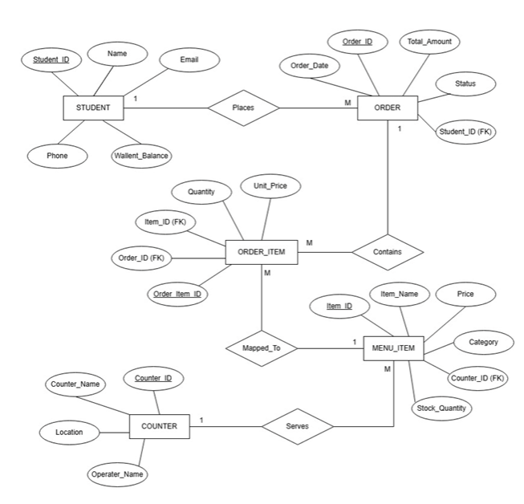
Figure 3.1: Entity Relationship Diagram for Food Court Management System.

Assumptions
The following assumptions are considered during the development of the system:
- Only registered students with a valid Student ID can place orders.
- A student can place multiple orders, but each order is tied to exactly one student (1:M relationship between Student and Orders).
- A specific food counter can serve multiple menu items, but each menu item belongs to only one counter (1:M relationship between Counter and Menu_Item).
- A single order can contain multiple menu items and a single menu item can be part of many different orders (M:N relationship resolved by the Order_Item table).
- Order placement requires sufficient funds in the student's digital wallet.

Mapping From ER Diagram to Schema Diagram
The ER diagram is converted into a relational schema using standard ER-to-relational mapping techniques. Each strong entity in the ER model is converted into a separate relation with appropriate primary keys. The many-to-many relationship between ORDERS and MENU_ITEM is mapped by creating a new relational table, ORDER_ITEM. This table utilizes foreign keys referencing the primary keys of both parent tables, ensuring data consistency.

Schema Diagram
The schema diagram represents the relational structure of the database system and illustrates the relationships between tables using primary and foreign keys.

Relational Schema

STUDENT (student_id PK, name, email, phone, wallet_balance)

COUNTER (counter_id PK, counter_name, location, operator_name)

MENU_ITEM (item_id PK, counter_id FK, item_name, price, category, stock_qty)

ORDERS (order_id PK, student_id FK, order_date, total_amount, status)

ORDER_ITEM (order_item_id PK, order_id FK, item_id FK, quantity, unit_price)

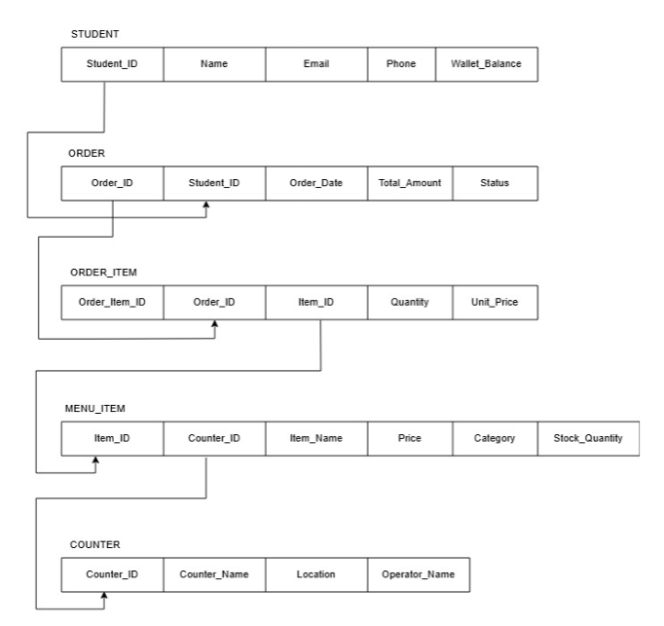
Figure 3.2: Schema Diagram of Campus Complaint and Maintenance Management System

Normalization
Normalization is performed to reduce data redundancy and improve data consistency within the database.

First Normal Form (1NF):
All attributes in each table contain atomic values and there are no repeating groups.

Second Normal Form (2NF):
All non-key attributes are fully dependent on the primary key. Partial dependency is removed from the relations.

Third Normal Form (3NF):
Transitive dependency is eliminated and all non-key attributes depend only on the primary key. This improves database efficiency and minimizes redundancy.

The database design for the FOOD COURT MANAGEMENT SYSTEM satisfies normalization requirements up to Third Normal Form (3NF).

Chapter 4 Implementation
The implementation phase involves developing the frontend application using Java Swing and connecting it with MySQL Database using JDBC. The system is divided into multiple modules for students and administrators. The student module allows users to browse menus, add items to a cart and place orders using a digital wallet. The administrator module enables order monitoring and report generation.
Triggers and stored procedures are implemented to automate inventory operations. A trigger automatically updates the MENU_ITEM stock whenever an order is placed. A stored procedure is used for compiling the daily sales dashboard.

Modules Implemented
    - Login and Registration Module
    - Menu Browsing and Cart Module
    - Digital Wallet and Payment Module
    - Order Placement Module
    - Inventory Management Module
    - Daily Sales Reporting Module

Pseudocode for Order Placement
- Student views cart and clicks checkout
- System verifies student wallet balance
- System deducts total amount from wallet
- System stores order header in ORDERS table
- System inserts items into ORDER_ITEM table
- Trigger updates MENU_ITEM stock automatically

Tables Used

STUDENT (student_id PK, name, email, phone, wallet_balance)

COUNTER (counter_id PK, counter_name, location, operator_name)

MENU_ITEM (item_id PK, counter_id FK, item_name, price, category, stock_qty)

ORDERS (order_id PK, student_id FK, order_date, total_amount, status)

ORDER_ITEM (order_item_id PK, order_id FK, item_id FK, quantity, unit_price)

Sl.  No. | Work | Duration (in  Weeks)
1 | Requirement Analysis & UI Planning | 1
2 | Database Design & ER Modeling | 2
3 | Frontend Development (Java Swing) | 3
4 | Backend Connectivity & Triggers (Oracle) | 2
5 | System Integration & Testing | 1
Table 4.1: Work Flow

TC# | Description | Expected Result | Actual Result | Status
TC-1 | Student places food order | DB Wallet balance deducted | 'ORDER CONFIRMED' displayed | Pass
TC-2 | Admin generates daily report | SP calculates total revenue | Sales report generated | Pass
TC-3 | Trigger fires on new order | Stock_qty reduced in MENU_ITEM | Inventory updated automatically | Pass
TC-4 | Student orders with low balance | DB transaction blocked | 'INSUFFICIENT FUNDS' displayed | Pass
Table 4.2: Test case

Chapter 5
Results and Discussion

The implementation of the Food Court Management System yielded a fully functional, multi-tier desktop application that successfully digitizes the previously manual workflow of campus food ordering and inventory tracking. Testing across different user roles confirmed that the system correctly enforces data access boundaries and automates routine database tasks.

Key Results Achieved:

Seamless Order Processing: The Student Dashboard allows for real-time menu browsing and cashless checkout, instantly writing transaction data to the MySQL backend without lag or data loss.

Efficient Inventory Automation: Database verification confirmed that the after_order_item_insert trigger fires precisely upon every new order, automatically deducting the purchased quantities from the menu items and preventing stock discrepancies without requiring additional frontend Java code.

Automated Administrative Insights: The Admin Dashboard effectively executes the GenerateDailySalesReport stored procedure, successfully aggregating critical metrics like daily gross revenue and top selling items directly on the database server.
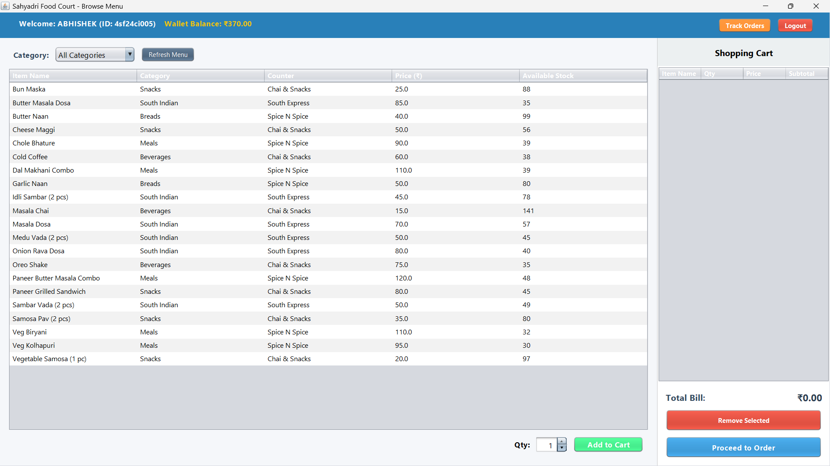
Figure 5.1: Student Dashboard

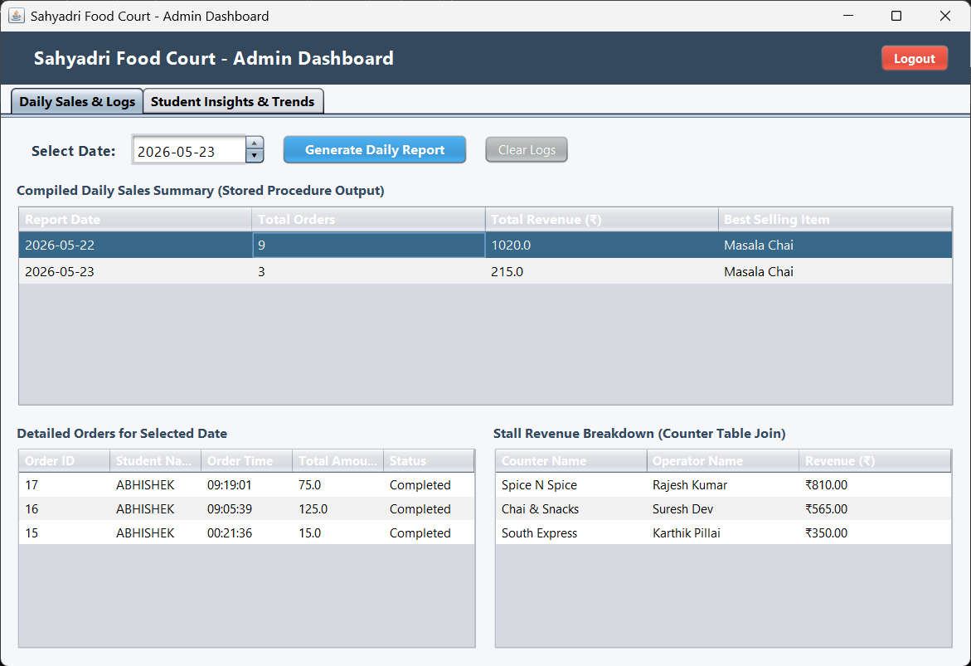
Figure 5.2: Admin Dashboard
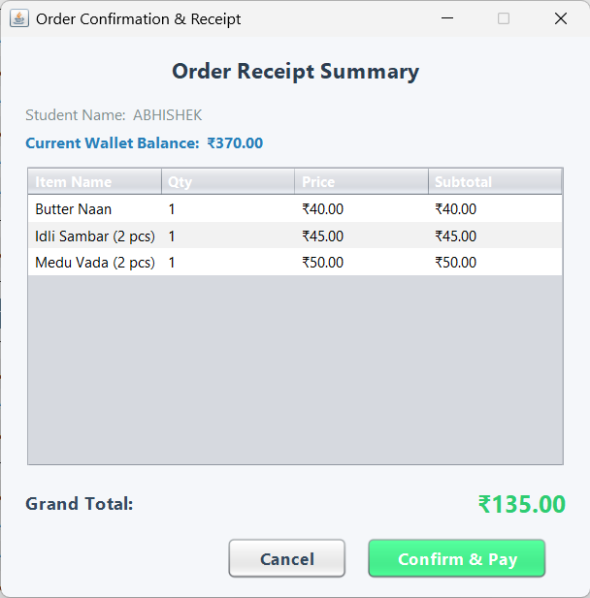
Figure 5.3: Order Summary.

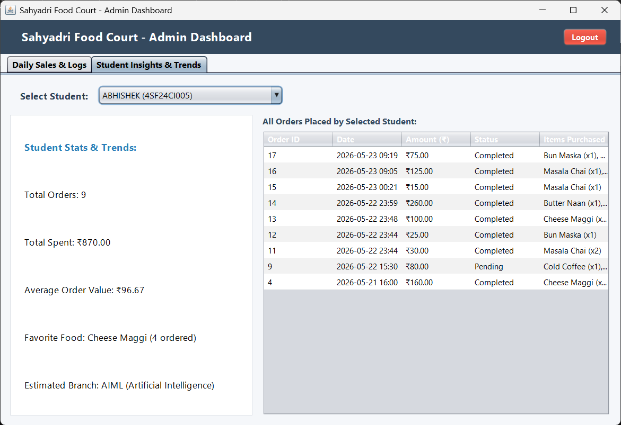

Figure 5.4: Student Trends.

Conclusion and Future Work

Conclusion
The Campus Food Court Management System successfully demonstrates the practical application of relational database management concepts to solve real-world operational challenges. By transitioning from manual, paper-based workflows to a digitized Java Swing and MySQL architecture, the project effectively streamlines student order placement, eliminates manual inventory tracking errors and provides instant administrative reporting.
The successful implementation of automated SQL triggers ensures real-time stock accuracy without application-layer overhead, while the use of stored procedures guarantees that canteen managers receive fast, data-driven daily sales insights. Ultimately, this system provides a robust, transaction-safe and highly efficient digital solution that fulfills all proposed objectives of the DBMS mini project.

Future Work
While the current desktop application provides a strong and reliable foundational system, several structural and functional enhancements can be implemented to scale the platform for a wider campus rollout :
- Mobile and Web Migration: Transitioning the frontend interface from a localized Java desktop application to a responsive web portal or cross-platform mobile app. This would allow students to browse menus and place orders directly from their personal smartphones anywhere on campus.
- Live Payment Gateway Integration: Upgrading the simulated digital wallet system to support real-time financial transactions via UPI, credit/debit cards and net banking through secure payment APIs (such as Razorpay or Stripe).
- AI-Driven Analytics and Forecasting: Leveraging the system's accumulated database records to train machine learning models. These models could forecast peak operational hours, predict inventory requirements to further reduce food wastage and offer personalized menu recommendations based on a student's historical purchase data.
- Automated Notification System: Integrating an SMS, email or push notification service to automatically alert students the moment their order status updates from "Preparing" to "Ready" eliminating the need to wait near the physical counter.

- Ramez Elmasri and Shamkant B. Navathe. Database systems Models, Languages, Design and Application Programming. 7th Edition, Pearson.
- Ramakrishnan and Gehrke. Database management systems. 3rd Edition, McGraw Hill, 2014.
- Silberschatz, Korth and Sudharshan. Database System Concepts. 6th Edition, Mc-Graw Hill, 2013.
- Coronel, Morris and Rob. Database Principles Fundamentals of Design, Implemen-tation and Management. Cengage Learning, 2012.

