 Notes

In this exercise, you will create two notes with different attributes using different methods.

1. As studentXX, add the following notes to the Kevin SmithXX claim:

1a) A note associated to Kevin SmithXX which indicates he will be on vacation for three weeks next month and cannot be contacted during this time.

1b) A claim-level note created from the "Status Report" template. In the note, indicate that Kevin SmithXX has been uncooperative. He has provided incomplete information and failed to return many phone calls. Mark this note as confidential. (Do not set security type.)

2. Verify that both notes appear in the claim file.

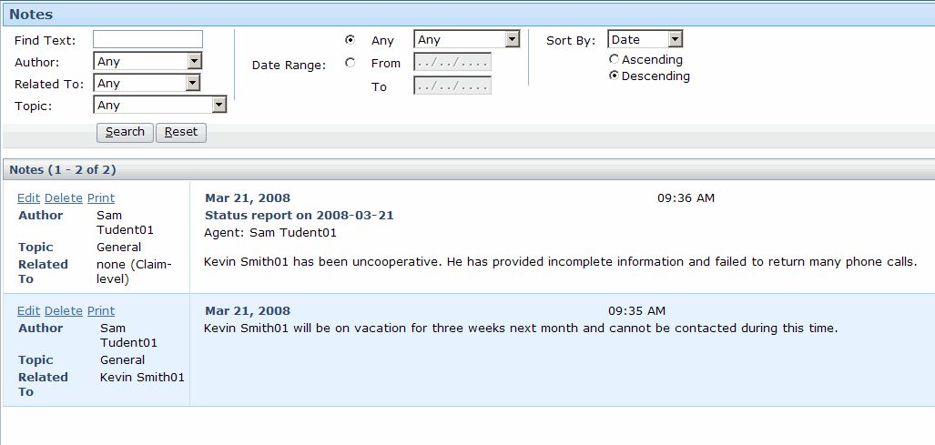

3. Log on to ClaimCenter as Ida Belt – ibelt/gw (a customer service representative who does not have permission to view confidential notes). Using the policy number of 123456-XX, search for and view the Kevin SmithXX claim (Remember that her landing page takes you to the New Claim Wizard so you will have to navigate to the Search tab). Verify that the vacation note is visible and that the confidential note is not.

