 Exposures

In this exercise, you will create the exposures for the Kevin SmithXX claim.

1. As studentXX, log on to ClaimCenter. Navigate to the Kevin SmithXX claim. Manually create the exposures for the claim. To help you determine what exposures are needed, the transcript from the First Notice of Loss has been copied below.

When it comes to selecting the correct coverage, keep the following definitions of coverages in mind:

Collision covers losses to the insured’s vehicle due to an accident (hitting another vehicle, a tree, an animal, and so on).
Medical Payments covers injuries to any driver covered on the policy and to any passenger in a covered vehicle.
Liability - Property Damage covers damage the insured does to something owned by a third party (either vehicle or non-vehicle "property").
Liability - Auto Bodily Injury covers damage the insured does to a person which results in an injury.

Note – You will NOT be using all of these coverages in your exercise.
_____________________________________________________________________________

Transcript

Hello. My name is Kevin SmithXX. My policy number is 123456-XX. I was involved in an accident yesterday and I wanted to report it.

You want to confirm my contact information? I live at 1024 Glenwood Avenue in Waukegan, Illinois. It's probably best to call me on my cell phone. It's (312) 336-6210. Yes, I should be the person you contact for questions about this claim. The accident involves my Honda Civic.

The accident occurred at the intersection of McAree Road and Grand Avenue in Waukegan, Illinois. I was driving my Honda Civic on Grand Avenue traveling north. I was trying to make it through a yellow light, but I wasn't able to. I hit the brakes, but there was oil on the road. I skidded into the intersection and hit a car traveling west on McAree.

The other vehicle was a 2002 Ford Fiesta with a Michigan license plate of 223RFT. It was driven by Michael CashmanXX. He lives at 713 Leith Avenue, Waukegan, Illinois, 60087. His cell phone number is (312) 343-2909.

My car has a large dent in the front fender and it was leaking a small amount of oil. Otherwise, it still runs just fine.

The left side of the other car is fairly smashed up, including damage to the driver-side door.

Mr. CashmanXX also hit his head against the steering wheel. He was taken to the hospital and diagnosed with a minor concussion.

Yes, my car will need servicing by an auto body repair shop, but I'm not sure which shop I'll be taking it to.

2. When you have completed the exposures, review them in the exposure list. Your exposures look like the ones listed below. Your exposures may appear in a different order and have a different XX suffix. But for each exposure, the Type, Coverage, and Claimant values should match the screenshot below. If they do not, then you have created exposures which do not match the business scenario.

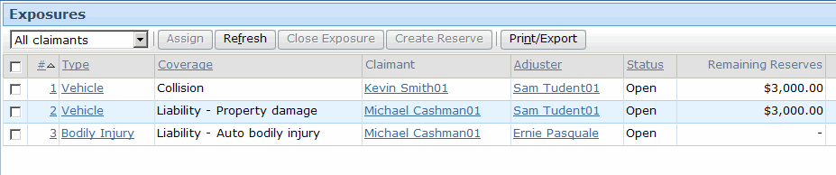

3. When each exposure was created, ClaimCenter executed exposure workplan rules. Review the claim's workplan. For each exposure, identify the activities that were created for that exposure.

Damage to Kevin SmithXX's vehicle:

Damage to Michael CashmanXX's vehicle:

MichalCashmanXX's concussion:

