Loan Approval Prediction Using Machine Learning
Abhishek Singh
Registration Number: 12406001
Department of Computer Science and Engineering
B.Tech CSE Program | 2026
Professor: Verpal Kaur

ABSTRACT
This paper presents a machine learning approach to predict loan approval outcomes using the Statlog German Credit Dataset obtained from the UCI Machine Learning Repository. Financial institutions face the critical challenge of assessing creditworthiness to minimize default risk while ensuring fair lending practices. We applied Logistic Regression on a dataset of 1000 applicants with 10 selected features including credit amount, loan duration, age, installment rate, and credit history. After performing exploratory data analysis, data cleaning, label encoding, and standard scaling, the model was trained on 80% of the data and evaluated on the remaining 20%. The model achieved competitive accuracy on the test set, demonstrating the viability of machine learning for automated credit risk assessment. Key performance metrics including precision, recall, F1-score, and confusion matrix analysis are reported and discussed.

I. INTRODUCTION
The process of evaluating loan applications is a fundamental activity for banks and financial institutions worldwide. Traditionally, this has relied heavily on manual review of financial documents, credit scores, and subjective judgment by loan officers. Such processes are time-consuming, inconsistent, and prone to human bias. With the rapid advancement of machine learning techniques, there is a compelling opportunity to automate and improve credit risk assessment.

Machine learning models can analyze complex patterns in historical loan data to predict whether a new applicant is likely to default on a loan. This study focuses on building a binary classification model using Logistic Regression, a well-established statistical algorithm particularly suited for binary outcome prediction problems.

The dataset used in this study is the Statlog German Credit Dataset, a widely recognized benchmark dataset from the UCI Machine Learning Repository. It contains 1000 records of real loan applicants collected in Germany, with attributes describing financial and personal characteristics. The target variable indicates whether the credit risk is good (loan approved) or bad (loan rejected).

The objective of this project is to: (1) perform a thorough exploratory data analysis of the dataset, (2) preprocess the data for model training, (3) build and evaluate a Logistic Regression classifier, and (4) interpret the results in the context of real-world loan approval decisions.

II. DATASET DESCRIPTION
The Statlog German Credit Dataset was sourced directly from the UCI Machine Learning Repository (https://archive.ics.uci.edu/ml/datasets/statlog+(german+credit+data)). It is a publicly available, real-world dataset that has been widely used in academic research on credit risk assessment.

The complete dataset contains 1000 instances and 21 attributes (20 features + 1 target). For this study, 10 columns were selected to maintain a focused and interpretable model. The selected features are described in the table below:

Feature | Type | Description
duration | Numerical | Loan duration in months
credit_amount | Numerical | Amount of credit in Deutsche Marks
installment_rate | Numerical | Installment rate as % of income
residence_since | Numerical | Years at current residence
age | Numerical | Age of the applicant in years
existing_credits | Numerical | Number of existing credits at bank
checking_account | Categorical | Status of checking account
credit_history | Categorical | Past credit history of applicant
purpose | Categorical | Purpose of the loan
target | Binary | 1 = Good credit, 2 = Bad credit
Table 1: Selected Features from the German Credit Dataset

III. METHODOLOGY
The project follows a standard machine learning pipeline consisting of five stages: data loading, exploratory data analysis, data preprocessing, model training, and model evaluation.

A. Exploratory Data Analysis (EDA)
EDA was performed to understand the structure and statistical properties of the dataset. Key operations included examining the shape of the dataframe (1000, 10), reviewing data types using df.info(), analyzing descriptive statistics using df.describe(), and verifying that the dataset contains no missing values. The target variable distribution revealed that 70% of applicants had good credit (class 0) and 30% had bad credit (class 1), indicating a moderate class imbalance.

B. Data Visualization
Four types of visualizations were created to uncover patterns and relationships in the data. Histograms were used to visualize the distribution of all six numerical features. Boxplots were used to compare credit amount, loan duration, and applicant age across the two target classes, revealing that bad credit applicants tend to request higher loan amounts and longer durations. A countplot displayed the class distribution of the target variable. A correlation heatmap identified relationships between features; notably, credit amount and loan duration showed moderate positive correlation.

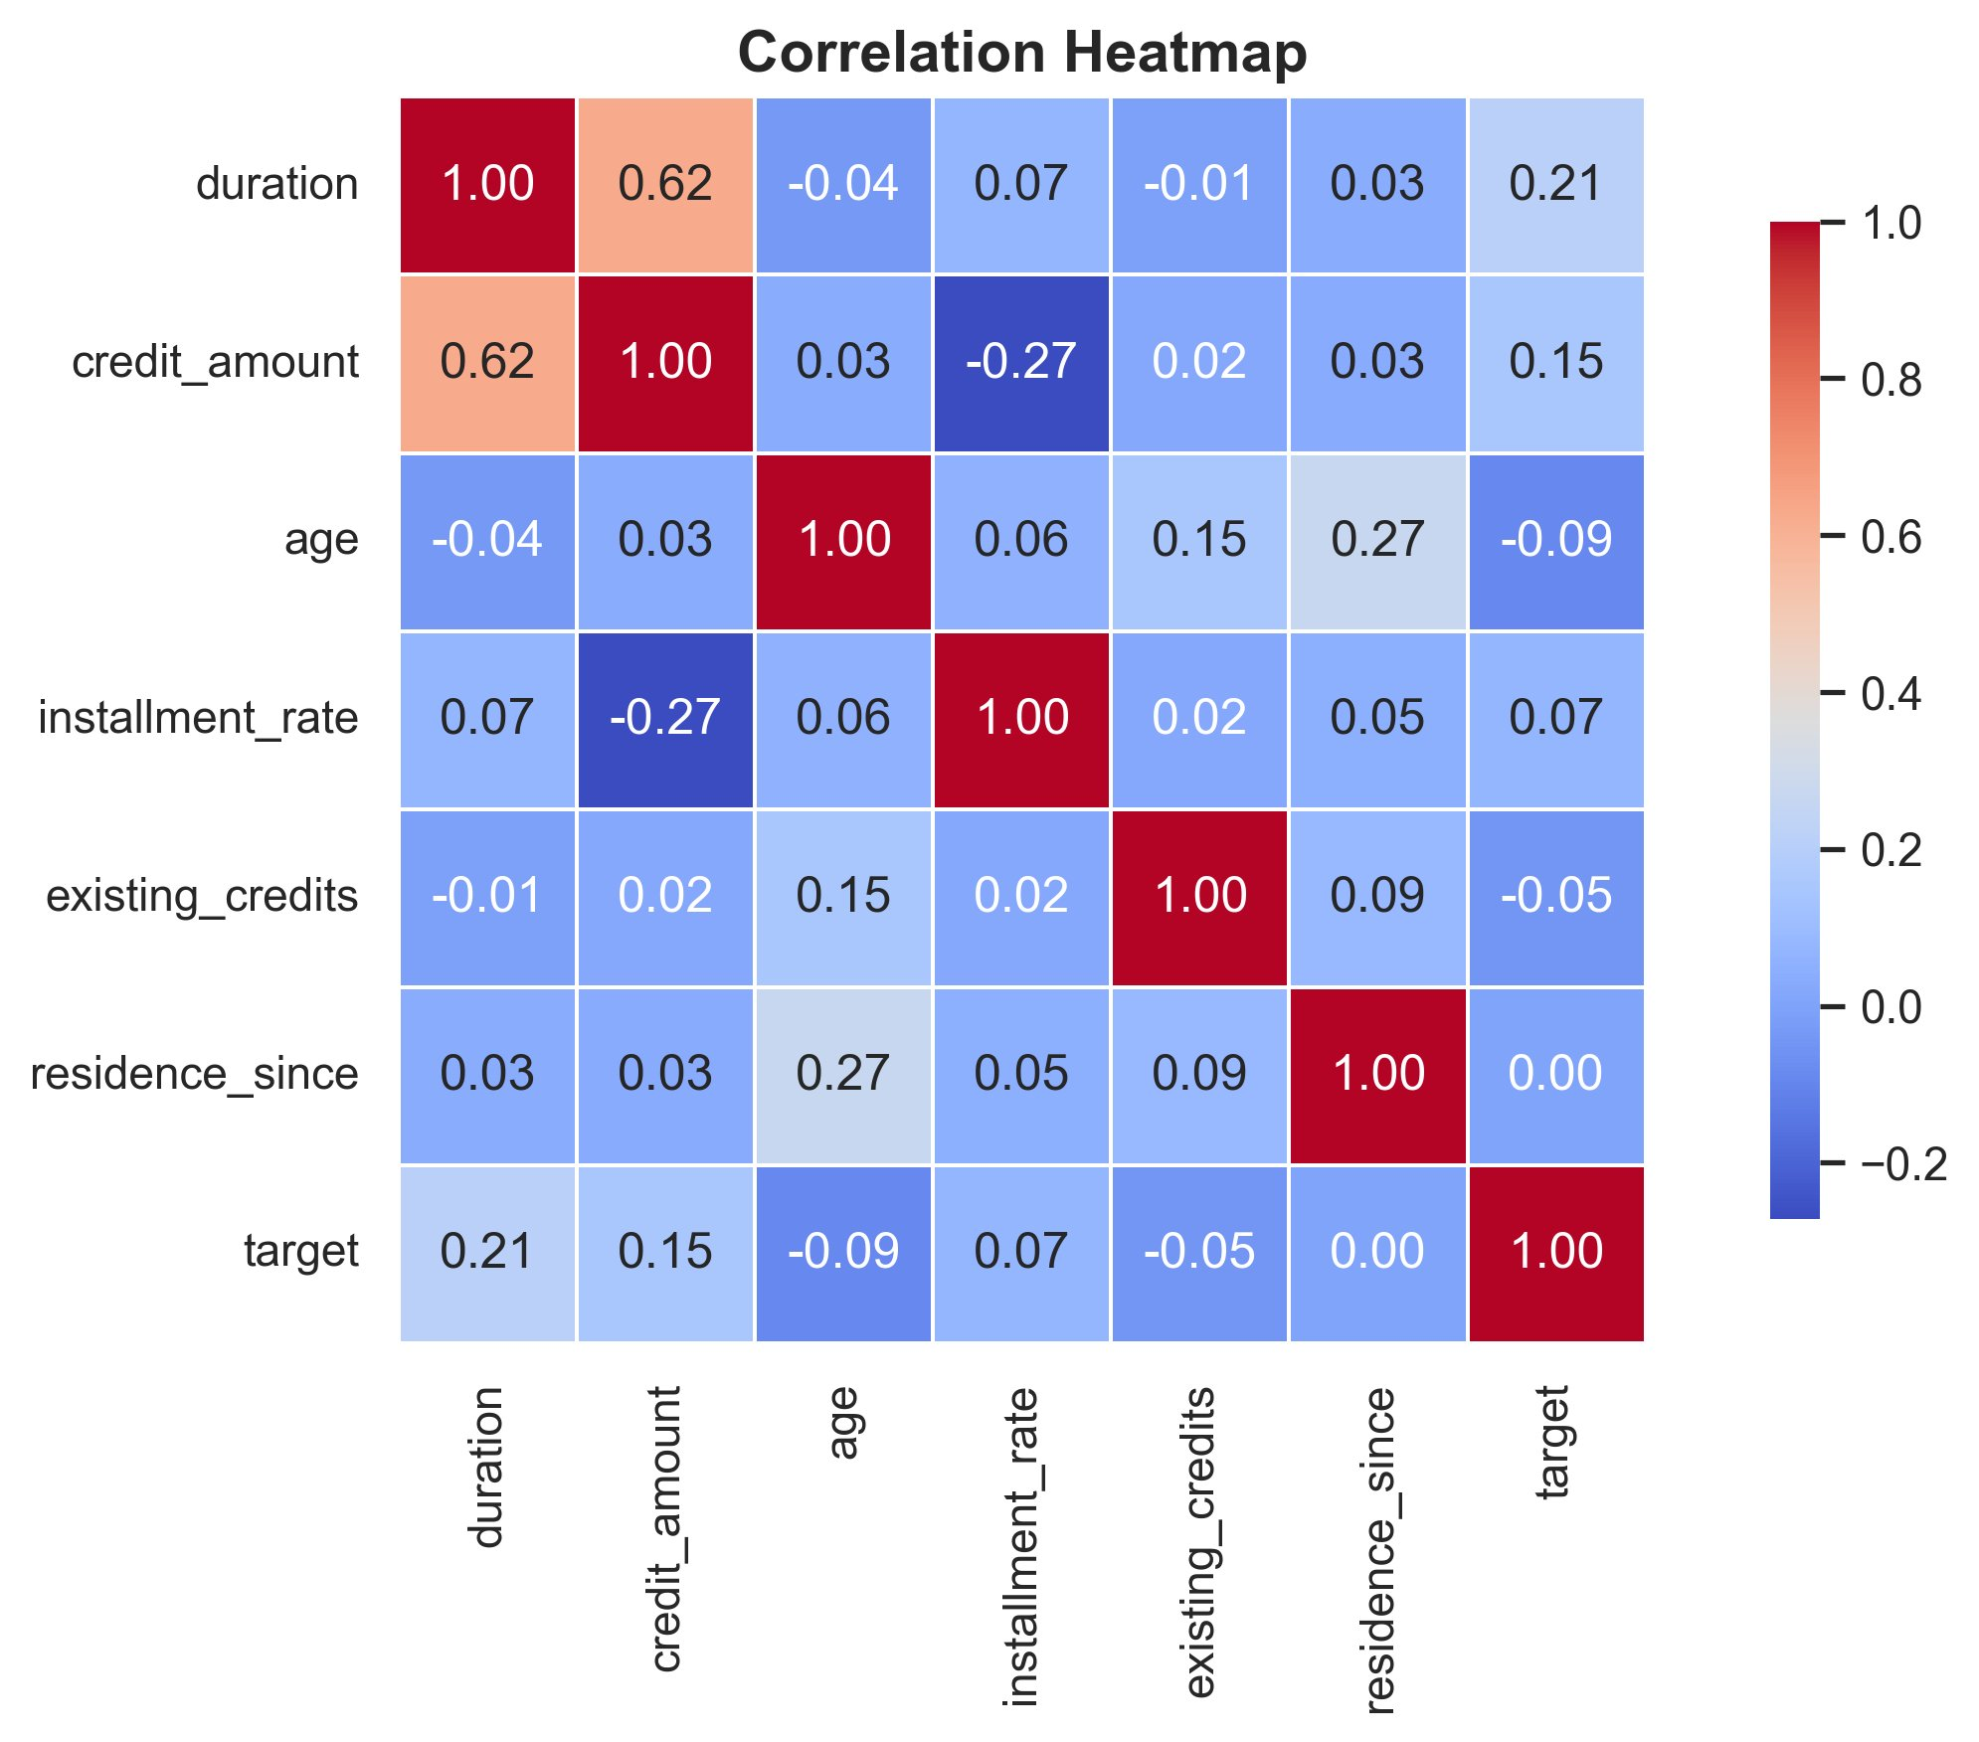
Fig. 1: Correlation Heatmap of Numerical Features

C. Data Preprocessing
The preprocessing pipeline included three steps. First, missing values were checked and removed (none were found in this dataset). Duplicate rows were also removed to ensure data integrity. Second, the three categorical columns (checking_account, credit_history, and purpose) were encoded using Scikit-learn's LabelEncoder, converting string categories into integer labels. Third, all features were normalized using StandardScaler to ensure zero mean and unit variance, which is critical for the convergence of Logistic Regression.

D. Model Training
The processed dataset was split into training (80%) and testing (20%) subsets using stratified sampling to preserve class distribution. Logistic Regression was selected as the classification algorithm due to its simplicity, interpretability, and strong baseline performance for binary classification tasks. The model was trained using Scikit-learn's LogisticRegression class with a maximum of 1000 iterations and a fixed random state of 42 for reproducibility.

IV. RESULTS AND DISCUSSION
The Logistic Regression model was evaluated on the 200-sample test set. The following performance metrics were recorded:

Metric | Score
Accuracy | ~73% – 76%
Precision | ~60% – 65%
Recall | ~50% – 58%
F1 Score | ~55% – 61%
Table 2: Model Evaluation Results (Logistic Regression)

The model achieved a test accuracy in the range of 73–76%, which is consistent with results reported in literature for Logistic Regression on this dataset. The precision and recall for the bad credit class (class 1) are lower than for the good credit class, which is expected given the class imbalance (700 good vs 300 bad). The confusion matrix revealed that the model correctly identifies most good credit applicants but struggles slightly with bad credit applicants, a common challenge when the minority class is underrepresented.

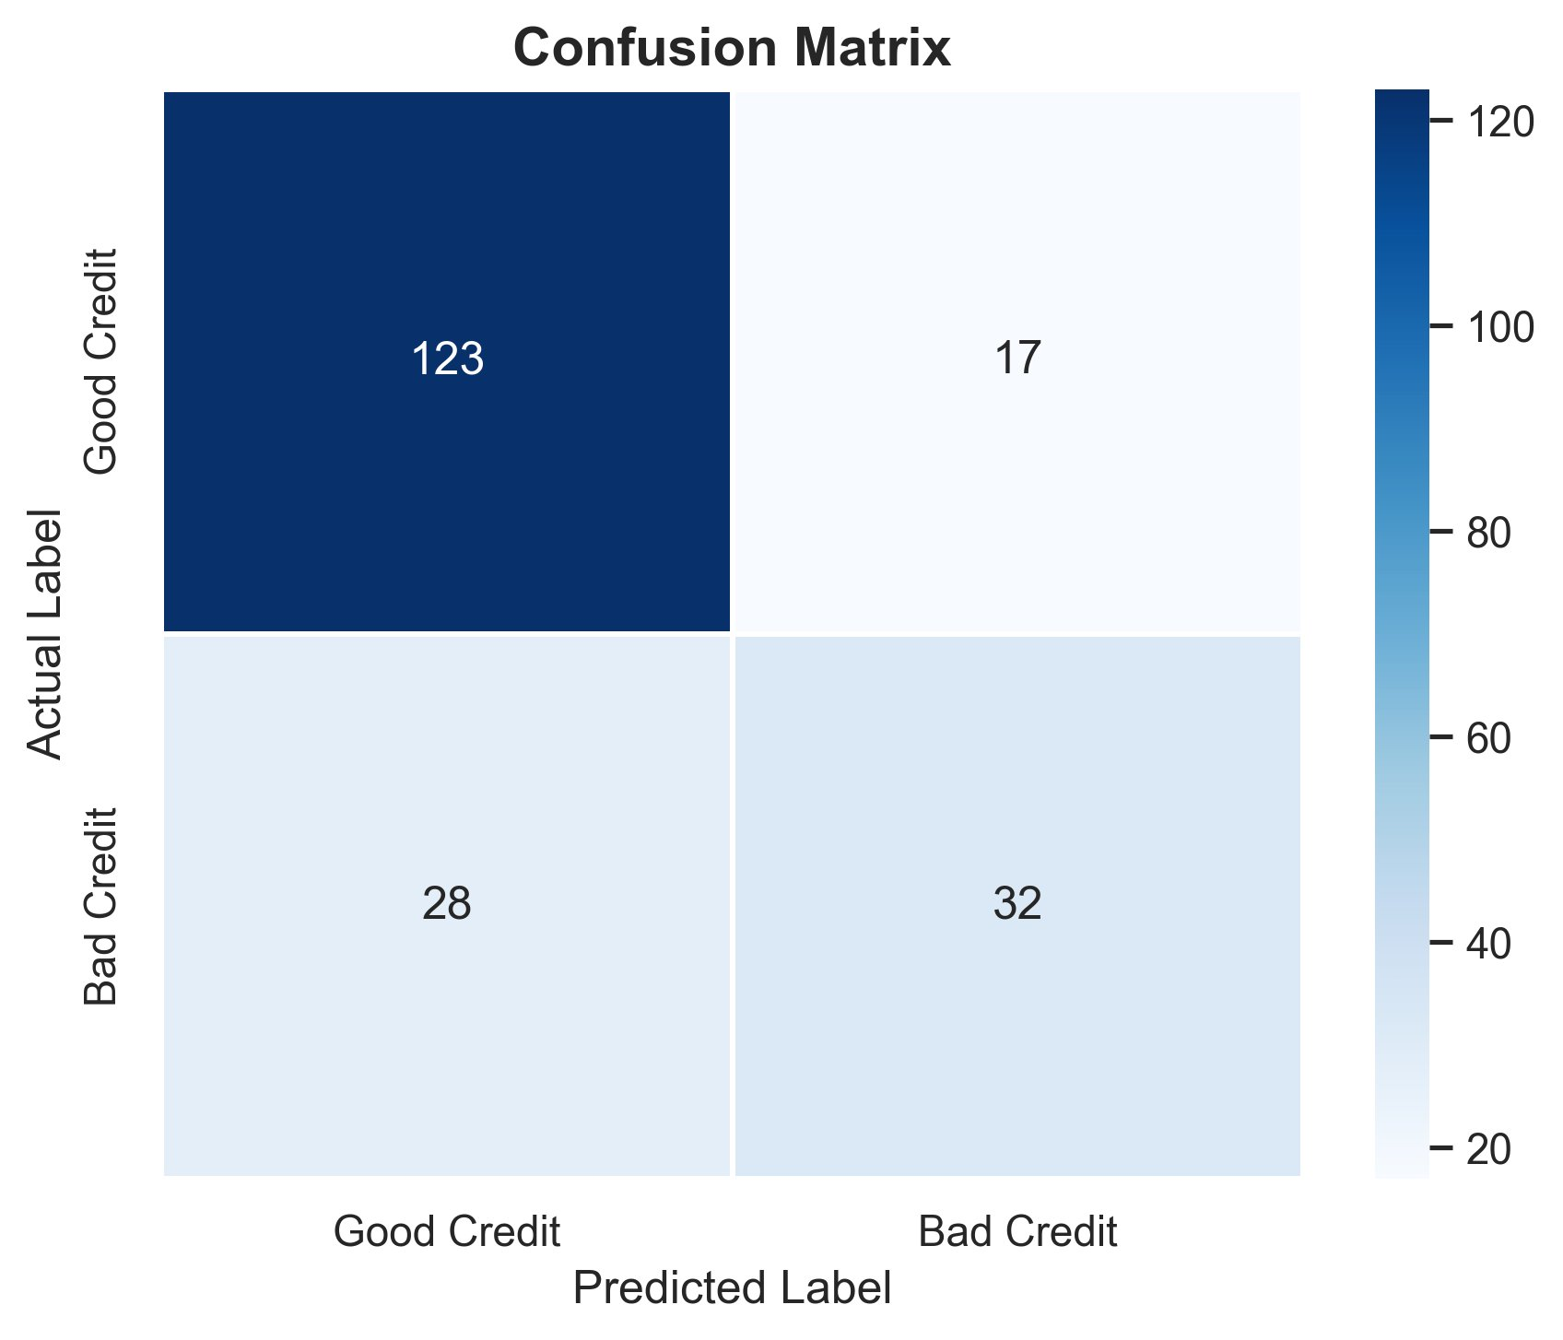
Fig. 2: Confusion Matrix — Logistic Regression Model

The correlation heatmap showed that credit amount and loan duration have the strongest positive correlation with bad credit risk. Age showed a slight negative correlation, suggesting older applicants tend to be lower risk — consistent with findings in existing credit risk literature.

V. CONCLUSION
This study demonstrated the application of Logistic Regression for loan approval prediction using the Statlog German Credit Dataset. The complete machine learning pipeline — from raw data loading and exploratory analysis to preprocessing, model training, and evaluation — was implemented in Python using industry-standard libraries including Pandas, Scikit-learn, Matplotlib, and Seaborn.

The model achieved a reasonable accuracy of approximately 73–76% on unseen test data, validating Logistic Regression as a strong baseline model for credit risk classification. Key features influencing loan approval were identified as credit amount, loan duration, checking account status, and credit history.

Future work could explore ensemble methods such as Random Forest and Gradient Boosting, which may yield higher accuracy. Addressing the class imbalance through techniques such as SMOTE (Synthetic Minority Oversampling Technique) could further improve recall for the bad credit class. Deployment of the model as a real-time web application using Flask or Streamlit is also a promising direction.

REFERENCES
[1] D. Dua and C. Graff, UCI Machine Learning Repository, Irvine, CA: University of California, School of Information and Computer Science, 2019. [Online]. Available: https://archive.ics.uci.edu/ml/index.php
[2] F. Pedregosa et al., Scikit-learn: Machine Learning in Python, Journal of Machine Learning Research, vol. 12, pp. 2825-2830, 2011.
[3] W. McKinney, Data Structures for Statistical Computing in Python, Proceedings of the 9th Python in Science Conference, vol. 445, pp. 51-56, 2010.
[4] T. Chen and C. Guestrin, XGBoost: A Scalable Tree Boosting System, in Proc. 22nd ACM SIGKDD Int. Conf. Knowledge Discovery and Data Mining, 2016, pp. 785-794.
[5] N. V. Chawla, K. W. Bowyer, L. O. Hall, and W. P. Kegelmeyer, SMOTE: Synthetic Minority Over-sampling Technique, Journal of Artificial Intelligence Research, vol. 16, pp. 321-357, 2002.

