Future of PEB in India
Future of PEB. The Indian construction industry is quietly undergoing a shift that is far more significant than it appears on the surface. For decades, concrete dominated the skyline, shaping everything from factories to commercial spaces. Today, that dominance is being challenged by a faster, smarter, and more efficient alternative—Pre-Engineered Buildings, commonly known as PEB.
What was once seen as a niche solution for industrial sheds has now evolved into a mainstream construction method. From logistics parks to modern commercial spaces, PEB is steadily becoming the preferred choice. If you look closely at how infrastructure is expanding across India, you will notice a clear pattern: speed, efficiency, and scalability are now more valuable than tradition.
This is exactly where PEB fits in.
The future of Pre-Engineered Buildings in India is not just promising—it is inevitable. And companies like Steelbuild Infra Projects Ltd are already part of this transformation, helping industries move toward more efficient construction solutions.

A Shift in How India Builds
Construction in India has always been time-consuming. Delays, cost overruns, and unpredictable outcomes were often considered normal. But as industries grow faster and competition becomes sharper, businesses can no longer afford to wait months—or years—for infrastructure to be ready.
This urgency has created space for new methods.
Pre-Engineered Buildings answer this need in a very practical way. Instead of building everything on-site, major components are designed and fabricated in a controlled environment and then assembled at the location. This reduces uncertainty and brings a level of precision that traditional construction often struggles to achieve.
What we are witnessing is not just a change in materials, but a change in mindset.

Why PEB is Gaining Ground in India
The rise of PEB is not accidental. It is the result of multiple forces coming together at the same time.
India’s industrial growth is one of the biggest drivers. Manufacturing units, warehouses, and logistics hubs are expanding rapidly. These projects require structures that can be built quickly and scaled easily. PEB offers exactly that.
At the same time, the growth of e-commerce has created an enormous demand for storage and distribution centers. These facilities cannot wait for long construction timelines. Businesses need them operational as soon as possible, and this urgency naturally favors steel-based construction.
Cost is another important factor. While initial perceptions sometimes suggest that steel construction might be expensive, the overall project cost often turns out to be lower. Reduced construction time, lower labor requirements, and minimal material wastage all contribute to this.
Over time, these advantages are becoming more widely understood, and adoption is increasing accordingly.

The Next 10 Years: What Will Change?
If we look ahead, the role of Pre-Engineered Buildings in India is expected to expand significantly. But the growth will not just be in numbers; it will also be in the type of projects being built.
Until recently, PEB was mostly associated with industrial use. That perception is changing.
Commercial spaces are beginning to adopt steel structures more openly. Offices, showrooms, and even institutional buildings are being designed using PEB concepts. The flexibility of design allows architects to move beyond the “box-like” structures that PEB was once known for.
Urban infrastructure is another area where change is visible. As cities expand, there is a growing need for faster construction methods that can keep up with development demands. Steel structures provide a practical solution for this challenge.
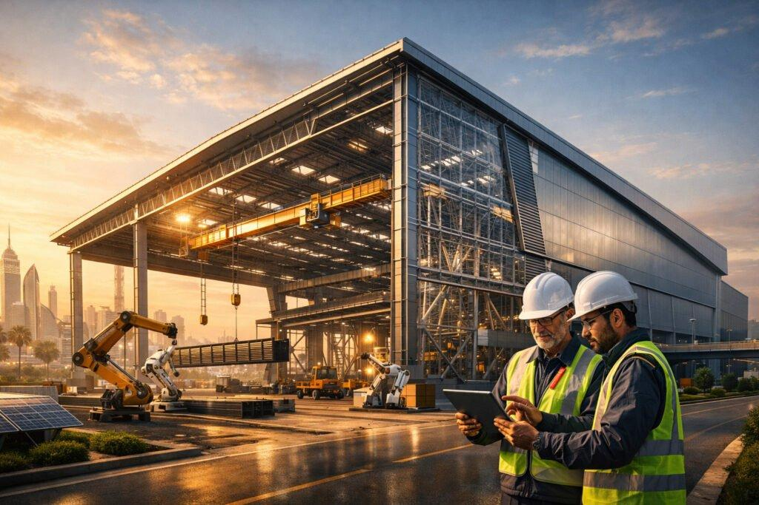
Sustainability will also play a major role in shaping the future. Construction is one of the largest contributors to environmental impact, and there is increasing pressure to adopt greener practices. Steel, being recyclable and efficient, aligns well with these goals.
Over the next decade, these factors will push PEB from being an alternative option to becoming a standard approach.

Technology is Changing Everything
One of the most interesting aspects of PEB growth is the role of technology.
Design is no longer limited to manual calculations and basic drawings. Advanced software now allows engineers to create highly optimized structures with precision. Every component can be planned in detail before a single piece is manufactured.
This reduces errors and improves overall quality.
Fabrication has also become more advanced. Automated processes ensure consistency and speed, which directly impacts project timelines. When components arrive at the site, they are ready to be assembled without major modifications.
This level of efficiency was difficult to achieve in traditional construction.
As technology continues to evolve, the gap between conventional methods and PEB will only widen.

The Speed Advantage
Time is one of the most valuable resources in any project. Delays not only increase costs but also affect business operations.
PEB addresses this issue in a very straightforward way.
Since design, fabrication, and site preparation can happen simultaneously, the overall project timeline is significantly reduced. What might take several months using traditional methods can often be completed in a much shorter period.
This is particularly important for industries where time directly impacts revenue. A warehouse that becomes operational earlier starts generating value sooner. A factory that is built faster can begin production without unnecessary delays.
This practical advantage is one of the strongest reasons behind the growing popularity of PEB.

Changing Perceptions
For a long time, there was a perception that steel buildings were only suitable for temporary or industrial use. That perception is gradually fading.
Modern PEB structures are not only strong but also visually appealing. With better design capabilities and improved materials, these buildings can meet both functional and aesthetic requirements.
Clients are beginning to see PEB as a long-term solution rather than a compromise.
This shift in perception is important because it opens the door to wider adoption across different sectors.

The Role of Expertise
While PEB offers many advantages, its success depends heavily on proper design and execution.
This is where experienced companies make a difference.
Steelbuild Infra Projects Ltd, for example, brings together design knowledge, engineering expertise, and practical experience. In a field where precision matters, having the right team ensures that projects are not only completed quickly but also meet quality standards.
As the industry grows, the importance of reliable partners will become even more critical.
Feature | PEB | RCC
Construction Time | Fast | Slow
Cost | Lower | Higher
Flexibility | High | Limited
Sustainability | High | Moderate

Challenges That Still Exist
No system is without challenges, and PEB is no exception.
One of the main issues is awareness. Many decision-makers are still more comfortable with traditional construction methods simply because they are familiar with them. Changing this mindset takes time.
Another challenge is the need for skilled professionals. Designing and assembling PEB structures requires specialized knowledge. As demand increases, the need for trained engineers and technicians will also grow.
There are also cases where initial planning is not given enough attention. Since PEB relies heavily on pre-designed components, any mistakes at the design stage can affect the entire project.
However, these challenges are gradually being addressed as the industry matures.

Opportunities Ahead
Despite these challenges, the opportunities in the PEB sector are immense.
India’s infrastructure needs are expanding rapidly. From industrial corridors to logistics hubs, the scale of upcoming projects is significant. Traditional methods alone cannot meet this demand efficiently.
PEB provides a scalable solution.
As more companies recognize its advantages, adoption will continue to grow. Smaller cities and emerging industrial areas will also contribute to this expansion.
The combination of demand, technology, and economic growth creates a strong foundation for the future of PEB in India.

Frequently Asked Questions

What is the future of Pre-Engineered Buildings in India?
The future is extremely strong. With increasing demand for faster and cost-effective construction, PEB is expected to become a preferred choice across industries.

Why are PEB structures becoming popular?
They offer speed, efficiency, and flexibility. These factors make them suitable for modern construction needs.

Is PEB better than traditional construction?
In many cases, especially industrial and commercial projects, PEB provides clear advantages in terms of time and cost.

Are PEB buildings durable?
Yes, when designed and executed properly, they are highly durable and reliable.

Which industries use PEB the most?
Manufacturing, logistics, warehousing, and commercial sectors are the major users.

Conclusion
The future of Pre-Engineered Buildings in India is not defined by trends alone—it is driven by necessity. As industries demand faster, smarter, and more efficient construction solutions, PEB naturally becomes the answer.
What started as an alternative is now moving toward becoming the norm.
The coming years will see wider adoption, better technology, and more innovative designs. Businesses that recognize this shift early will be better positioned to take advantage of it.
Companies like Steelbuild Infra Projects Ltd are already part of this journey, contributing to a construction approach that aligns with the needs of modern India.
In the end, the question is no longer whether PEB will grow, but how quickly it will become the standard.

