The Time and Cost Benefits of Prefabricated Site Offices in PEB
The Time and Cost Benefits of Prefabricated Site Offices in PEB. In the rapidly evolving world of construction, staying ahead of the curve means adopting innovations that not only improve quality but also reduce time and cost. Among the game-changing advancements in the construction landscape is the use of prefabricated site offices in Pre-Engineered Buildings (PEBs). These site offices are transforming the way construction projects are managed, executed, and delivered. Prefabricated site offices, often built off-site and assembled on location, are setting new benchmarks for efficiency, affordability, and sustainability.
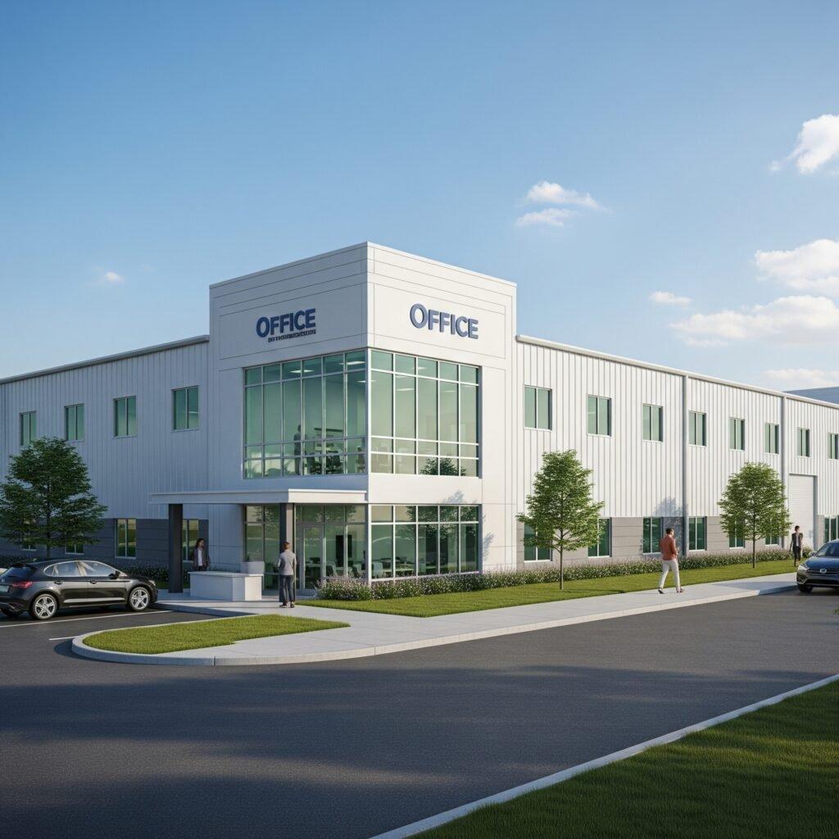

What Are Prefabricated Site Offices?
Prefabricated site offices are modular structures built using components that are pre-manufactured in a controlled factory environment. These components are then transported to the construction site for quick assembly. Often integrated into the broader PEB ecosystem, these offices are designed for functionality, durability, and ease of relocation.
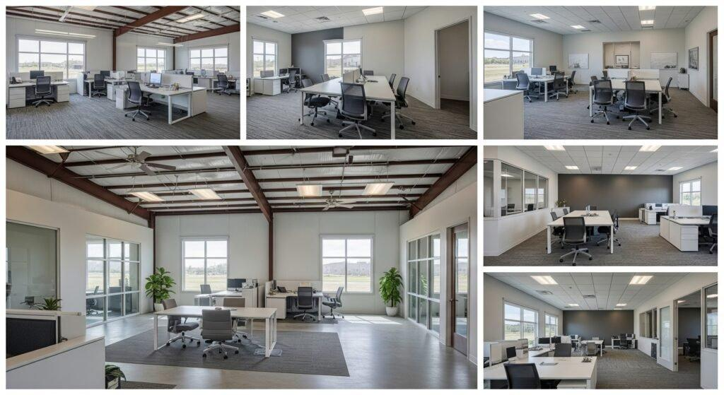
Whether you are managing a large infrastructure project, real estate development, or a manufacturing plant, having a functional, well-equipped site office is critical for project coordination, supervision, and administration. Prefabricated site offices offer just that—and much more.

Time Savings with Prefabricated Site Offices

1. Accelerated Construction Timelines
One of the standout advantages of prefabricated site offices is the significantly reduced construction timeline. Traditional brick-and-mortar site offices may take months to complete due to unpredictable weather, labor shortages, or site constraints. In contrast, prefabricated structures can be installed in as little as 2-3 weeks, thanks to their modular design and off-site manufacturing process.

2. Parallel Site Development
While the site is being prepared, the prefabricated units can be manufactured simultaneously in the factory. This parallel workflow eliminates idle time and ensures that the site office is ready for use as soon as the groundwork is complete.
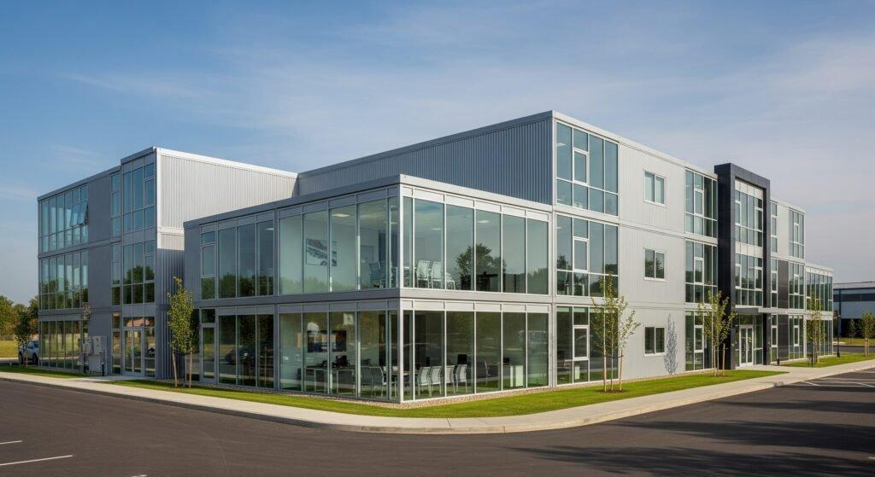

3. Fewer Weather Delays
Since most of the construction takes place indoors, there is minimal impact from weather-related disruptions. This ensures that the project timeline remains consistent and reliable.

Cost-Effective Advantages of Prefabricated Site Offices

1. Reduced Labor Costs
The factory-based production model of prefabricated site offices significantly reduces the dependence on skilled labor at the site. Assembly on-site requires minimal manpower, leading to substantial labor cost savings.

2. Lower Material Wastage
Prefabrication allows for precision cutting and material optimization, which means there's minimal material waste. This not only reduces the cost but also supports sustainable construction practices.

3. Predictable Budgeting
Prefabricated solutions come with predefined specifications and fixed costs, helping project managers avoid budget overruns commonly seen in traditional construction.
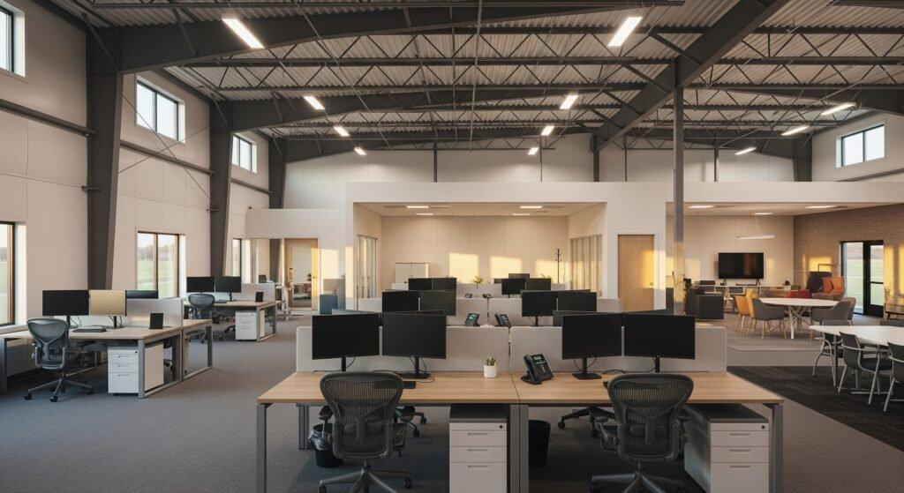

4. Economies of Scale
Manufacturers of prefabricated structures often produce at scale, enabling them to offer competitive pricing. As a result, a prefabricated site office that might cost ₹24,00,000 could easily save $20,000 compared to a traditional setup that might reach ₹40,00,000.

Additional Benefits of Prefabricated Site Offices

1. Tailored Flexibility
Each construction project has unique needs, and prefabricated site offices can be fully customized to meet these requirements. From floor plans to utilities, everything can be adapted to fit your operational demands.

2. Lasting Durability
Modern prefabricated structures are built from high-quality materials such as galvanized steel and insulated sandwich panels. They are designed to withstand harsh weather conditions, frequent relocations, and long-term usage.

3. Eco-Friendly Choice
Prefabricated construction is inherently more sustainable. Reduced material waste, energy-efficient production, and recyclability of materials make these site offices an environmentally responsible choice.

4. Portability and Reusability
These site offices are not permanent structures. Once a project is completed, they can be dismantled and transported to a new location. This mobility adds immense value, especially for contractors handling multiple projects.
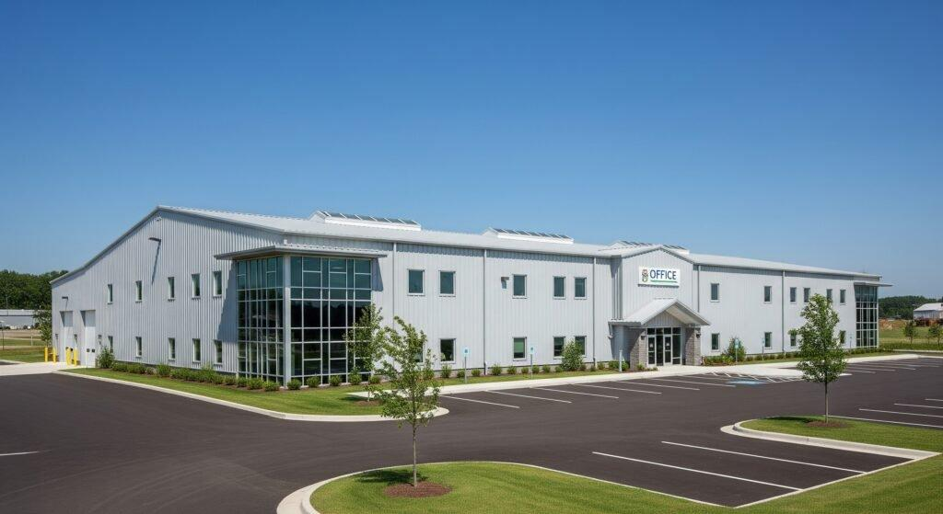

Real-Life Impact on Construction Projects
Let's take a moment to consider real-world scenarios where prefabricated site offices have made a tangible difference:
- Infrastructure Projects: In large government or private infrastructure ventures, delays can mean financial penalties. The quick setup of prefab site offices allows operations to start sooner and stay coordinated.
- Real Estate Development: For builders constructing housing or commercial complexes, having a quick-to-setup, presentable, and functional office on-site enhances both productivity and professionalism.
- Industrial Construction: In remote or industrial zones, getting materials and skilled labor can be challenging. Prefabricated units mitigate this challenge by reducing on-site requirements.

How PEB Complements Prefabricated Site Offices
Pre-Engineered Buildings (PEBs) are steel structures designed and fabricated in advance, making them ideal partners for modular offices. Here’s how PEBs elevate prefab site offices:
- Structural Integrity: PEBs offer high load-bearing capacities and seismic resilience, making the structures safe and secure.
- Design Versatility: PEBs can accommodate modern designs, ensuring that your prefab office doesn’t just function well but also looks good.
- Rapid Erection: Steel members are easy to assemble on-site, complementing the speed of prefab office installation.
- Energy Efficiency: With insulation panels and intelligent design, PEBs offer temperature control, making the site offices comfortable and energy-efficient.

Innovations and Future Trends
The prefabricated building sector is continuously evolving. Emerging trends in prefab site offices include:
- Smart Technology Integration: Offices equipped with smart lighting, surveillance, and IoT devices for improved safety and productivity.
- Green Building Certifications: Use of materials and designs that meet green building standards.
- Hybrid Construction Models: Combining prefab modules with traditional elements to enhance functionality.
- Advanced Insulation Materials: Better climate control in extreme environments.
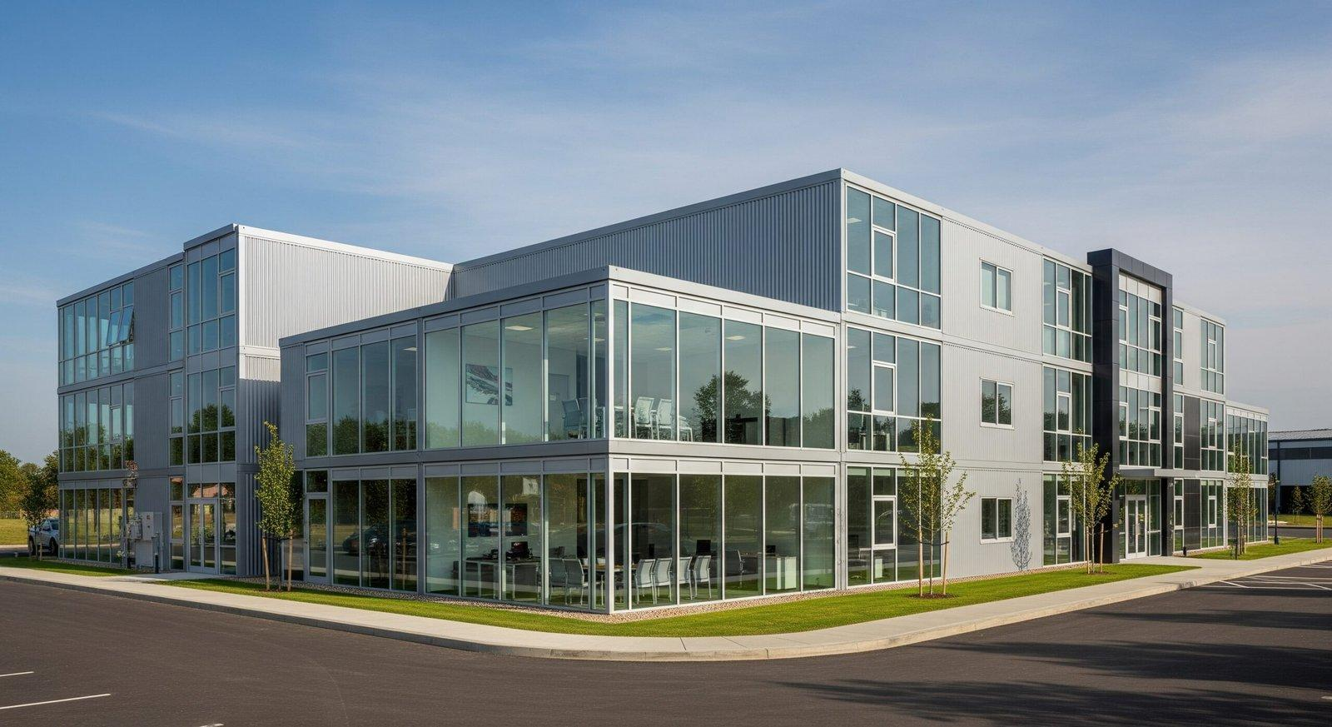

Prefab Site Offices: A Must-Have for Modern Construction
If you’re planning a construction project, overlooking the value of a prefabricated site office would be a costly mistake. Their impact is more than logistical; they contribute to the overall success of your project by creating an environment that promotes coordination, efficiency, and productivity.
Whether you're an architect, builder, project manager, or business owner, adopting prefabricated site offices is a step towards smarter, faster, and more cost-efficient construction practices.

Conclusion: The Smart Choice for Smart Builders
In today’s competitive construction landscape, time and budget are critical drivers of success. Prefabricated site offices, especially when integrated with Pre-Engineered Building (PEB) solutions, offer a practical, scalable, and sustainable option. They are not just temporary workspaces; they are strategic assets that drive efficiency, reduce overheads, and align with modern construction demands.
From quick deployment to cost efficiency, from customization to eco-friendliness, the advantages are too compelling to ignore. If you're looking to maximize your construction project’s success, it’s time to embrace the future of smart site management—and that future is prefabricated.

Explore how Steelbuild Infra Projects Ltd delivers top-tier prefabricated site offices tailored to your needs. Reach out today for customized solutions that transform your construction experience.
For more information, visit: steelbuildinfra.com or email us at info@steelbuildinfra.com.

