Revolutionizing Healthcare Infrastructure with PEB

Introduction
Revolutionizing Healthcare Infrastructure with PEB. Healthcare infrastructure is the backbone of any thriving society. It plays a pivotal role in ensuring the health and well-being of a population, especially in a country as diverse and populous as India. With the healthcare sector facing mounting challenges due to population growth, evolving disease profiles, and recent global health crises, the need for robust and rapidly scalable infrastructure has never been more urgent.
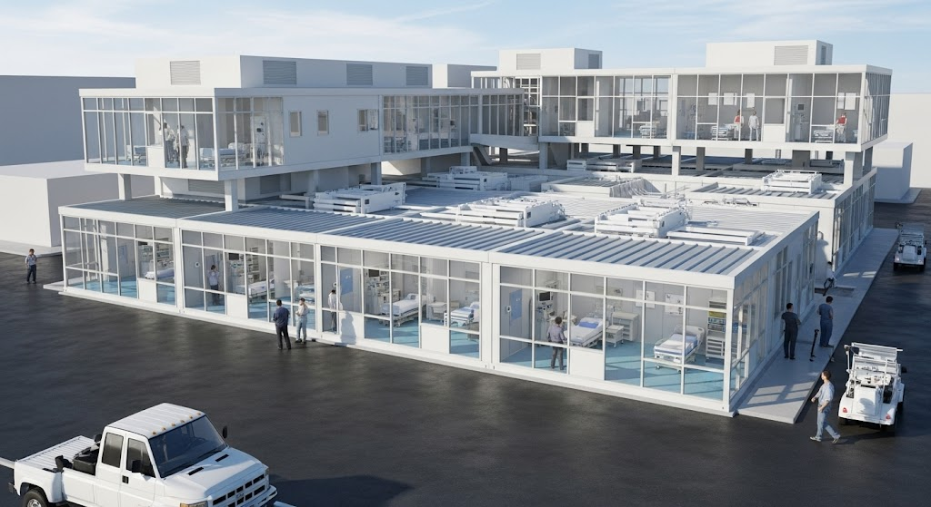
Traditional brick-and-mortar construction methods, though time-tested, come with numerous limitations such as extended timelines, labor-intensive processes, inflexibility, and higher costs. In contrast, Pre-Engineered Steel Buildings (PESBs) offer an innovative, efficient, and sustainable alternative that can revolutionize how healthcare infrastructure is designed and deployed across India and globally.

Why Rapid Healthcare Infrastructure Development Is Critical
India continues to grapple with significant disparities in healthcare access, particularly in rural and semi-urban regions. A shortage of medical facilities, infrastructure, and healthcare personnel continues to pose serious challenges. The Indian government, through various initiatives and public-private partnerships, has set out to bridge this gap by constructing hospitals, community health centers, and diagnostic labs at scale.
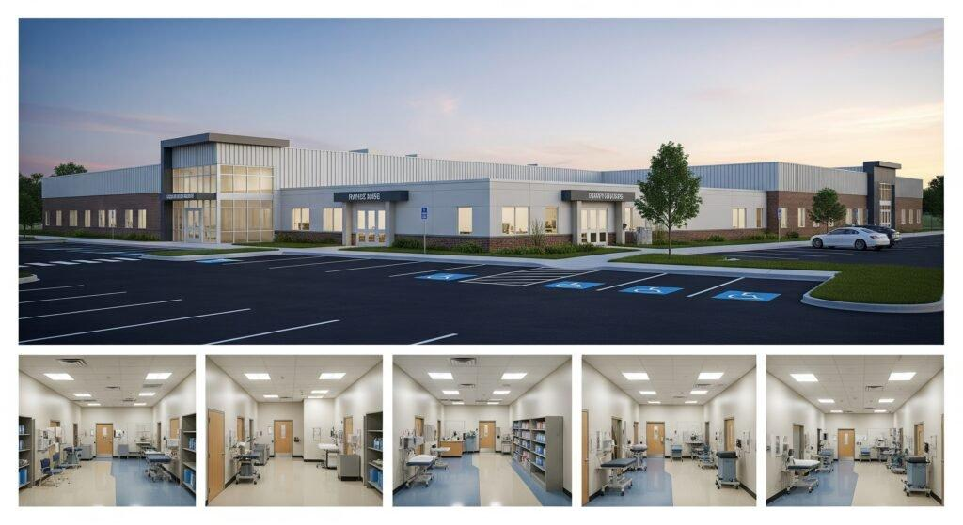
However, traditional construction methods often fall short due to the time and resources they require. This is where Pre-Engineered Steel Buildings present a compelling solution. These structures can be planned, fabricated, transported, and assembled much more quickly than conventional buildings, making them ideal for urgent, large-scale healthcare infrastructure needs.

Advantages of Pre-Engineered Steel Buildings in Healthcare

1. Speed of Construction
- Pre-Fabrication: PESBs are fabricated in off-site factories under controlled conditions, allowing for simultaneous site preparation and component manufacturing.
- Quick On-Site Assembly: Components are shipped ready for assembly, reducing the time needed for on-site work and minimizing delays caused by weather or labor shortages.

2. Cost-Effectiveness
- Reduced Labor Costs: Assembly requires fewer skilled workers and less time, reducing overall labor costs.
- Minimal Material Wastage: Factory fabrication ensures precise cuts and efficient material usage, lowering waste and cost.
- Long-Term Maintenance Savings: Steel buildings are corrosion-resistant and require significantly less upkeep than traditional structures.

3. Flexibility and Scalability
- Modular Design: Healthcare facilities can be customized to accommodate various departments and medical needs.
- Future Expansion: Modular architecture allows easy expansion as service demand increases, without disturbing existing operations.

4. Sustainability
- Recyclability: Steel is 100% recyclable, reducing environmental impact.
- Energy Efficiency: Can be integrated with insulated panels, solar panels, and energy-efficient HVAC systems.

5. Structural Strength and Safety
- Seismic and Wind Resistance: PESBs are engineered to withstand extreme environmental conditions, crucial in disaster-prone areas.
- Fire Resistance: Steel does not combust, offering better fire safety than traditional materials.
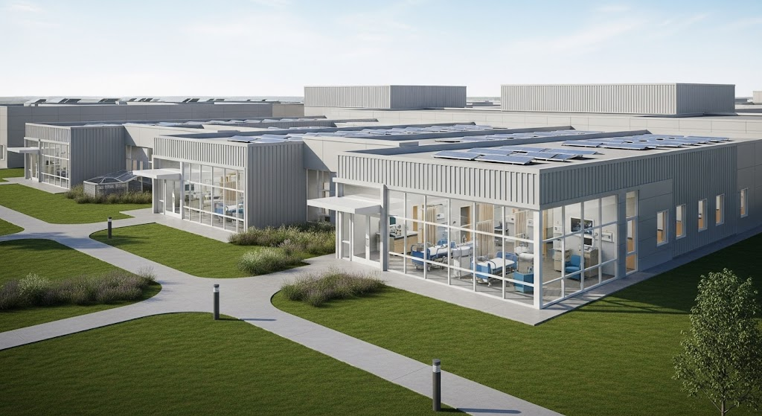

Technical Excellence Behind Steelbuild's Healthcare Solutions
When constructing healthcare infrastructure, every detail matters—from the layout of operation theatres to ventilation in ICUs. Steelbuild Infra Projects Ltd brings precision, performance, and planning to the forefront with technically superior solutions.

Key Technical Features:
- High-Strength Steel: Grades like E410 ensure high load-bearing capacity.
- Slim Deck Systems: Integrates concrete with steel beams for strength and fire resistance.
- Prefabricated Joists and Speed Floors: Enables swift assembly and reduced on-site effort.
- Column and Beam Configurations: Custom-designed UB and UC sections accommodate specific architectural and load-bearing needs.
- Seismic Resilience: Designed with reinforced concrete cores and braced frames for maximum stability.

Customization Tailored for Healthcare Facilities
Every hospital and clinic has unique spatial and functional requirements. Steelbuild’s PESBs allow tailor-made designs, offering spaces that can house:
- Emergency rooms and trauma centers
- Operating theaters with required sterile environments
- In-patient wards
- Diagnostic labs and imaging centers
- Administrative offices
- Waiting areas and patient lounges
- Pharmacies and cafeterias
The structural flexibility allows healthcare planners to optimize flow, ensuring that patient movement, doctor access, and emergency procedures are conducted seamlessly.

Operational Benefits Enhancing Healthcare Delivery

1. Enhanced Patient Flow
The open, modular layout of PESBs allows for better-designed floor plans that optimize movement within the facility.

2. Support for Advanced Medical Technology
Steel structures are highly adaptable, allowing integration of heavy diagnostic machinery, advanced ventilation systems, and digital health infrastructure without compromising safety.

3. Improved Hygiene and Infection Control
Smooth, steel-clad surfaces are easier to clean and disinfect, helping in the prevention of infections.

4. Adaptability to Health Crises
Modular steel hospitals can be rapidly deployed in response to pandemics or natural disasters, offering ICU beds, isolation units, and temporary treatment centers.

Case Studies: PESBs in Action
Across India, PESBs are already being deployed in:
- COVID-19 Response Facilities: Temporary COVID wards, testing labs, and quarantine centers.
- Rural Clinics: Low-cost, high-impact clinics in underserved areas.
- Medical Warehouses: Secure storage for pharmaceuticals and medical equipment.
- Mobile Testing Labs: Transportable steel buildings for mobile diagnostics.
These examples prove the adaptability and effectiveness of PESBs in meeting diverse healthcare needs.

Environmental Benefits
Healthcare institutions are increasingly adopting green practices. PESBs support these initiatives by:
- Using recyclable materials
- Supporting solar panel installations
- Reducing construction waste
- Facilitating natural lighting and energy-efficient HVAC systems
This aligns with global healthcare trends emphasizing sustainable practices and eco-conscious building operations.

Meeting Future Healthcare Demands
As medical science evolves, infrastructure must keep pace. PESBs offer unmatched adaptability, allowing facilities to upgrade or expand without significant operational downtime. They support:
- Telemedicine Centers
- Research Labs
- Elderly Care Units
- Post-Operative Rehabilitation Centers
Whether it's converting outpatient wings to intensive care units or adding diagnostic capacity, PESBs provide the agility required in modern healthcare.

Challenges and Overcoming Them
Adoption of PESBs in healthcare still faces a few challenges:
- Perception Issues: Some stakeholders still favor traditional construction methods.
- Initial Investment Concerns: While long-term ROI is excellent, upfront costs may be a deterrent.
- Regulatory Hurdles: Building codes and compliance frameworks need to evolve with new construction technologies.
Steelbuild Infra Projects Ltd addresses these challenges through:
- Comprehensive client education
- Transparent cost-benefit analysis
- End-to-end project management
- Close collaboration with regulatory bodies
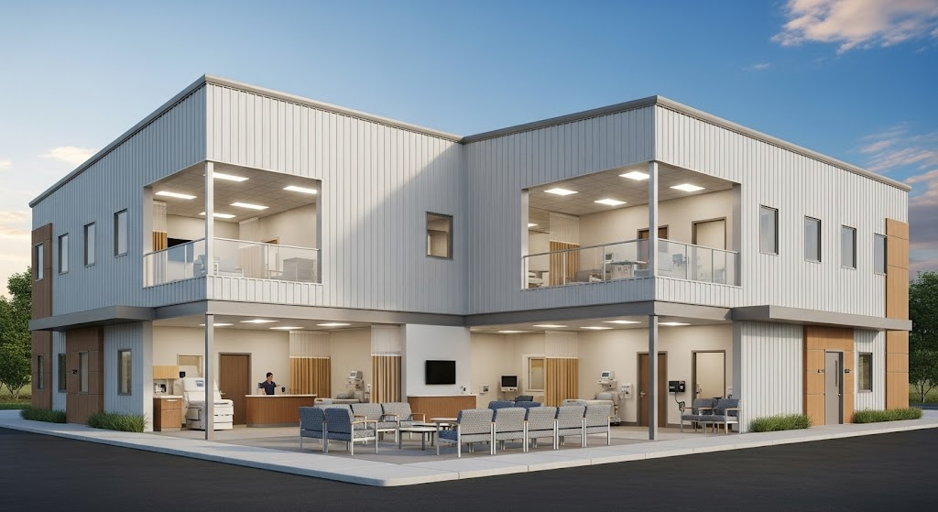

Why Steelbuild Infra Projects Ltd?
Steelbuild Infra Projects Ltd is at the forefront of innovation in pre-engineered steel construction. Our experience across diverse industries, including healthcare, makes us a trusted partner in building infrastructure that saves lives.

What Sets Us Apart:
- Turnkey Solutions: From design and fabrication to installation and post-construction support.
- Quality Assurance: ISO-certified processes and stringent quality checks.
- Custom Designs: We tailor every project to meet the specific functional needs of the client.
- Proven Track Record: Successful delivery of high-quality PEBs across India.

Conclusion
India and many other nations are at a healthcare crossroads, where the need for scalable, sustainable, and cost-effective infrastructure is more urgent than ever. Pre-Engineered Steel Buildings offer an unparalleled opportunity to transform healthcare delivery by enabling rapid construction, operational efficiency, and design adaptability.
By moving towards PESBs, healthcare systems can ensure better accessibility, reduced costs, and faster service delivery—improving lives at scale.
Steelbuild Infra Projects Ltd is committed to driving this transformation with its world-class PEB solutions tailored to healthcare needs. Join us in building the future of healthcare—efficient, resilient, and sustainable.

For more information on our healthcare infrastructure projects, visit: steelbuildinfra.com

